**Test Case 1: Display points balance SUCCESS**

**Preconditions:**

* User is logged in.

**Steps:**

1. Navigate to the points dashboard or profile page.

**Expected Result:**

* The current points balance is displayed prominently on the screen.

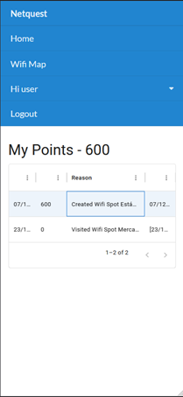

**Test Case 2: Display "0 points" when balance is zero SUCCESS**

**Preconditions:**

* User is logged in.
* The user's total points balance is 0.

**Steps:**

1. Navigate to the points dashboard or profile page.

**Expected Result:**

* The points balance is displayed as "0 points."
* A message is shown encouraging the user to take actions to earn points (e.g., "Start earning points by completing activities!").

**Test Case 3: Show loading indicator while retrieving points balance SUCCESS**

**Preconditions**:

* User is logged in.
* Points balance is being retrieved from the server.

**Steps**:

1. Navigate to the points dashboard or profile page.

**Expected Result**:

* A loading indicator is displayed while the points balance is being fetched.
* The loading indicator disappears once the points balance is successfully loaded.

**Test Case 4: Handle error when retrieving points balance SUCCESS**

**Preconditions**:

* User is logged in.
* There is a network or server error while retrieving the points balance.

**Steps**:

1. Navigate to the points dashboard or profile page.

**Expected Result**:

* An error message is displayed (e.g., "Unable to retrieve your points balance. Please try again later.").
* A "Retry" button is available to attempt reloading the points balance.

**Test Case 5: Prevent unauthorized access to points balance SUCCESS**

**Preconditions**:

* User is **not** logged in.

**Steps**:

1. Attempt to access the points dashboard or profile page.
2. This page should not be available

**Expected Result**:

* User is redirected to the login page or shown an error message (e.g., "You must be logged in to view your points balance.").