Finances Management App

Rafael Gómez Pérez

**Resum—** Este proyecto intenta cubrir las necesidades que todo grupo de amigos se encuentra y, suele ser el centro de la mayoría de problemas, el dinero. Nos ha pasado a todos que salimos a hacer algo con los amigos y, a la hora de pagar, alguien no tiene suficiente dinero por lo que otro miembro del grupo paga su parte. Es fácil que, con el paso del tiempo, nos olvidemos de quien le debe dinero a quien, el motivo y la cantidad, y esto puede resultar en peleas y/o enfados. Ya sea que la persona que debe dinero carece de la moral para intentar saldar su deuda lo antes posible, o deja pasar el tiempo sin comentarlo para que el tema se olvide, es díficil acordarse de todo esto. Para resolver ese problema hemos creado la app llamada WhoPays. WhoPays permite al usuario, de manera rápida y sencilla, mantener un historial claro de todos los eventos que ha realizado ese grupo y cuanto dinero debe cada miembro de éste.

**Pataules clau—**Programación Reactiva, Arquitectura de Microservicios, I/O No bloqueante, Spring Webflux, Aplicaciones Híbridas Ionic

**Abstract**—This project tries to cover the need that every group of friends has and is always the center of problems, money. It’s happened to everyone that we go out with friends and someone doesn’t has the money to pay and someone has to pay for him. It’s easy as time goes by to lose track of that money, whether the guy who owns money lacks the moral conviction to pay it as soon as possible and tries to not talk about it in order for everyone to forget it or the guy who paid simply doesn’t think there’s a problem there. In order to solve that problem we’ve created the app called WhoPays. An easy to use app that allows the users to track every member of his multiple groups debts with ease and hold them accountable.

**Index Terms**— Reactive Programming, Microservices Architecture, Non-Blocking I/O, Spring Webflux, Ionic Hybrid Apps

—————————— ◆ ——————————

# 1 Introduction

T

he term micro web services was first used by Dr.Peter Rodgers during a conference on cloud Computing in 2005. At a later event in 2011 the term Microservices premiered when the Netflix team was asked to described a style of architectura that they were experimenting with.

The popularity of microservices has recently been on the rise because they can solve many current IT challenges such as increasing speed and scalability of applications.

The microservices style of architecture develops complex application software from small, individual applications that communicate with each other using API. Services in a microservice architecture (MSA) are processes that communicate with each other over a network to fulfill a goal.

As we talked before, some of the benefits of the microservice architecture are incresing speed and scalability but there’s more. Because each service is a small, modular and independent service is really easy to implement them by small teams separating them by service boundaries which makes it easier to scale up the development effort if need be.

Once developed, these services can also be deploed independently of each other and hence its easy to identify hot services and scale them independent of whole application.

Microservices also offer improved fault isolation whereby in the case of an error in one service the whole application doesn’t necessarily stop functioning. When the error is fixed, we only need to deploy the service that had that bug and not the whole application.

The microservice trend has been increasing the last years and motivated by that we wanted to try to implement, to the extent we’d be capable, our application with a microservice architecture (MSA).

Given that there’s no to-do list or a standarized list of best practices to follow we’ve tried to follow this rules.

* Allow each microservice to have it’s own persistance unit (DB).
* Decentralize things, allow the Message Broker to know only what it needs to send
* Failure resilient, isolate the failure in one system so it doesnt spread to the whole application
* Obtain high cohesion and low coupling
* Start Small

We’ve tried to follow those rules to the best of our current capabilities, we are sure that our work could be improved and that will be our next mission going fordward.

# 2 State of the art

Developing this mobile-based application is not something completely new. There are some other applications in the market that provide similar functionalities, however we wanted to be able to create a similar solution that could later be further customized for our own needs.

We see the other applications in the market as an all-rounder whose target is a large amount of people while our application’s target is not to be used by millions of people but our own group of friends so that we can create new features that could be good for our needs but not necessarily to every user.

Having said that, we looked at a couple of those applications in order to get requirements for our own project but we tried to keep those to a minimun since we wanted to experiment the process of having to get the requirements from the stakeholders.

# 3 Project Proposal

WhoPays is an application that solves the problem of financial disputed among a group of friends. What the app provides is a simple way to identify which group members from the group owns money (quantity and who is owned).

Through simple charts we can recognize almost immediately who are the members that own money, so we can hold them accountable and make them pay at the next event or tell them to make us a transfer into our bank account.

After looking at similar projects and having multiple conversations with possible stakeholders this are the key requirements that we got:

* The app must have an easy way to show which members own money
* The app must have a history of the events/expenses of that group
* The app must have a list of all the members of the group
* The app must have an easy way to introduce new expenses (not forms)

To facilitate the fact, if necessary, of applying changes in the future the WhoPays app will be needed to be as scalable as possible. That along with speed and fault tolerance made us go with a microservices architecture **(MSA)**.

The problem we found with MSA is that even though it really speeds up performance, it is much more complicated to develop that a typical monolitical architecture. And there remains the difficulty of the project.

## 3.1 Project Objectives

-**TFG-OBJ-01** – Usage of the Software Development knowledge acquired throughout my specialization. Consists of implementing the knowledge I’ve acquitted to the whole Software Development Lifecycle (Planning, Analysis, Design, Implementation, Test, Document).

-**TFG-OBJ-02** – Polish my Software Development skills. Consists of further my knowledge on every aspect of the Software Lifecycle in order to become a better professional.

-**TFG-OBJ-03** – Learn about the best tools in Software Development. Consists of learning new frameworks (Spring Webflux), methodologies (Kanban), tools (Docker) and architectures (MSA) that are becoming the standards of our field in order to get used to using them everyday.

-**TFG-OBJ-04** – Usage of Clean code and Design Patterns.

Consists of using the standards of Clean Code throughout the whole project (according to the Clean Code book), and getting familiar with a couple of the most commonly used Design Patterns like Visitor or Factory Method.

-**TFG-OBJ-05** – Create an application to track expenses with ease.

-**TFG-OBJ-05.1** – Track and manage the expenses of different groups of friends within the same application with an easy to understand UI.

-**TFG-0BJ-05.2** – Track and manage the home expenses of the user with an easy to understand UI.

-**TFG-OBJ-06** – Create a microservice architecture and clustering. Consists of implementing an **MSA** with the help of cloud clustering and deployment to speed performance and have fault tolerance.

**-TFG-OBJ-07** – Create a multiplatform application. Consists of creating a hibryd application with Ionic so that can be deployed in both mobile OS (Android and iOS).

# 4 Working Methodology

To develop WhoPays we thought of using a methodology that could allows us to develop features in an agile way while being able to focus on finishing a specific feature before moving onto the next one.

However, we didn’t find any existing methodology that would fit with those requirements, but we found a way to merge two already existing methodologies into one that would fit our requirements.

## 4.1 Working Methodologies: Kanban

Kanban is a mean to design, manage and improve the flow of work. It provides a visual representation of the flow of work where we can see the state of our issues (PLANNED,

IN PROGRESS, TESTING, DONE, RELEASED).

Kanban really excells in an environment where we want to deploy work as soon as it’s ready because we will know the exact moment a feature has been finished.

Among the multiple benefits of using Kanban this are the ones that usuaylly are the easiest to recognize:

* **Transparency** : sharing information openly using clear language improves the flow of business balue.
* **Balance** : different aspects, viewpoints and capabilities must be balanced in order to achieve effectiveness.
* **Flow** : Work is a continous or episodic flow of value.
* **Understanding** : Individual and organizational self-knowledge of the starting point is necessary to continue improving.

In order to use Kanban to it’s fullest potential there’s a list of practices that we have to follow within a Kanban system:

* **Visualize** : use a kanban board in order to show the team WIP limits, state of all issues and the delivery point to a client.
* **Limit work in progress** : limit the amount of work you have in progress in a system and use those limits to guide when to start new features.
* **Manage flow** : try to maximize the delivery value while minimizing lead times and be as predictable as possible. A key aspect of flow management is identifying and addressing bottlenecks and blockers.
* **Implement feedback loops** : feedback loops are an essential element in any kanban system looking to provide the ability to change and improve.

## 4.2 Working Methodologies: Feature oriented programming (FOP)

Feature oriented programming is a programming paradigm to develop software in an incremental way. It has multiple ways to apply it to a project since it is based in three equations that allow us to see in advance which feature to choose and develop first.

Having said that, we thought that using that approach would only increase our development time since it adds an extra level of difficulty to the development cycle.

After thinking about it, we thought of using the methodogy approach of prioratizing certain features and implementing those first. But we didn’t use any mathematical equation in order to do that.

What we did was, after having all the requirements completed we talked to our stakeholders and asked them which features they thought were more important and which of those would they want to get first.

Between the answers we got from our stakeholders and our own vision of how much value each feature would give to the product we created a list of priority before the development cycle had begun.

The list is the following :

1. Create groups and add/remove expenses
2. Add/Remove members from group
3. Calculate a the debts of the group as well as the debts of each group member
4. Create Payments in order to pay off debts
5. Login and Create an account
6. Change user credentials
7. Upload Image for groups and users
8. Config app properties

Once we had this list, the rest of the process was easy. We simply started from top to bottom developing each feature, but there is another problem. A mobile application is divided in two environments backend (server) and frontend (client/mobile device) and that woudl make it difficult for us to develop each functionality in both environments before moving into the next one because most of the functionalities have dependencies with others.

In order to solve that problem, we separated the methodolgy in two parts, we would still use feature oriented programming but we’d first develop the functionalities of that complete list at the backend environment (because is the most time consuming) and once those were finished, we would develop the functionalities in that exactly same order on the frontend environment.

# 5 planning

To develop this project from beginning to end, a planning has been prepared which mentions the tasks that must always be completed. These tasks have been divided to make it easier to develop. To carry out this planning, a Gantt Chart has been created where these activities are established where the deadlines of each task add up to the project deadlines.

Broadly speaking the Gantt is made of three main blocks which encompasses almost all the activities.

These blocks are:

* **Research & Planning**: Carry out a preliminary study on the project to look for other similar applications and try to figure out how were they made so we have some additional requirements.
* **Design**: Create an initial design based on the requirements obtained from our stakeholders and our team, such as MSA or scalable software.
* **Development**: Develop and deploy the project.

The Gantt chart of this section can be found at the appendix of this document.

# 6 development cycle

## 6.1 Requirements Gathering

Before starting the Design and Implementation stages, it is necessary to carry out a preliminary and exhaustive analysis to determine the requirements that the project must meet. With this stage we are able to reflect with clarity and precision the different characteristics of the system (requirements) classified between functional requirements (what the system must include) and non-functional requirements (system constrainst, performance requirements).

For the reasons mentioned above, we started conducting an investigation stage that would be later called **Research & Planning** where we would try to find requirements for our project in other similar applications and through meetings with our stakeholders.

## 6.2 Application Design

Talking about the design we can distinguish three different main parts:

* Database or Model Design
* Front end Design or UI
* Backend Design or Architecture

In this section will look at the Model Design and the Backend Design and we’ll leave the UI for the results section of this document.

## 6.2.1 Database/Model Design

Given that our current technological stack is based on reactive programming, we had no more options that to use a non SQL Database. The reason being that typical SQL Databases don’t support non-blocking calls (which is the base of reactive programming).

After looking at multiple non SQL option like Cassandra and Couchbase we endend up deciding to work with MongoDb.

MongoDb is a non SQL open source document based Database that has grown in popularity over the last years due to it’s easy quey language, scalability and speed.

Like we said beofre, mongo in a non SQL Database so what benefits do we get by using MongoDb over a relational database like PostgresSQL or MySQL.

The benefits are the following :

* Designed to be decentralized, works well in distributed systems.
* Easier to adapt to project necessities since it isn’t as restrictive as a traditional SQL.
* We can change the Database Schema without having to stop the whole development (adaptability).
* Horizontal scalability, they can grow by multiplying the number of machines instead of the machine’s specs.
* Can be used in an low resources environment.
* Queries optimized to work with great volumes of data.

MongoDB schema is organized in Collections (a list of same type documents). In the following image we can see the Collection we’ve created with the document schema and fields.

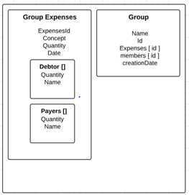

The result stored with this Collection schema is the following.

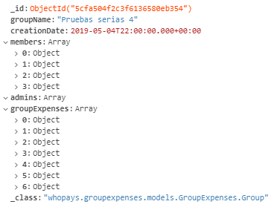

As we can see, the objects are store according to the schema, but that’s not something mongo does for us. We said before that mongo treats it’s data as Json, we can select types for each document on the Database but it’s the developer’s job to ensure consistency thoughout the app since mongo won’t raise exceptions if some data is not provided when we insert an object.

## 6.2.2 Microservice Architecture

One of the most common trends in Software Development is the use of services that provide the user what he asks for. It has come to a point that almost every major framework has adopted this aproach (Spring, Angular, Django ...).

Due to the necessity to remove the dependencies formed between these services that are generated at development and deployment **the microservice architecture (MSA)** was created.

Microservices are a new way to design and implement distributed systems where each service is completely independent from the others (normally done with Docker).

Obviously, everything comes with some benefits and drawbacks and here a fer of both.

Benefits of using microservices:

* **Scalability**: since the project is composed of small modular pieces of code that we can easily scale to multiple instances of the same service.
* **Fault tolerance**: since the project is modular, if one service becomes unavailable for some reason the rest of the system can keep working without problems.
* **Auto-Healing**: when a service becomes unavailable, the circuit breaker will redirect all incoming calls while he tries to reboot it.

Drawbacks of using microservices:

* **Complexity**: a microservices architecture forces the developers to have a deeper knowledge about deployment, testing and monitoring since there will be multiple errors as the project starts.
* **Paradigm**: People coming from a monolithic architecture will have a hard time adjusting to such a new paradigm.
* **Bug Fixing**: Finding a problem in a chain of business activities when there is a logical error can be way more complex than with a regular monolithic approach.

Now that we know about a couple of benefits and drawbacks of the microservices architecture, we can start looking into how do they work.

Here we have the four microservices that form our architecture. Later on, we’ll explore what each and every one of them exposes but for now, how does the debt service know if the user has been authenticated, or the expenses service which group to add the expense to.

## 

## The answer to all those questions is, via the JMS (Java Message Service).

## 

The Message Broker (in our case ActiveMQ), is a implementation of the JMS that provides asynchronous communication between microservices. Message Brokers like ActiveMQ are mostly server programs running some advanced routing algorithms.

Each microservice connects to a broker via a service called Publisher to send information and Subscriber to receive it. Messages are temporary stored in queues with a specific topic so the receiver only gets the messages from the topics which he has subscribed.

ActiveMQ allows us to create a queue architecture where we define where our services will store and retrieve data from. We can see below, the queues that our architecture has.

## 

Here we have a simple example of how two microservices communicate.

## 

What we can see in the diagram above, is the communication that’s happening when we try to create the economic balance of a specific group.

Even though we can only see here the response, previous to this diagram the Debt Service sents a message to the group service to indicate which group he needs the balance from and the Group Service returns the data according to that request as we can see.

Now that we know how a microservice architecture works and communicates between each other, lets explore what each microservice of our system has to offer.

Each service is a modulo that provides an API with different endpoints and methods that may have multiple puposses.

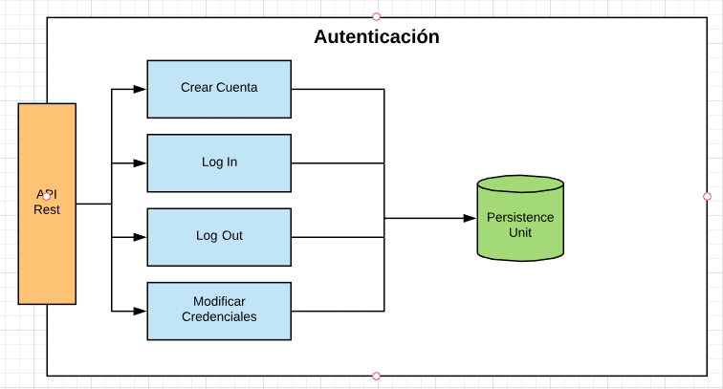

Auth Service as we can see above, provides four methods

* **Create Account**: allows the user to create an account.
* **Log In**: checks the credentials and authenticates the user.
* **Log Out**: logs the current user out of the application
* **Update Credentials**: allows the user to change his credentials (username, password).

Auth service is the one in charge of securing the access to the whole system.

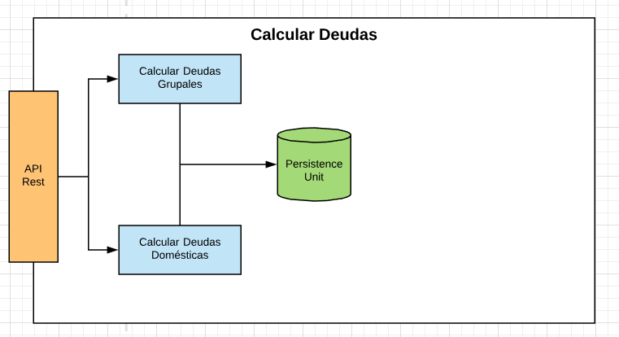

Debt Service, is the service we can see in the image. It provides two main functions but only one could be implemented.

* **Compute Group Balance**: creates the data structure of the balance of each user of the group to know who owns money.

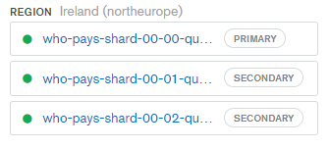

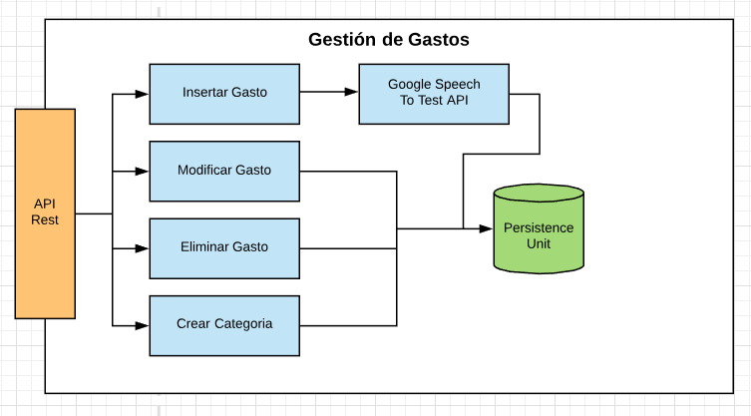**Expenses Service** is the microservice above. It is in charge of managing the expenses throughout the whole system. This service is the most complex and would be the most difficult to implement due to the complexity of adding Speech Recognition to it.

It provides the following methods:

* **Add expenses**: allows the user to add a new expense to a determined group.
* **Update expenses**: allows the user to change every aspect of the expenses in case of mistakes.
* 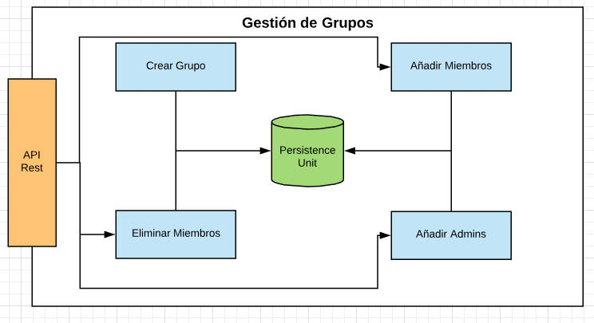**Remove expenses**: allows the user to remove a specific expense.

The service we can see above is **Group Service**. It is in charge of managing the groups of the whole system. The service provides the following methods:

* **Create Group**: allows the user to create a new group.
* **Add Members**: allows the user to add members to a specific group.
* **Add Admins**: allows the user to make another member an admin of the group.
* **Remove Members**: allows the user to remove members from a specific group.

## 6.5 Implementation

Once the Design stage was finished, the Development stage started and with it the long awaited time to start implementing this architecture.

We started to implement the project from the backend environment. We needed a Persistance Unit (Database) for every service that would be eventually developed. So we started the project by creating four clusters of MongoDb from their **DbaaS** (Database as a Service) at MongoDb Atlas.

As we can see at the image above, we have here three shards of one of the four clusters that we currently have at **MongoDb Atlas**. Shards are replicas with the same dataset of the others that can be used as a backup in case of failure.

Once we had our database clusters up and running on MongoDb Atlas, we could start implementing the project on Spring Webflux.

Given the difficulty of some services and the fact that we had to implement the Ionic app, we decided to implement the platform first from a monolithic approach in order to make it easier to implement each functionality while we were migrating later.

Spring Webflux bases his own architecture separating the project on different layers. These layers can be **Controllers**, **Services** or **Repositories** as they are the main layers but there can also be found Command or Converters.

The **Controller** layer is in charge of receiving the request and mapping it to and endPoint that our API is exposing. It binds a specific URL to an endpoint and can perform additional comprobations (access restrictions).

The **Service layer** is where the “**Business Logic**” is. By Business Logic we mean all the specific transformations or operations that are needed by the requirements. In this layer is where normally we use Converters to go from a **Data Transfer Object** (DTO) to **a Plain Old Java Object** (POJO) which is the one we’ll be working.

The **Repository layer** is the one in charge of interacting with the Database, it’s main function is to perform **CRUD** operations to the Database.

## 2.1 Exemple de subsecció

..... .... .... .......... ...... ........ ...... ..... ...... ..... ..... .... .......... ...... ........ ............ ........ ...... ..... ...... ..... ..... .... .... .......... ...... ........ ...... ..... ...... ..... ..... .... .... .......... ...... ........ ...... ..... ...... ..... ..... .... ........ ...... .

## 2.2 Exemple de subsecció

..... .... .... .......... ...... ........ ...... ..... ...... ..... ..... .... .......... ...... ........ ............ ........ ...... ..... ...... ..... ..... .... .... .......... ...... ........ ...... ..... ...... ..... ..... .... .... .......... ...... ........ ...... ..... ...... ..... ..... .... ........ ...... .

# 3 Conclusió

..... .... .... .......... ...... ........ ...... ..... ...... ..... ..... .... .......... ...... ........ ............ ........ ...... ..... ...... ..... ..... .... .... .......... ...... ........ ...... ..... ...... ..... ..... .... .... .......... ...... ........ ...... ..... ...... ..... ..... .... ........ ...... .

**Agraïments**

..... .... .... .......... ...... ........ ...... ..... ...... ..... ..... .... .......... ...... ........ ............ ........ ...... ..... ...... ..... ..... .... .... .......... ...... ........ ...... ..... ...... ..... ..... .... .... .......... ...... ........ ...... ..... ...... ..... ..... .... ........ ...... .

**Bibliografia**

1. Referència 1
2. Referència 2
3. Etc.

**APPENDIX**

**A1. Secció d’apèndix**

..... .... .... .......... ...... ........ ...... ..... ...... ..... ..... .... .......... ...... ........ ............ ........ ...... ..... ...... ..... ..... .... .... .......... ...... ........ ...... ..... ...... ..... ..... .... .... .......... ...... ........ ...... ..... ...... ..... ..... .... ........ ...... .

**A2. Secció d’apèndix**

..... .... .... .......... ...... ........ ...... ..... ...... ..... ..... .... .......... ...... ........ ............ ........ ...... ..... ...... ..... ..... .... .... .......... ...... ........ ...... ..... ...... ..... ..... .... .... .......... ...... ........ ...... ..... ...... ..... ..... .... ........ ...... .