Softpotentiometer Report

Rafael Antonio Laya Alfonzo

ENGR102 Intro to Electronics

Shoreline Community College

November 2017

**Setup**

The following measurements are related to the softpotentiometer found in the Sparkfun SIK kit V2 for Arduino.

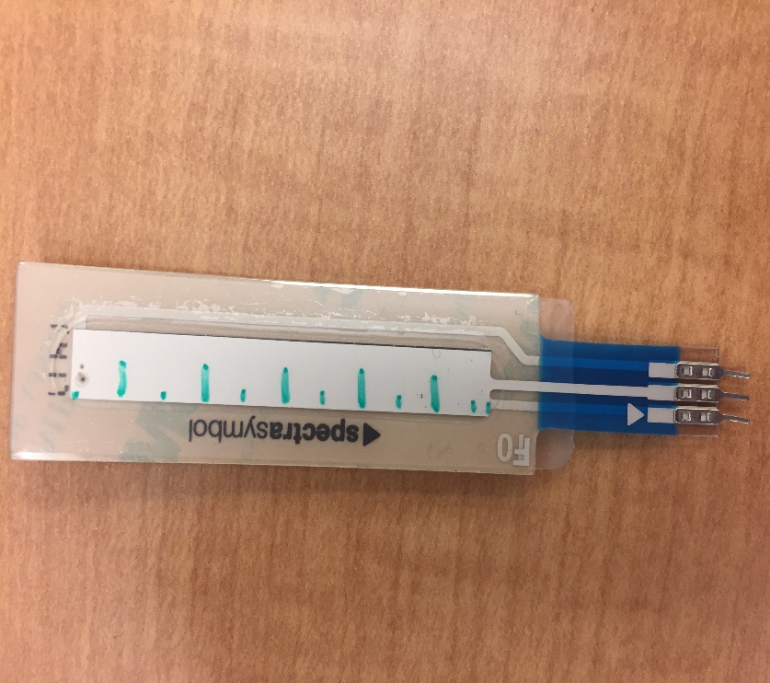

**Figure 1.** Softpotentiometer

The quantities measured in this section were measured using an Etekcity MSR-R500 Digital Multimeter. The datasheets are found in the resources section. When reading the datasheets consider this soft potentiometer is the 7182 (65.22mm of part length. Take also into account that in the websites of each of the sensors you can find many complains of inconsistencies between the datasheets and the products people bought.

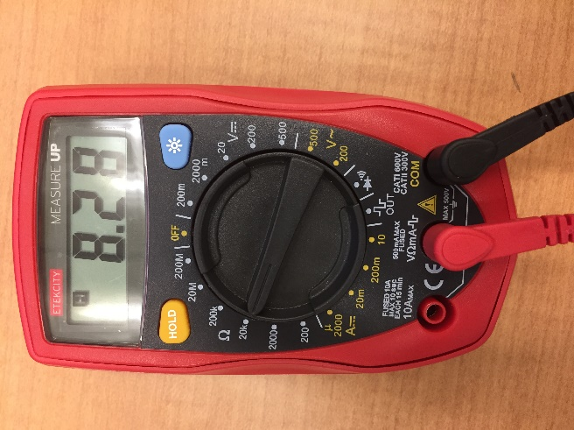

**Figure 2.** Etekcity MSR-R500 Multimeter.

The resistance is measured in kΩ as a function of the displacement of the finger from the top part of the softpotentiometer in direction to its lower part.

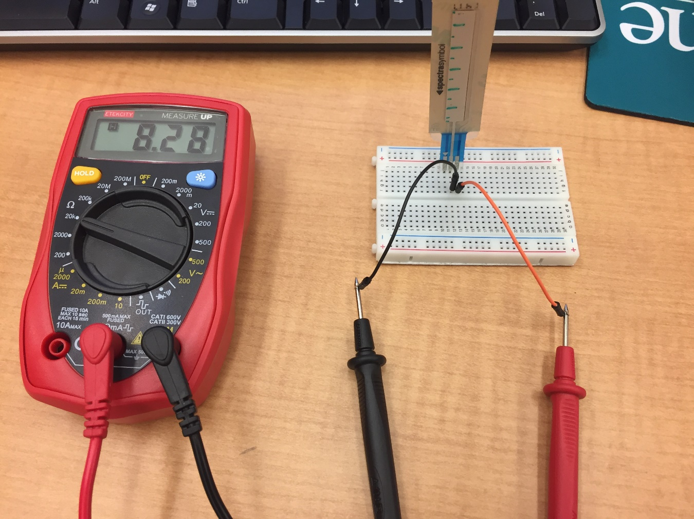

**Figure 3.** Setup

**Graph and tables**

The tables along with the raw data can be found on the SoftPot.xlsx excel file. The graph in this report is also the same graph from the .xlsx file. The graph does not fit into this page and therefore the rest of this page is blank.

|  |  |
| --- | --- |
| **Column1** | **Column2** |
| Lower limit of detection | 0.25 cm |
| Upper limit of detection | 5 cm |
| Offset Error | -0.4855 kΩ |
| Ideal Transfer Function Curve | y = 1.9491x - 0.4855 |
| Error at each point (xi, Ri) | Ri - y(xi) |
| Standard deviation of positive errors | 0.19 |
| Standard deviation of negative errors | 0.10 |
| Standard deviation | 0.24 |
| Y-intercept of upper line | -0.06 |
| Y-intercept of lower line | -0.82 |
| Upper line | y = 1.9491x - 0.06 |
| Lower line | y = 1.9491x - 0.82 |
| Coefficient of Linear Relationship | R^2 = 0.9947 |

**Excel**

The excel report is also included as a separate file in the submission documents.

|  |  |
| --- | --- |
| **Displacement (cm from top to bottom)** | **Resistance (kΩ)** |
| 0.00 | 0.00 |
| 0.50 | 0.38 |
| 1.00 | 1.30 |
| 1.50 | 2.20 |
| 2.00 | 3.11 |
| 2.50 | 4.30 |
| 3.00 | 5.52 |
| 3.50 | 6.39 |
| 4.00 | 7.61 |
| 4.50 | 8.25 |
| 5.00 | 9.20 |

|  |  |  |
| --- | --- | --- |
| **x: Measured Resistance (kΩ)** | **y=1.9491x-0.4855** | **x-y** |
| 0.00 | -0.49 | 0.49 |
| 0.38 | 0.49 | -0.11 |
| 1.30 | 1.46 | -0.16 |
| 2.20 | 2.44 | -0.24 |
| 3.11 | 3.41 | -0.30 |
| 4.30 | 4.39 | -0.09 |
| 5.52 | 5.36 | 0.16 |
| 6.39 | 6.34 | 0.05 |
| 7.61 | 7.31 | 0.30 |
| 8.25 | 8.29 | -0.04 |
| 9.20 | 9.26 | -0.06 |

|  |  |  |  |
| --- | --- | --- | --- |
|  | **std (positive error)** | **std (Negative Error)** | **std (error)** |
|  | 0.19 | 0.10 | 0.24 |
| b | -0.06 | -0.82 |  |

|  |  |  |  |
| --- | --- | --- | --- |
| **x** | **Upper** | **Lower** | **Resistance (kΩ)** |
| 0.00 | -0.06 | -0.82 | 0.00 |
| 0.50 | 0.91 | 0.15 | 0.38 |
| 1.00 | 1.89 | 1.13 | 1.30 |
| 1.50 | 2.86 | 2.10 | 2.20 |
| 2.00 | 3.84 | 3.08 | 3.11 |
| 2.50 | 4.81 | 4.05 | 4.30 |
| 3.00 | 5.79 | 5.03 | 5.52 |
| 3.50 | 6.76 | 6.00 | 6.39 |
| 4.00 | 7.74 | 6.98 | 7.61 |
| 4.50 | 8.71 | 7.95 | 8.25 |
| 5.00 | 9.69 | 8.93 | 9.20 |

|  |  |
| --- | --- |
| **Parameter** | **Value** |
| Lower limit of detection | 0.25 cm |
| Upper limit of detection | 5 cm |
| Offset Error | -0.4855 kΩ |
| Ideal Transfer Function Curve | y = 1.9491x - 0.4855 |
| Error at each point (xi, Ri) | Ri - y(xi) |
| Standard deviation of positive errors | 0.19 |
| Standard deviation of negative errors | 0.10 |
| Standard deviation | 0.24 |
| Y-intercept of upper line | -0.06 |
| Y-intercept of lower line | -0.82 |
| Upper line | y = 1.9491x - 0.06 |
| Lower line | y = 1.9491x - 0.82 |
| Coefficient of Linear Relationship | R^2 = 0.9947 |

**Resources**

https://www.sparkfun.com/datasheets/Sensors/Flex/SoftPot-Datasheet.pdf