Document Design

Contents
Contents 2
1 Introduction 3
2 Design Patterns and technologies 3
3 Components 4
4 UML 5

Introduction
The application allows users a simple way to manage medical conferences. This document will provide: technologies and design patterns used, components implemented and UML diagrams showing interaction and data control flow.

Design Patterns and technologies
The application was used “Tell Don’t Ask” design to implement parts of data (some methods have public access to use in unit tests, sorry for inconvenient). I use this design because has objects as major concepts. This design allows the object to make certain task when called and not allow access to private data, facilitating their responsibilities. It was used the technique class-responsibility-collaboration card (CRC) to model class.
Technologies used in development are:
- Language development:
Native Android language (Java). It was used because is native language in android application.

- Tools:
Android Studio. It was user because is an official IDE for building android applications

- Design Tools:
Gradle 2.10, it was used because is native build tools in Android Studio.
Mockito, it was used to mock objects in unit test (I don’t use Espresso for tests because was not working).
CardView, it was used to design view, showing conference cards
RecyclerView, it was used to design view. Used with CardView to showing list
JUnit, it was used to make unit test

Components
I used CRC to modelling classes sort out by responsibilities. To start design, I see project scenario on assignment and make cards index.
The cards:
Class Name
Responsibilities | Collaborations
Some responsibilities | Contributor: possible contributor  Collaboration: know something

The components broken down example:
Class Conference Activity
Responsibilities | Collaborations
Show conferences | Contributor: Conference schedule  Collaboration: Constructor

Each component was broken according to their responsibility and implemented in different classes.
- Objects
Conference: show conferences, view conferences details
DataBase: create, read, update, delete some data
Edit conferences: edit conferences
View conferences: conferences details
Invitations: view invite details
Register: create new user
Login: login on system

UML

Overview Database – DataBase Dependencies and Interactions (Zoom to see)
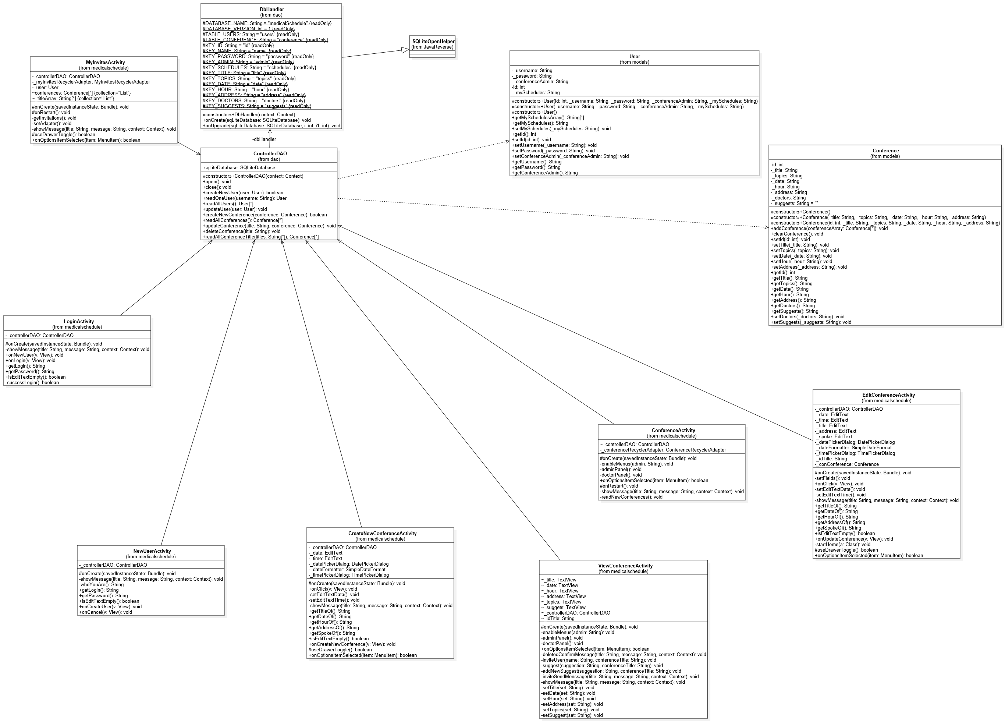

- Data control flow – Activity Login / DataBase

- Data flow – Activity Conference / DataBase

- Data flow – Activity Create Conference/DataBase

- Data flow – Activity Edit Conference

