**ARCore Library for Unity - User Manual**

Contents:

* *GoogleARCore* folder: ARCore Unity SDK version 1.20.0.
* *Resources/Plan* folder: Includes the files (images and corresponding width and height) for the scale comparation. Any image with this goal can be added and it will be automatically recognized by the library.

1. *plan_sizes.txt* file: Might contain the image width (x) and height (y) for dynamic purposes. After a new image being added, the file can be updated to contain its real size, adding a new line (*image_name*: x=*image_real_width*,y=*image_real_height*).
2. *planta_casa.png*, *planta_iris.png* images: Plan examples for scale comparison.

* Scripts: C# scripts to transfer the game for android an add all the required ARCore components.

How to use:

1. Import the package “*gameLibraryPackage.unitypackage*”. *Assets $→$ Import Package $→$ Custom Package…* and select the corresponding package. (Figure 1)
2. 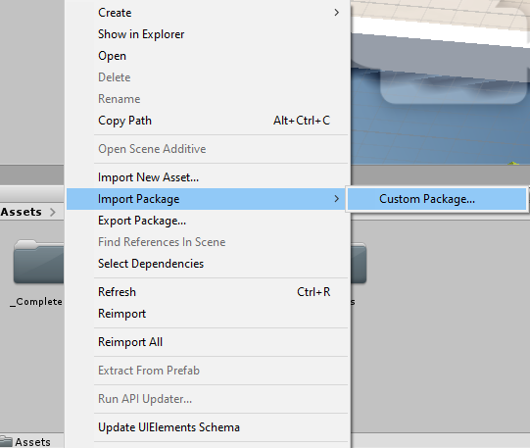Tag the intended GameObject player with the tag “*Player*”, if any (it is possible to be just a spectator).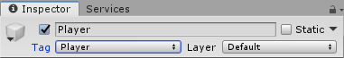 (Figure 2)

Figure 1: Import Package.

Figure 2: Tag player GameObject.

1. 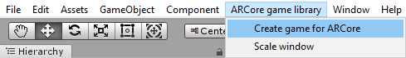Transfer the game to Android platform and associate the player to ARCore and to the phone camera. For this, just use the menu: *ARCore game library $→$* *Create game for ARCore*. (Figure 3).

Figure 3:Transfer the game to and ARCore game.

1. Open the scaling window, if any adjust to the scene scale must be made to fit in the real word. (Figure 4).

Figure 4: Open the scale window.

1. 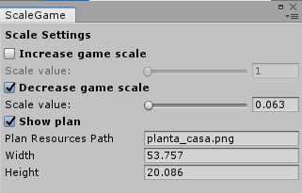Choose the scale comparison image, if any and set its width and height. (Figure 5 $→$*Show plan*).

Figure 5: Scaling window.

1. Increase or decrease the scene scale. (Figure 5).
2. Change the *“arcoreHandler”* GameObject position and rotation to the intended starting pose on the real world, relatively to the game scene.
3. *Build and Run* and enjoy the game in the Augmented Reality environment.