Project acronym: **IoTrust**

Project title: Secure trust bootstrapping and peer-to-peer network connections in

the Internet of Things

Third Party: DW/ODINS

Logo of partners

|  |  |
| --- | --- |
| Digital Worx GmbH (DW) - Germany |  |
| Odin Solutions SL (ODINS) - Spain |  |

Deliverable D.1

IoTrust Architecture Design

|  |  |
| --- | --- |
| **Deliverables leader:** | **Digital Worx GmbH, Germany** |
| **Authors:** | Silke Capo, Mihaly Virag, Mirko Ross, Rafael Marin-Perez, Antonio Skarmeta Gomez, |
| **Due date:** | 31-01-2021 |
| **Actual submission date:** | 22-01-2021 |
| **Dissemination level:** | Public / confidential |

Abstract: It is a deliverable document designed and developed under the IoTrust project. It gives extensive information about the IoTrust architecture. This document will serve as a reference document for the future deliverables of the IoTrust.

**Disclaimer**

The sole responsibility for the content of this publication lies with the authors. It does not necessarily reflect the opinion of the European Commission. The European Commission is not responsible for any use that may be made of the information contained therein.

**Copyright**

This document may not be copied, reproduced, or modified in whole or in part for any purpose without written permission from the NGI Consortium. In addition, an acknowledgement of the authors of the document and all applicable portions of the copyright notice must be clearly referenced.

All rights reserved.

This document may change without notice.

**Table of contents**

1 Introduction 1

2 Activities carried out to complete the deliverable 1

3 Technical description 1

3.1 End-Device 2

3.2 Gateway 3

3.3 Network Server 3

3.4 IoT Controller 5

3.5 Authentication Server 5

3.6 IoT Agent 6

3.7 asvin Platform 6

IPFS 7

Blockchain 7

Customer Platform 7

Version Controller 7

4 Conclusions and next steps 8

Appendix 9

Acronyms 9

Nb: The deliverable structure below is only provided for guidance and you may adapt in a free form manner the structure to fit your needs.

# Introduction

The deliverable **D.1 IoTtrust Architecture Design** fulfils the objective **O1** which aims to design a human-centric and open IoTrust solution to increase the use trust and application of secure IoT networks in worldwide sectors like Smart Cities, Industry 4.0 etc. The deliverable D.1 is the output of the task **T.1 IoTrust Architecture Design**. The task T.1 was completed in the duration of month M1 to M6. The DW was the leader of the task. The milestone **MS2 Enhanced final version of IoTrust architecture** was achieved by deliverable D.1. The milestone MS2 is the advanced version of the first architecture design from the MS1.

# Activities carried out to complete the deliverable

The user-centric requirement analysis was performed in the task T.1 to deliver deliverable D.1. It was an iterative process in which requirements of end users and other stakeholders such as internet developers were taken into consideration in designing the IoTrust architecture.

The task T.1 was performed based on Agile SCRUM[1] methodology. Each SCRUM sprint cycle was of 2 weeks. At the start of each sprint cycle requirements were gathered from end users and patterners. These requirements were analysed and an IoTrust architecture draft was designed and developed based on them. At the end of the cycle, this draft was verified and validated against the requirements. This process was performed iteratively throughout the lifecycle of the task T.1.

In the IoTrust project, a minimal viable product (MVP) is creating according to the end user and external stakeholders' requirements. To achieve that, some unforeseen issues might arise in the areas such as requirement gathering, changing and unclear requirements, functional requirements verification and validation criterion etc. These problems were identified and solved using the iterative SCRUM cycle before they could occur and hinder the project. The requirement gathering and analysis were continuous process like the designing the architecture.

There were some unforeseen technical issues also addressed and fixed in the task T.1. The project is going to employ LoRaWAN[2] protocol to send data packets between a LoRa[3] node and gateway using radio communication in the 868 MHz ISM band. There are a large number of development boards available with different LoRa modems such as SX1276/77/78/79[4] from [Semtech](https://www.semtech.com/), RFM95/96/97[5] from [HopeRF](https://www.hoperf.com/), RN2483[6] from [Microchip](https://www.microchip.com/) etc. We identified early enough that some libraries used for SX127X chips can send a packet of maximum 51 bytes which is not desirable for this project. It would have been a blocker in the project if we had not identified it at the start of the project.

# Technical description

The core aim of the deliverable D.1 was to prepare an advanced IoTrust architecture design with an iterative process. There are many aspects to the architecture design. We have analysed and prepared it with the details of hardware, software stack, communication protocols, DevOps, user interface, customer experience, API end points etc. This architecture design will serve as a reference for further deliverables. Although the core attributes of the architecture will be the same, there might be some minor changes as we reach to the end of the project. The Figure 1 illustrates the overall IoTrust architecture.

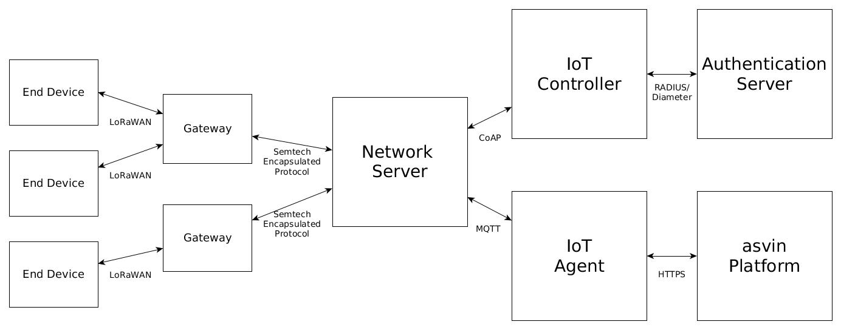

Figure 1: The IoTrust Architecture

The architecture components are described as follows.

## End-Device

It is a small form-factor hardware which sits on the edge of an IoT network. It consists of microcontroller, memory, input/output peripherals, communication protocol, etc. These end-devices are put in to work for a specialized task. These end-devices are typically installed in hard-to-reach locations or in adverse conditions and are meant to work autonomously without human supervision during months or even years. For this purpose, these devices are commonly operated using a battery and do not include user interfaces such as keypads or displays. In some cases, they are permanently installed in hazardous locations, sustaining extreme conditions, and require rugged cases that prevent dust and water penetration. Due to their small form-factor and lower power consumption, these end-devices are relegated to very specific monitoring and actuation tasks with a simple operation logic that normally relies communications with a centralized cloud infrastructure.

In the IoTrust architecture, an end-device will be used to collect, format, and send sensor data to a server. It is paramount to authenticate an end-device before it connects to the server using a critical network. Because if the end-device is compromised than it opens the flood gate to the critical network infrastructure. The authentication, authorization and key management tasks will be performed by a secure bootstrapping protocol, peer to peer and distributed ledger technologies.

The End-Device shall incorporate at least a LoRaWAN capable module, as opposed to a plain LoRa implementation, in order to guarantee a set networking of features in which this project leverages. Also, the device is expected to operate with one battery charge during months or even years without human supervision. This project requires microcontrollers with a minimum set of features that can be found in the description of Class 1 and above as defined in RFC7228[7]. Therefore, constrained devices of Class 1 and above can be employed to run the software designed in this project. E.g., an Arduino Zero with a LoRaWAN module would be close to the minimum hardware required. It includes an ATMEL SAMD21 microcontroller running at 48 MHz and 32 KiB of SRAM.

The End-Device establishes a secure communication link with the Network Server through the LoRaWAN application payload encryption scheme, based in AES128, as described by the LoRaWAN protocol specification. This scheme saves bandwidth and power since no base-station attachment procedure is performed in the LoRaWAN protocol, i.e., no key agreement or authentication procedure is performed among End-Device and Gateway.

## Gateway

A LoRaWAN Gateway — Gateway for short — is a device that provides last-mile LoRaWAN radio access to the end-devices. It is the edge component at the end of the LoRaWAN network infrastructure. Gateways are base-stations that deliver the end-device messages to a central network server through a non-constrained backhaul network, e.g., LTE or Ethernet. Basically, a gateway is a multi-channel high performance LoRa transceiver module that can receive, process, and send several LoRa packets simultaneously using different spreading factors on various channels. An end-device will send LoRaWAN messages via LoRa PHY layer technology. The LoRa packets will be received by all gateways within the radio coverage area of the end-device and will deliver their contents to the central Network Server, which performs deduplication tasks. In order to provide scalable massive coverage area, gateways can handle communications from thousands of devices in the range up to a few kilometres in densely populated urban areas, and up to tens of kilometres in rural areas. Therefore, large coverage areas can be covered with a reduced number of gateways, which makes LoRaWAN a desirable technology for expansive deployments.

Communications’ security is provided through the LoRaWAN message encryption, as defined by the protocol specification. This scheme is employed in communications to and from the End-Device and the Network Server. The LoRaWAN MAC payload received from the End-Device is encapsulated with the Semtech encapsulation protocol[8], and transmitted over the backhaul network to the Network Server.

The Gateway is required to embed at least one high-performance LoRa multi-channel module such as the commercially available integrated SX1301[9] LoRa transceiver, and are equipped with a high performance 868 MHz fiberglass antenna with peak gain of 3.0dBi. Additionally, the Gateway must be connected to the backhaul network through 4G LTE connectivity or via Fast Ethernet, with enough bandwidth to support the communications of up to thousands of devices. Also, this device is supposed to be installed outdoors, thus requiring a rugged encasing and a high grade of protection from dust, rain, and an electrostatic discharge/surge protection for the antennas.

## Network Server

The Network Server is part of the LoRaWAN back-end infrastructure. It represents the central hub of all communications from and to LoRaWAN end-devices. It aims to hide the Physical (PHY) and Medium Access Control (MAC) layer details of the LoRaWAN protocol to the components that need to communicate with end-devices. The Network Server is in charge of collaborating with the end-devices to keep the overall network health, i.e., optimise the data-rate and overall energy consumption of the deployment site, as well as orchestrate what radio configuration parameters end-devices should employ in order to avoid packet loss or unnecessary retransmissions.

The IoTrust project will employ the ChirpStack.io open source LoRaWAN Network Server Stack[10]. This project is a popular a Free Open-Source Software (FOSS) implementation of the LoRaWAN network server that provides several operation and administrative facilities in order to deploy a network of end-devices. All the components are licensed under the MIT license. Therefore, modifications and improvements can be made commercially available. Its architecture employs several operation and administrative end-points common in IoT application scenarios. These include, a web interface dashboard, standardised protocol event-based broker using MQTT[11] and a management REST[12] API over secure HTTPS connections. Hence, its integration with other IoT-centric services and networking components is relatively easy.

Overall, the LoRaWAN network server is a unique component. There is only one single instance per deployment and provides high-level abstraction of end-device communications. The applications and users are presented with a high-level abstraction end-point to send and receive messages to and from end-devices. These end-points may be a REST APIs, an MQTT broker or other customizable solutions. The network server will manage all the low-level details in order to guarantee secure and reliable delivery of messages to and from the LoRaWAN infrastructure.

The ChirpStack LoRaWAN server components require a MQTT broker in order to work. Typically, this MQTT broker is distributed within the ChirpStack installation itself. However, an existing MQTT broker instance can be employed instead, by pointing the ChirpStack components to its network address and configuring access credentials. Security mechanisms of the MQTT protocol vary from implementations. Concretely, ChirpStack is shipped with the Eclipse Mosquitto MQTT broker[13] that implements authentication and authorization mechanisms via pre-shared keys, and additionally message encryption via TLS/SSL.

Please note that End-Devices do not require MQTT libraries to work in this project. The MQTT communication is a feature implemented solely on the non-constrained side of the Network Server.

As part of this project, the state-of-the-art advancements in providing constrained network devices with IPv6 connectivity are implemented. As such, this project follows closely the work by the Internet Engineering Task Force (IETF) lpwan Working Group[14]. Low-power wide-area technologies, such as LoRaWAN, leverage on simple network stacks. The application layer data is transmitted directly over a thin MAC layer. This goes against the vision of IoT, that employs the Internet and its protocols as a central connectivity hub. In order to foster interoperability, LoRaWAN devices must be able to send and receive IPv6 packets. At the centre of these efforts lies the Static Context Header Compression (SCHC) technology[15]. It is a header compression and packet fragmentation adaptation layer aimed at supporting the transmission of IPv6/UDP packets. Through header compression, a higher level of efficiency is gained, enabling constrained network nodes connectivity through the Internet. Through saving signalling payload size there are improvements in the usage of radio spectrum, and energy power. Since not all low-power technologies include a minimum transmission unit (MTU) large enough to fit the IPv6 1280 B requirement[16], SCHC presents an optional fragmentation procedure tailored to low data rates.

Overall, SCHC’s best contribution is its capacity to hide the constrained network architecture and details employed by the End-Device. Instead, all end-devices are effortlessly integrated in IPv6 networks by being addressable with their own unique IPv6 address through Internet standardised protocols. SCHC is configurable and provides genericity. Different parameters can be tailored to each deployment and requirements. The best use-case scenarios for SCHC are those where network administrators have a good notion of the kind of messages that are going to be transmitted by end-devices, such as the typical size and protocol stack employed, E.g., UDP/CoAP. It is in those cases where SCHC becomes highly efficient. Even in the worst-case scenario, when the original packet cannot be compressed, SCHC enables its transmission over LoRaWAN through a lightweight and configurable fragmentation and reassembly mechanism. This mechanism is not provided by the LoRaWAN specification protocol, thus improving on the network infrastructure capabilities.

The SCHC compression and fragmentation adaptation layer is placed in both the End-Device and the Network Server to offer the transparent IPv6 Internet connectivity. Figure 2 shows the network stack required for the End-Device and Network Server SCHC integration, in order to enable IPv6/UDP/CoAP connectivity.

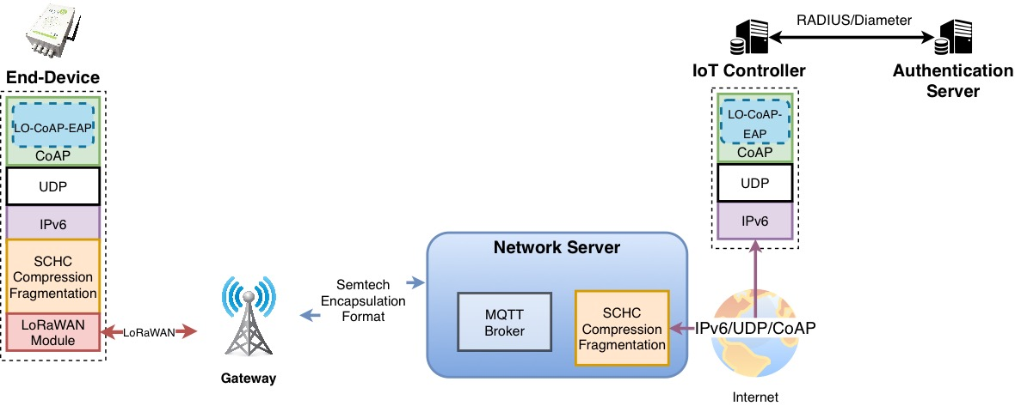

Figure 2: IPv6 End-Device connectivity through SCHC

## IoT Controller

The IoT Controller plays the role of authenticator in the Authentication, Authorisation, and Accounting (AAA) architecture[17]. End-devices perform a bootstrapping process when they are deployed for the first time. This process includes an authentication and key agreement stage. Once the device successfully authenticates itself, session keys are shared with the device in order to securely perform the regular operation tasks.

Typically, end-devices transmitting over non-constrained networks perform the bootstrapping by directly addressing any authentication server connected to an IP network. This exchange usually employs a standardised protocol such as RADIUS[18] or Diameter[19] to carry Extended Authentication Protocol (EAP)[20] messages over regular IP networks. However, RADIUS and Diameter require an exchange of relatively large messages with a large number of transmissions. This only exacerbates the problem of energy consumption and radio bandwidth usage due to header overhead for constrained radio technologies such as LoRaWAN.

Therefore, a lightweight Low-Overhead EAP over CoAP (LO-CoAP-EAP)[21] protocol is chosen instead. LO-CoAP-EAP employs the novel Constrained Application Protocol (CoAP)[22] and a set of efficient primitives to significatively reduce the header overhead of transmitting authentication EAP messages over a constrained network. The IoT Controller includes the LO-CoAP-EAP protocol logic that parses the upstream messages transmitted by the end-devices and forwards its contents to an authentication server that employs typical AAA protocols such as RADIUS or Diameter to carry EAP payloads. Likewise, when the authentication server answers with the new downlink EAP messages, the IoT Controller generates a new LO-CoAP-EAP packet and forwards it to the end-device. Additionally, a new SCHC scheme for further improving CoAP header compression is currently under standardisation[23].

Standardisation efforts by the IETF with regards to security have been considered during the design of the IoTrust architecture. In RFC8576[24], a summary of challenges and state-of-the-art IP-based protocols for IoT is presented. The protocols already standardised, as well as those currently under standardisation, by the IETF working groups for IoT related scenarios could be roughly differentiated in two categories. On the one hand, some working groups focus on the transmission of data over IP-based protocols in constrained networks by constrained devices. On the other hand, specific working groups focus on the security aspects of IP-based protocols for IoT scenarios. For the later, the most significant working group relative to the IoTrust project is the IETF Authentication and Authorization for Constrained Environments (ACE) working group[25]. This working group leverages on the authenticated and authorised access to resources hosted by constrained end-devices, identified by a unique Unified Resource Identifier (URI) — E.g., *coap://AAAA::1234/humidity*. The technologies and mechanisms standardised by the ACE working group are aimed at covering a broad and diverse set of use-cases in IoT scenarios — identified in RFC7744[26] — where the need for efficient authentication and authorisation mechanisms has been stated as a necessity. The IETF standardisation efforts leverage on a request and response model for accessing resources hosted in constrained end-devices. Thus, a RESTful access model has been adopted by using CoAP. Similarly, to HTTP, CoAP supports CREATE, GET, UPDATE, and DELETE operations on resources identified by a URI. For this reason, the security protocols focus on granting permissions to those resources only to authenticated and authorised entities — for instance, some entities may be authorised to update a resource, but not to delete it.

IETF novel security mechanisms leverage on this basic principle of resources hosted in end-devices and addressed by a URI. Some highlights include: Concise Binary Object Representation (CBOR)[27], CBOR Object Signing and Encryption (COSE)[28], and Object Security for Constrained RESTful Environments (OSCORE)[29]. At the application level, JavaScript Object Notation (JSON) has become the more popular encoder for the transmission of serialized structured data. However, JSON is text-based, which makes it inefficient in constrained scenarios where smaller message sizes are preferred. Thus, the CBOR protocol is employed in constrained scenarios. CBOR is a schema-free binary codification mechanism for serialized structured data that focuses on small message and implementation simplicity. Thus, the same RESTful applications for IoT scenarios running over HTTP/JSON can be attained in constrained environments through the equivalent CoAP/CBOR paradigm. One of the most significant advantages is the high level of integration with web services by intermediate agents that translate messages from networks employing CoAP/CBOR, with web services running on HTTP/JSON APIs that were not designed with constrained environments in mind. Additionally, this advantage does not present a trade-off, thus constrained networks are kept efficient, regardless of their integration with HTTP/JSON services or not.

Due to all of the aforementioned advantages of the response and request model implemented via CoAP, many security solutions standardized by the IETF ACE working group assume that end-devices include libraries for the CoAP code/decode operation. It is safe to assume that the adoption of CoAP as a solid building block for the IoTrust bootstrapping procedure, as it is closely aligned with the current IETF security-related working group efforts.

## Authentication Server

The AAA architecture has been proposed by standardisation organisation, such as IETF, to provide a scalable solution to security management tasks in heterogeneous IoT ecosystems, especially those employing long-range wide-area networks[30]. At the centre of the AAA architecture, lays the Authentication Server. It provides an administrative end-point that abstracts the technology specific details of deployed end-devices. Thus, the administrator simply manages identity and key materials, and relays on the technology to employ the security mechanisms that fit each specific case. In order to do so, the authentication server employs EAP, a flexible solution that supports several methods, with various degrees of performance requirements for each end-device. On the one hand, more constrained devices may employ lightweight cryptographic primitives, such as AES with the EAP-PSK method. On the other hand, other non-constrained end-devices may rely on more computationally demanding methods such as those based on public key infrastructure, or certificates.

First, each end-device credentials and key information need to be previously configured in the authentication server. Next, the end-device will be installed in its deployment site and will perform the bootstrapping procedure. During the bootstrapping, the device will authenticate itself against the network and will obtain a set of session specific keys. Finally, the end-device finishes the bootstrapping procedure and commences its operation phase.

Please note that the ultimate result of the bootstrapping process is attaining an encryption key that is securely stored within the End-Device. It will be employed for securing the following communications with the rest of the architecture components. This key is typically stored in a non-volatile storage area of the device, such as an EEPROM or even the microcontroller’s programmable memory. The key is to be protected through anti-tampering techniques, that prevent reading the key by attackers with physical access to the device itself.

## IoT Agent

The IoT Agent is a MQTT client which subscribes to the topics exposed by the MQTT broker running in the Network Server. At the heart of MQTT are the MQTT broker and clients. The data sent by the end-devices is received by the Network Server over LoRaWAN, which is in turn dispatched using MQTT messages. Each message is posted in a device-specific application reception topic. The IoT agent will subscribe to the topics to receive these messages. Additionally, it will publish messages in the device-specific transmission topics, exposed for this purpose. The topics will post events with device registration, device data, config data etc.

IoT Agent forwards the device metadata and sensor data to the asvin platform. It does it over HTTPs using REST API end-points. The IoT Agent acts as a bridge between the Network Server and the asvin Platform.

The communication between Network Server and IoT Agent is performed over MQTT protocol. The channel is secured at two levels, Transport and Application. TLS/SSL[31] is utilized for the transport encryption. It is very secured and commonly used method in digital solutions. The communication is encrypted and identities are authenticated using the client certificates. On the application level, username/password credentials are employed to authenticate MQTT client. Which means only authorized MQTT clients can read and send MQTT messages on topics.

## asvin Platform

The number of Cyber-attacks on IoT devices have risen up significantly. One of the major contributors to these attacks is the aging firmware and architecture. These smart things are operated on ‘set and forget’ policy. Which means they are configured while deploying and then left alone to fight against the security threats. The IETF has also stressed the need of facilitating update mechanism of IoT devices[32]. The asvin platform aims to function along those lines.

It is a Platform as a Service (PaaS) to facilitate over the air security patches for IoT devices using novel decentralized and distributed technologies. The asvin Platform[33] provides a complete solution for device, security patches and rollout management. It is comprised of 4 components as depicted in the Figure 3.

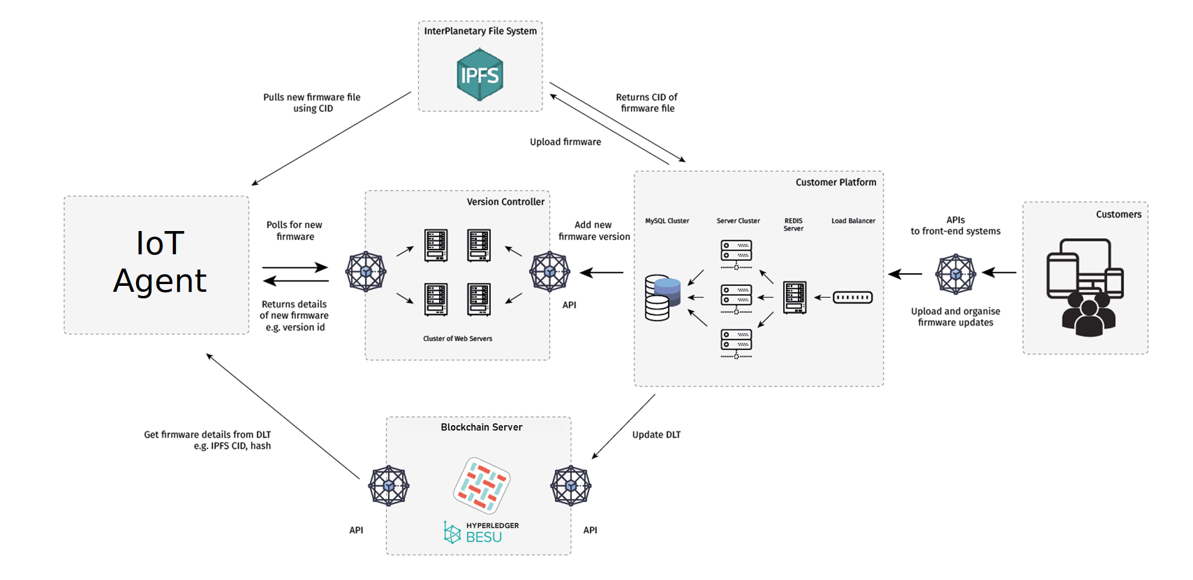

Figure 3: asvin Platform architecture

Each component of the asvin platform is tailored to perform specific set of tasks efficiently.

### IPFS

Interplanetary File System (IPFS)[34] protocol is utilized to store firmware and patches. The IPFS is a content-addressable peer to peer method for storing and sharing hypermedia in a distributed file system. It solves the problem of duplicate files across the network as it exists in the HTTPS and remove redundancy. When a firmware file is stored on the network a hash is generated based on content of the firmware and is stored on a blockchain network. This unique hash is called Content Identifier (CID)[35]. Subsequently, the CID is utilized to pull the firmware from IPFS server.

### Blockchain

asvin employs distributed ledger technology to provide an extra layer of security and resiliency to the platform. All events of the platform are recorded in a shared ledger. The distributed ledger also contains critical meta data information of devices and firmware. The blockchain infrastructure is based on Hyperledger Fabric[36] and Besu[37]. Both are private permissioned blockchain network technologies designed and developed under the Linux Foundation[38].

### Customer Platform

The Customer platform provides one stop solution to register, control, manage devices, firmware and rollouts. It facilitates an intuitive and wholesome dashboard web interface to customers. It hides the complexity of distributed and decentralized technologies of the asvin Platform.

### Version Controller

The Version Controller exposes backend REST APIs for device and rollout management. The Customer Platform and Version Controller work hand in hand. It handles the device registration and rollout success requests from the IoT agent.

The asvin platform exposes its services using the REST API end-points. The other IoT services and platforms can interact with the asvin Platform using these APIs. The IoT agent forward its data to the platform using the respective API end-points. The asvin Platform can send data to the Network Server directly as it also has REST API end-points or it can send data through the IoT Agent.

A critical security feature of IoTrust architecture is the use of the encryption key which is generated as the result of bootstrapping process. The key is exercised to encrypt the data sent by the End Device after the successful bootstrapping process. The encryption process keeps the data secured from the [man-in-middle](https://en.wikipedia.org/wiki/Man-in-the-middle_attack).

The communication channels among asvin Platform, IoT Agent and Network Server are secured using HTTPS. It is a secured extension of HTTP. TLS/SSL is used for encryption in HTTPS. It provides defence against man-in-middle attacks. X.509[39] certificates are used to authenticate components of asvin Platform. These certificates include long term public and private keys for the server. These keys are employed to generate short-term session keys. The exchanges between clients and asvin Platform are encrypted using the session keys. It protects against eavesdropping and tampering.

### Trust monitoring

The threat landscape of end devices is quite large. There are multiple pain points for an end-device where it can be compromised. An attacker can steal data from the device or employed it as a bot to raise DDos attacks. It is even more alarming when an end-device is part of a critical company network. The IETF has given guidelines like MUD (Manufacturer Usage Description, RFC8520)[40] to substantially reduce the threat surface of end-device to those communication intended by the manufactures. In that line, the asvin Platform will provide a novel dynamic trust monitoring feature in the IoTrust project. The aim of this feature is to monitor the end-devices continuously for external threats and raise an alarm on the dashboard before an end-device comes under threats.

The trust monitoring service includes scanning the critical characteristics of end-devices for an example number of successful patches, number of device reboots, last heartbeat from the device and availability of the encryption key generated after the secure bootstrapping process. All these parameters play crucial role to determine end-device security. The asvin Platform will collect these parameters from end-device in user defined configurable time interval. On the platform the parameters will be analysed and a dynamic trust score will be calculated. The platform will also generate a weekly, monthly trust monitoring report for end-devices.

# Conclusions and next steps

The IoTtrust architecture is designed and submitted in the deliverable D.1. This deliverable gives comprehensive information about each component of the architecture. Every component of the IoTtrust architecture is designed after multiple rounds of discussions. It will be employed as a reference for the future deliverables.

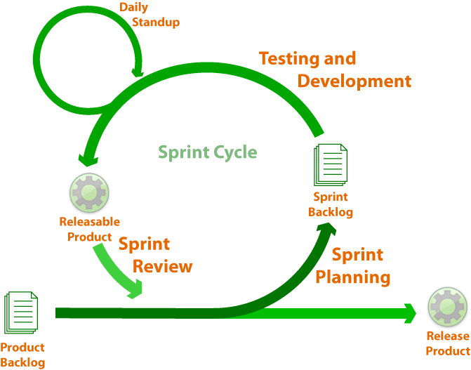

Figure 4: The Agile – SCRUM Framework [41]

Going ahead in the future, we are developing and integrating the SW components of the architecture using the SCRUM framework. The Figure 4 gives an overview of the SCRUM framework with one week sprint. All tasks allocated during the week will be discussed in the sprint review meeting which includes the problems faced, solved and their status. This process will be executed iteratively for the IoTrust development of Task2. The further development process will result in a minimal viable product (MVP) that will be validated in testbed laboratories of OdinS (Spain) and DW (Germany) as well as in two real-world pilots: Smart City of Murcia (Spain), and Industry Monitoring Applications (Germany).

Appendix

Acronyms

AAA Authentication Authorization and Accounting

ACE IETF’s Authorization for Constrained Environments working group

API Application Programming Interface

CoAP Constrained Application Protocol

DW digital worx GmbH

EAP Extended Authentication Protocol

FOSS Free Open-Source Software

HTTPS Hypertext Transfer Protocol Secure

IETF Internet Engineering Task Force

IoT Internet of Things

IPFS InterPlanetary File System

LoRa Long Range

LoRaWAN Long Range Wireless Area Network

LTE Long-Term Evolution

MAC Medium Access Control

MQTT Message Queuing Telemetry Transport

MTU Maximum Transmission Unit

PaaS Platform as a Service

RADIUS Remote Authentication Dial In User Service

REST Representational State Transfer

RTC Real Time Clock

SCHC Static Context Header Compression

Spreading Factor LoRa/LoRaWAN PHY radio coverage configuration parameter

SSL Secured Sockets Layer

TLS Transport Layer Security

URI Unified Resource Identifier

1. https://www.scrumguides.org/scrum-guide.html
2. https://lora-alliance.org/sites/default/files/2018-05/2015_-_lorawan_specification_1r0_611_1.pdf
3. http://wiki.lahoud.fr/lib/exe/fetch.php?media=an1200.22.pdf
4. https://www.mouser.com/datasheet/2/761/sx1276-1278113.pdf
5. https://www.hoperf.com/modules/lora/RFM95.html
6. http://ww1.microchip.com/downloads/en/devicedoc/50002346c.pdf
7. Bormann, C., Ersue, M., & Keranen, A. (2014). *Terminology for Constrained-Node Networks* (Request for Comments, Issue 7228). RFC Editor. https://doi.org/10.17487/rfc7228
8. https://github.com/Lora-net/packet_forwarder/blob/master/PROTOCOL.TXT
9. https://www.mouser.com/datasheet/2/761/sx1301-1523429.pdf
10. <https://www.chirpstack.io/> ChirpStack, open-source LoRaWAN® Network Server stack
11. OASIS. (2014). MQTT Version 3.1.1. OASIS Standard, October, 81. http://docs.oasis-open.org/mqtt/mqtt/v3.1.1/os/mqtt-v3.1.1-os.html
12. https://roy.gbiv.com/pubs/dissertation/top.htm
13. https://mosquitto.org/
14. https://datatracker.ietf.org/wg/lpwan/about/
15. Minaburo, A., Toutain, L., Gomez, C., & Barthel, D. (2020). *SCHC: Generic Framework for Static Context Header Compression and Fragmentation* (Request for Comments, Issue 8724). RFC Editor. https://doi.org/10.17487/RFC8724
16. Deering, S., & Hinden, R. (2017). *Internet Protocol, Version 6 (IPv6) Specification*. https://doi.org/10.17487/RFC8200
17. Spence, D., Gross, G., de Laat, C., Farrell, S., Gommans, L. H. M., Calhoun, P. R., Holdrege, M., de Bruijn, B. W., & Vollbrecht, J. (2000). AAA Authorization Framework (Issue 2904). RFC Editor. https://doi.org/10.17487/RFC2904
18. Rubens, A., Rigney, C., Willens, S., & Simpson, W. A. (2000). Remote Authentication Dial In User Service (RADIUS) (Issue 2865). RFC Editor. https://doi.org/10.17487/RFC2865
19. Zorn, G. (2014). Diameter Network Access Server Application (Issue 7155). RFC Editor. https://doi.org/10.17487/RFC7155
20. Aboba, B., Blunk, L., Vollbrecht, J., & Carlson, J. (2004). Extensible Authentication Protocol (EAP) (H. Levkowetz (ed.)). https://doi.org/10.17487/rfc3748
21. Garcia-Carrillo, D., Marin-Lopez, R., Kandasamy, A., & Pelov, A. (2017). A CoAP-Based Network Access Authentication Service for Low-Power Wide Area Networks: LO-CoAP-EAP. Sensors, 17(11), 2646. https://doi.org/10.3390/s17112646
22. Shelby, Z., Hartke, K., & Bormann, C. (2014). The Constrained Application Protocol (CoAP). In Journal of Chemical Information and Modeling. https://doi.org/10.17487/rfc7252
23. Minaburo, A., Toutain, L., & Andreasen, R. (2020). *LPWAN Static Context Header Compression (SCHC) for CoAP* (Issue draft-ietf-lpwan-coap-static-context-hc-16). Internet Engineering Task Force. https://datatracker.ietf.org/doc/html/draft-ietf-lpwan-coap-static-context-hc-16
24. Garcia-Morchon, O., Kumar, S., & Sethi, M. (2019). *Internet of Things (IoT) Security: State of the Art and Challenges*. https://doi.org/10.17487/RFC8576
25. https://datatracker.ietf.org/wg/ace/charter/
26. Garcia-Morchon, O., Kumar, S., & Sethi, M. (2019). *Internet of Things (IoT) Security: State of the Art and Challenges*. https://doi.org/10.17487/RFC8576
27. Bormann, C., & Hoffman, P. (2013). *Concise Binary Object Representation (CBOR)*. https://doi.org/10.17487/rfc7049
28. Schaad, J. (2017). *CBOR Object Signing and Encryption (COSE)* (Issue 8152). RFC Editor. https://doi.org/10.17487/RFC8152
29. Selander, G., Mattsson, J., Palombini, F., & Seitz, L. (2019). *Object Security for Constrained RESTful Environments (OSCORE)*. IETF. https://doi.org/10.17487/RFC8613
30. Farrell, S. (2018). Low-Power Wide Area Network (LPWAN) Overview (Issue 8376). RFC Editor. https://doi.org/10.17487/RFC8376
31. https://en.wikipedia.org/wiki/Transport_Layer_Security
32. https://datatracker.ietf.org/wg/suit/about/
33. https://asvin.readthedocs.io/en/latest/
34. ttps://ipfs.io/ipfs/QmR7GSQM93Cx5eAg6a6yRzNde1FQv7uL6X1o4k7zrJa3LX/ipfs.draft3.pdf
35. https://docs.ipfs.io/concepts/content-addressing/
36. https://www.hyperledger.org/use/fabric
37. https://www.hyperledger.org/use/besu
38. https://www.linuxfoundation.org/
39. https://en.wikipedia.org/wiki/X.509
40. https://tools.ietf.org/html/rfc8520
41. https://carlleedrowsycat.wordpress.com/2014/09/28/what-is-an-agile-sprint-retrospective/