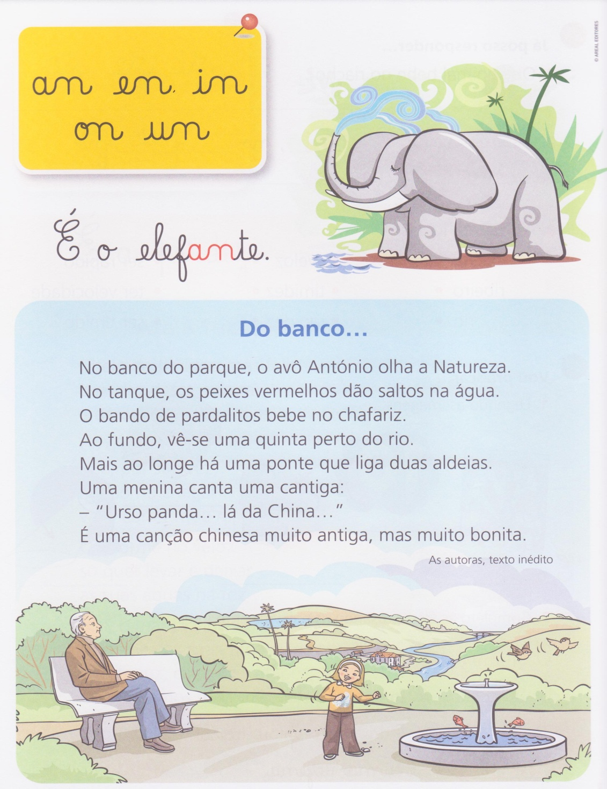

**Ficha de trabalho de Português**

**Nome**________________________________________**Data**________________

**1. Lê o texto com atenção.**

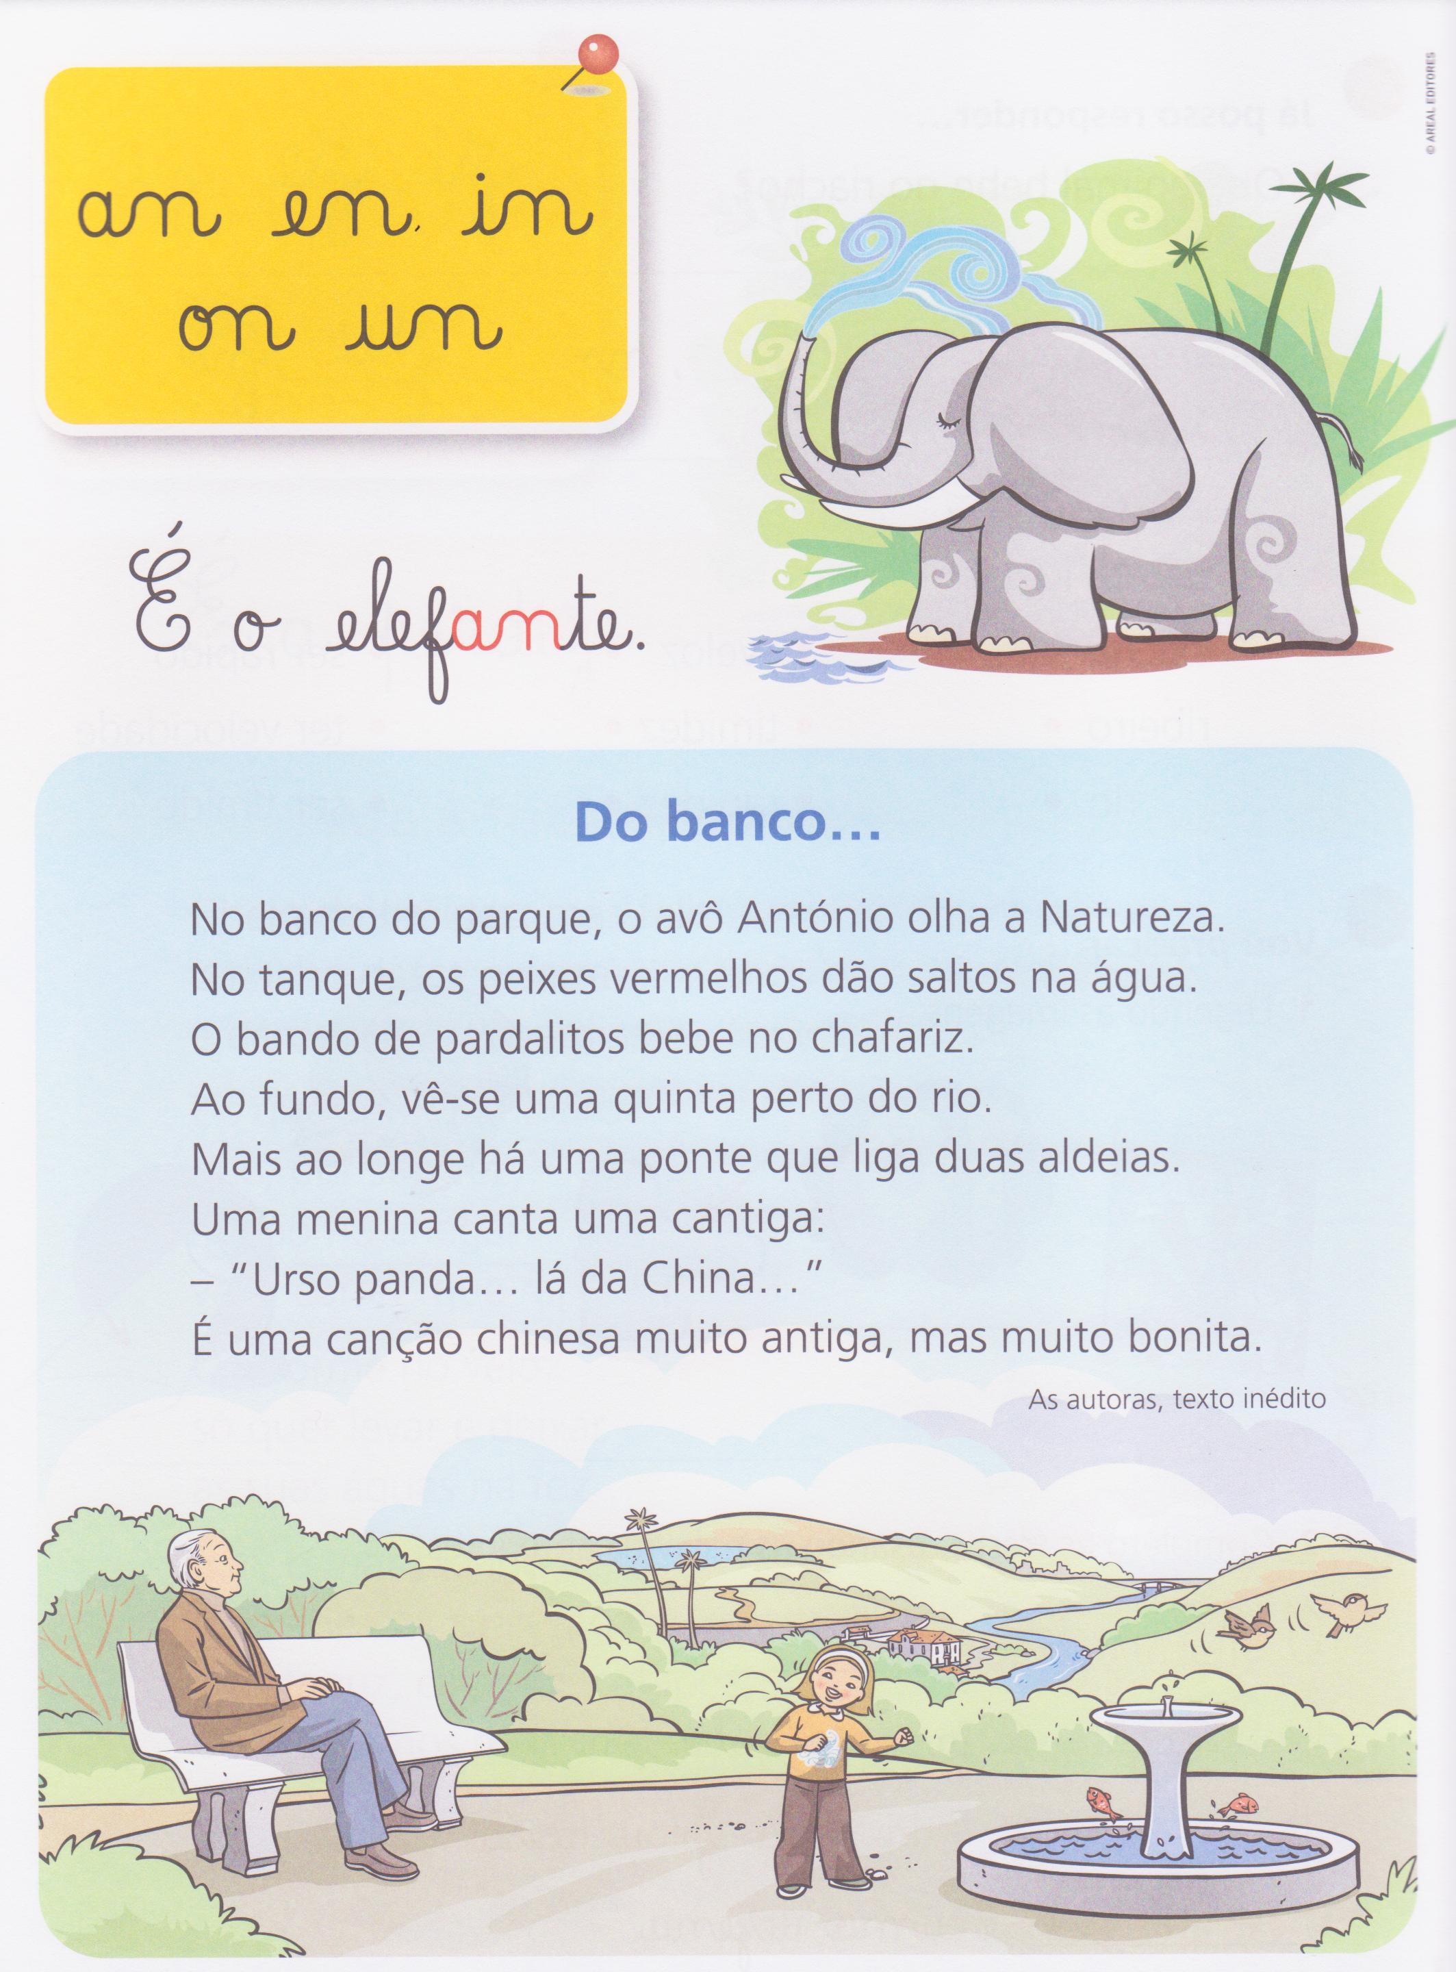

**Do banco …**

No banco do parque, o avô António vê a Natureza.

No tanque, os peixes laranja dão saltos na água.

O bando de pardalitos bebe da fonte.

Ao fundo, vê-se uma quinta perto do rio.

Mais ao longe há uma ponte que liga duas aldeias.

Uma menina canta uma cantiga:

- “Urso panda … lá de cima… “

É uma canção muito antiga, mas muito bonita.

Autor desconhecido

**2. Responde às questões.**

**2.1 -** No bando, o avô António vê para o monte?

____________________________________________________________________

____________________________________________________________________

**2.2** - Os peixes laranja dão saltos na água?

____________________________________________________________________

____________________________________________________________________

**2.3 -** Que animais bebem água da fonte?

____________________________________________________________________

____________________________________________________________________

**2.4 -** O que se vê perto do rio?

____________________________________________________________________

____________________________________________________________________

**2.5 -** O que liga a ponte?

____________________________________________________________________

____________________________________________________________________

**2.6 -** Transcreve do texto a canção que a menina canta.

____________________________________________________________________

____________________________________________________________________

**3 – Ordena do 1 ao 5 de acordo com o texto.**

|  |  |
| --- | --- |
| No tanque, os peixes laranjas dão saltos na água e o bando de pardalitos bebe da fonte. |  |
|  |  |
| Mais ao longe há uma ponte que liga duas aldeias. |  |
|  |  |
| Ao fundo, vê-se uma quinta perto do rio. |  |
|  |  |
| Uma menina canta uma canção muito antiga, mas bonita. |  |
|  |  |
| No banco do parque, o avô António vê a natureza. |  |

**4 – Completa com an, en, in, on, un.**

|  |  |  |  |
| --- | --- | --- | --- |
| faz____da | rot____da | serp____te | m____do |
| lar____ja | elef____te | qu____tal | p____go |
| c____tura | mor____go | ____verno | qu____te |
| p____tapé | sem___te | ____da | f____do |

**5 – Completa como no exemplo (singular e plural).**

**a tenda – as tendas** a semente - ____________________

o elefante – _________________ a ponta - ______________________

a bandeira - _________________ o cântaro - ____________________

**5.1 – Observa o exemplo e completa.**

**dente – dentinho** onda - ________________________

mundo – ____________________ pente - _______________________

santo - ______________________ linda - ________________________

**6 – Escreve as palavras.**

|  |  |  |
| --- | --- | --- |
|  | Panda |  |
| __________________ | __________________ | __________________ |
|  |  |  |
|  | Anjo |  |
| __________________ | __________________ | __________________ |

**7 – Ordena as palavras e forma frases.**

Armanda A faz avó renda.

________________________________________________________________________________

panda O na vive China.

________________________________________________________________________________

**8 – Divide as palavras em sílabas.**

mundo_________________________________ andor___________________________

domingo __________________________ pintura_________________________

lentidão _________________________ panda__________________________

ronda __________________________ fonte____________________________

parente _________________________ cintura_________________________

**9 – Completa.**

O Orlando 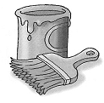 o 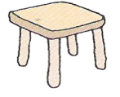.

________________________________________________________________________________

O 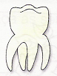 do 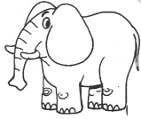 dói muito.

________________________________________________________________________________

O António atravessou a 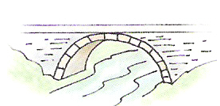 para ir buscar água à 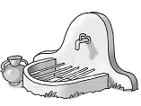.

________________________________________________________________________________

**10 - Liga corretamente.**

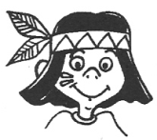 * * cinto _____________________

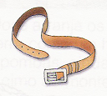 * * dente _____________________

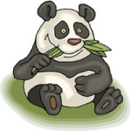 * * balança _____________________

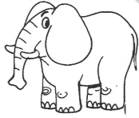 * * índio _____________________

 * * tanque _____________________

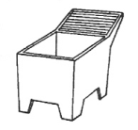 * * elefante _____________________

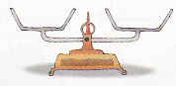 * * panda _____________________

**11 - Inventa frases com as imagens.**

** **

**____________________________________________________________________**

** **

**____________________________________________________________________**

**12 – Ordena as sílabas e forma palavras.**

|  |  |  |
| --- | --- | --- |
| tu  cin  ra | do  mun | te  gen |
| ________________________ | _________________________ | _________________________ |
| ti  can  ga | ten  con  te | te  fon |
| _________________________ | __________________________ | _________________________ |
| que  tan | min  do  go | ten  se  ta |
| _________________________ | _________________________ | _________________________ |

**13 – Completa o crucigrama.**

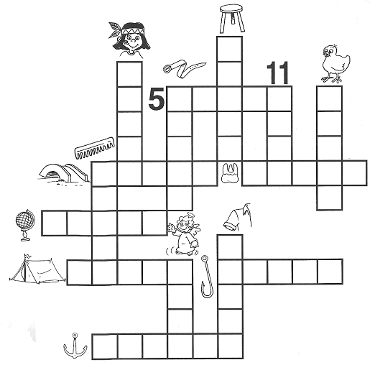

**14 – Escreve as palavras por ordem alfabética**

|  |  |  |  |  |
| --- | --- | --- | --- | --- |
| banco | tinta | quintal | lenço | concha |

**1 - ______________________________ 2 - _______________________________**

**3 - _______________________________ 4 - _______________________________**

**5 - ______________________________**

**15 – Separa as palavras com / e escreve as frases.**

AIolandacolocaopentedentrodamala.

________________________________________________________________________________________________________________________________________

OAndrépesouopandanabalança.

________________________________________________________________________________________________________________________________________

**AUTO-AVALIAÇÃO:**

Conseguiu Consegui com ajuda Não consegui

☺ 😐 ☹

Bom trabalho!