**EB 1, 2, 3/JI da Vila de Rabo de Peixe**

Escola Rui Galvão de Carvalho

English

**School objects**

(Objetos escolares)

* book (livro)
* ****calculator (máquina de calcular)
* coloured pencils (lápis de cor)
* ****crayons (lápis de cera)
* exercise book (caderno)
* folder (pasta, dossiê)
* ****glue (cola)
* pen (caneta)
* ****pencil (lápis)
* ****pencil-case (estojo, porta-lápis)
* pencil-sharpener (apara-lápis)
* rubber (borracha)
* ruler (régua)
* ****schoolbag (pasta, mochila)
* scissors (tesouras)
* workbook (livro de exercícios)
* notebook (caderno de notas)

**1**

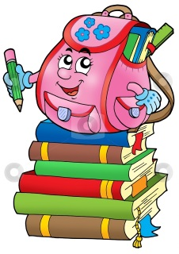**Exercise**

**School objects**

🖉1- Match.

|  |  |  |  |  |
| --- | --- | --- | --- | --- |
| http://www.clker.com/cliparts/i/V/f/T/F/d/style-pen-md.png | ⚫ |  | ⚫ | book |
| http://www.clipartpal.com/_thumbs/pd/education/book_w_blank_title.png | ⚫ |  | ⚫ | pen |
|  | ⚫ |  | ⚫ | pencil |
|  | ⚫ |  | ⚫ | ruler |
| http://vector.me/files/images/1/4/148019/pencil_office_eraser_document_rubber_writing_correction.jpg | ⚫ |  | ⚫ | pencil-sharpener |
| http://www.englishexercises.org/makeagame/my_documents/my_pictures/2012/feb/E7F_u11865458%5b1%5d.jpg | ⚫ |  | ⚫ | rubber |
| http://www.clipartpal.com/_thumbs/pd/education/backpack_02.pnghttp://sr.photos2.fotosearch.com/bthumb/CSP/CSP462/k4622368.jpg | ⚫ |  | ⚫ | schoolbag |
|  | ⚫ |  | ⚫ | pencil-case  **2** |