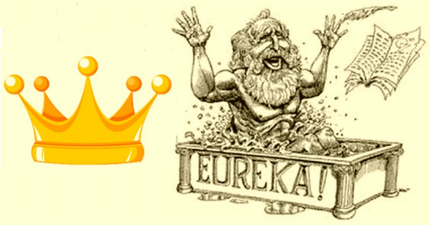Físico-Química - 7º ano

## *Guião do filme:*

www.leme.pt/magazine/o-saber-nao-ocupa-lugar/0700.jpg

## *“Era uma vez – Arquimedes e os Gregos”*

Nome ____________________________________________ nº ______ Turma _____

1. Onde estudou Arquimedes? Como se chamava o seu professor?

__________________________________________________________________________

__________________________________________________________________________

1. Qual a nacionalidade de Arquimedes?

__________________________________________________________________________

1. Em que século viveu Arquimedes?

__________________________________________________________________________

1. Qual o problema que o rei apresenta a Arquimedes?

____________________________________________________________________________________________________________________________________________________

1. Como resolve Arquimedes o problema? Descreve as etapas.

____________________________________________________________________________________________________________________________________________________

____________________________________________________________________________________________________________________________________________________

1. O que disse Arquimedes quando descobre a solução do problema?

__________________________________________________________________________

__________________________________________________________________________

1. Descreve o procedimento realizado por Arquimedes para resolver o problema.

____________________________________________________________________________________________________________________________________________________________________________________________________________________________________________________________________________________________________________________________________________________________________________________________________________________________________________________________

____________________________________________________________________________________________________________________________________________________

1. Que importância pode ter no dia-a-dia a descoberta que Arquimedes fez ao resolver o problema do rei?

________________________________________________________________________________________________________________________________________________________________________________________________________________________________________________________________________________________________________

1. De que forma a ciência tem vindo a melhorar a vida das pessoas e as suas condições de trabalho?

__________________________________________________________________________________________________________________________________________________________________________________________________________________________________________________________________________________________________________________________________________________________________________________

1. Que outras descobertas fez Arquimedes?

__________________________________________________________________________________________________________________________________________________________________________________________________________________________________________________________________________________________________________________________________________________________________________________