Big Mountain Resort Weekend Price Analysis

After reviewing the 2018 data of compiled resort characteristics and cost of an adult weekend chairlift ticket I think it is reasonable to increase the ticket price an amount of $5 to satisfy the objective of recovering the $1.54 M in operational cost added by the new chair lift while keeping constant the profit margin at 9.2%, based on an average of 300k resort visitors per year.
The model built using the 2018 ski data predicts a weekend ticket price of $88, while the current price is set at $81. The largest driving variable is a combination of resort’s vertical drop and summit elevation. Figure 1 shows the spread of the data on these variable relative to the Big Mountain resort (black point).
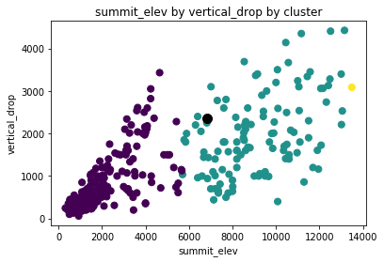Figure 1: Resort' s summit elevation vs. vertical drop clustered using k-means. Big Mountain resort is on the green class (black point).
When considering price increase it is important to look at neighboring resort prices, as a way to understand the possibility of losing customers due to the price increase. Figure 2 shows the distribution of ticket prices in the state of Montana, which are the direct competitors in the local market.

In this case the Big Mountain resort is the most expensive resort in Montana, and it is priced about $15 above the second most expensive (Red Lodge Mountain). This can be interpreted as customers being OK paying more for more amenities, which is the purpose of figure 3, where we see that Big Mountain resort has he second largest number of chair lifts, behind Big Sky Resort. In this figure we also realize that the ticket price to Big Sky Resort seems off, and after further data review I found that this price was not provided in the original data, but infilled using the mean of all resorts, highlighting the dangers of data imputation methods.
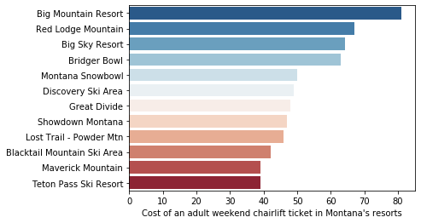Figure 2: Distribution of ticket prices in the state of Montana.
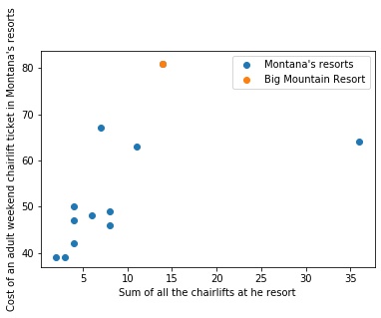Figure 3: Total number of chairlift vs. Cost of an adult weekend chairlift ticket. The point to the right represents Big Sky Resort.

