**setacarro-traseiraefrontal**

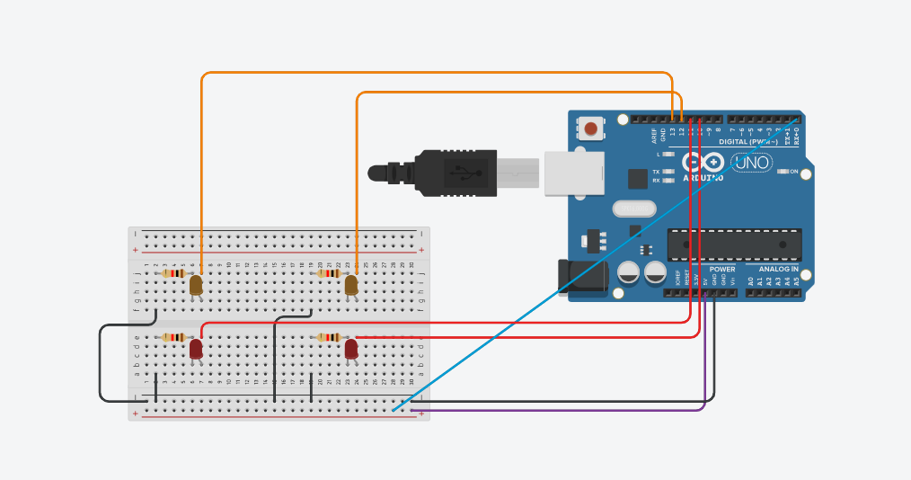

**PROGRAMAÇÃO:**

**// C++ code**

**//**

**const int btn1 = 0;**

**int cond = 0;**

**void setup()**

**{**

**pinMode(13, OUTPUT);//laranja1**

**pinMode(12, OUTPUT);//laranja2**

**pinMode(11, OUTPUT);//vermelho1**

**pinMode(10, OUTPUT);//vermelho2**

**pinMode(btn1, INPUT);**

**}**

**void loop()**

**{**

**cond = digitalRead(btn1);**

**if(cond == HIGH )**

**digitalWrite(13, HIGH);**

**digitalWrite(12, LOW);**

**digitalWrite(11, HIGH);**

**digitalWrite(10, LOW);**

**delay(1000); // Wait for 1000 millisecond(s)**

**digitalWrite(13, LOW);**

**digitalWrite(12, HIGH);**

**digitalWrite(11, LOW);**

**digitalWrite(10, HIGH);**

**delay(1000); // Wait for 1000 millisecond(s)**

**}**