23.04
Problems with the project
- When using the camera, the image is normal. In python: flipped. Actually, in opencv no flip happens, camera app does background processing
- Viola-Jones seems a bit outdated => use it, but compare with: MediaPipe and DNN
- For data set: AffectNet, RAF DB
Videos used:
https://www.youtube.com/watch?v=n12PXImCWFo
https://www.youtube.com/watch?v=uEJ71VlUmMQ
Refferences:
https://github.com/Donny-Hikari/Viola-Jones
Iterrating through image and computing the needed sums / differences: time consuming => need optimization => Integral image
Each pixel: p(i,j) contains the sum of all pixels in the rectangle starting at (0,0) and ending at it
Problem: in python it would be slower. There is a function in numpy that does it... But I want to do it myself : D (FUU)
Question: how to call it in python?
Use a C file, compile and import it, use cython OR numba + njit
Numba+njit
-python syntax + numpy that is translated into optimized machine code
To get the sum of a rectangle:
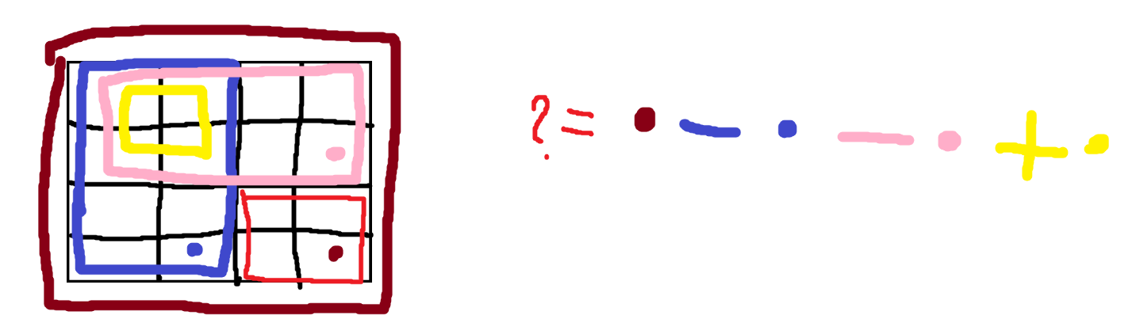

Need Grayscale images => cv2.cvtColor
Questions
-Trebuie si histogram equalization / CLAHE? – nu stiu cum ar functiona daca fac live... (prea lent)

25.04
Deci
Pentru cel final mergem pe modelul deja existent, din XML (oribil de optimizat altfel)
Ca demo:
Luam imaginea la apasarea unui buton
Aplicam mini algoritmul pe ea, sa vedem ce rezulta dupa cativa pasi
- Folosesc haar feature urile care au fost demonstrate ca sunt mai importante (ochi, nas, etc)
- Ada boost pe vreo 5 nivele
- Feature ul: 48*48
- Imaginea luata din camera: 480*640
- Facem Image pyramid pe imagine (un factor de 1.25)
- Aplicam feature urile dupa adaboost
- Punem chenar in jurul zonelor care au trecut de cele 5 => putem vedea cum ar continua si de ce feature uri ar mai fi nevoie
Pentru cele mai importante feature-uri:
https://scikit-image.org/docs/0.25.x/auto_examples/applications/plot_haar_extraction_selection_classification.html
Sistemul de coordinate: (x,y,W,H)
Pentru mai tarziu:
https://medium.com/@rohan.chaudhury.rc/adaboost-classifier-for-face-detection-using-viola-jones-algorithm-30246527db11
NB-ul ( e 3:51 dimineata ;-;)

Ca pipeline ma gandeam:
until image >= 24*24 (my camera makes it 480*640)
move around it with the 24*24 window (step: 2-4 pixels... poate 3?)
for each window:
try the masks, until failure
if none fail:
add it into a priority queue based on a probability feature ( i'll see how i do this, based on some weights )
modify dimensions of image

Ca modification: TREBUIE INTEGRAL IMAGE LA FIECARE PAS!!!

Pentru resize:
Exista in opencv resize, dar putem si implementa
Go from normal -> resized? NO
Resized: get data from normal
Each point (x,y) from the resized: is (x*scale,y*scale), unde scale = 1.25 (se foloseste si 1.1, dar...)

19.05
Stai ca am uitat ce era pe aici XD
EU FACEAM SCALE DOWN LA IMAGINE, MULT MAI BINE DAU UP LA FEATURES, FAAA
- Schimbam pipeline ul
- Luam imaginea, aplicam pe ea features. La fiecare pas trimitem un scale ca sa crestem dimensiunea la haar features
- As putea arata pe imaginea originala si feature ul, ca sa fie mai frumi (il plimb pe acolo daca se ajunge la un anumit scaling)

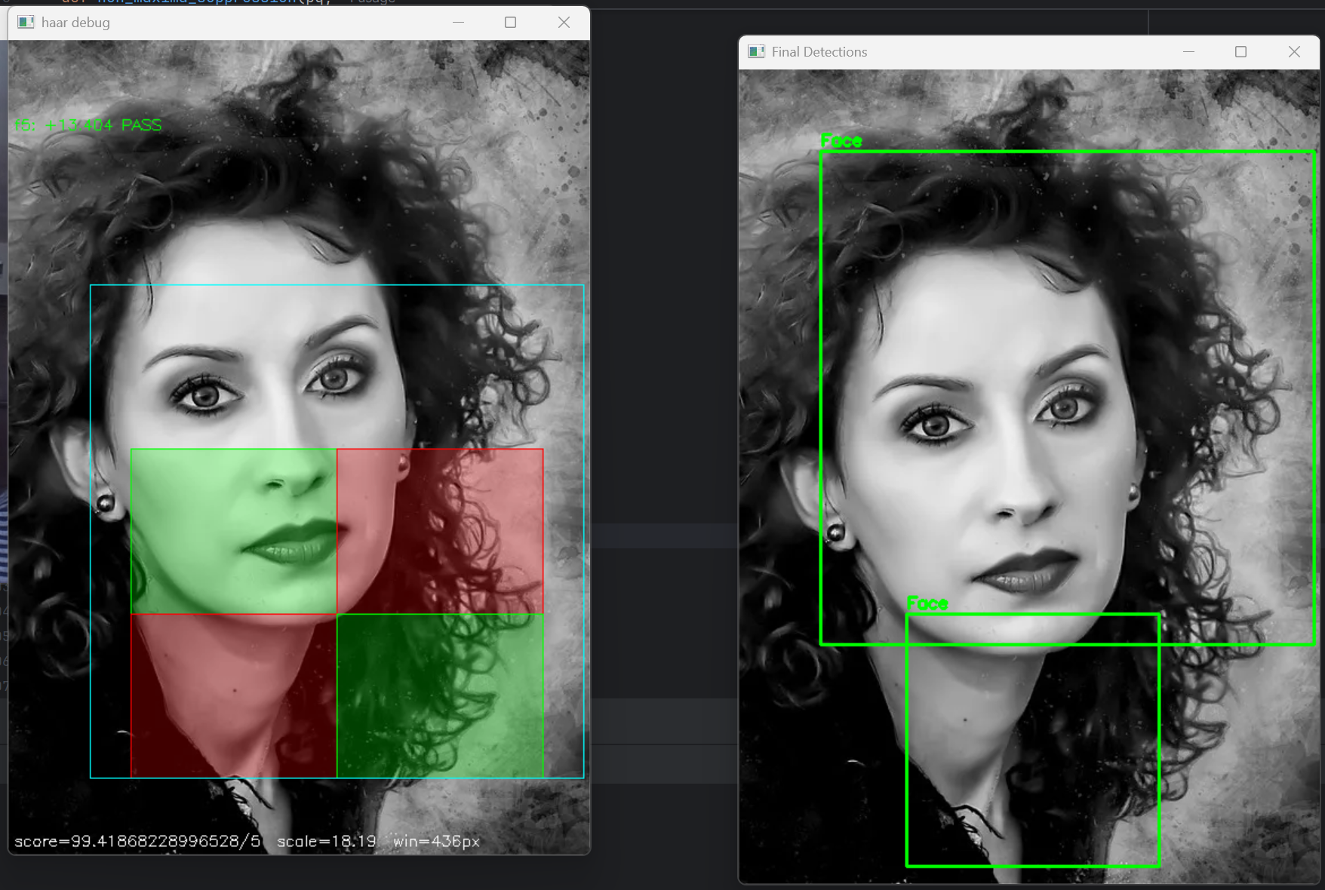
22.05
Cred ca mai bine ma concentrez pe partea de IP. TODO: fac la vara un CNN care sa se ocupe de emotions
Acum: partea de preprocessing a imaginii din camera... Poate 2 thread uri? (2 modele)
Ce facem ca preprocesare:
- Gamma correction
- CLAHE
- Filtru bilateral
- Detectarea fetei
- ROI tighten
- Face alignment
- Z-score normalize
- Resize to model input

CURSE YOU PYTHOOOOOOOOOON
E mult prea incet daca incerc sa imi fac eu functiile fata de viteza pe care mi o da un simplu call la ele...
O sa implementez ce pot in folderul de math functions si notez ce se intampla
Linkuri utile:
https://www.cambridgeincolour.com/tutorials/gamma-correction.htm - Gamma
Dupa mai multe cautari (GOOGLE, PLZ ;-;):
1. Flip (camera returneaza invers) - DONE
2. Mild gamma correction (adaptam brightness ul -> la camin becul / fereastra) - DONE
3. Convert grayscale - DONE
4. CLAHE – REMOVED. Se pierde FPS ;-;
5. Gaussian/Bilateral filter –REMOVED: camera e destul de buna, e nevoie de edge uri (ochi)
6. Face detection – Haar, my beloved DONE
7. ROI tighten – REMOVED – Box ul dat de viola and jones e deja destul de tight. Daca ii dam crop mai tare nu mai functioneaza CNN ul
8. Face alignment – REMOVED – cu haar se detecteaza fata „IN PICIOARE”. Rareori se trimite mai departe daca e la un unghi (30-40 grade?) – ADDED BACK - ... pare interesant
9. Resize - DONE
10. Normalize
11. Emotion inference

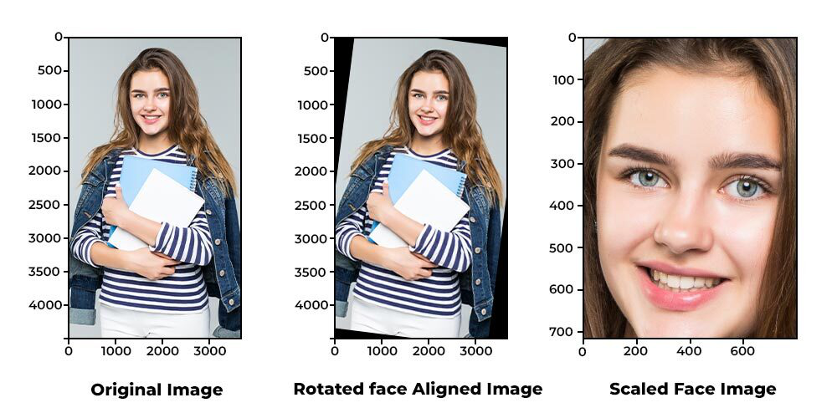
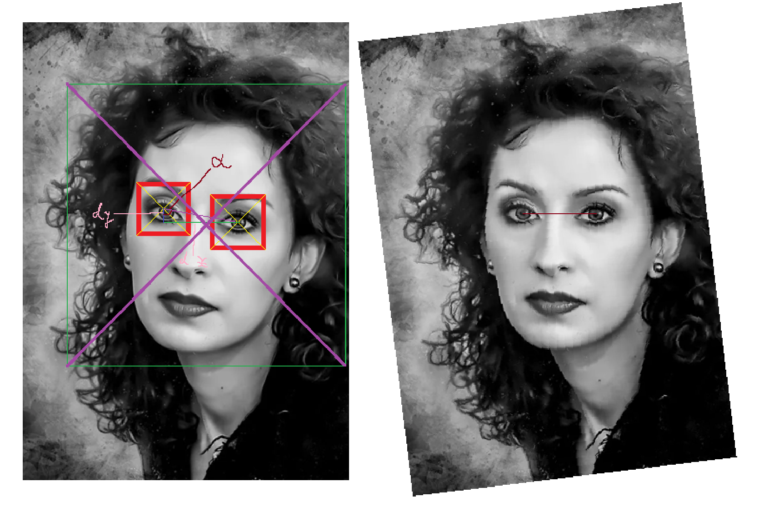
aligned = cv2.warpAffine(
face_roi,
M,
(w, h),
flags=cv2.INTER_CUBIC
)

https://www.geeksforgeeks.org/python/python-opencv-affine-transformation/
-liniile paralele raman paralele

Project Overview
Real-time Emotion Detection via Viola–Jones & FER CNN
■ Project Details
Detect emotions dynamically using the Viola–Jones approach and the FER pre-trained CNN model.
■ Main Components
▸ Python OpenCV library
▸ Viola–Jones algorithm
▸ fer.fer FER model for emotion detection
▸ user controlled tracing of a naïve VnJ algorithm

■ Pipeline
1. Integrated camera video
2. Flip
3. Mild gamma correction
4. Convert to grayscale
5. Face detection
6. Face alignment
7. Resize
8. Emotion detection
9. Beautify response

What Was Hard
Analysis of Problems That Appeared During Development
■ General PROBLEMS
Python functions are, generally, very slow, so, for performing such a dynamic task, I had to choose between:
-Writing C code and using ctypes to load it
-using numba
-using cython
- I chose to write the main functions using njit and tried to call them, but the speed left a lot to be desired. That is why many of the functions in “math_functions.py” are not used anywhere. They were developed in testing but replaced with a higher speed version. I also tried to “improve” some algorithms (using LUTs for faster results, avoiding loops where possible) in order to increase speed.
■ Camera Video
-is given flipped via: cap = cv2.VideoCapture(0)
- Flip it back: img = cv2.flip(img, 1)
- Lighting in dorm: kind of bad
- Apply a gamma correction
- PROBLEM: Slow originally => use a LUT img = cv2.LUT(img, GAMMA_LUT)
? Why not CLAHE?
- Applying it on every frame makes the output clunky
- Not really necessary. The mild gamma corrected image is enough. This would’ve helped if dark / overexposed.
■ Grayscale Conversion
- The classifiers used work on grayscale images
■ Face Detection
- Viola and jones approach
- Based on the idea: all faces... are faces
- Faces have higher intensity at eyes, intensity differs for nose and the gaps to left and right, the hair
- Study an image and check, for each possible spot, if a face could appear there.
- For the dynamic approach used: a model was pretrained and the .xml file was taken from github: cv2.CascadeClassifier('haarcascade_frontalface_default.xml')
- For the teaching purpose of the assignment, a naïve approach was used as a trace
- Some user defined features were used for a scaling sliding window in order to detect containers likely to have a face present
- The approach: AdaBoost. Perform the sliding and check with a threshold. If the score passed it, go further, else fail. This can be seen in the trace part

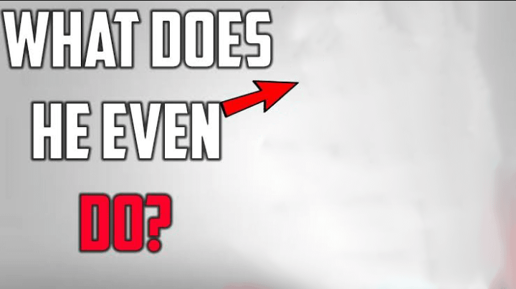
-

Updated version: improved jawline detector
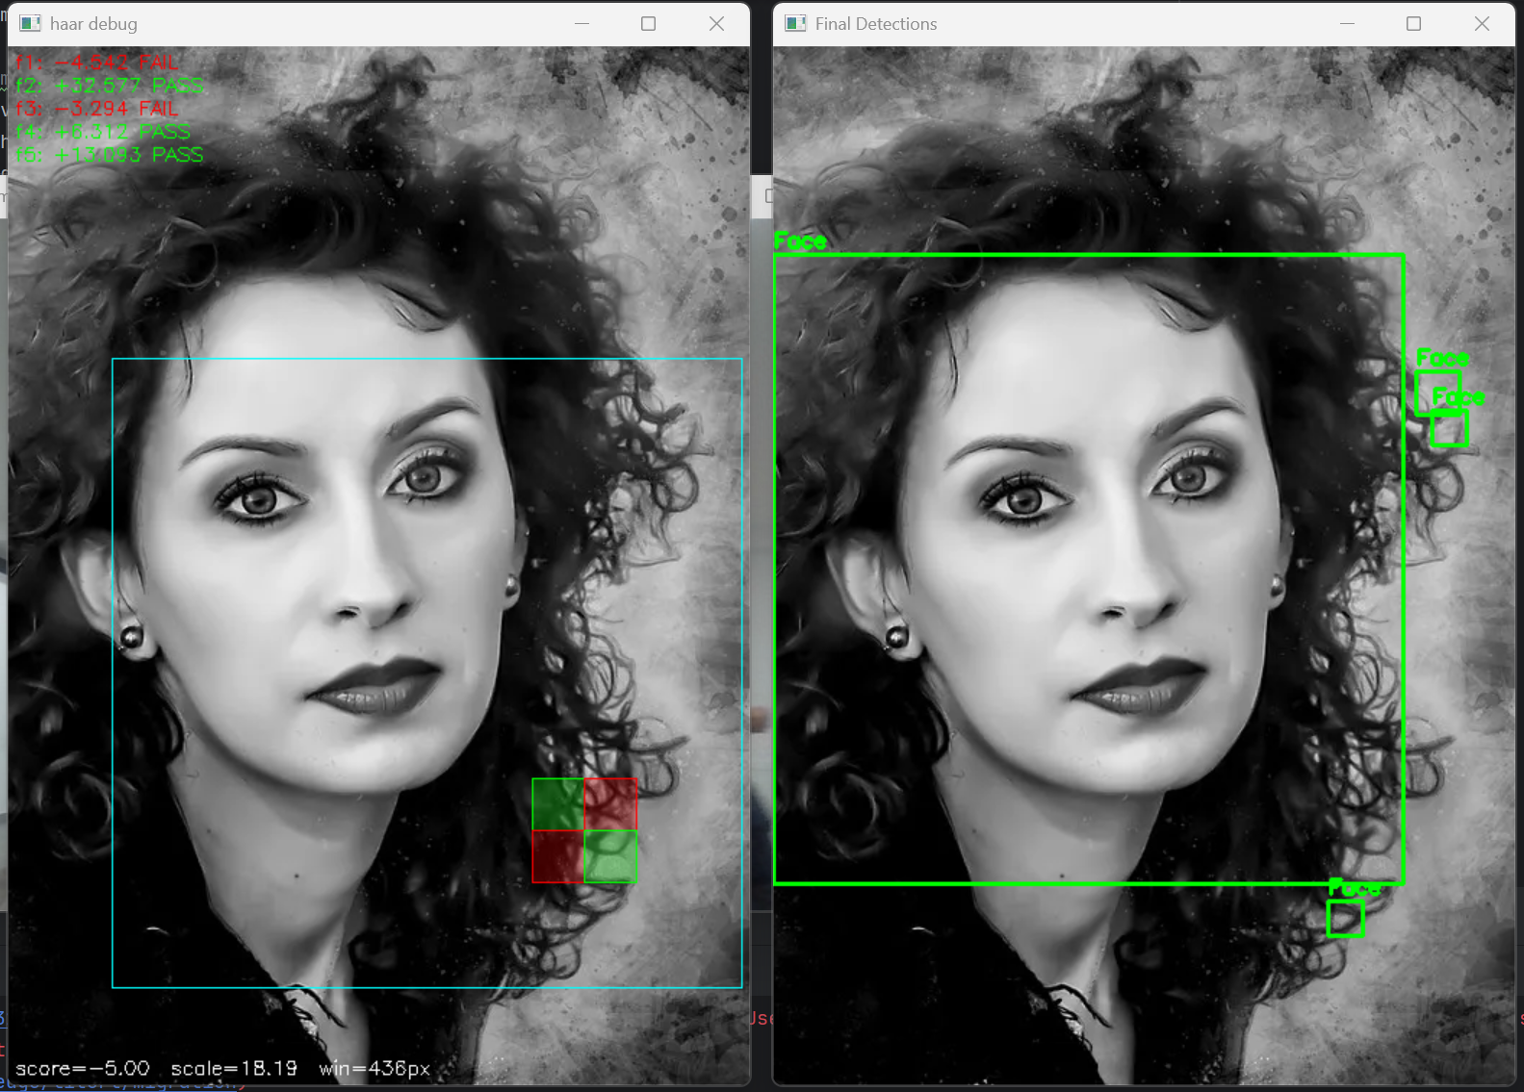

The actual computation:
=> As seen in the above image, the window is used for placing a “stylized window” inside of it...
=> the contrast is calculated by subtracting the values in the green (+) zone from the ones in the red zone (-)
!!! Subtraction: very costly. It would need to calculate the sum of those regions at EACH STEP
- Need speed, can spare memory...
- MEMOIZATION
- Use the integral image representation

The sum of the red region is the large burgundy zone – blue zone – pink + yellow
- Compute the integral image ONCE and use it always (would still be slow in practice, that’s why the VnJ is a ML approach)
- As seen above, it works!!! :)
- JK. I got, by sheer luck (mostly) a very good result. The problem: the result was obtained via a size based non-maxima suppression: boxes.append((area, [x, y, w, h]))
=> the given area had a lower score than others, but, in a thousand number of features, it’s score would’ve been boosted greatly
!!! Problem: how to scale?
Initially (see here) I tried to scale the image down...
=> bad quality
=> had to do pixel interpolation
=> scale window UP
How?
=> features are defined by zones, so multiplying the coordinates has a scaling effect
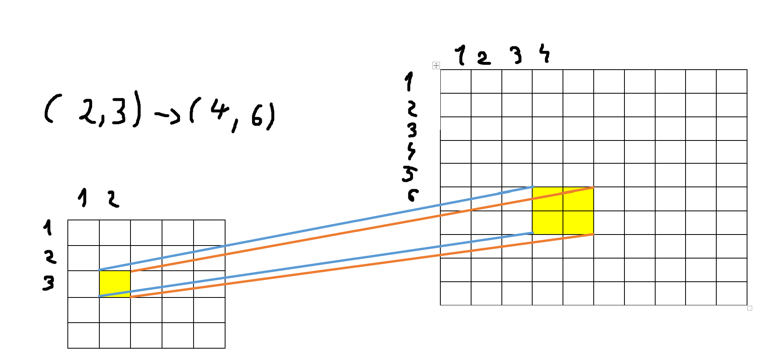
The algorithm stops when the window wouldn’t fit in the image
- at each step: 1.25x increase of feature
- the features were chosen to represent: eye, nose, forhead, hair differences
-NON-MAXIMA SUPP – Multu, Vivi:)
-Why show every possible face? Show the ones most probable (disclaimer)
-For all identified faces: order descending by score / (area) and check the overlap percentage (IoU + Containment)
-IoU: interface over union. How much the intersect as a percentage of the full combined size. Containment: intersection / min_of_compared_areas. If they pass a threshold, discard
-As said before: the achieved result is “magical”, because area was used as deciding factor instead of score
■ Face Alignment
- idea: face isn’t perfectly positioned => hard for emotion (tilts)
- Shift / modify it such that eyes are horizontal
- ROTATE IT!!! Mathematics shown below



aligned = cv2.warpAffine(
face_roi,
M,
(w, h), <- Actual rotation performed
flags=cv2.INTER_CUBIC
)
- the mechanism is based on detection of eyes, so another classifier is used

■ Resizing
-classifier works for 244*244 images => up the resolution
-tried it manually via: resize_bilinear(image, scale_factor)
-too slow... remained as an exercise

■ Emotion Detection
- Uses the fer.fer FER detector... I will try to improve this for the thesis project, but I focused mostly on the image processing side of things (Mr Oniga said so as well)
-
■ Response Creation
- open cv’s functionality is used to illustrate the information in a graphic manner

