**COMSOL MULTIPHYSICS**

***Two-dimensional superconductor in uniform magnetic field  
  
-Analysis of Abrikosov lattice in type II superconductor***

*Rafał Świętek  
indeks: 236668*

*Maksymilian Kliczkowski  
indeks: 236490*

1. **Wstęp**
   1. **Abstract**

In this work, the vortex nucleation process in a mesoscopic superconductor with different geometry is numerically investigated in terms of time dependent Ginzburg– Landau theory. We solved the equations simultaneously for different initial parameters.   
The influence of the magnetic field on the numer of vortices was tested and further analised. Although all parameters are temperaturę dependent, in this study it was chosen to be , therefore no critical temperature could be established.   
Tha main goal of this studie is to show the reader the impact of defects in different geometries in comparison to ideal geometries.   
Through the whole simulation the parameters are chosen as follows: , unless stated otherwise.

* 1. **Theoretical model**(This paragraph is left as an exercise for the reader)

1. **COMSOL simulation and geometry**

The simulation was based on the paper published by Tobias Bonsen [1]. Having the time dependent Ginzburg-Landau equations (using units):

One has to rewrite those equations to use them in COMSOL. Therefore we define

So the G-L equations take the form:

Where we assumed the boundary conditions:

Which can be simplified defining another variable :

Using the general form of a PDE (seen belowe)

One can write the coefficients as:

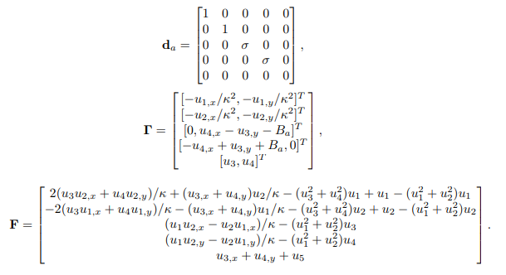

Additionally we assume the boundary conditio , which means that the superconducting current is parallel to the Edge of the sample.

The external magnetic field is taken in the z-direction. Because of gauge invariance for the magnetic vector potential, one can use the symmetric gauge defined as:

The simulations were made for different magnetic field strenghts, various G-L parameters and conductivities . The influence of both magnetic field and G-L parameters are considered in the analysis.

The Energy of the system is calculated for selected parameters using the forumla:

Analysis of the Energy graph one can see when the vortices nucleate.

1. **Analysing result**

|  |  |  |  |  |  |
| --- | --- | --- | --- | --- | --- |
| *(Tab.3.1 ) Magnetic field dependence of the order parameter* | | | | | |
| *Magnetic field* |  | 0.4 | 0.8 | 1 | 3 |
| *Defected SC* |  |  |  |  |  |
|  |  |  |  |  |
| *Non-*  *defected SC* |  |  |  |  |  |
|  |  |  |  |  |

* 1. **Square superconductor**In this section we investigate the square geometry for different external magnetic fields. First we last the system till the Energy starts to stabilizes and investigate the influence of the magnetic field. Then we analyze the nucleation of vorticies for selected parameters.The table (Tab.3.1) shows the change of the order parameter and the magnetic field in the sample for external magnetic fields. One could note, that for the order parameter starts to vanish. Thats because the field is closing up to the critical field , which defines the transition to the normal state. In contrast to the field , where the superconductor is in the Meissner phase. Below the critical field the vorticies can’t nucleate at any time.

|  |  |  |  |  |  |
| --- | --- | --- | --- | --- | --- |
| *(Tab.3.2 ) Magnetic field dependence of the order parameter* | | | | | |
| *Magnetic field* |  | 0.4 | 0.8 | 1 | 3 |
| *Defected SC* |  |  |  |  |  |
|  |  |  |  |  |
| *Non-defected SC* |  |  |  |  |  |
|  |  |  |  |  |

* 1. **Hexagonal superconductor**In analogy to the earlier case we choose the same parameters for this geometry. The procedurę is exactly the same. The same as for the square geometry occurs for the hexagonal superconductor. We can distinguish each phase by the order parameter. In the Meissner phase it is uniform in the sample (except the boundaries, where we have fluctuations) and equals . The table (Tab. 3.2) presents the order parameter and the field in the sample in each case of the external magnetic field:  
       
     As expected the last case presents the external field almost entirely penetrating the sample, which means (in comparison with the order parameter) that we are close the transition point to the normal state.
  2. **Vorticies counting**

*(fig.3.1) Type II superconductor phase diagram*

* + 1. 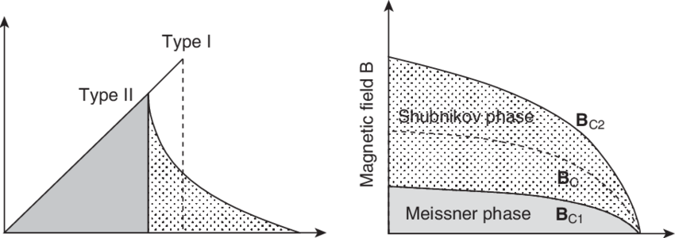**External field**An important aspect of simulating a type II superconductor is to know the critical fields for one. The shubnikov phase lies between two critical fields, which where numerically found in this subsection. The phase diagram for a type II superconductor is shown in (fig. 3.1). One can count the numer of vorticies for a given field, which is done in the figure (fig.3.2).  
       One can note the lower critical field between the Meissner phase and the Shubnikov phase . We also conclude that the numer of vortices is much higher for higher fields. For fields larger than the vortices start to combine as there isn’t enough space for them to stay apart [2]. Above a field around the order parameter vanishes on the boarder and stays only nonzero in the middle of the sample. This yields that in fields higher than the sample is in the normal state.
    2. **Time nucleation**  
       Here we investigate the generation and movement of the vortexes voer time for the defected square geometry. One can note that the vortices stabilize in a square lattice. For the other geometries we can see the triangular lattice for the vortexes. Looking at the overall Energy of the system across the timelapse one can note when the vorticies are nucleated and what happens later. The origin of the nucleated vorticies is always the distortion (indentation etc.)  
       The simulation was last for 1000 timesteps. The first vortices nucleated in the 6 second (pic.1), then around the 120 second the lattice started to relocate (pic.2) to find its steady-state   
       (pic.3-4). And finally the system is at a steady-state, which corresponds to the last plot in (fig.3.3)

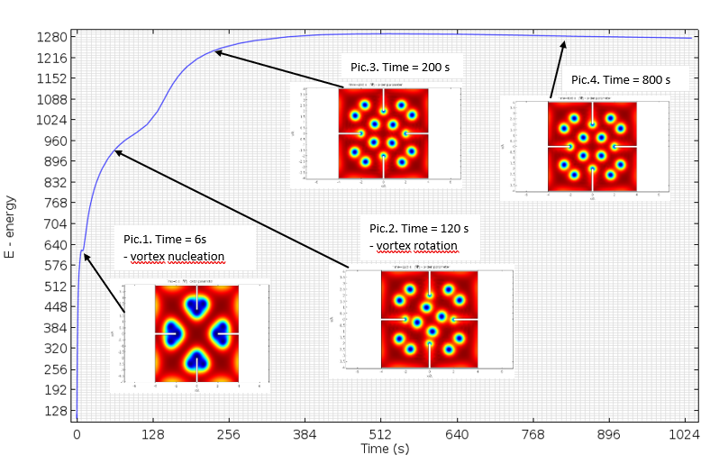

*(fig.3.3) Energy of the system*

* 1. **Applying external current**

According to Ögren [5] one can imply a external current to the system using some approximation. It turns out that a good approximation is to write the additional magnetic field generated by the current as:

The additional field is in the z-direction, therefore it is paralel to our external field. On would expect the current induces the vortecies to move along some special direction. The vorticies started to move in the y-direction, so along the direction the field induced by the current increases. This charactereristic behaviour was shown in the simulation for some currents.

1. **Final remarks**

To summarize one can note that each case is characterized by the same unchanged parameters. For instance in each plot we see some small fluctuations on the boundaries which are assosiated with the London penetration depth which was kept constant the G-L parameter was kept constant, but ). Th elondon penetration depth gives us information about how much does the field intrude in the sample. On the othe hand we see something similiar in the order parameter. The fluctuations on the boundary are here associated by the coherence lenght.

Most of the Times the Abrikosov lattice is shown to be triangular (or hexagonal). Only in special cases one can see different lattices, for example the square lattice in the middle in the for the square superconductor with slits. If we had analyzed a cylindrical geometry one would expect vortices lining on a circle [4].

The simulations in this paper presents the instability of the Shubnikov phase for high magnetic fields. An important fact is that the vortex sources are always the sharp edges [3] in the system. For the square geometry the vortexes nucleate from the slits (for high field above 1.1 they nucleate from the side too) . For the hexagon lattice the vorticies originate from the sharp edges of the inside hexagon. This result is rather unphysical, because it takes a relative high vortex to enter the material. One possible solution could be to refine the mesh [1], but it turns out the mesh convergence of this problem is very slow.

Comparing geometries with defects (slits, holes etc) to ones without one can immidiately notice that the disturbed superconductor is more resistant to the magnetic field maintaning a non-zero order parameter. This could be caused by the discontinuity of on sharp edges [4]. This yields one could use distortion to maintain a penetrating high magnetic field in the superconductor giving high application possibilities. For instance in newest magnetic resonance deivices or SQUID (Supeconducting Quantum Interference Device).

1. **References**[1] Tobias Bonsen, *„Numerical simulations for type II Superconductors”*

[2] Isaías G. de Oliveira , *„Instability in the magnetic field penetration in type II superconductors”*

[3] Tommy Sonne Larsen , Mads Peter Sørensen , *„The Ginzburg-Landau Equation Solved by the Finite Element Method”*

[4] Tommy Sonne Alstrøm · Mads Peter Sørensen , *„Magnetic Flux Lines in Complex Geometry Type-II Superconductors Studied by the Time Dependent Ginzburg-Landau Equation”*

[5] M. Ögren ⇑ , M.P. Sørensen, N.F. Pedersen, *„Self-consistent Ginzburg–Landau theory for transport currents in superconductors”*

*[6]* Mads Peter Sørensen and Niels Falsig Pedersen, *„The Dynamics of Magnetic Vortices in Type II Superconductors with Pinning Sites Studied by the Time Dependent Ginzburg-Landau Model”*