House Prices
Project Report

Machine Learning Regression Project
Public English Version

Personal author/contact data removed

Table of Contents
- Study name and objective
- Research team
- Introduction
- Hardware and software used in the study
- Description of the analyzed dataset
- Exploratory data analysis
- Data preprocessing
- Research hypotheses and statistical tests (optional)
- Data modeling
- Model evaluation and comparison
- Visualization of results
- Conclusions and summary of the analysis
- Appendices
- Glossary

Study name and objective
Study topic: Predicting house prices based on property characteristics - a regression problem.
Research objectives:
- Identify which house characteristics have the strongest impact on the sale price.
- Prepare the data for modeling, including missing value handling, outlier removal, feature reduction and encoding of categorical variables.
- Build a regression model that predicts house sale prices.
- Compare model quality on training and test data.
- Present the results using histograms, a correlation matrix and regression metrics.

Research team
This is a public version of the report. Personal author details, student index number and contact data have been removed.
Roles covered in the project:
- modeling and report quality control specialist,
- data analyst,
- model building and validation specialist,
- machine learning analyst responsible for modeling and interpretation of results.

Introduction
This stage of the project focused on predicting house prices based on property characteristics. The aim of the analysis was to determine which information about a property has the strongest impact on sale price and to prepare a regression model capable of estimating that price.
The scope of the analysis included loading the data, checking variable types, analyzing missing values, analyzing distributions, detecting outliers, preparing data for modeling and evaluating model quality. Histograms and a correlation matrix were also used to show relationships between variables more clearly.
The source of the data was the public Ames Housing Dataset available on Kaggle. The data describe house sales in Ames, Iowa, USA. The dataset contains property characteristics such as lot area, living area, year built, quality of materials and finishing, number of bathrooms, garage, basement, location and sale conditions.
The analyzed file contains 1,460 observations and 81 columns. The target variable is SalePrice, meaning the sale price of the house. The remaining columns describe property features. The dataset includes numerical variables, such as living area and year built, as well as categorical variables, such as building type, neighborhood, kitchen quality and garage type.

Hardware and software used in the study
Hardware used during the project:
- Dell Inspiron 15
Software used in the R&D work:
- Jupyter Notebook
- Python 3
- NumPy 2.3.5
- Pandas 2.2.3
- Matplotlib 3.10.8
- Seaborn 0.13.2
- Scikit-learn 1.8.0
The project used a fixed random seed: random_state = 42. It was used, among other steps, for splitting the dataset into training and test sets. This makes the results reproducible: after rerunning the code, the same data split and comparable model results can be obtained.

Description of the analyzed dataset
The analyzed dataset is the Ames Housing Dataset. It contains data on house sales in Ames, Iowa. It was used to predict house sale prices based on property characteristics.
The dataset includes 1,460 observations and 81 columns. One column is an observation identifier (Id), one column is the target variable (SalePrice), and the remaining columns describe house characteristics. Both numerical and categorical variables are present.
Table 1. General characteristics of the dataset
Element | Description
Dataset name | Ames Housing Dataset
Number of observations | 1,460
Number of columns | 81
Target variable | SalePrice
Problem type | Regression
Analysis objective | Prediction of house sale price
Variable types | Numerical, ordinal and categorical
Example features | Living area, lot area, year built, house quality, garage, basement, location, sale conditions
Units | Mainly square feet, years, number of rooms and US dollars

Table 2. Description of variables in the dataset
Variable | Type | Unit / scale | Description
Id | identifier | none | Observation identifier.
MSSubClass | categorical / numeric code | category | Type of residential dwelling.
MSZoning | categorical | category | General zoning classification, such as residential or commercial.
LotFrontage | numerical | feet | Linear feet of street connected to the property.
LotArea | numerical | square feet | Lot size.
Street | categorical | category | Type of road access to the property.
Alley | categorical | category | Type of alley access or no alley access.
LotShape | categorical | category | General shape of the property.
LandContour | categorical | category | Flatness or contour of the property.
Utilities | categorical | category | Type of utilities available.
LotConfig | categorical | category | Lot configuration, e.g. inside lot or corner lot.
LandSlope | categorical | category | Slope of the property.
Neighborhood | categorical | category | Physical location within Ames city limits.
Condition1 | categorical | category | Proximity to relevant conditions, such as roads or railways.
Condition2 | categorical | category | Second proximity condition if more than one is present.
BldgType | categorical | category | Type of dwelling, e.g. detached house, duplex or townhouse.
HouseStyle | categorical | category | Style of dwelling, e.g. one-story or two-story.
OverallQual | ordinal | 1-10 scale | Overall quality of materials and finish.
OverallCond | ordinal | 1-10 scale | Overall condition of the house.
YearBuilt | numerical | year | Original construction date.
YearRemodAdd | numerical | year | Remodel date or original construction date if no remodeling occurred.
RoofStyle | categorical | category | Type of roof.
RoofMatl | categorical | category | Roof material.
Exterior1st | categorical | category | Primary exterior covering.
Exterior2nd | categorical | category | Secondary exterior covering if more than one material is used.
MasVnrType | categorical | category | Masonry veneer type.
MasVnrArea | numerical | square feet | Masonry veneer area.
ExterQual | ordinal | Ex-Po | Exterior material quality.
ExterCond | ordinal | Ex-Po | Current condition of exterior material.
Foundation | categorical | category | Type of foundation.
BsmtQual | ordinal | Ex-Po / NA | Basement quality, mainly height.
BsmtCond | ordinal | Ex-Po / NA | Basement condition.
BsmtExposure | categorical | category | Walkout or garden-level basement wall exposure.
BsmtFinType1 | categorical | category | Rating of basement finished area type 1.
BsmtFinSF1 | numerical | square feet | Finished basement area type 1.
BsmtFinType2 | categorical | category | Rating of basement finished area type 2.
BsmtFinSF2 | numerical | square feet | Finished basement area type 2.
BsmtUnfSF | numerical | square feet | Unfinished basement area.
TotalBsmtSF | numerical | square feet | Total basement area.
Heating | categorical | category | Type of heating.
HeatingQC | ordinal | Ex-Po | Heating quality and condition.
CentralAir | categorical | Yes/No | Central air conditioning indicator.
Electrical | categorical | category | Electrical system type.
1stFlrSF | numerical | square feet | First floor area.
2ndFlrSF | numerical | square feet | Second floor area.
LowQualFinSF | numerical | square feet | Low-quality finished area.
GrLivArea | numerical | square feet | Above-ground living area.
BsmtFullBath | numerical | count | Number of full bathrooms in the basement.
BsmtHalfBath | numerical | count | Number of half bathrooms in the basement.
FullBath | numerical | count | Number of full bathrooms above ground.
HalfBath | numerical | count | Number of half bathrooms above ground.
BedroomAbvGr | numerical | count | Number of bedrooms above ground.
KitchenAbvGr | numerical | count | Number of kitchens above ground.
KitchenQual | ordinal | Ex-Po | Kitchen quality.
TotRmsAbvGrd | numerical | count | Total rooms above ground, excluding bathrooms.
Functional | categorical | category | Home functionality.
Fireplaces | numerical | count | Number of fireplaces.
FireplaceQu | ordinal | Ex-Po / NA | Fireplace quality or no fireplace.
GarageType | categorical | category | Garage location/type.
GarageYrBlt | numerical | year | Year garage was built.
GarageFinish | categorical | category | Interior finish of the garage.
GarageCars | numerical | car capacity | Garage capacity expressed as number of cars.
GarageArea | numerical | square feet | Garage area.
GarageQual | ordinal | Ex-Po / NA | Garage quality.
GarageCond | ordinal | Ex-Po / NA | Garage condition.
PavedDrive | categorical | category | Whether the driveway is paved.
WoodDeckSF | numerical | square feet | Wood deck area.
OpenPorchSF | numerical | square feet | Open porch area.
EnclosedPorch | numerical | square feet | Enclosed porch area.
3SsnPorch | numerical | square feet | Three-season porch area.
ScreenPorch | numerical | square feet | Screen porch area.
PoolArea | numerical | square feet | Pool area.
PoolQC | ordinal | Ex-Fa / NA | Pool quality or no pool.
Fence | categorical | category / NA | Fence quality or no fence.
MiscFeature | categorical | category / NA | Miscellaneous feature, such as shed or second garage.
MiscVal | numerical | USD | Value of miscellaneous feature.
MoSold | numerical | month | Month of sale.
YrSold | numerical | year | Year of sale.
SaleType | categorical | category | Type of sale.
SaleCondition | categorical | category | Condition of sale.
SalePrice | numerical | USD | House sale price; target variable.

Table 3. Missing values in the dataset
Variable | Missing values | Missing share | Interpretation / handling
PoolQC | 1,453 | 99.5% | Mostly means no pool. Removed because of an extremely high missing-value rate.
MiscFeature | 1,406 | 96.3% | Mostly means no miscellaneous feature. Removed.
Alley | 1,369 | 93.8% | Mostly means no alley access. Removed.
Fence | 1,179 | 80.8% | Usually means no fence. Replaced with the category None.
FireplaceQu | 690 | 47.3% | Means no fireplace. Replaced with the category None.
LotFrontage | 259 | 17.7% | Missing street frontage. Filled using the neighborhood median.
GarageType | 81 | 5.5% | Usually means no garage. Replaced with None.
GarageYrBlt | 81 | 5.5% | Missing garage construction year. Filled with YearBuilt.
GarageFinish | 81 | 5.5% | Usually means no garage. Replaced with None.
GarageQual | 81 | 5.5% | Usually means no garage. Replaced with None.
GarageCond | 81 | 5.5% | Usually means no garage. Replaced with None.
BsmtExposure | 38 | 2.6% | Usually means no basement. Replaced with None.
BsmtFinType2 | 38 | 2.6% | Usually means no basement. Replaced with None.
BsmtQual | 37 | 2.5% | Usually means no basement. Replaced with None.
BsmtCond | 37 | 2.5% | Usually means no basement. Replaced with None.
BsmtFinType1 | 37 | 2.5% | Usually means no basement. Replaced with None.
MasVnrType | 8 | 0.5% | Missing masonry veneer type. Replaced with None.
MasVnrArea | 8 | 0.5% | Missing masonry veneer area. Replaced with 0.
Electrical | 1 | 0.1% | Single missing value. Filled with the most frequent category.

Table 4. Outliers and distribution issues
Area | Variable | Issue | Project decision
Living area | GrLivArea | Very large living-area values could distort model training. | Observations with GrLivArea > 4000 were treated as outliers.
Lot area | LotArea | Some lots were much larger than most observations. | The feature was kept, but its distribution was interpreted carefully.
Basement area | TotalBsmtSF | Single very large values appeared. | The feature was kept because it can affect price.
Garage | GarageArea | High garage-area values appeared. | GarageCars was preferred later because GarageArea is strongly linked to garage capacity.
Sale price | SalePrice | The target had a right-skewed distribution. | The target was transformed using log1p(SalePrice).

Exploratory data analysis
Exploratory data analysis was used to understand the dataset before modeling and to identify variables likely to be important for house price prediction. The analysis covered numerical distributions, descriptive statistics, missing values, outliers and correlations with the target variable SalePrice.

Descriptive statistics of selected variables
For numerical variables, the mean, median, standard deviation, quartiles and minimum and maximum values were calculated. The table below presents selected features that are important for price prediction or useful for understanding the dataset structure.
Table 5. Selected descriptive statistics for numerical variables
Variable | N | Mean | Median | Std. dev. | Min | Max | Interpretation
LotArea | 1,460 | 10,516.83 | 9,478.50 | 9,981.26 | 1,300 | 215,245 | Lot area varies strongly and contains very high values.
OverallQual | 1,460 | 6.10 | 6.00 | 1.38 | 1 | 10 | Overall quality is one of the key variables.
YearBuilt | 1,460 | 1971.27 | 1973.00 | 30.20 | 1872 | 2010 | The dataset contains both old and new houses.
TotalBsmtSF | 1,460 | 1,057.43 | 991.50 | 438.71 | 0 | 6,110 | Basement area may be zero but is relevant for many houses.
GrLivArea | 1,460 | 1,515.46 | 1,464.00 | 525.48 | 334 | 5,642 | Living area has a strong relationship with price.
GarageCars | 1,460 | 1.77 | 2.00 | 0.75 | 0 | 4 | A typical house has a garage for one or two cars.
GarageArea | 1,460 | 472.98 | 480.00 | 213.80 | 0 | 1,418 | Garage area is strongly related to garage capacity.
OpenPorchSF | 1,460 | 46.66 | 25.00 | 66.26 | 0 | 547 | Many houses have low or zero open porch area.

Distributions and outliers
Histograms show that several variables are right-skewed, including lot area, basement area, garage area and different porch or deck variables. Many variables contain many zero values because not every house has a pool, fireplace, additional porch, deck or second floor.
The sale price was also right-skewed before transformation. For this reason, log1p(SalePrice) was used. After this transformation, the target distribution became more regular and more suitable for linear regression.
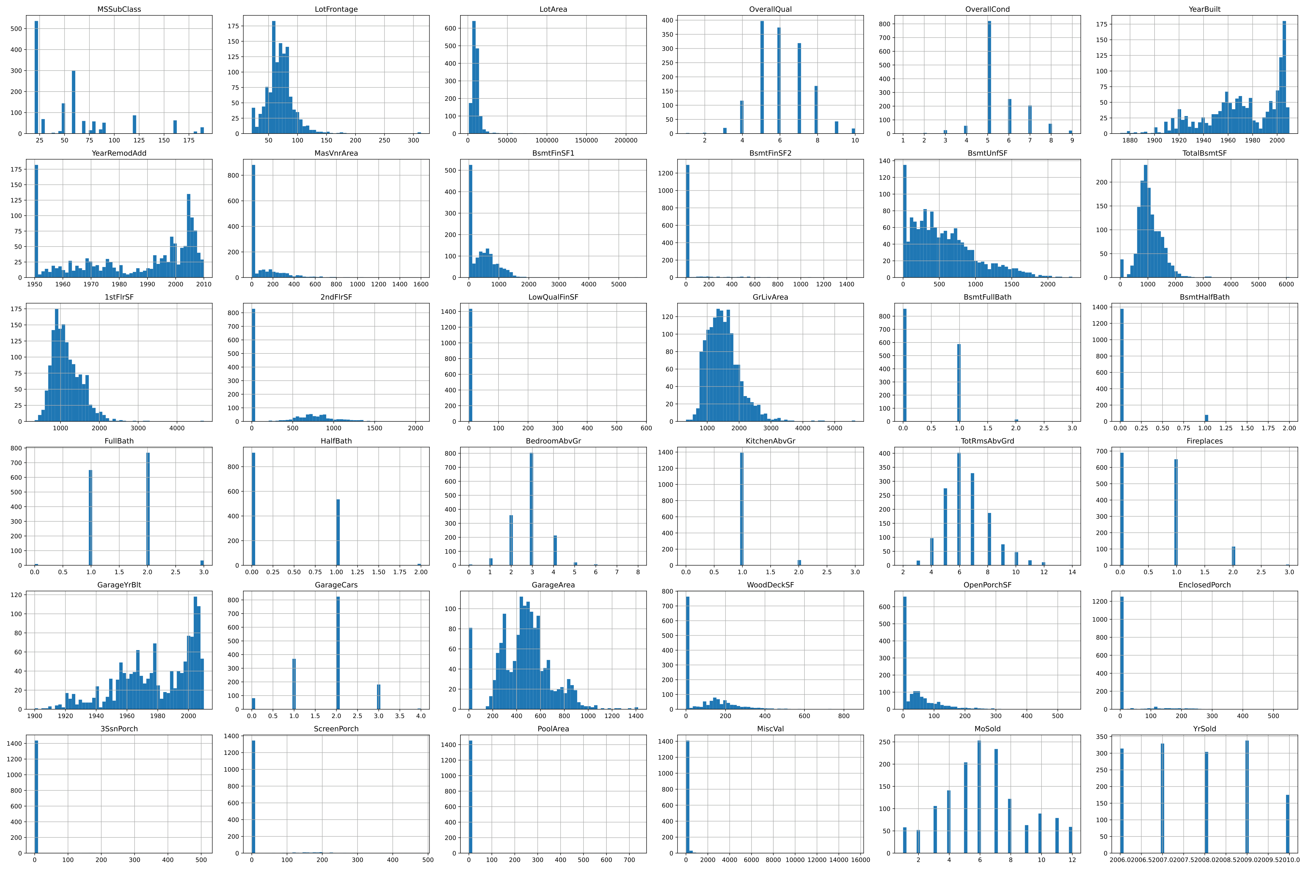
Figure 1. Histograms of numerical variables used in exploratory data analysis.

Categorical variables
The dataset also contains categorical variables such as Neighborhood, HouseStyle, ExterQual, KitchenQual, GarageType, SaleType and SaleCondition. They describe location, building style, finish quality and sale type. Category shares were checked before modeling. Several categories were rare, which made encoding and feature selection necessary.
Table 6. Example categorical variables and their meaning
Variable | Meaning in the analysis | Why it is important
Neighborhood | District where the house is located. | Location usually strongly affects real estate prices.
ExterQual | Quality of exterior materials. | Higher exterior quality increases expected price.
KitchenQual | Kitchen quality. | The kitchen is an important part of house standard.
GarageType | Garage type. | Attached or built-in garages can increase house value.
SaleCondition | Sale condition. | Normal, partial or new-house sales can affect price.

Correlation analysis
The correlation matrix was calculated for numerical variables and the log-transformed target variable. The strongest positive relationship with SalePrice_Log was observed for OverallQual. High correlations were also found for GrLivArea, GarageCars, ExterQual, KitchenQual, TotalBsmtSF and 1stFlrSF.
Weak relationships with price were observed for MoSold, ExterCond, YrSold, OverallCond and MSSubClass. In the notebook, these were treated as low-signal features because their correlation with the target was below 0.1.
Table 7. Key relationships with log-transformed price
Variable | Correlation with SalePrice_Log | Interpretation
OverallQual | 0.82 | Strongest relationship; house quality has a major impact on price.
GrLivArea | 0.72 | Larger living area usually means a higher price.
ExterQual | 0.68 | Better exterior quality increases value.
KitchenQual | 0.67 | Kitchen quality is an important part of house standard.
GarageCars | 0.68 | Greater garage capacity is associated with a higher price.
TotalBsmtSF | 0.64 | Larger basement area supports a higher price.

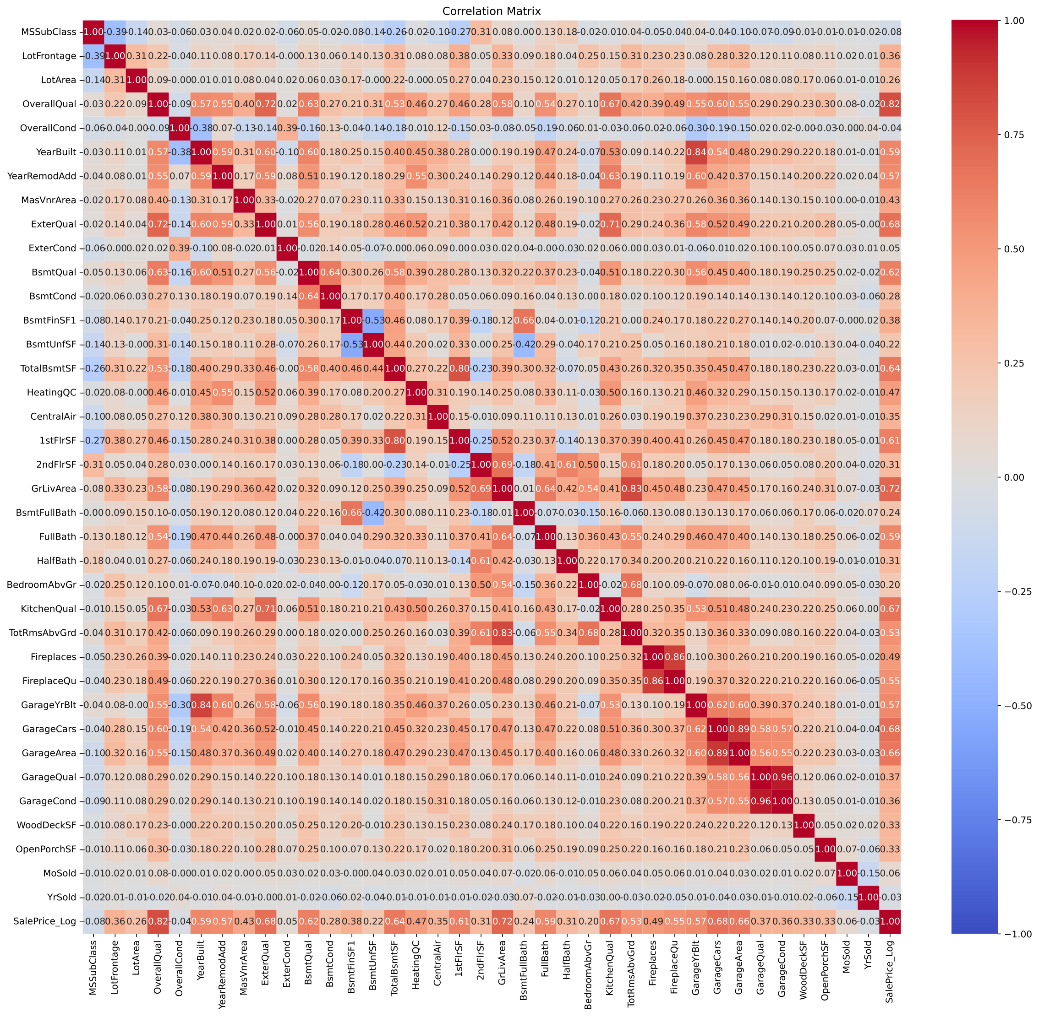
Figure 2. Correlation matrix of numerical variables with SalePrice_Log.

Conclusions from exploratory analysis
- The strongest price drivers are related to house quality, living area, basement and garage.
- Missing values are present, but many of them have a business meaning, such as no garage, no basement, no fence or no pool.
- Some features contain many zero values, so not all variables are equally useful for modeling.
- Four outlying observations were detected for GrLivArea greater than 4000 square feet.
- SalePrice was log-transformed because the original price distribution was skewed.

Data preprocessing
Data preprocessing prepared the dataset so that machine learning models could learn from clean and consistent data. The main steps included removing selected low-value columns, handling missing values, removing outliers, encoding categorical variables, selecting features and scaling where necessary.

Removing low-information columns
At the beginning, variables with low variability, many zero values or limited information value were removed. These included Street, Utilities, Condition2, RoofMatl, BsmtFinSF2, LowQualFinSF, BsmtHalfBath, KitchenAbvGr, EnclosedPorch, 3SsnPorch, ScreenPorch, PoolArea and MiscVal.
Additionally, PoolQC, MiscFeature and Alley were removed because they had many missing values. In practice, the missing values in these columns usually indicated no pool, no miscellaneous feature or no alley access.

Missing value handling
Table 8. Key decisions for missing value handling
Problem | Applied solution | Justification
Missing GarageYrBlt | Filled with YearBuilt. | If garage year was missing, the construction year of the house was used as a reasonable approximation.
Missing MasVnrArea | Filled with 0. | Missing masonry veneer area usually meant no masonry veneer.
Missing garage, basement or fireplace variables | Replaced with None. | Missing value usually meant that the feature did not exist.
Missing LotFrontage | Filled with neighborhood median. | Street frontage depends on neighborhood, so group median is safer than one global median.
Missing Electrical | Filled with the mode. | There was only one missing value, so the most frequent category was used.

After cleaning, the number of missing values in matrix X was 0. This means the data were ready for encoding and model training.

Encoding and transformations
Some ordinal variables were converted into numerical values. For example, the quality scale Ex, Gd, TA, Fa, Po was mapped to 5, 4, 3, 2, 1, while the absence of a feature was encoded as 0. This was applied to variables such as ExterQual, BsmtQual, HeatingQC, KitchenQual, FireplaceQu, GarageQual and GarageCond.
CentralAir was encoded as a binary variable: Y as 1 and N as 0. The remaining categorical variables were transformed using One-Hot Encoding, meaning they were converted into 0/1 columns.
The SalePrice target variable was transformed using log1p. This prevented single very expensive properties from dominating model training.

Removing multicollinearity and noise
After the correlation analysis, some features strongly related to other variables were removed. For example, GarageArea was strongly linked to GarageCars, so GarageCars was given higher priority in later modeling. Low-correlation variables such as YrSold, MoSold, MSSubClass, OverallCond and ExterCond were also removed.
This step was especially important for linear regression. A linear model performs better when features are organized and do not duplicate the same information.

Feature selection and scaling
SelectKBest with the f_regression score was used to reduce the number of features. First, 65 best categorical features after encoding were selected, giving 92 features in matrix X. In the later LassoCV version, 80 encoded categorical features were selected, giving 107 features.
StandardScaler was used for LassoCV and the pipeline models because regularized models and KNN are sensitive to feature scale. Scaling is less important for a decision tree, but the pipeline approach helped keep the workflow consistent.

Pipeline
The final part of the project used the pipeline approach. This means that data preparation and the model were treated as one process. This reduces the risk of data leakage, where information from the test set accidentally influences training.
Table 9. Data preparation stages in the pipeline
Stage | Description | Impact on the model
Missing value handling | Missing values were replaced with logical values, median, mode or None. | The model receives a complete feature matrix without empty cells.
Variable encoding | Categorical variables were converted into numerical representation. | Scikit-learn models can work with the transformed data.
Scaling | StandardScaler was used where needed. | KNN and regularized models are not dominated by large-scale variables.
Feature selection | SelectKBest was used and low-signal features were removed. | Less noise and lower risk of overfitting.
Model | The selected regression algorithm was placed at the end of the pipeline. | The same process was used for training and evaluation.

Research hypotheses and statistical tests (optional)
This section is optional. No separate formal statistical tests were performed because the main goal was to build and evaluate machine learning models. Instead, the project used correlation analysis and evaluation on training and test data.
However, a practical working hypothesis can be formulated: features related to house quality and living area have the strongest impact on sale price. The correlation matrix supports this hypothesis because OverallQual and GrLivArea had among the highest correlations with SalePrice_Log.

Data modeling
The modeling stage focused on predicting the house price, represented by SalePrice after logarithmic transformation. This is a regression problem because the model output is a number, not a class label.

Data split
The data were split into training and test sets in an 80/20 ratio. train_test_split was used with random_state = 42. The fixed seed allows the split to be reproduced and results to be compared after rerunning the notebook.
The training set was used to fit the models, while the test set was used to check how the models perform on unseen data. The difference between training and test performance was used to assess generalization.

Applied models
Table 10. Machine learning models used in the project
Model | Model type | Reason for selection
Linear Regression / OLS | Linear model, baseline | A simple reference point. It works well after solid feature preparation and noise removal.
Decision Tree Regressor | Tree-based model | Can capture nonlinear relationships, but can easily overfit without depth control.
KNN Regressor | Neighbor-based model | Checks similarity between houses, but is sensitive to feature scale and high dimensionality.
LassoCV | Linear regression with L1 regularization | Automatically reduces the impact of weak features and improves resistance to overfitting.

Model parameterization
Table 11. Key model settings
Element | Project setting | Comment
Data split | test_size = 0.2; random_state = 42 | Fixed split ensures reproducibility.
Linear Regression | LinearRegression | Baseline model without regularization.
Decision Tree | DecisionTreeRegressor, random_state = 42 | Tree-based model used for comparison; prone to overfitting.
KNN | KNeighborsRegressor | Requires scaling because it calculates distances between observations.
LassoCV | LassoCV, alpha = 0.0016 | The model selected the L1 penalty strength using cross-validation.
Feature selection | SelectKBest, f_regression, k = 65 or k = 80 | Reduced the number of features after One-Hot Encoding.

Dimensionality reduction
PCA was not used because the goal was to preserve feature interpretability. Instead of feature extraction, feature selection with SelectKBest was used. This reduced the number of columns after One-Hot Encoding while preserving information about which features were selected.
The baseline variant after selection had 92 features. The LassoCV variant had 107 features. LassoCV additionally reduced the influence of weak variables through L1 regularization.

Unsupervised learning
No separate clustering method, such as K-means, was applied because the main objective was supervised regression: predicting house price from known SalePrice values.

Model evaluation
The main evaluation metric was R². This metric shows how much of the target variability is explained by the model. The closer R² is to 1, the better the model fits the data.

Model evaluation and comparison
The comparison covered the full process of data preparation and modeling. The key numerical results saved in the notebook concern linear regression and LassoCV. For Decision Tree and KNN, the evaluation was supplemented by interpretation of Actual vs. Predicted plots and residual plots.
Table 12. Model comparison
Model | R² train | R² test | Generalization assessment | Conclusion
Linear Regression / baseline | 0.9206 | 0.8962 | Good generalization, small train-test gap. | Very strong result for a simple model.
Decision Tree Regressor | 1.0000 | 0.6542 | Visible overfitting. | A textbook example of overfitting: the model memorizes training data but predicts new data worse.
KNN Regressor | 0.8522 | 0.7734 | Quality drops with many features. | KNN became a victim of the curse of dimensionality after One-Hot Encoding.
LassoCV | 0.9272 | 0.9001 | Best balance between fit and robustness. | Best final model; exceeded 90% R² on the test set.

Interpretation of comparison
LassoCV performed best because it combined strong feature preparation with L1 regularization. Its R² on the test set was 0.9001, meaning that the model explained about 90% of the variability in the log-transformed price.
Linear Regression also achieved a very strong result: test R² of 0.8962. This shows that a simple method can perform very well when preprocessing is done properly: noise was removed, multicollinearity was reduced, categorical variables were encoded and the most important features were selected.
The Decision Tree showed typical overfitting. A tree can fit the details of the training set too closely, which makes it worse on new observations. The residual plot shows larger errors than for linear regression.
KNN performed worse because One-Hot Encoding increased the number of features. In high-dimensional space, distances between observations become less informative. This is a practical example of the curse of dimensionality.

Visualization of results
The results were presented using histograms, a correlation matrix and plots comparing actual values with predicted values. For regression models, the most important plots are Actual vs. Predicted and Residuals Plot.

Histograms and correlation matrix
Histograms showed numerical variable distributions and helped identify skewness and outliers. The correlation matrix identified features most strongly related to price, especially OverallQual, GrLivArea, GarageCars, KitchenQual and TotalBsmtSF.

Model plots
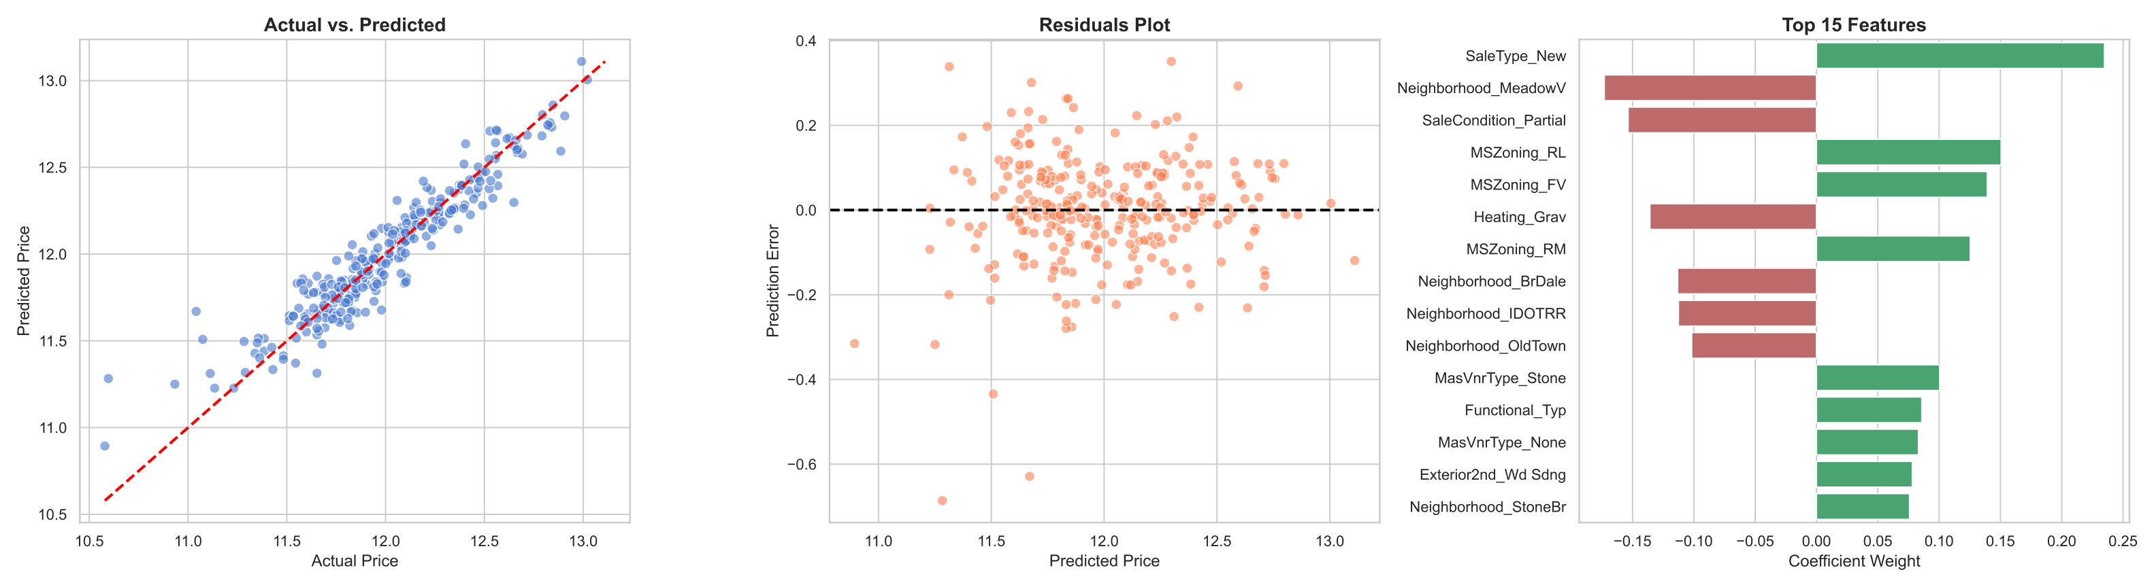
Figure 3. Baseline model: actual and predicted prices, residuals and most important features.
For the baseline model, the points in the Actual vs. Predicted plot lie close to the ideal line. This indicates that linear regression predicts log-transformed prices well. The residual plot shows errors centered around zero, although some larger deviations are present.
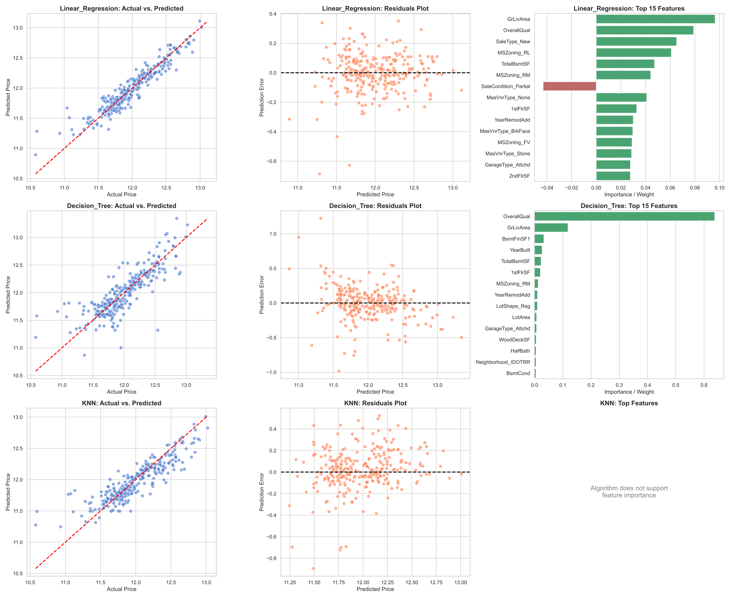
Figure 4. Pipeline comparison for Linear Regression, Decision Tree and KNN.
The comparison of three models shows that linear regression was the most stable. Decision Tree had a wider error spread, which indicates overfitting. KNN produced flatter predictions and performed worse at the extreme ends of the price distribution.
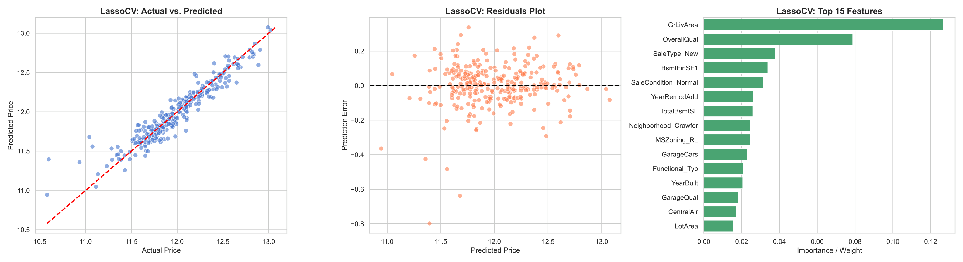
Figure 5. LassoCV: predictions, residuals and most important features.
LassoCV preserved strong linear prediction behavior while limiting the influence of weak features. The most important variables in this model included GrLivArea, OverallQual, SaleType_New, BsmtFinSF1, SaleCondition_Normal, YearRemodAdd, TotalBsmtSF and GarageCars.

Conclusions and summary of the analysis
The main conclusion is that the simplest model does not have to be the weakest. In this project, linear regression achieved a very strong result because the data were carefully prepared first. Noise was removed, multicollinearity was reduced, categorical variables were encoded and the most important features were selected.
LassoCV was the best final model. It achieved a test R² of 0.9001 and kept a small difference between training and test performance. This means good generalization ability.

Answers to research objectives
Table 13. Fulfillment of research objectives
Objective | Answer
Identify the impact of features on price | The strongest effects came from house quality, living area, garage, basement, year built and finishing quality.
Prepare the data | Missing values were filled, selected columns were removed, categorical variables were encoded and price was log-transformed.
Build a regression model | Linear Regression, Decision Tree, KNN and LassoCV models were built.
Compare models | The best result was achieved by LassoCV, with Linear Regression very close behind.
Visualize results | Histograms, a correlation matrix, Actual vs. Predicted plots and residual plots were used.

Error analysis
The largest errors usually occurred for unusual properties. Based on the residual plots, several typical situations can be identified where the model could make larger mistakes:
- houses with very large living area - such observations are rare and harder to predict,
- very expensive or very cheap houses - models have fewer training examples at distribution extremes,
- properties from unusual locations or rare Neighborhood categories - rare categories have fewer examples after One-Hot Encoding,
- houses with unusual sale conditions, such as new houses or partial sales - SaleType and SaleCondition strongly affected predictions,
- objects with unusual feature combinations, such as large area but lower quality, or the reverse.
The error pattern is therefore logical: the model performs worst on rare, unusual or price-extreme cases.

Overfitting and underfitting
Linear Regression and LassoCV did not show serious overfitting because the difference between training and test performance was small. Decision Tree was more prone to overfitting because the tree could fit the training data too precisely. KNN did not overfit in the same classic way; rather, it lost effectiveness because of the high number of features after categorical encoding.

Model interpretability
The most important features in the best models were consistent with intuition. The strongest features included GrLivArea, OverallQual, SaleType_New, BsmtFinSF1, SaleCondition_Normal, YearRemodAdd, TotalBsmtSF, GarageCars and YearBuilt. This means the model mainly relied on area, quality, house age, basement, garage and sale conditions.

Practical recommendations
The model can be used as a supporting tool for preliminary house valuation. It should not replace a professional appraiser because it does not include all market factors, such as current economic conditions, negotiations, legal status of the property or precise street-level location.
In practice, the model can help quickly estimate whether a house price is close to the expected value based on similar properties. It would be most useful after being updated with newer sales data.

Final conclusions from the R&D work
- House quality and living area are the most important price drivers.
- Linear Regression achieved a very strong result thanks to strong feature engineering.
- LassoCV was the best final model because it combined high predictive quality with resistance to overfitting.
- Decision Tree showed classic overfitting, while KNN struggled with high dimensionality.
- Good data preparation mattered more than choosing an apparently more complex algorithm.

Appendices
List of files used in the project:
- Appendix 1 - train.csv with the raw training dataset.
- Appendix 2 - house-prices.ipynb with Python source code.
- Appendix 3 - histograms_house-prices.pdf with histograms of numerical variables.
- Appendix 4 - Ames_Correlation_Matrix.pdf with the correlation matrix.
- Appendix 5 - baseline-model.pdf with baseline model plots.
- Appendix 6 - pipeline-models.pdf with comparison of Linear Regression, Decision Tree and KNN.
- Appendix 7 - lasso-pipeline.pdf with LassoCV results.

Example code fragment
# Data split with fixed random seed
X_train, X_test, y_train, y_test = train_test_split(
X, y, test_size=0.2, random_state=42
)
# Baseline model
baseline_model = LinearRegression()
baseline_model.fit(X_train, y_train)
# Model quality evaluation
r2_train = r2_score(y_train, baseline_model.predict(X_train))
r2_test = r2_score(y_test, baseline_model.predict(X_test))

Glossary
Table 14. Glossary
Term | Explanation
Regression | A machine learning task in which the model predicts a numerical value, such as a house price.
SalePrice | House sale price; the target variable in the project.
R² | Regression quality metric showing how much of the target variability is explained by the model.
Overfitting | A situation where the model performs very well on training data but worse on new data.
Underfitting | A situation where the model is too simple and poorly describes the data.
Pipeline | A combination of preprocessing and model training into one consistent workflow.
One-Hot Encoding | Conversion of text categories into 0/1 columns.
SelectKBest | A method for selecting the best features based on their relationship with the target variable.
LassoCV | Linear regression with L1 regularization and automatic penalty selection through cross-validation.
KNN | An algorithm that predicts the result based on similar observations.
Residuals | Differences between actual and predicted values.
Data leakage | Leakage of information from the test set into the training process.
Random seed | A randomization setting that ensures reproducible results.

