BELLABEAT
How Can a Wellness Technology Company Play It Smart?
An analysis of smart fitness device usage data and marketing strategy recommendations for the Bellabeat Time product

Data source: FitBit Fitness Tracker Data (Kaggle / Mobius, CC0)
1. Executive Summary
Bellabeat is a successful technology company that creates wellness products for women. Cofounder and Chief Creative Officer Urška Sršen asked the Marketing Analytics team to analyze usage data from independent (non-Bellabeat) smart fitness devices, in order to draw insights that could inform the company's marketing strategy — with a specific focus on the Bellabeat Time smartwatch.
The analysis draws on the public FitBit Fitness Tracker Data dataset, covering daily and hourly activity, sleep, and weight for 35 Fitbit users over a 32-day period (2016-03-12 – 2016-04-12). The key findings are:
- Users take an average of 6,547 steps per day (median 5,986) — clearly below the commonly recommended threshold of 10,000 steps. Only 17.1% of users reach it on an average day.
- Activity is heavily concentrated in two windows of the day: around lunchtime (~12:00) and in the evening (peak at 19:00) — these are natural moments where the device and app can reinforce an existing habit rather than compete with it.
- Users spend an average of 16.6 hours per day sedentary, which correlates strongly with shorter sleep (r = -0.59). Nearly half of all nights (49.5%) involve less than 7 hours of sleep.
- Weekday and weekend behavior are nearly identical — unlike typical recreational activity patterns, there is no clear "weekend effect" here, which has direct implications for how marketing campaigns should be scheduled.
- Device-wear consistency is low — the median is 12 out of 32 days in the period (about 40.8%), signaling a retention challenge that matters for Bellabeat's product and loyalty strategy.
Based on these findings, the team recommends three marketing directions for Bellabeat Time, detailed in Section 7 (Act): (1) notifications and content timed to natural activity windows (lunch and evening), (2) a "break the sitting streak, improve your sleep" feature/campaign linking sedentary behavior data to sleep, and (3) rewarding daily consistency instead of weekend-focused campaigns, to support user retention.

2. Ask — Business Task
2.1 Context
Bellabeat is a boutique technology company that manufactures wellness devices for women (Leaf, Time, Spring) alongside a companion app and a membership subscription. The company has the potential to become a larger player in the global smart-device market, and cofounder Urška Sršen believes the key to further growth lies in better understanding how consumers actually use wearable devices.
2.2 Business questions
- What are some trends in smart-device usage?
- How could these trends apply to Bellabeat customers?
- How could these trends help influence Bellabeat's marketing strategy?
2.3 Stakeholders
- Urška Sršen — Bellabeat's cofounder and Chief Creative Officer (commissioned this analysis).
- Sando Mur — mathematician, cofounder, member of the executive team.
- The Marketing Analytics team — responsible for the findings and recommendations presented in this document.
2.4 Scope and deliverables
As instructed, the analysis focuses on data from independent fitness devices, and the findings are then applied to a single, selected Bellabeat product — in this case, the Bellabeat Time smartwatch, which functionally comes closest to the scope of the source data (activity, sleep, heart rate). This report includes: a description of the data sources, documentation of the data cleaning, a summary of the analysis, visualizations of the key findings, and high-level marketing recommendations.

3. Prepare — Data
3.1 Data source
The analysis uses the FitBit Fitness Tracker Data dataset, published on Kaggle by Mobius under a CC0 (public domain) license. The data comes from 30 respondents recruited via Amazon Mechanical Turk, who consented to sharing data from their Fitbit devices, covering physical activity, heart rate, and sleep down to minute-level resolution. The export used here (mturkfitbit_export_3.12.16-4.11.16) covers the period from 2016-03-12 to 2016-04-12 (32 days).
3.2 Data organization
The data was supplied in long format as 11 CSV files, each representing a different level of detail and a different measure:
File | Content | Level of detail | Used in this analysis
dailyActivity_merged.csv | Steps, distance, active minutes, calories | Daily | Yes — basis of the analysis
hourlySteps_merged.csv  hourlyIntensities_merged.csv  hourlyCalories_merged.csv | Steps, intensity, calories | Hourly | Yes — daily activity patterns
minuteSleep_merged.csv | Sleep state (asleep/restless/awake) | Minute | Yes — aggregated to daily level
weightLogInfo_merged.csv | Weight, BMI, body fat | Daily (irregular) | Limited — small sample (n=11)
heartrate_seconds_merged.csv | Heart rate | Second | No — out of scope for this report
minuteCaloriesNarrow_merged.csv  minuteIntensitiesNarrow_merged.csv  minuteMETsNarrow_merged.csv  minuteStepsNarrow_merged.csv | Steps, calories, intensity, METs | Minute | No — too granular for trend analysis

3.3 Data credibility assessment (ROCCC)
Criterion | Assessment
Reliable | Moderate — the daily-activity data contains only 35 unique identifiers (the dataset description cites 30 people — a possible version mismatch); no statistical weighting.
Original | Data collected directly from Fitbit devices, but distributed by a third party (Mobius / Amazon Mechanical Turk), not directly by Fitbit.
Comprehensive | Partial — no demographic metadata (age, gender, location); the data isn't specific to women, which limits how directly it can be mapped onto Bellabeat's customers.
Current | Low — the data is from 2016, roughly 10 years old; wearable-device habits may have changed substantially since then.
Cited | Yes — the dataset has a clear provenance, a CC0 license, and is widely used in analytics education.

ROCCC conclusion
The dataset is sufficient as a starting point for identifying general behavioral patterns among fitness-device users and forming marketing hypotheses, but given the age of the data, the lack of demographic information, and the small sample, it should not be the sole basis for strategic decisions. Section 7 recommends specific supplementary data.

3.4 Licensing, privacy, and accessibility
The dataset is released under a CC0 (public domain) license — it can be freely used, including commercially, without attribution. The data is anonymized (numeric identifiers instead of personal data), which minimizes privacy risk. The files are publicly available on Kaggle.

4. Process — Data Cleaning and Preparation
4.1 Tools
The entire process — from loading the raw CSV files, through cleaning and analysis, to generating the charts and this document — was done in Python (pandas and numpy for data processing, matplotlib for visualization, python-docx for assembling the report), consolidated into a single Jupyter notebook. Intermediate tools such as spreadsheets were deliberately skipped: this keeps the whole process fully scripted and reproducible — rerunning the notebook top to bottom on the same data always produces an identical result, and every number cited in the text can be traced back to a specific cell. The notebook is attached to this report.
4.2 Data-cleaning steps
- Standardized date formats and data types across all files.
- Removed duplicate rows: 0 in dailyActivity_merged, 525 in minuteSleep_merged (likely caused by device sync duplication).
- Identified 53 days (out of 457 daily records) where step count was 0 while sedentary time was nearly 24 hours — a signal the device may not have been worn. These days were kept in the dataset (and flagged as a limitation in Sections 3.3 and 5.6), since removing them could artificially inflate average activity.
- The sleepDay_merged file (suggested in the case study's source materials) wasn't available in this particular export — daily TotalMinutesAsleep and TotalTimeInBed values were computed independently by aggregating the minuteSleep_merged file (value 1 = "asleep") up to the daily level for each user.
- Joined daily activity data with daily sleep data by user ID and date (left join), to enable correlation analysis between activity/inactivity and sleep.
- Created derived variables: day of week, weekend flag, total active minutes, and a user activity category (segment) based on average daily step count.
- The weight log (weightLogInfo_merged) contained data for only 11 of 35 users, mostly entered manually — this sample was judged too small to support reliable conclusions, and was excluded from the main trend analysis.

4.3 Data quality verification
Every table was explicitly checked for missing and negative values rather than assumed clean. The daily-activity, hourly, and minute-level sleep files contain no missing values and no negative figures in the key numeric columns (steps, calories, sedentary minutes). The weight log is the one exception: its "Fat" column is missing for 31 of 33 entries — too sparse to use, so body-fat percentage is excluded from the analysis entirely (weight and BMI themselves are complete).
The activity-sleep join was also checked for coverage: 258 of 457 daily-activity records (56.5%) have no matching sleep reading, meaning the sedentary-vs-sleep correlation in Section 5.2 is based on the remaining, smaller subset of days with both measurements — a caveat worth keeping in mind when weighing that finding.
Every summary statistic in this report is calculated directly from the cleaned data earlier in this notebook and saved to stats.json — so there isn't a single number in the text that was typed in by hand, and rerunning the notebook on the same data always reproduces an identical report.

5. Analyze — Analysis and Key Findings
5.1 Movement activity: below recommendations, but with a clear daily rhythm
The average daily step count across the study group is 6,547 (median 5,986), clearly below the commonly recommended threshold of 10,000 steps per day. Only 27.8% of days in the dataset reach that threshold, and only 17.1% of users do so on an average day. User segmentation shows that the largest group (14 of 35 people) is the low-activity segment ("Sedentary", below 5,000 steps/day) — see Chart 1 in Section 6.
At the same time, the hourly data reveals a clear, repeating daily rhythm: activity rises sharply from 6:00, reaches a local peak around lunchtime (~12:00), stays elevated through the afternoon, and hits its overall maximum at 19:00 (Chart 2). This suggests users are most likely to be active during a lunch break and right after work/in the evening — not, say, early in the morning.
5.2 Sedentary time and its link to sleep
Users spend an average of 16.6 hours per day in "sedentary" mode — by far the longest segment of the day, exceeding the combined total of light, moderate, and intense activity (averaging 170.1, 13.1, and 16.6 minutes per day, respectively). Correlation analysis shows a significant negative relationship between sedentary time and sleep duration (r = -0.59) — the more hours spent sitting, the shorter and likely poorer a user's sleep (Chart 3).
5.3 Sleep: a widespread shortfall, but efficient when it happens
Average sleep duration in the study group is 6.53 hours per night — below the recommended 7–9 hours. As many as 49.5% of recorded nights involve less than 7 hours of sleep (Chart 5). Interestingly, once users are asleep, they sleep fairly efficiently — the average "sleep efficiency" (the ratio of time asleep to time spent in bed) is 92.2%. This suggests the main problem isn't sleep quality, but simply not enough time set aside for sleep — which ties back to the long sedentary time described in 5.2.
5.4 Weekdays vs. weekend: no clear difference
Counterintuitively, activity, sedentary time, and calories burned are nearly identical on weekdays and weekends (Chart 4). The difference in step count is under 1%. This means fitness-tracker users' activity patterns are largely independent of the day of the week — with direct implications for how marketing communication should be scheduled (see Section 7).
5.5 Steps vs. calories burned
Step count correlates positively with calories burned (r = 0.58), as does time spent in very intense activity (r = 0.52) — a stronger relationship than steps alone, confirming that intensity, not just volume of movement, best explains calorie burn (Chart 6). This is a product insight: motivational messaging based solely on step count overlooks the value of short, intense bursts of activity.

5.6 Engagement and device-wear consistency
The median number of days with logged activity per user is 12 out of the 32-day period (about 40.8% of days), with a very wide range — from 8 to 32 days. This means a significant share of users don't wear the device (or don't sync their data) every day. This is an important signal for Bellabeat: selling a device doesn't by itself guarantee consistent, long-term engagement — reminder and motivation mechanisms are needed to encourage steady wear and app use.

6. Share — Visualizations and Key Findings
The charts below illustrate the most important patterns identified in the analysis. Each one is directly tied to a marketing recommendation presented in Section 7.
Chart 1. User segmentation by average daily step count
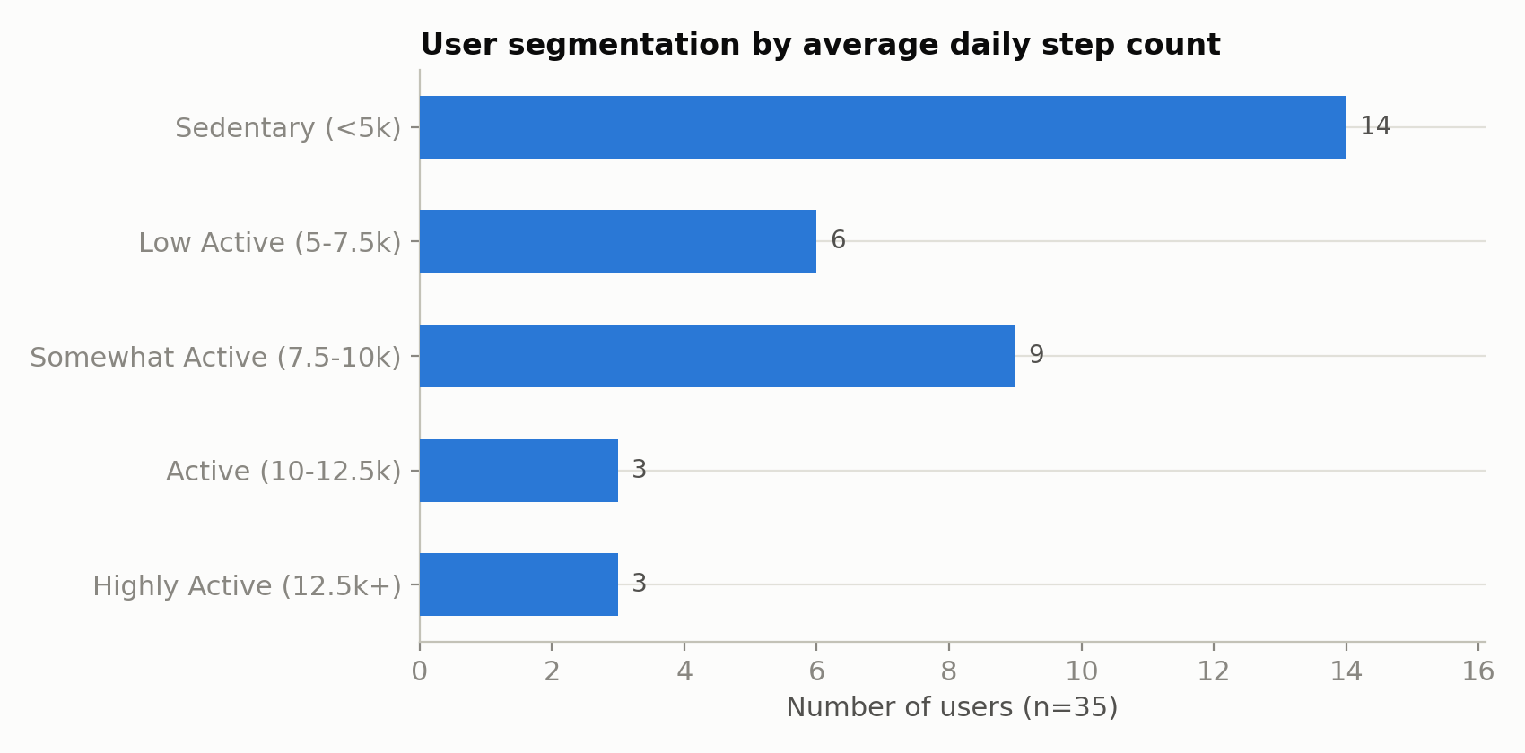
14 of 35 users are in the low-activity segment (<5,000 steps/day) — the largest single segment in the dataset.
Chart 2. Average activity (steps) across the day
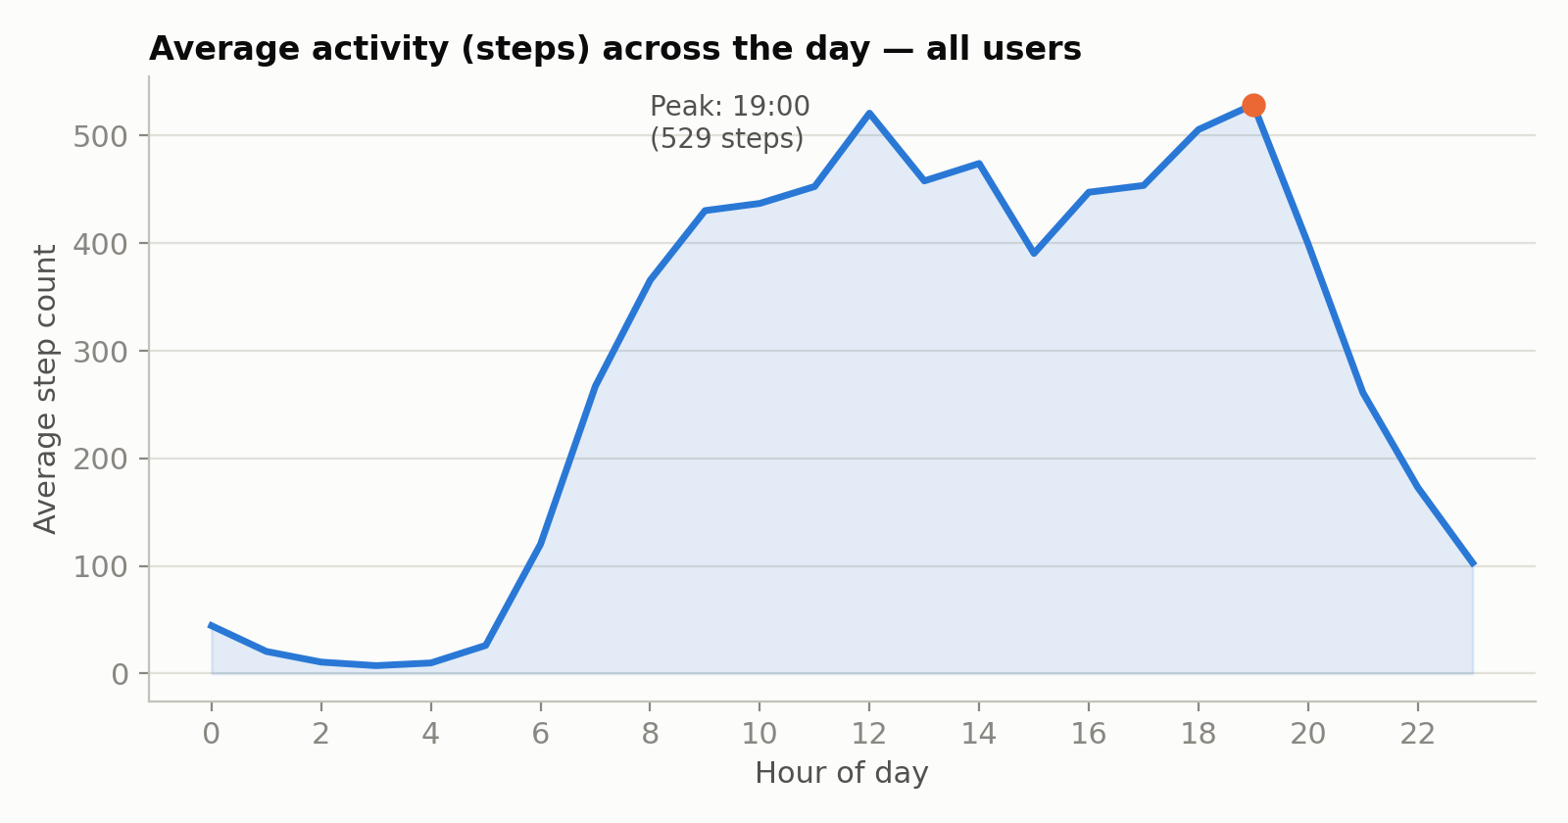
Activity is concentrated around lunchtime (~12:00) and in the evening, peaking at 19:00 (529 steps/hour on average).

Chart 3. Sedentary time vs. sleep duration
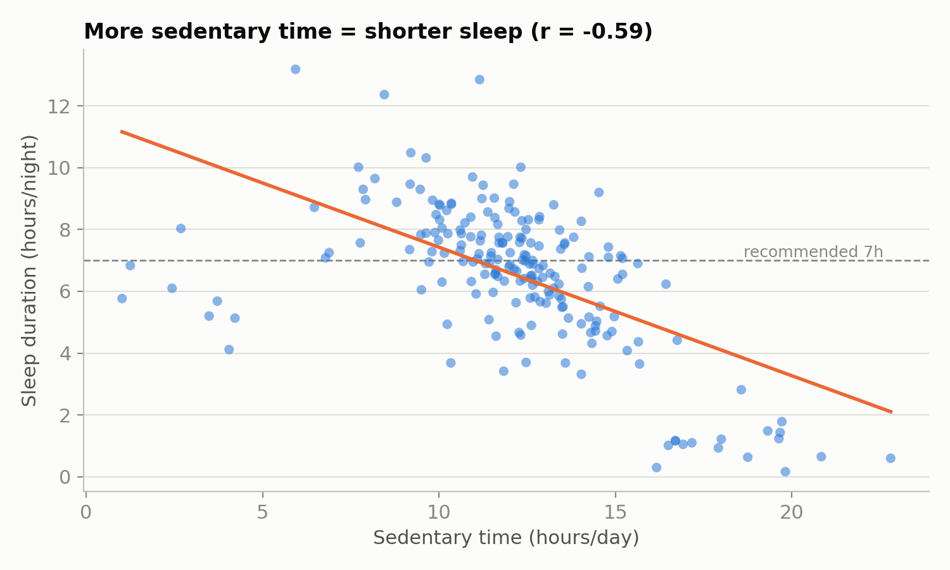
The more hours spent sitting, the shorter users' sleep tends to be (r = -0.59); the dashed line marks the recommended minimum of 7 hours of sleep.
Chart 4. Weekdays vs. weekend
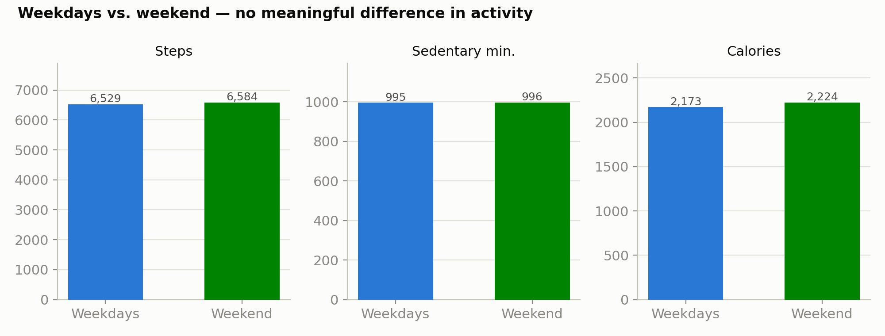
Steps, sedentary minutes, and calories are nearly identical on weekdays and weekends — differences under 3%.

Chart 5. Sleep-duration distribution
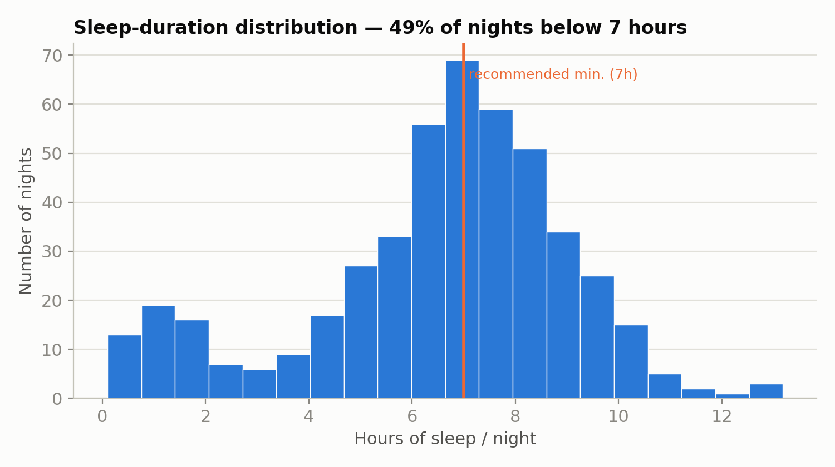
Nearly half (49.5%) of recorded nights involve less sleep than the recommended 7 hours.
Chart 6. Steps vs. calories burned
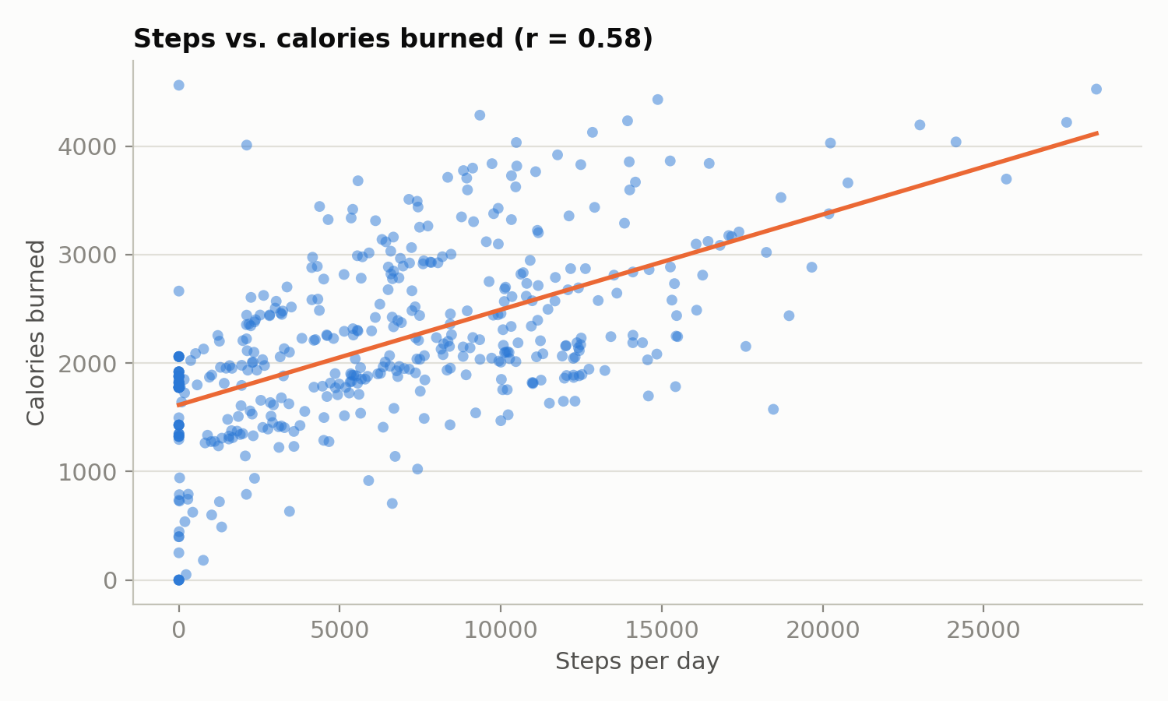
A positive correlation (r = 0.58) — more steps go along with higher calorie burn, though the relationship isn't perfectly linear, suggesting movement intensity plays a meaningful role too.

7. Act — Recommendations for Bellabeat Time
Among Bellabeat's products, the Bellabeat Time smartwatch was chosen as the target product for the recommendations below: it tracks activity, sleep, and stress in a way that most closely matches the scope of the analyzed Fitbit data, allowing the most direct translation of findings into concrete features and marketing messages.
Recommendation 1: Communication and reminders timed to natural activity windows
The data shows two clear windows where users are naturally more active: lunchtime (~12:00) and early evening (~19:00). Rather than competing with users' habits (e.g. sending notifications in the morning, when activity is lowest), Bellabeat Time and the app should reinforce the existing windows: personalized reminders like "time for a break walk" around 11:30–12:00 and "close your activity rings" around 18:00–19:00. Ad campaigns and social media content (Instagram, Facebook) can be scheduled around the same windows, when health-related audience engagement is naturally higher.
Recommendation 2: A "break the sitting streak, improve your sleep" feature and campaign
The strong relationship between sedentary time and shorter sleep (r = -0.59), along with the fact that nearly half of all nights fall below 7 hours of sleep, point to a concrete, measurable value proposition for Bellabeat Time: gentle reminders to break up long sitting periods (e.g. after 60 minutes of inactivity), framed as an investment in better sleep rather than just "more steps." This is a natural entry point for selling Bellabeat membership (personalized sleep and recovery guidance) and material for a content-marketing campaign ("Your day shapes your night") consistent with positioning the brand around holistic wellness rather than fitness alone.
Recommendation 3: Reward daily consistency instead of "weekend" campaigns
Since activity on weekdays and weekends is nearly identical, Bellabeat's marketing shouldn't over-index on messaging like "do something active this weekend." Instead, we recommend a streak-and-daily-consistency reward mechanic in the Bellabeat app — which also addresses the observed problem of low device-wear consistency (median 41% of days in the period). Short, personalized daily goals (e.g. "+1,000 steps more than yesterday") for the low-activity segment could build the habit more effectively than general goals like 10,000 steps, which are currently out of reach for that group.
Additional observation: segmenting communication by activity level
The user base isn't homogeneous — ranging from 40% low-activity users to 17% highly active ones (Chart 1). We recommend differentiating Bellabeat Time's marketing communication: messaging based on small, achievable steps and reducing sedentary time for the beginner segment; performance analytics, heart-rate trends, and athletic-goal features for the advanced segment.

7.1 Limitations and recommended next steps
- The dataset is from 2016 and drawn from a general (not exclusively female) Fitbit user population — we recommend validating these findings against Bellabeat's own, current telemetry data from Bellabeat Time devices once available at sufficient scale.
- The lack of demographic data (age, location, lifestyle) prevents precise marketing persona mapping — we recommend supplementing with survey or demographic data from Bellabeat's own users.
- The short observation period (32 days) doesn't allow for assessing seasonality (e.g. differences between summer and winter) — we recommend extending the analysis period to at least 6–12 months.
- We recommend an A/B test of push-notification timing (lunch window vs. evening window) on a real Bellabeat Time user base before fully rolling out Recommendation 1.

8. Sources and Appendices
The entire analytical process behind this report is fully reproducible from the Jupyter notebook attached to this document — every table, statistic, and chart traces back to a specific cell in it.
- Bellabeat_analysis.ipynb — the full pipeline: load, clean, join, analyze, chart.
Data source: FitBit Fitness Tracker Data, Kaggle (made available by Mobius), CC0: Public Domain license. https://www.kaggle.com/datasets/arashnic/fitbit
Source material for this case study: "Case Study 2: How Can a Wellness Technology Company Play It Smart?" (Google Data Analytics Certificate).

