|  |  |  |
| --- | --- | --- |
|  | Add-in Marketplace | |
|  | | |
| PTV’s add-in Marketplace | |  |
| Submit your Add-in Proposal | |  |
|  | |  |
|  | | |
|  | | |
|  | | |
| Karlsruhe, January 2014 | | |

Please fill in some basic information about your add-in and send the form to Traffic.Marketing@ptvgroup.com

1. Name of your add-in

MapFormers

1. Short description

Map Formers finds a Geographic Projection for your model. By matching the points from the google maps it projects your network coordinates into WGS84.

1. Description

This add-in allows you to geolocate your network in case it was created without any geographic reference. Result is WGS-84 geolocated network with appropriate georeference.

This add-in will ask You for reference nodes. The more nodes You will reference the better results you will get. For each of them You need to point it exact location on the map. The more precisely You will specify node locations the better results you will get.

This add-in will ask You for reference nodes. The more nodes You will reference the better results you will get. For each of them You need to point it exact location on the map. The more precisely You will specify node locations the better results you will get.

If node references are collected press Next button. You can choose one of three available options. First one is appropriate for networks where scale for x axis and scale for y axis are equal. This case is unlikely in most cases. But it provides the most straightforward solution. Second option is appropriate for most cases. By means of linear regression it chooses the most coherent subset from referenced nodes and adjusts the network. You can specify the confidence factor for references (default 0.8). Third option is appropriate for adjusting acitve part of network. It doesn’t adjust the scale, it only moves the network based on reference node, which number is to be specified with box on the right.

1. Compatibility with software

X PTV Visum

☐ PTV Vissim

☐ PTV Viswalk

1. Compatibility with software release

12, 12.5, 13

List the major releases with which your add-in is compatible. Example: 12.5, 13.

1. Language support

Click if applicable

x English

☐ Chinese

☐ French

☐ German

☐ Spanish

x Others: Polski

1. URL

www.intelligent-infrastructure.eu

1. Tagging

Optimization, Measuring, Count Locations, Detectors,

1. Visualisation

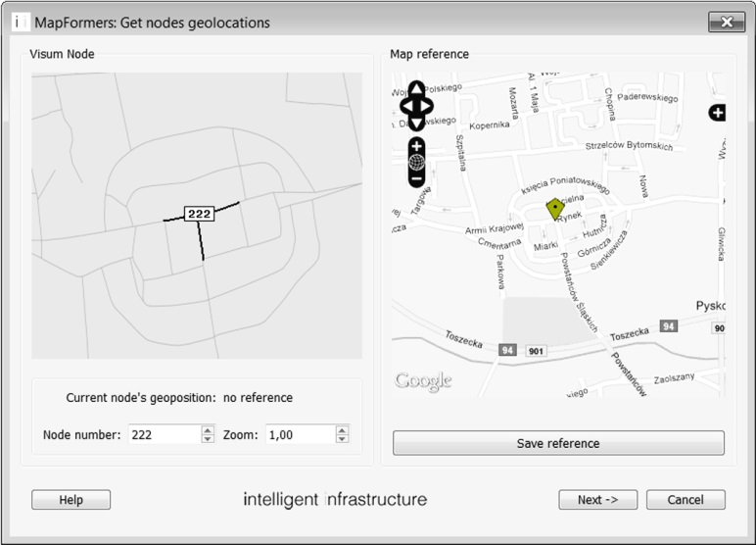



1. Price

1 000 €

Who's working on your add-in? Tell us about the author or company behind this add-in.

1. Name of the company

i2 Intelligent-Infrastructure

1. Primary author

Rafał Kucharski

1. Contributors

*Please enter the names of any other contributors to this extention

For invoicing your contact details are needed.

☐ Mrs x Mr

☐ Prof. ☐ Dr

First name: Rafał

Last name: Kucharski

Company: i2 Anna Skoczylas

Tax-ID: PL 677 236 16 69

PTV customer number: - (Politechnika Krakowska)

Street: al. Krasińskiego 4/5

Post code: 30-101

Town: Kraków

Country: Polska

Email: info@intelligent-infrastructure.eu

Phone: +48 501 694 896