|  |  |  |
| --- | --- | --- |
|  | Add-in Marketplace | |
|  | | |
| PTV’s add-in Marketplace | |  |
| Submit your Add-in Proposal | |  |
|  | |  |
|  | | |
|  | | |
|  | | |
| Karlsruhe, January 2014 | | |

Please fill in some basic information about your add-in and send the form to Traffic.Marketing@ptvgroup.com

1. Name of your add-in

ANPR Support

1. Short description

From raw input files to Visum OD and travel time matrices*.* This add-on processes number plate survey data for you.

1. Description

Number Plate survey (ANPR) is always a chance to improve your model. However it always comes along with data processing problems - thousands of records stored in number of files and all need to be processed to gather information. That's why we integrated data processing within VISUM. Now all standard steps between ANPR and OD

But not anymore: ANPR Support will support you with every step of ANPR data processing:

1. Flexible data importer will create SQL database from your records.
2. Powerful database engine will organize results
3. Full Visum integration will import counting points' locations
4. Filtering engine will show data you need (i.e. list of truck crossing two count locations during morning peak hour).
5. Data processing machine will calculate OD matrices with several error detection procedures.
6. You will be able to export travel time skim matrices, paths, OD matrices to Visum.
7. You will see your results on histograms and charts.

2. Summary

1. take advantage of integrating ANPR data and VISUM network model in one flexible Add-In
2. speed up your calculations with highly efficient database engine
3. work with user friendly GUI to simply see the data in tables, lists and plots or export ones to Visum and Excel.

ANPR created by i2 runs as a script from Visum 12. It uses data from Visum network and ANPR data to provide not only advanced queries to ANPR database but also calculation of the characteristics based on Visum network and Count Locations.

1. Compatibility with software

X PTV Visum

☐ PTV Vissim

☐ PTV Viswalk

1. Compatibility with software release

12, 12.5, 13

List the major releases with which your add-in is compatible. Example: 12.5, 13.

1. Language support

Click if applicable

x English

☐ Chinese

☐ French

☐ German

☐ Spanish

x Others: Polski

1. URL

www.intelligent-infrastructure.eu

1. Tagging

Optimization, Measuring, Count Locations, Detectors,

1. Visualisation

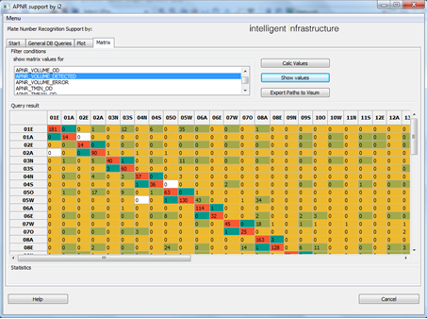

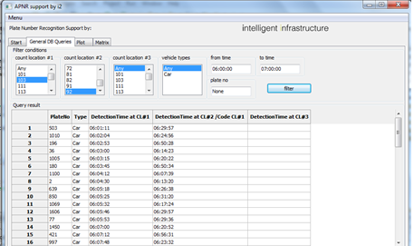

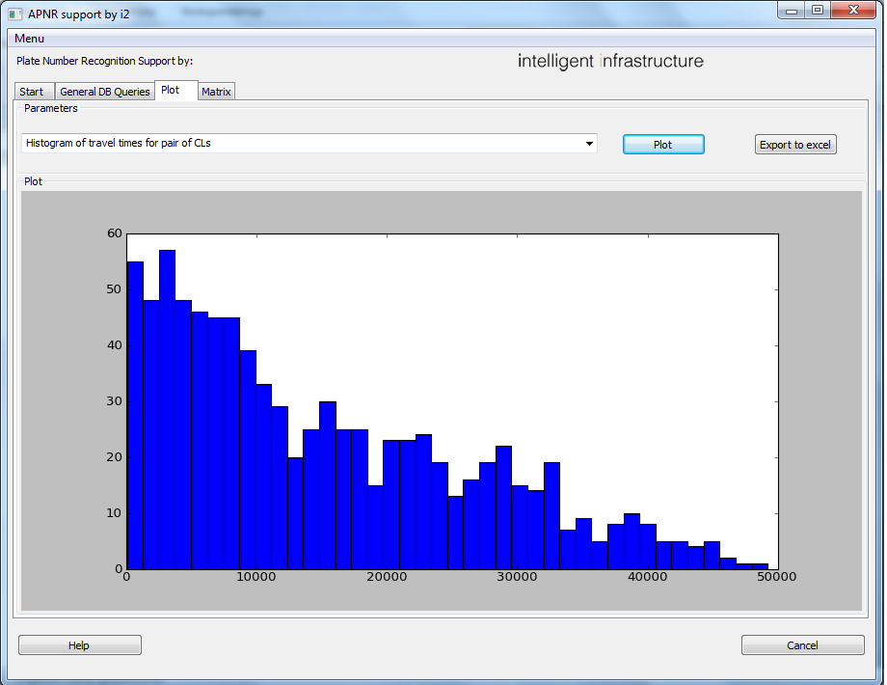



1. Price

2 000 €

Who's working on your add-in? Tell us about the author or company behind this add-in.

1. Name of the company

i2 Intelligent-Infrastructure

1. Primary author

Rafał Kucharski

1. Contributors

Dipl.-Ing. Timotheus Klein - ARGUS Hamburg

*Please enter the names of any other contributors to this extention

For invoicing your contact details are needed.

☐ Mrs x Mr

☐ Prof. ☐ Dr

First name: Rafał

Last name: Kucharski

Company: i2 Anna Skoczylas

Tax-ID: PL 677 236 16 69

PTV customer number: - (Politechnika Krakowska)

Street: al. Krasińskiego 4/5

Post code: 30-101

Town: Kraków

Country: Polska

Email: info@intelligent-infrastructure.eu

Phone: +48 501 694 896