Networking method implemented: Online Leaderboards

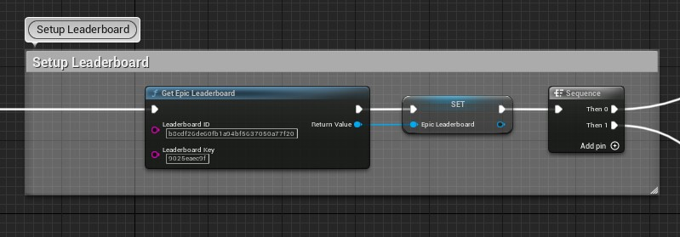

Using Leaderboards plugin UE5 gains access to additional nodes, such as getting leaderboard from online host based on ID and Key. Me showing the ID and Key on this screenshot does mean that my leaderboard can be stolen or edited using other UE5 projects.

After leaderboard has been accessed by the node, the widget used to display the leaderboard places correct variables into correct rows on a data table, then displays it to the player.

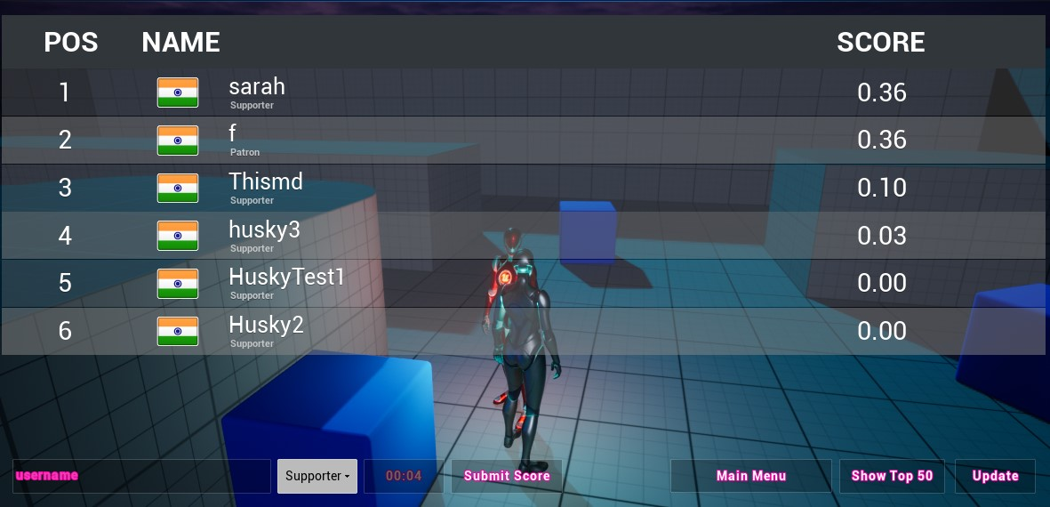

Position and sorting is handled on the online host, using plugin’s code. The username is chosen by the player themselves, which is currently not checked or validated, meaning that the player can write literally whatever they want even repeat the same name that was already on the leaderboard. Repeating the same username actually overwrites the existing score instead of creating copy or duplicate with the same name meaning that the player can remove someone else’s top position by simply retyping their name when submitting score. This is something that would need to be solved in the widget that gets the leaderboard, before submitting the score the name should be checked for rules or checked if it is repeating itself. Essentially on the client side is the best place for the solution.

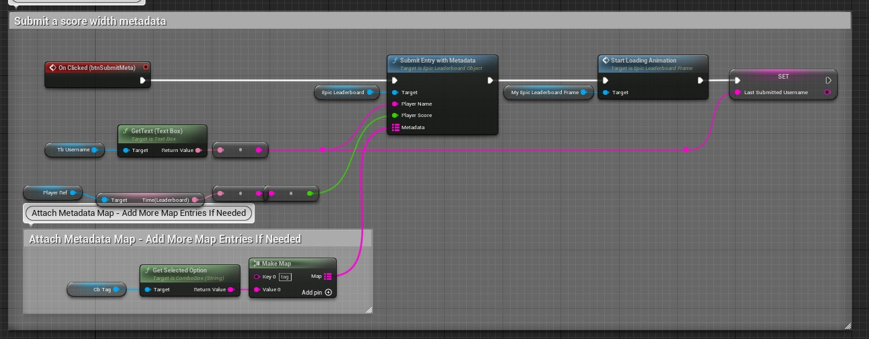

This is how it is submitted. It takes inputted player name with no restrictions, then time elapsed that was calculated in player blueprint as the game went on, which also stopped counting when the player has died. The additional metadata attached is a tag that player can select, again with no restrictions. The tag shows is the player is supporter, legend, patron or anything from the list provided. The online host also takes player’s IP address to determent their country and add a flag next to their name. This however, can be very easily manipulated with any VPN.

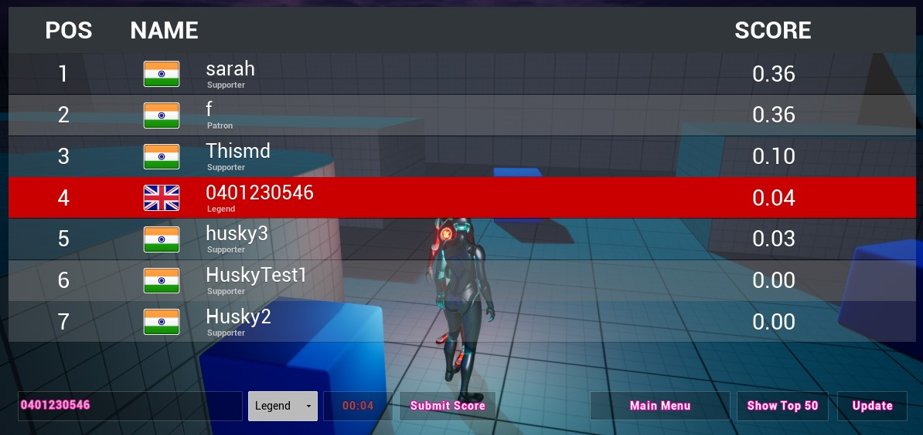

The India scores where me using VPN at a different house while the only UK score is me in house back in Cornwall without a VPN.

The online host allows to see the date of submitted score, the time, the score itself, the country, the position and username. As owner of the leaderboard I can remove specific score/user from the leaderboard. The host is an free online website.

Feedback

I actually missed the peer review session due to travelling.

But I did get feedback from 2 other programmers that compared their work to mine, they pointed out the obviously problems with username and some possible UI design flaws and inconsistencies.

However the most important feedback was the suggestions on how and where to create the function that would make sure username works properly as intended, it was suggested to me to create the function on client’s side not on the host. This would allow the username to be validated or accepted before submission. This way of doing it has a flaw, where the function is much easier to being cheated or manipulated by players, as if the host would check the validity of username it would only use information that is received and would be hard to manipulate with 3rd party tools, glitches and bugs or internet connection.

The requirements of possible validation function include but are not limited to checking length of the username, checking if username was already used, then deciding if there should be a copy created or should the score submission be rejected if player doesn’t change username, checking for potentially unwanted symbols or characters like ż ź or п ц which can be done by only allowing specific formatting of text, checking for certain words like curses or discriminatory phrases etc.