ECPI University Rafat Khandaker

CIS_126 08/26/18

**Unit 5 Final Exam part 2 Outputs**

**Program #1**

***Output:***

*Using string formatting and assigning value by calculation, I am able to display value into a tabular format*

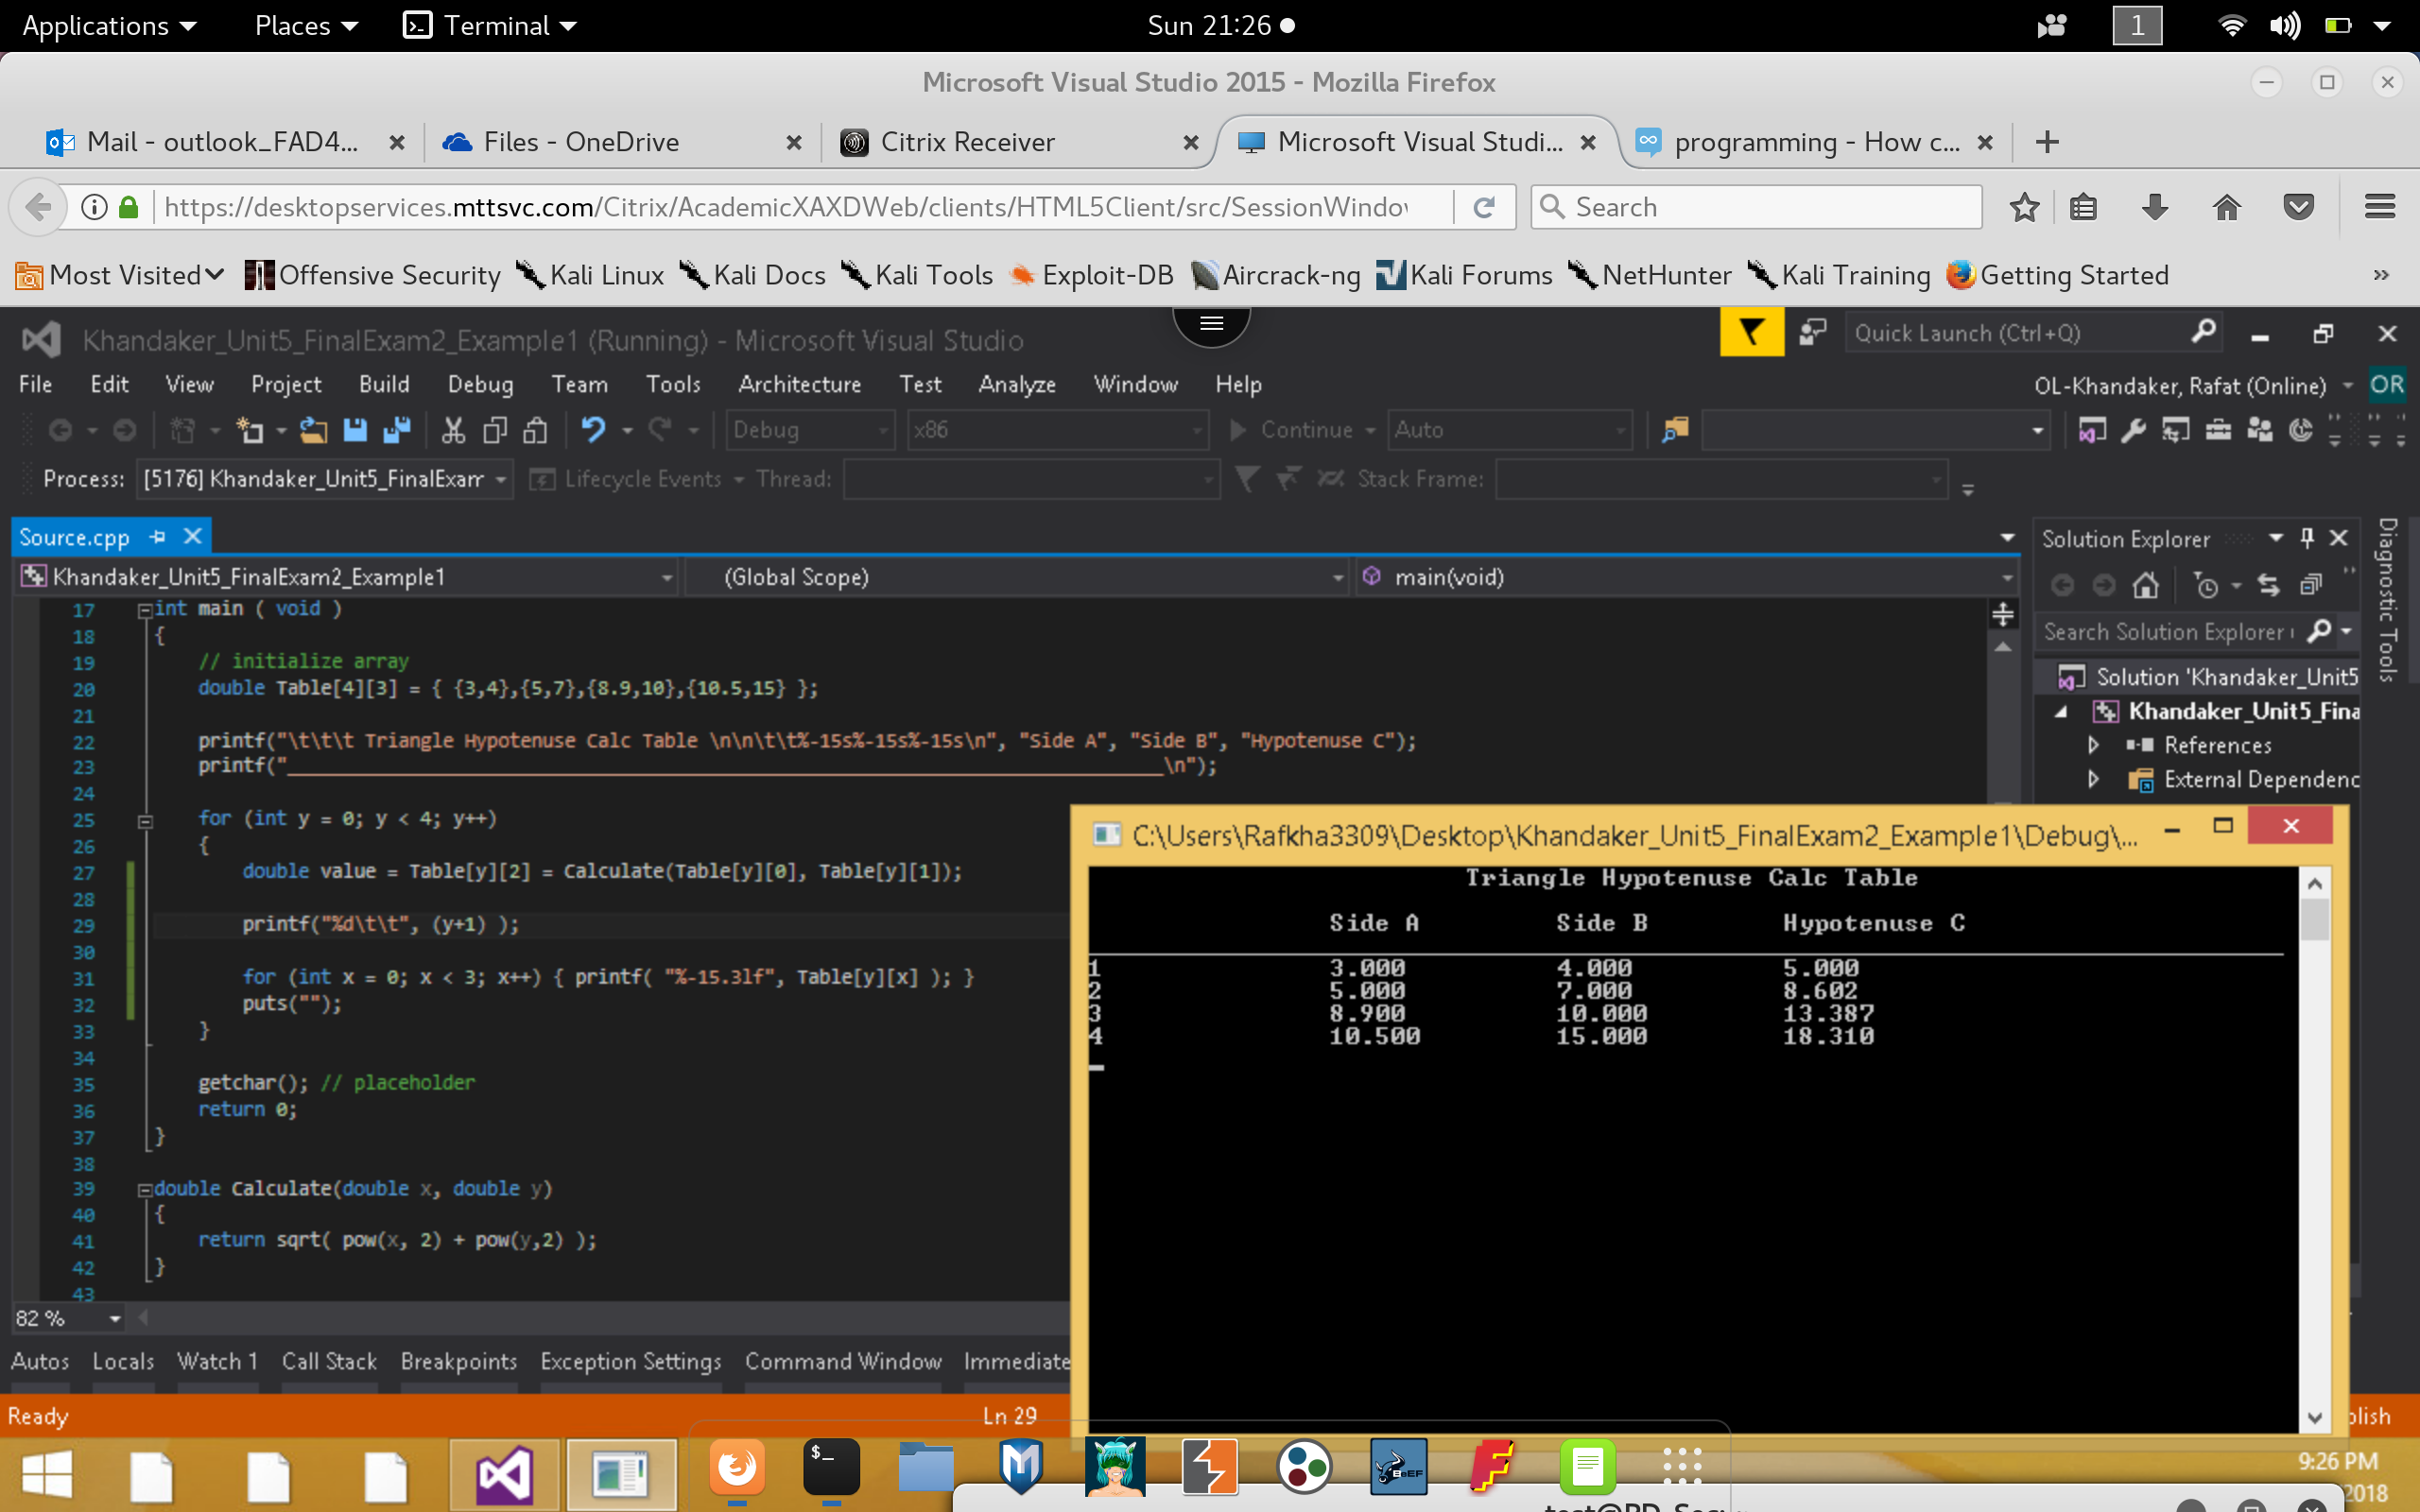

**Program #2**

***Output:***

*By importing the <string.h> library, I can use string comparison and compute the length of a string.*

