ECPI University Rafat Khandaker

CIS_126 08/25/18

**Unit 5 Graded Assignment**

Step 1

1. Open your Visual Studio 2015 XenDesktop image, create a new project, and type the coding segments down below into the source file. Run the program(s) (Debug > Start without debugging). If you are asked to re-build, select yes to ensure that you are compiling the latest typed code. If you are asked to run your last successful build, check the box not to ask you again, and select No. Make sure that your output details box is open so that you can see where any errors may have occurred. See screen shot below:

**Incorrect:**

*In here, this example, fails to successfully terminate the comment with a ‘*/’ & we also fail to return an int value for the main method.*

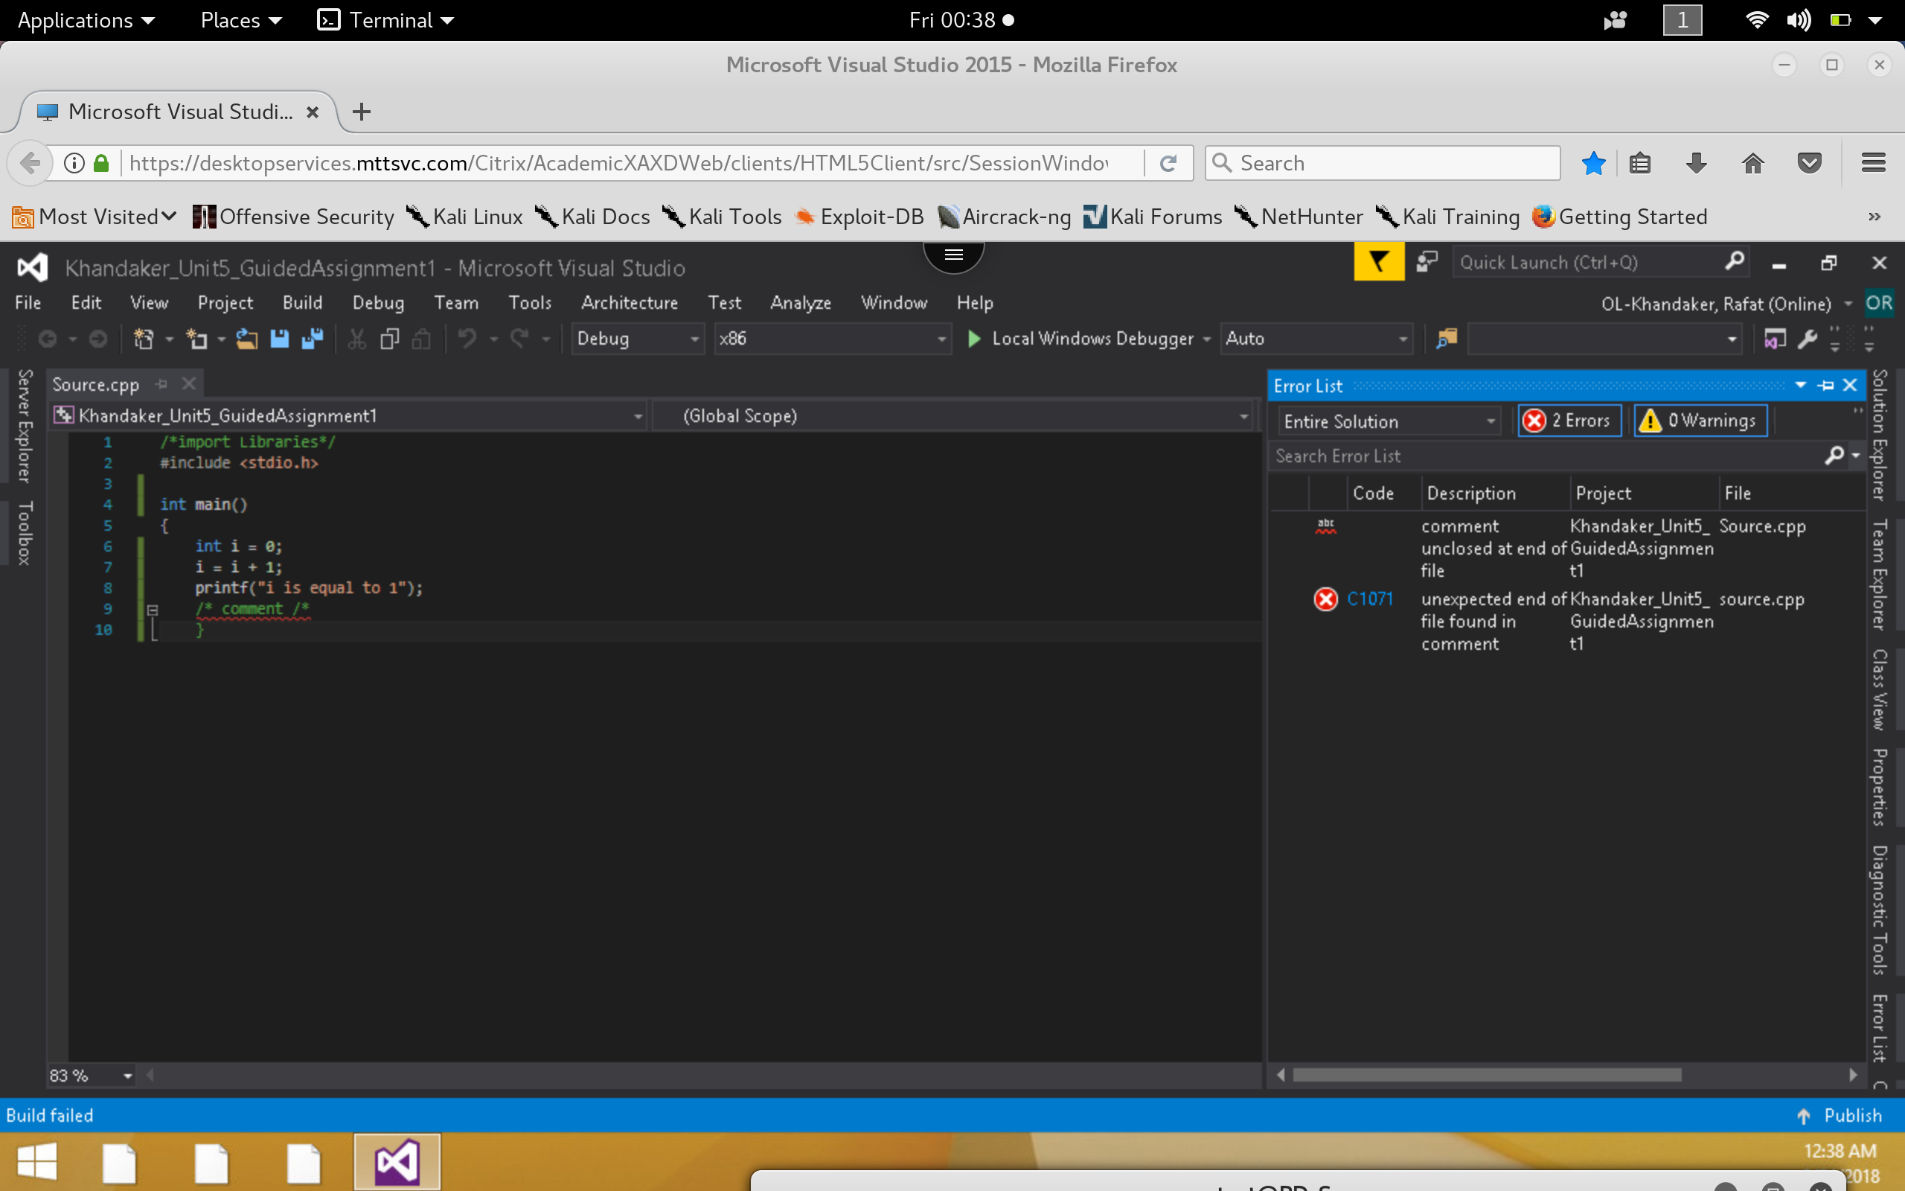

**Correct:**

*After successfully terminating the comment & returning a 0 value, we successfully display the output for our code.*

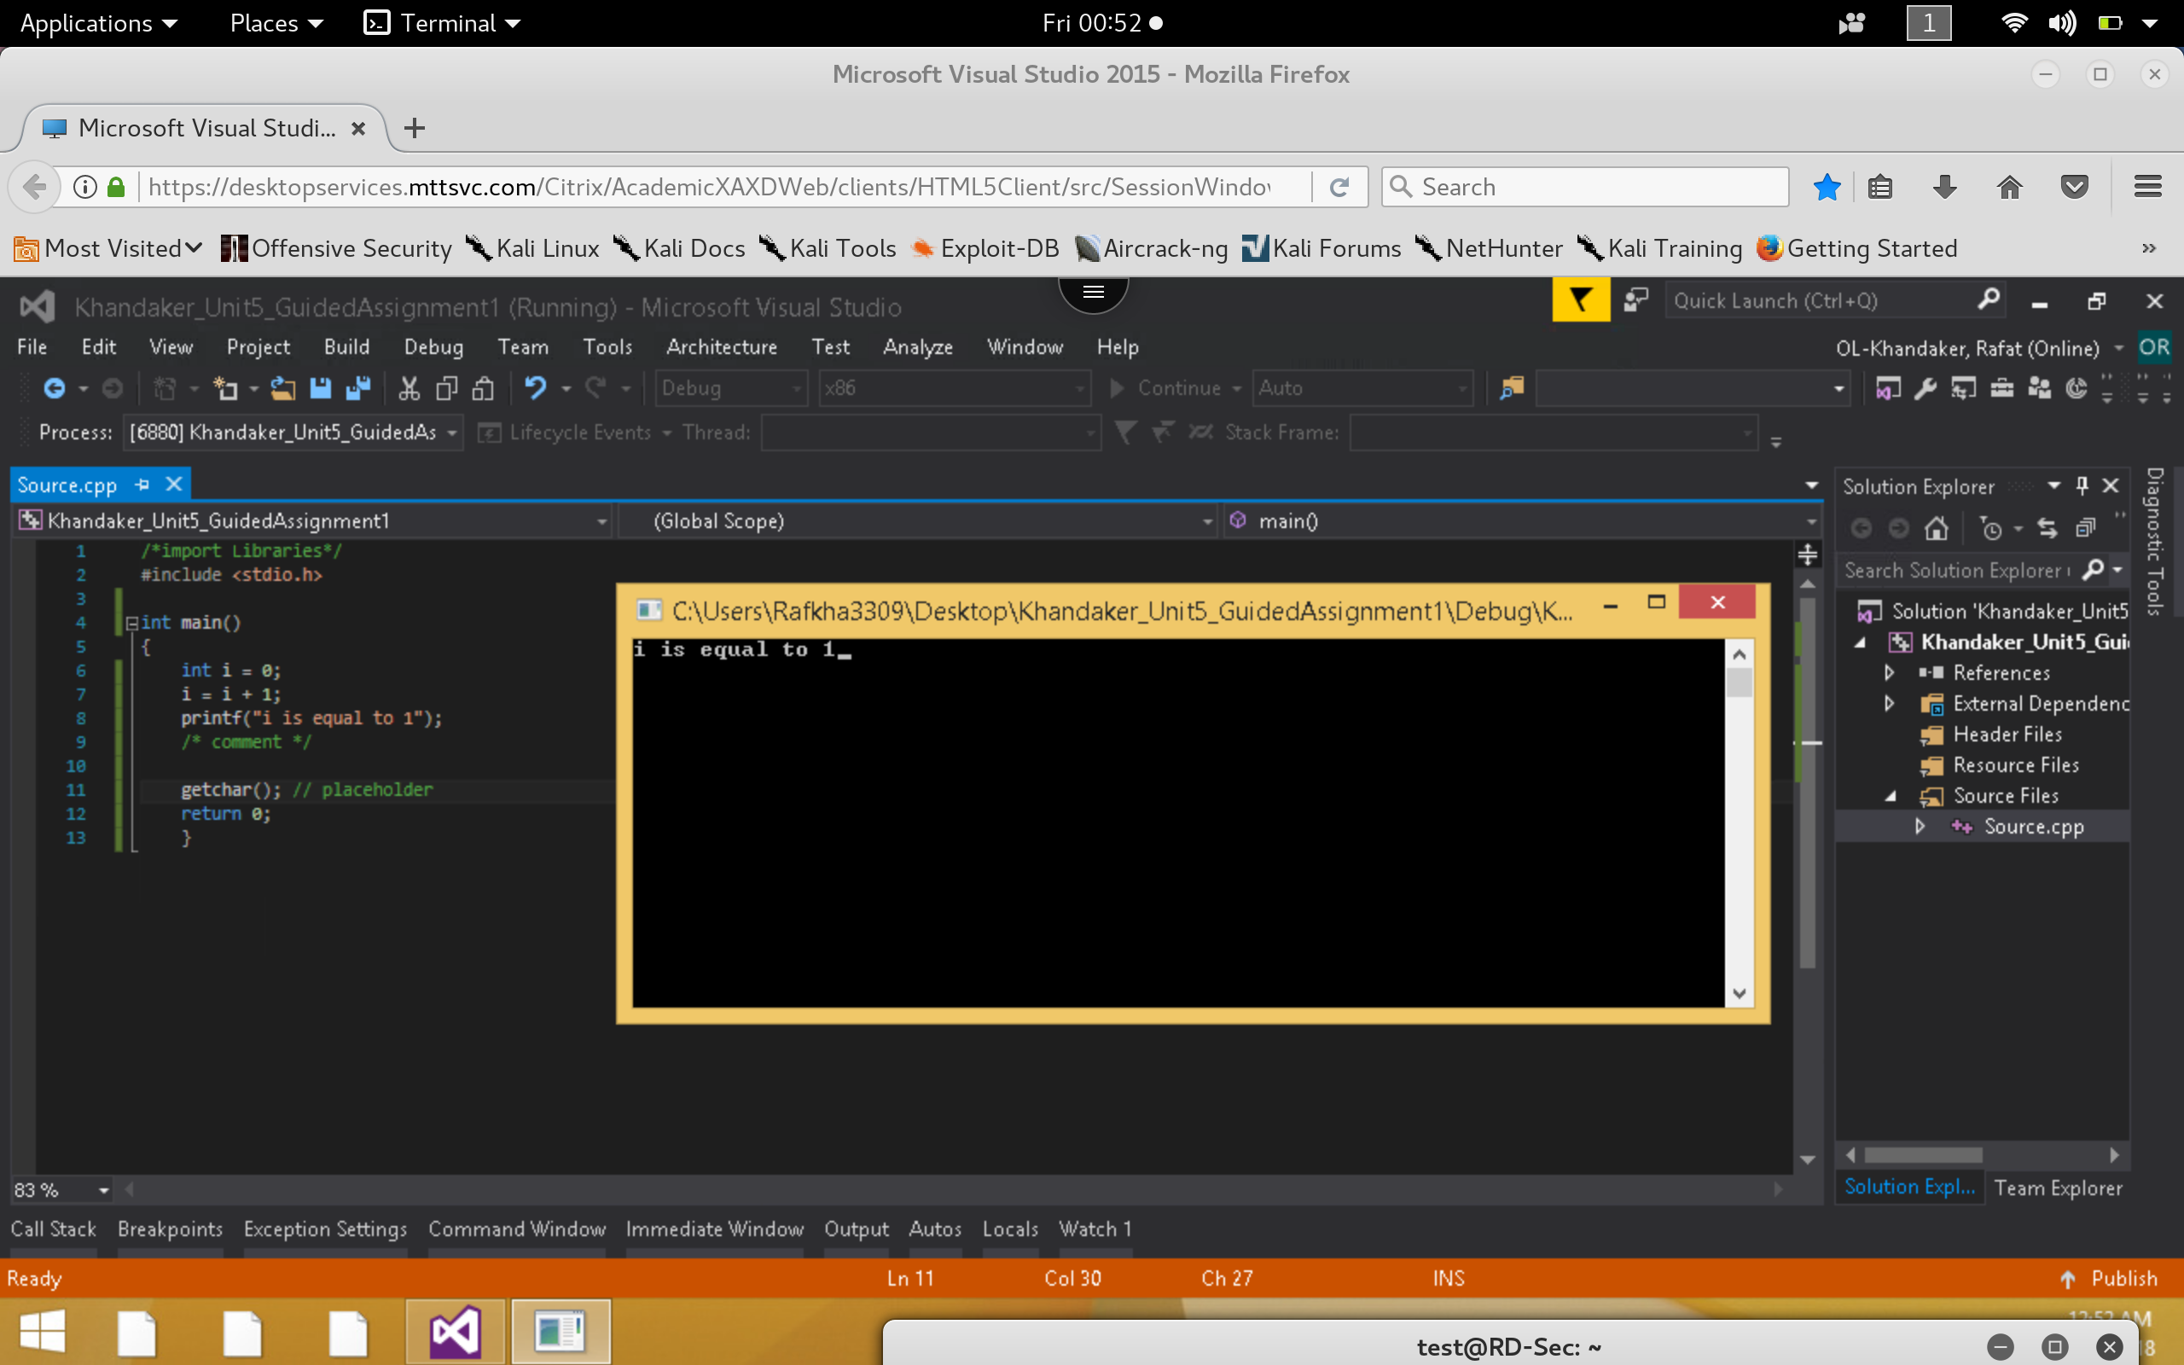

**Step 2**

1. Execute the following coding segment and identify the errors in the program. Debug the program and provide the correct version of the code. Note: The errors can be syntactical or logical.

**Incorrect:**

*Output of compiler indicates that we have failed to insert a break ‘;’ in the line. This is because structures are initialized like variables and they must terminate with a semi-colon ‘;’ .*

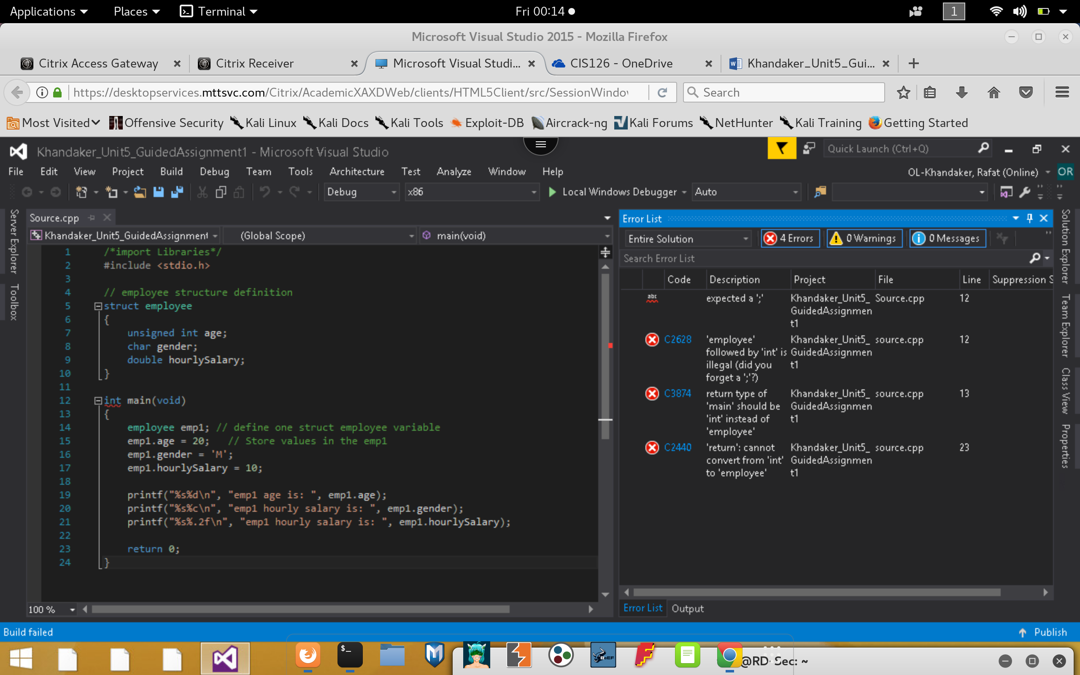

1. Execute the following coding segment and identify the errors in the program. Debug the program and provide the correct version of the code. Note: The errors can be syntactical or logical.

**Correct:**

*Inserting the break semi-colon ‘;’ fix the compile time error & allows us to execute the code.*

