**ECPI University**

**Lab 3**

**“XenDesktop”**

**CIS 142**

**Rafat Khandaker**

**10/21/18**

**Introduction**

In this lab we will use Xendesktop to analyze how Citrix function as a platform cloud solution to host virtual applications or desktops through a web browser. In this lab we are to log into Xendesktop, using our ECPI credentials then access Microsoft Office Word through a single instance application environment. Xendesktop is a virtualized environment, their goal is to provide a multi-platform software solution that is universally available to access in any operating environment: (mobile, desktop, mac, windows, Linux, android or web) **(Parallel, 2018)**. The advantage Citrix Xendesktop supplies to its users are compatibility between multiple devices and manageability.

**Technology Details**

To get into more detail of the Citrix application, according to an article written in Parallels, Citrix uses Virtualization centralized server technology that deploys applications into a central server and allows other devices to remote access into the application or remote operating system. In this case scenario, Citrix is used as a platform virtualized service that host a software available for remote access from a centralized server. This functionality is known as RAS (Remote Access Service) **(Parallel, 2018)**. Remote Access Service provides application streaming in an isolated instance, leveraging session virtualization & VDI deployment **(Parallel, 2018).** Citrix offers security advantage for hosting isolated, legacy applications, in a safe environment; whereas otherwise would pose a threat to security in a self-contained environment. Many companies that relies on legacy applications that are no longer supported in new devices are able to remote in through a Citrix receiver to access resources through a secured instance.

Other instances of Citrix product allowing users to access a virtual desktop through the Citrix receiver application or web hosted through the browser. This is a very useful product in terms of flexibility and sometimes is used as a default means for remote access, other than direct VPN solution. Centralized access to virtualized session also allows users to rely on a centralized storage and is essentially became a pre-cursor to platform or infrastructure cloud solution.

**Conclusion**

In summary, Citrix allows users to authenticate into a virtualized remote access service that is hosted on a centralized server. Citrix is a multi-platform solution that is available for access in many devices, their goal is to be able to support & manage an application from other devices such as (mac, windows, linux, mobile or web browser). They offer compatibility between devices and manageability of the service by hosting application into an isolated environment. Companies find good cost savings and secure solution, managing and deploying legacy applications. Sometimes it is a good alternative to host a centralized desktop for remote access as an alternative to VPN access.

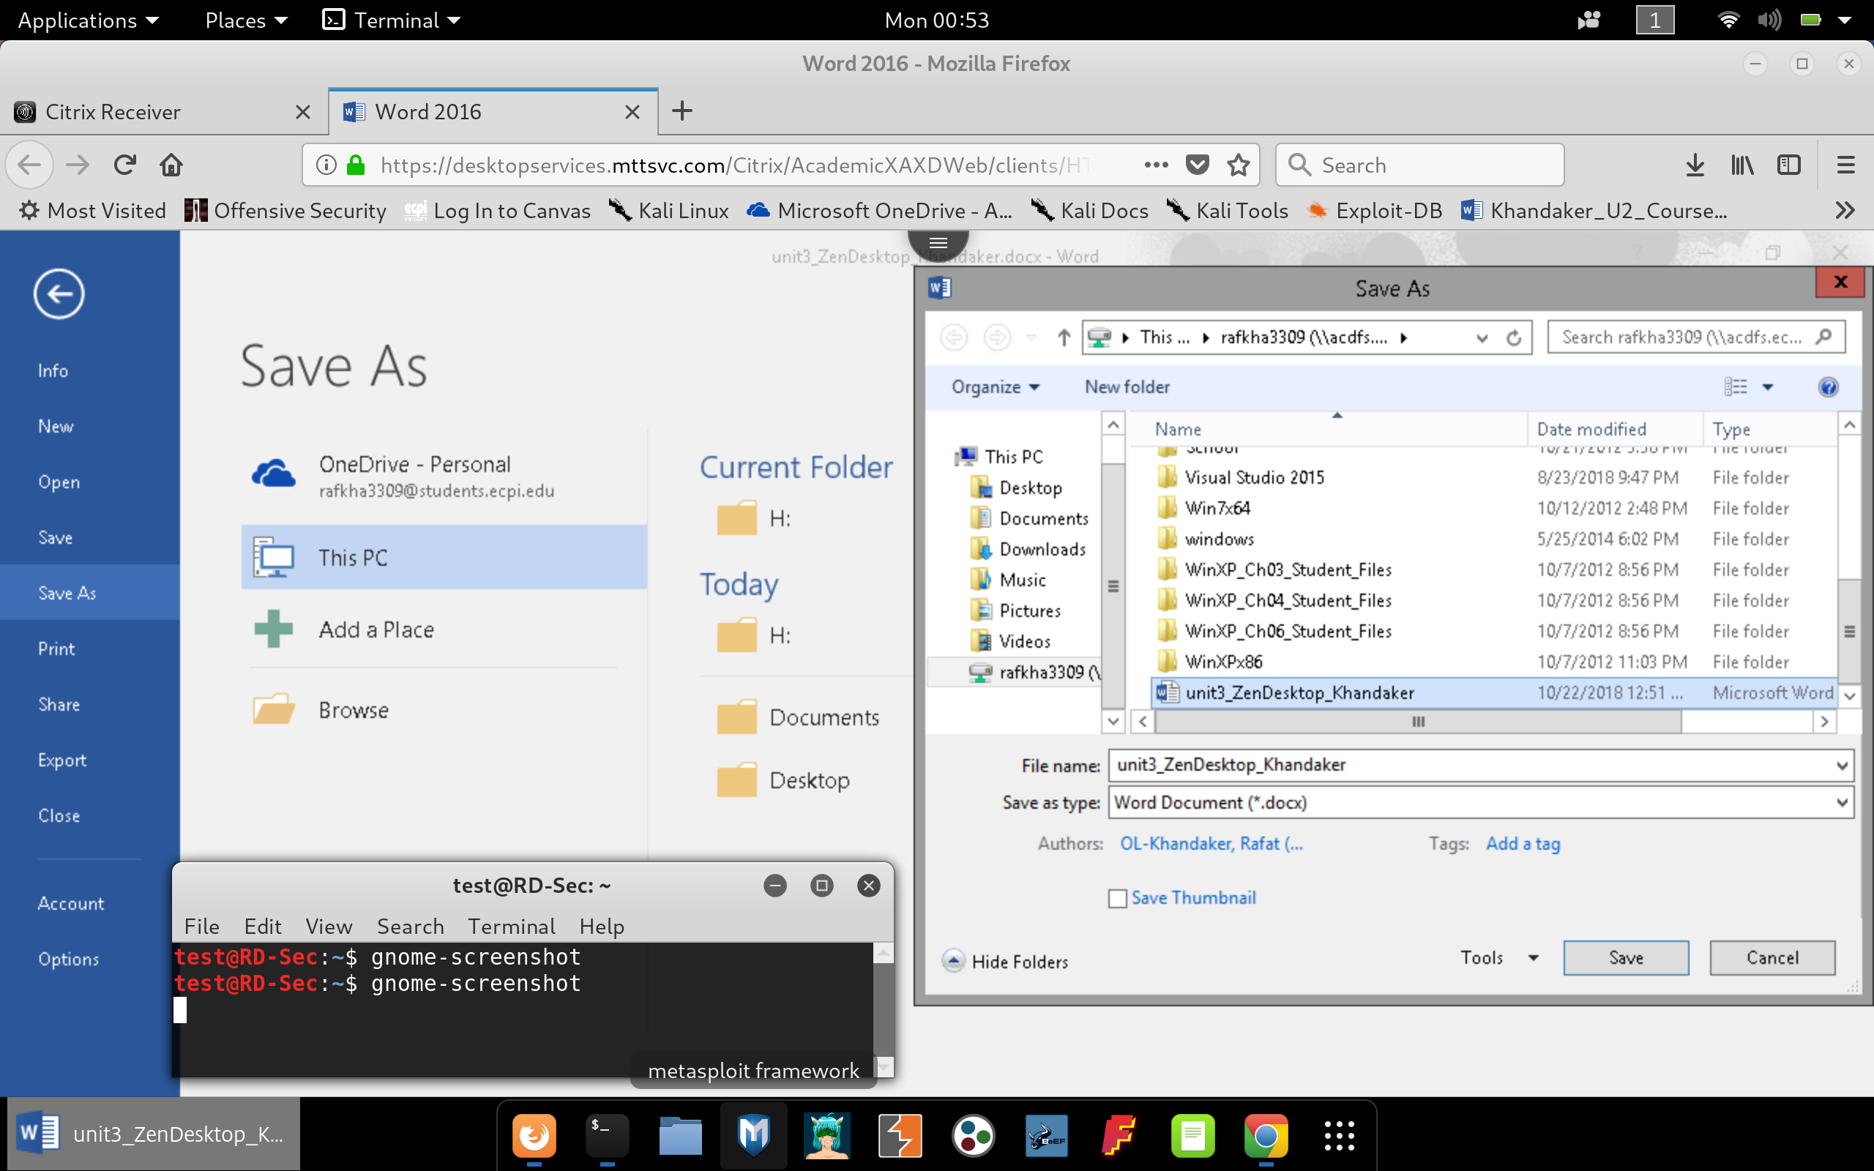

**References**

**(1)** Jamsa, K. (2013). *Cloud Computing: SaaS, PaaS, IaaS, Virtualization, Business Models, Mobile, Security, and More*. Burlington, MA.: Jones & Bartlett Learning.

**(2)** *How does Citrix Work*. (2018). Parallel. Retrieved From: <https://www.parallels.com/products/ras/how-does-citrix-work/>