**ECPI University**

**CIS_202L**

**By: Rafat Khandaker**

**Lab 3**

**Instructor:**

**Albert Ostering**

**11/26/18**

**LAB 1: (Pings from PC A into PC-C & Lo0)**

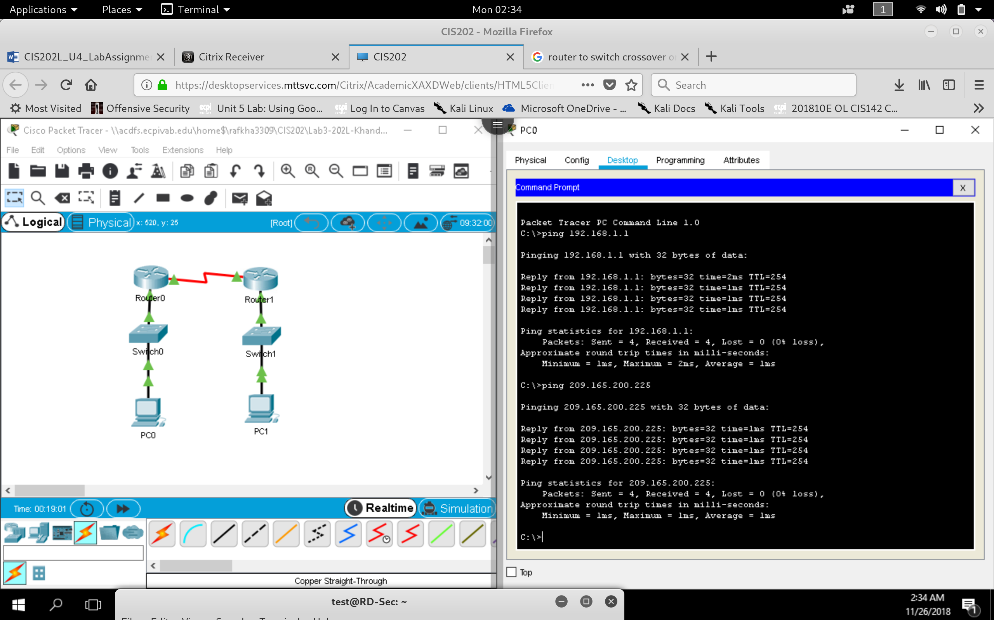

**a.** Test connectivity by pinging from each PC to the default gateway that has been configured for that host.

From PC-A, is it possible to ping the default gateway? **YES**

From PC-C, is it possible to ping the default gateway? **YES**

**b.** Test connectivity by pinging between the directly connected routers.

From R1, is it possible to ping the S0/0/0 interface of R3? **YES**

***\*\*If the answer is no to any of these questions, troubleshoot the configurations and correct the error\*\****

**c.** Test connectivity between devices that are not directly connected.

From PC-A, is it possible to ping PC-C? **YES**

From PC-A, is it possible to ping Lo0? **YES**

From PC-A, is it possible to ping Lo1? **YES**

Were these pings successful? Why or why not?

**The pings are successful because the default route for router 1 is router 2 & vice versa. When a packet with a destination address is unknown to router 1, it will be forwarded to router 2. Lo0, Lo1 & PC –C is contained in Router 2 LAN network, so router 2 will be able to identify the destination address on its local area network.**

**Show IP Int Brief**

**Router 1**

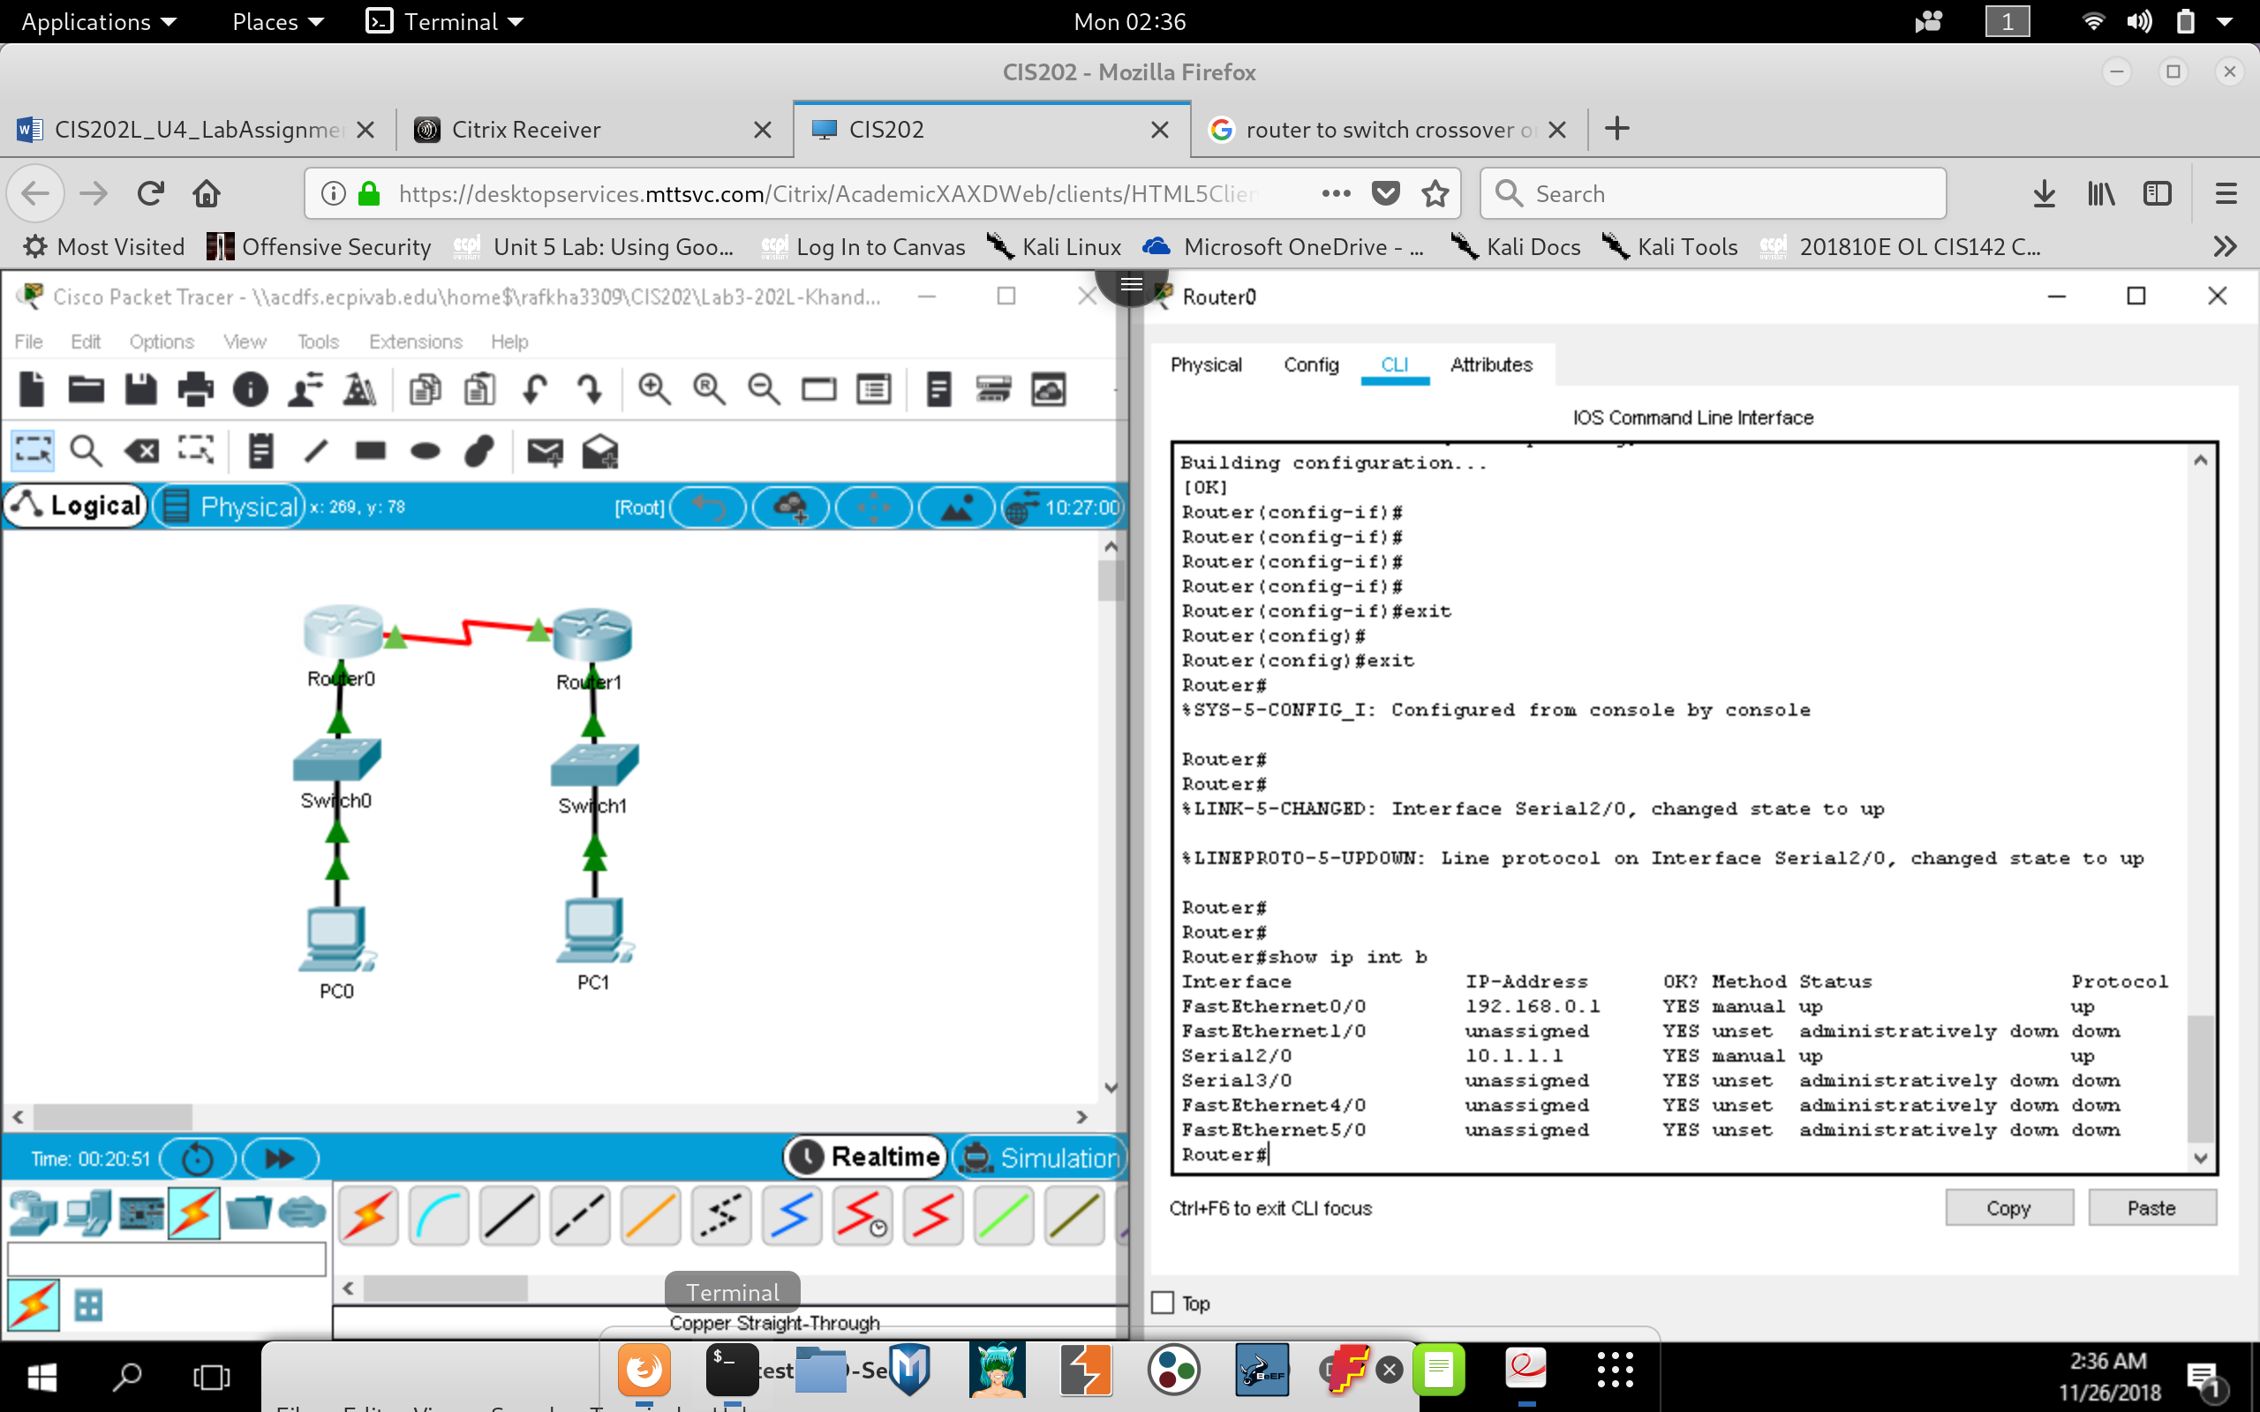

**Router 3**

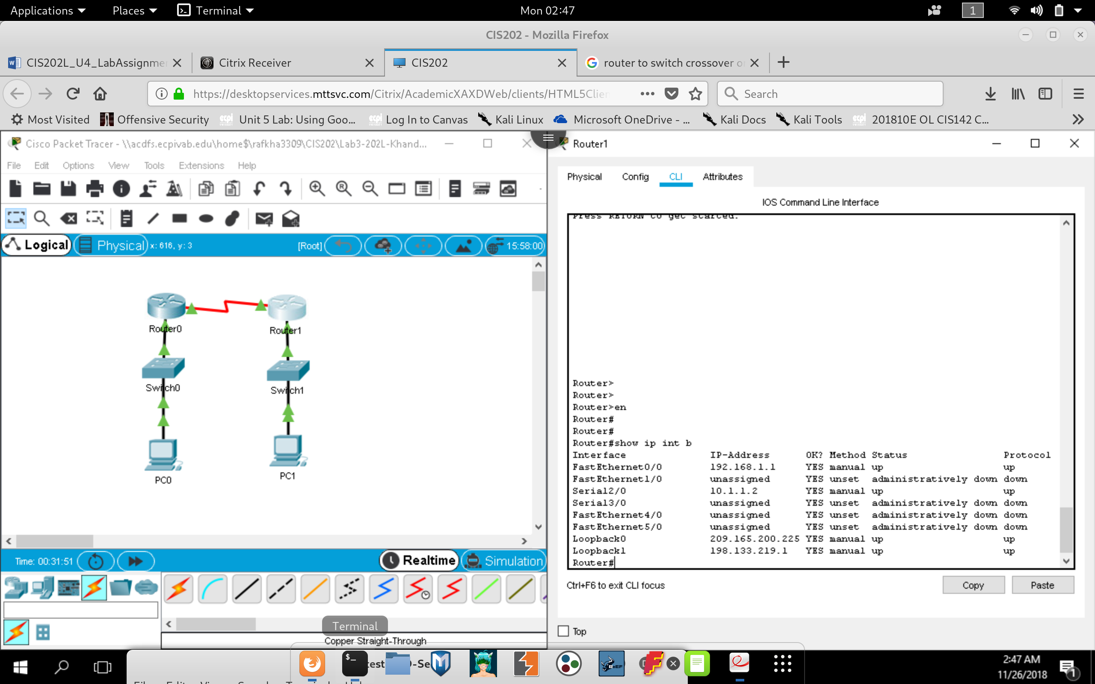

**a.** Check the status of the interfaces on R1 with the show IP interface brief command.

How many interfaces are activated on R1? **2 Interfaces**

**b.** Check the status of the interfaces on R3.

How many interfaces are activated on R3? **4 Interfaces**

**c.** View the routing table information for R1 using the show IP route command.

**Show IP Route on R1**

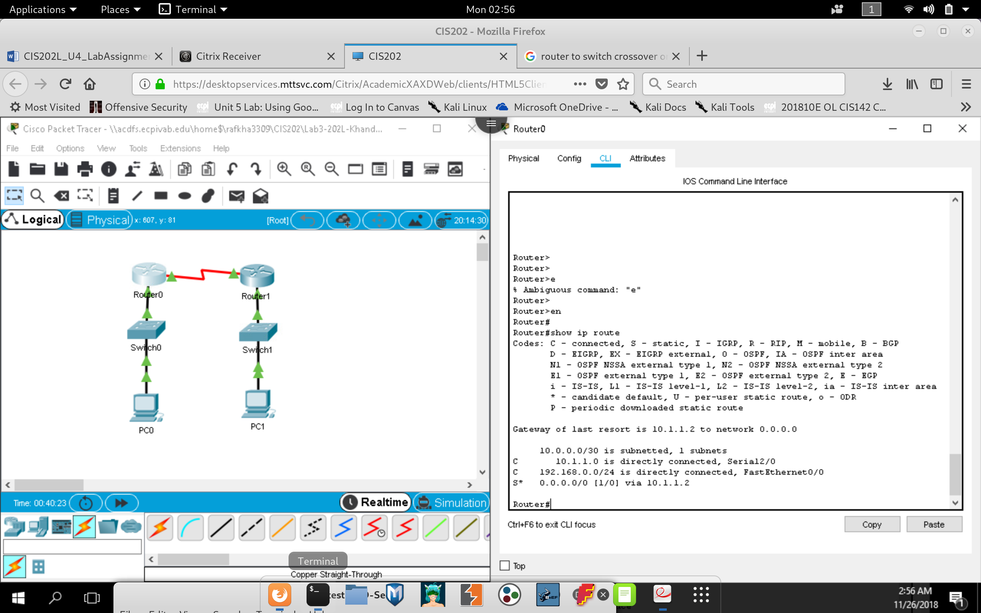

What networks are present in the Addressing Table of this lab, but not in the routing table for R1?

* + - **Router 1 Only contain routes from Its Internal** **LAN & The Directly Connected Router 3 IP Address. It does not contain, The network for Lo0, Lo1 & Network for PC-C.**

**d.** View the routing table information for R3.

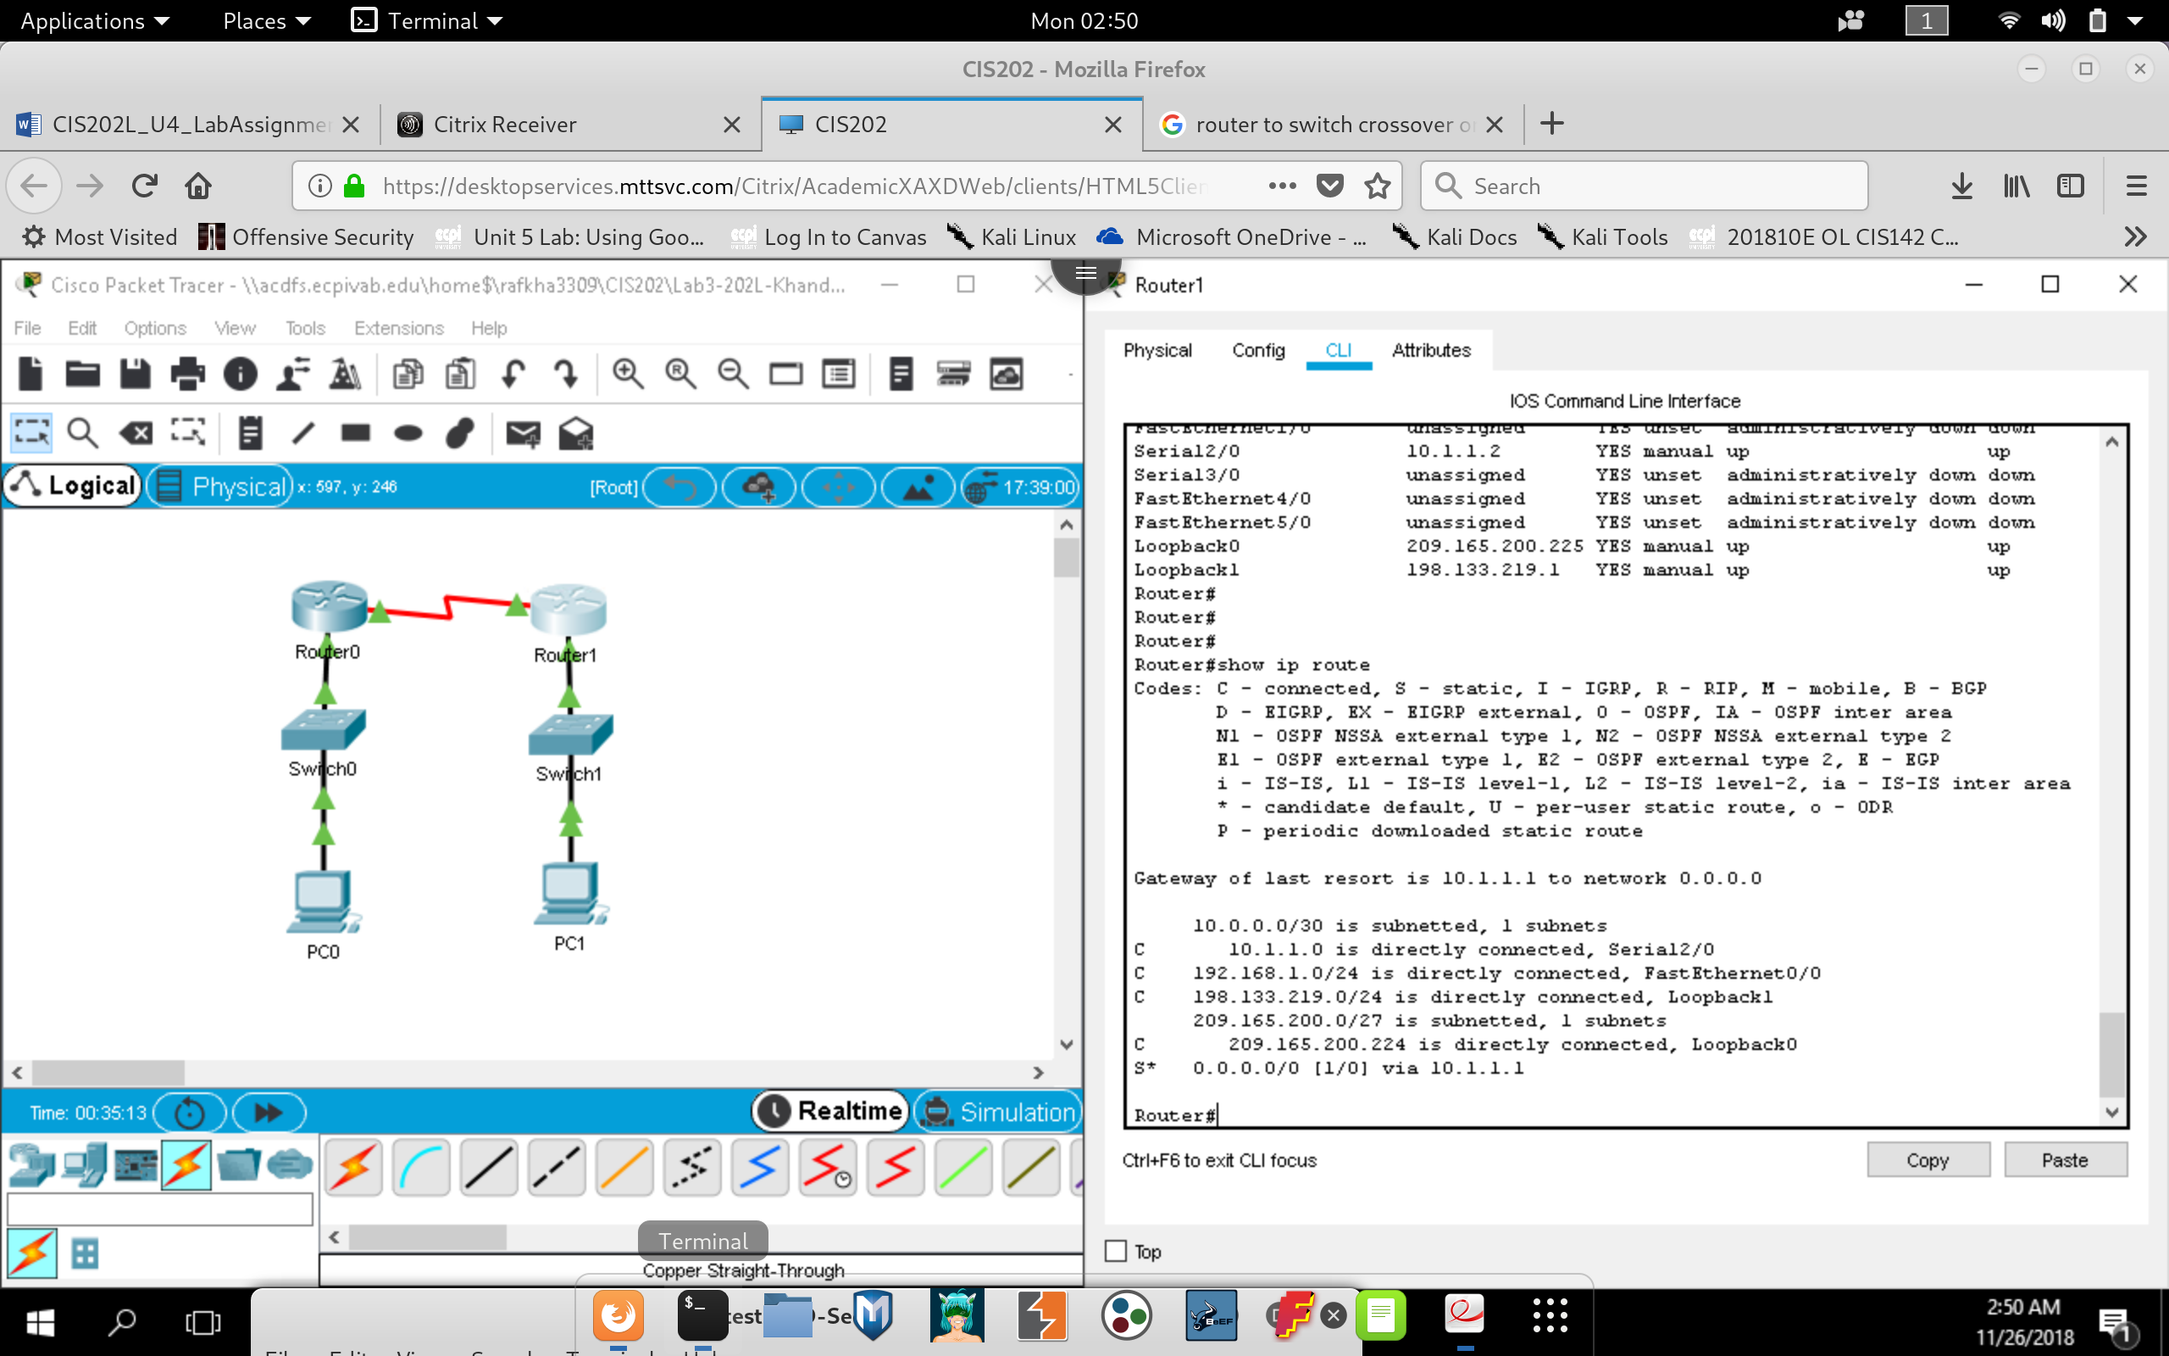

What networks are present in the Addressing Table in this lab, but not in the routing table for R3?

* + - **Router 3 contain all the Lo0, Lo1, Internal Lan and directly connected route through its Serial link. It does not contain the route table for PC-A Network:**

**( 192.168.0.0/24 )**

Why are all the networks not in the routing tables for each of the routers?

* + **There was no static route or routing protocol used in the configuration for the routing table. Instead a default route was set to each router, this will forward all packets outside the routing table to the adjacent router.**

**a.** On the R1 router, configure a static route to the 192.168.1.0 network using the IP address of the Serial

0/0/0 interface of R3 as the next-hop address. Write the command you used in the space provided.

* + - **IP Route 192.168.x.x 255.255.255.0 10.1.1.x (on each router)**

**b.** View the routing table to verify the new static route entry.

How is this new route listed in the routing table?

* + **When configured these routes will show up as static configured: ‘S’ code.**

From host PC-A, is it possible to ping the host PC-C?

* + **Yes, Previously I configured with a default route, which allowed devices to ping each other. Static route should allow devices to ping each other. In this case it is best to create a static single route with no default route, because default routing into an unknown network by both routers will create congestion within the serial link.**

**a.** On the R3 router, configure a static route to the 192.168.0.0 network using S0/0/0 as the exit interface.

Write the command you used in the space provided.

* + **Ip route 192.168.x.x 255.255.255.0 Serial2/0**

**(in this case I used S2/0 on both routers)**

**b**. View the routing table to verify the new static route entry.

How is this new route listed in the routing table?

* + **The new routes are listed as a Static route, by ‘S’ code via serial link.**

**c.** From host PC-A, is it possible to ping the host PC-C?

* + **YES**

**Step 3: (Configure a static route)**

**a**. On the R1 router, configure a static route to the 198.133.219.0 network using one of the static routes:

configuration options from the previous steps. Write the command you used in the space provided.

* + **ip route 192.133.219.0 255.255.255.0 Serial2/0**

**b.** On the R1 router, configure a static route to the 209.165.200.224 network on R3 using the other static

route configuration option from the previous steps. Write the command you used in the space provided.

* + **ip route 209.165.200.224 255.255.255.224 Serial2/0**

**c.** View the routing table to verify the new static route entry.

How is this new route listed in the routing table?

* + **The new routes are listed as a Static route, denoted by ‘S’ code.**

**d.** From host PC-A, is it possible to ping the R1 address 198.133.219.1?

This ping should be successful.

* + **Yes, it should.**

**On R1, use the no command to remove the static routes for the two loopback addresses from the routing**

table. Write the commands you used in the space provided.

* **no ip route 192.133.219.0 255.255.255.0 Serial2/0**
* **no ip route 209.165.200.224 255.255.255.224 Serial2/0**
* **no ip route 192.168.x.x 255.255.255.0 Serial2/0**

**b**. View the routing table to verify the routes have been removed.

How many network routes are listed in the routing table on R1?

* + **Only 2 routes should be connected**

Is the Gateway of last resort set?

* + - **YES**

What is the Gateway of last resort? **10.1.1.2**

**c.** From host PC-A, is it possible to ping the 209.165.200.225? **YES**

**d.** From host PC-A, is it possible to ping the 198.133.219.1? **YES**

**Reflection**

**1.** A new network 192.168.3.0/24 is connected to interface fa0/0 on R1. What commands could be used to

configure a static route to that network from R3?

* + **Ip route 192.168.3.0 255.255.255.0 fa0/0**

**2**. Is there a benefit to configuring a directly connected static route instead of a recursive static route?

* + **The benefit is that all request to that static network will only go out from that interface, configured. This means that no two interfaces can route the same network.**

**3.** Why is it important to configure a default route on a router?

* + **The benefit of a default route is the ability to configure with redundancy. If I have only a single cable towards a core router, for example, then there is no point in statically routing all the networks on that router. We might as well just set a default route into the core router which will have the decision to make network-based routing decisions.**

**LAB 2 (Reflection)**

**1.** Why should you configure the vty lines for the switch?

* **The VTY line is configured for telnet access to the switch, to access remotely.**

**2.** Why change the default VLAN 1 to a different VLAN number?

* **VLAN 1 is default & is sent through the default Native VLAN trunk. Which means that by default VLAN 1 can be shared through all Trucking cables. It is considered bad security practice to do so. Also because VLAN 1 is used for VLAN management.**

**3.** How can you prevent passwords from being sent in plain text?

* **You can configure service password-encryption command.**

**4.** Why configure a static MAC address on a port interface?

* + **Mac sticky will ensure that only one device with the correct hardware address can access the port & will be in shutdown for all other mac address. It is a good practice security configuration.**

**LAB 3**

Can PC-A ping PC-B?

Can PC-A ping PC-C?

Can PC-A ping S1?

Can PC-B ping PC-C?

Can PC-B ping S2?

Can PC-C ping S2?

**YES !**

What is the default VLAN?

* **Default VLAN is configured at VLAN 1**

What ports are assigned to the default VLAN?

* **All ports, by default are configured at VLAN 1**

What is the status of VLAN 99? Why?

* **It is active, once the VLAN 99 is created, it is activated.**

Why might you want to manually configure an interface to trunk mode instead of using DTP?

* **By Manually configuring trunk ports, we disable dynamic updates of VLAN information between trunk ports. This can be a security hazard if configured and is considered bad practice. DTP is a cisco proprietary protocol that is enabled by default.**

To initialize a switch back to its default settings, what other commands are needed?

* “**write erase**”, ‘**Erase Startup Config**’

**Reflection**

**1.** What is needed to allow hosts on VLAN 10 to communicate to hosts on VLAN 20?

* **Routing needs to be configured to enable VLAN 10 to communicate with VLAN 20**

**2.** What are some primary benefits that an organization can receive through effective use of VLANs?

* **This enhance the security of department, better management of IP addressing through subnetting. Ensures to limit access to resources, “principal of least privilege.”**