**ECPI University**

**CIS 202**

**Unit 3 Lab**

**By: Rafat Khandaker**

**Albert Ostering**

**Lab 1:**

**(Static IP Routing)**

Routers 1 & 3 are configured with a default route to router 2 & router 2 is configured with static routes between the networks connected to router 1,2 & 3. This way, we have a recursive static route where the routing table are processed at router 2 while router 1 & 3 trust their packets and forward to router 2, without checking their internal routing-table.

**Pings from PC 1 Pings from PC 2**

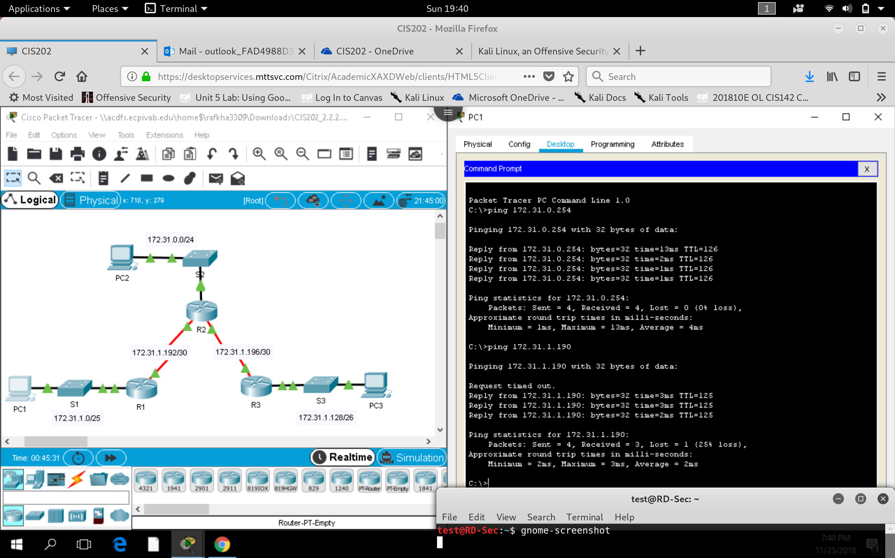 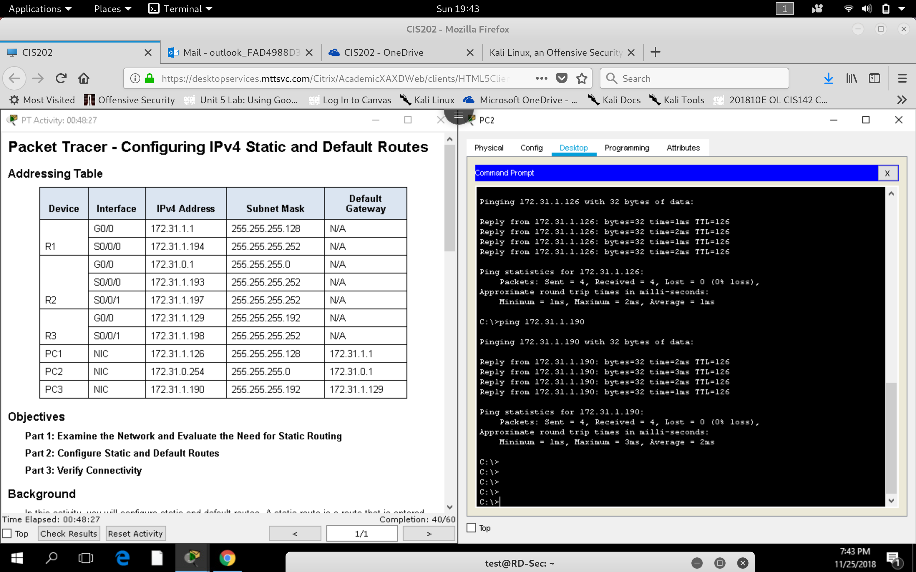

**Pings from PC 3**

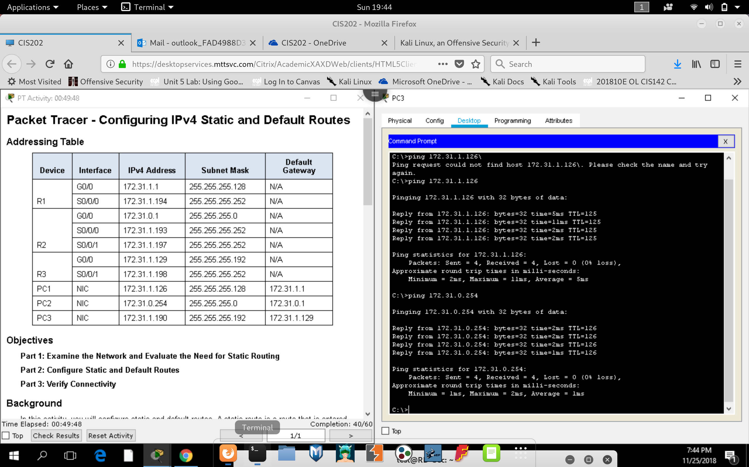

**Lab 2:**

**(OSPFv2 Configuration)**

In this lab, OSPFv2 was configured for the 3 routers; using process ID 10 and router ID from: {1.1.1.1, 2.2.2.2 & 3.3.3.3}. Network was configured for each subnet within the same area 0. LAN interface was set to passive.

**OSPF Routes configured:**

**(Router 1)**

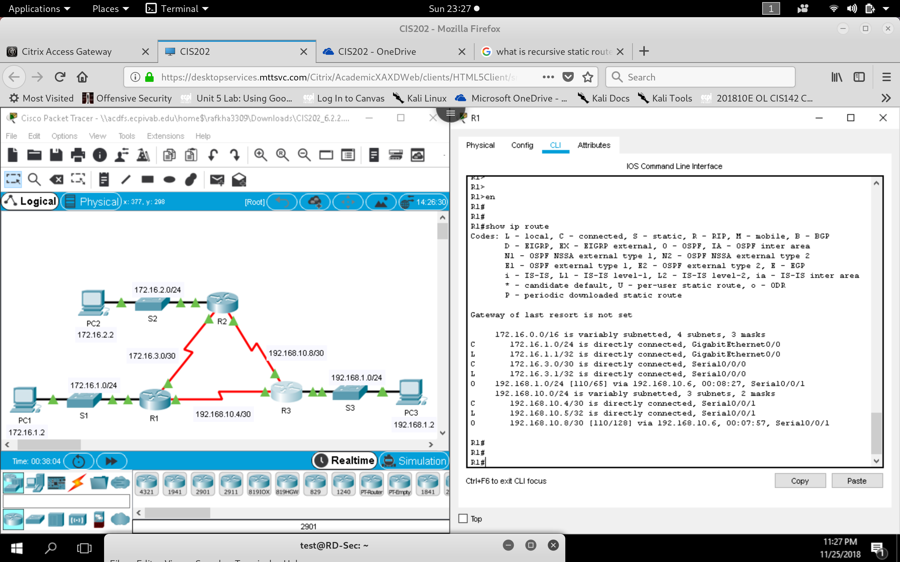

**(Router 2)**

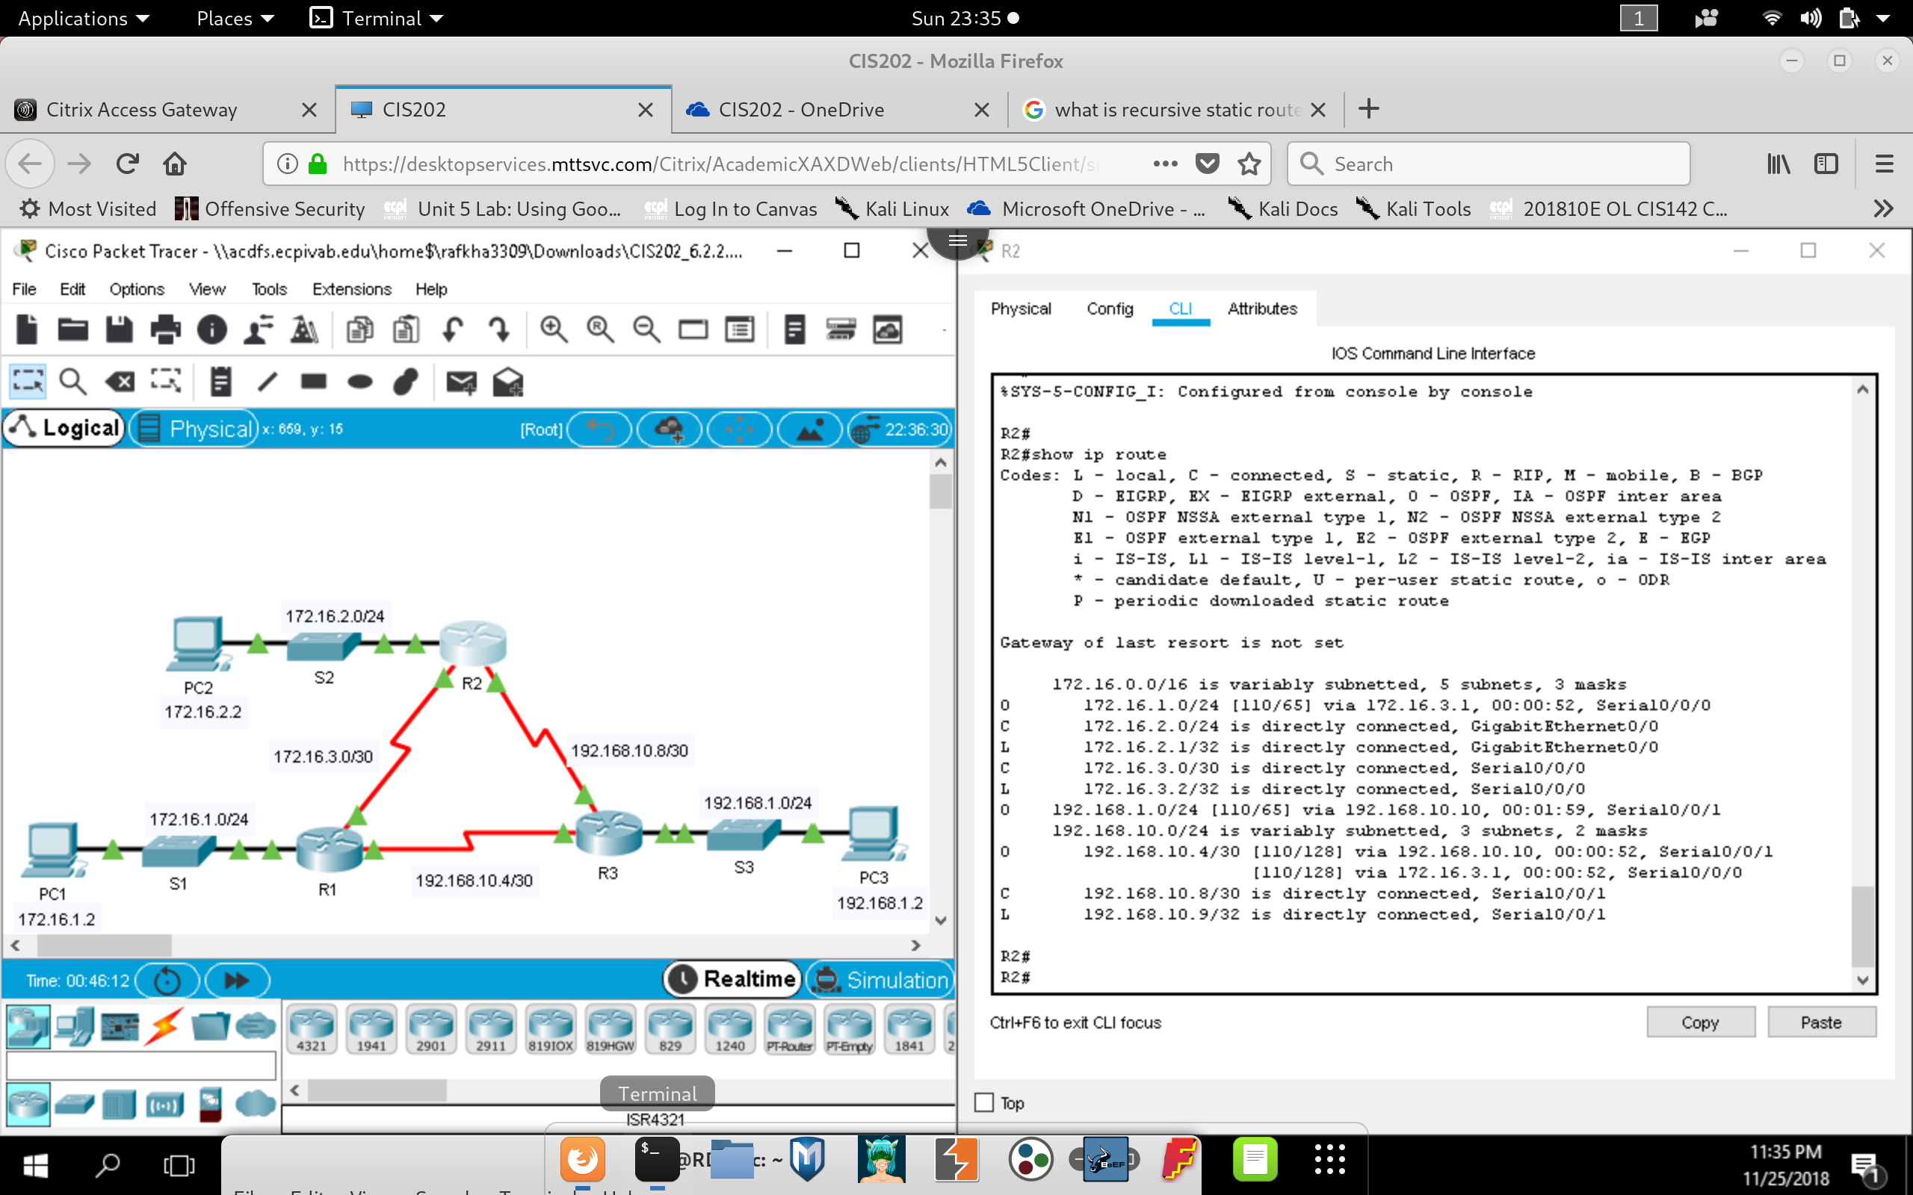

**(Router 3)**

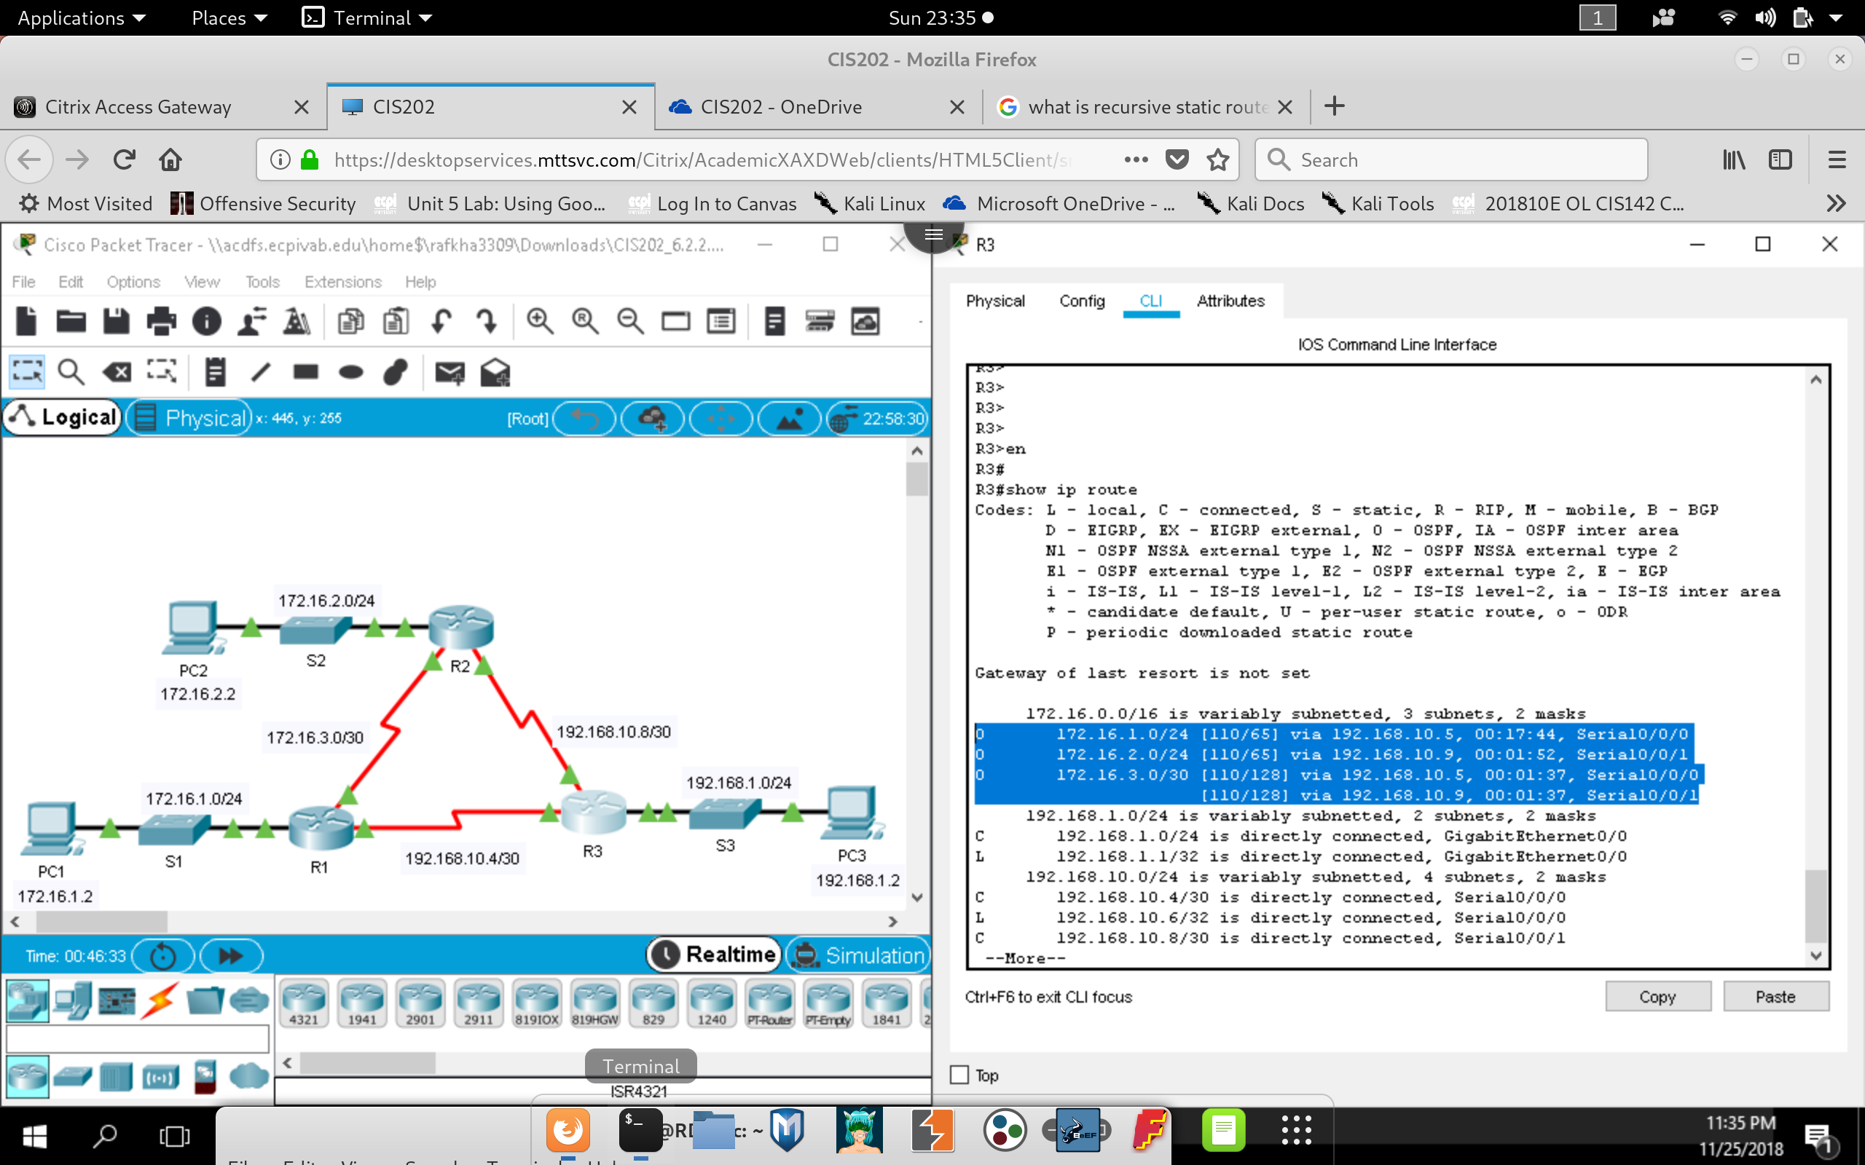

**CIS202 Unit 3 Lab Report**

1. How does a directly attached static route differ from a recursive static route? (Lab 2.2.2.4)
   * ***Directly attached static route differ from recursive static route in a way where configuration of the next route is determined by the exit interface rather than the next destination IP address. In recursive static route (next hop determined by IP address), we can swap the exit interface and configure the interface IP address of the interface while the routing table routes maintain validity.***
2. Which command only displays directly connected networks? (Lab 2.2.2.4)
   * ***‘Show IP Route’ command will show the directly connected network that is attributed by the ‘C’ code, which stand for ‘connected.’***
3. How is a static route displayed in the routing table? (Lab 2.2.2.4)
   * ***In the ‘Show IP Route’ command, static routes are designated by the ‘S’ code, which stand for ‘Static.’***
4. Why are the subnet masks used on serial interfaces so much smaller than those used on gigabit or fast ethernet interfaces between Cisco devices? (Lab 6.2.2.7)
   * ***This is because we want to limit the number of devices that can connect to a serial link network. In the case of a serial link Point to Point connection, we only want 2 available devices on a network that can communicate; so, the subnet mask (CIDR) for that network becomes /30.***
5. Based on the topology, how many subnets are needed? (Lab 9.1.4.6)
   * ***In the Subnetting part 1 packet tracer lab, a total of 5 subnetworks are needed in this configuration.***
6. How many bits must be borrowed to support the number of subnets in the topology table? (Lab 9.1.4.6)
   * ***A total of 3 bits must be borrowed to support the networking scheme in the lab Scenario. Borrowing 3 bits for network leaves 5 bits for host addressing. 2^5 supports 32 hosts per network.***
7. How many subnets does this create? (Lab 9.1.4.6)
   * ***We can have a total of 8 subnetworks within the /24 Super-network.***
8. How many usable hosts does this create per subnet? (Lab 9.1.4.6)
   * ***We have 30 usable host address that can be created per subnet.***
9. Based on the topology, how many subnets are needed? (Lab 9.1.4.7)
   * ***7 subnetworks are needed for this topology.***
10. How many bits must be borrowed to support the number of subnets in the topology table? (Lab 9.1.4.7)
    * ***Each network needs at-least 4 bits for host address, meaning that 2^4 gives us 16 available addresses with maximum of 14 host address. The super-net needed for this entire network will require a total of 16 x 4 (subnetworks) + 4 x 3 addresses to accommodate for the router serial links***

***76*** ***total hosts to accommodate for. So, we need a super-net of at least 7 host bits or 128 hosts to accommodate for at-least 76 addresses being used within the subnetworks***

1. How many subnets does this create? (Lab 9.1.4.7)
   * ***We have a total of 7* subnetworks that is created in this topology. 4 subnets to assign to each router and 3 subnetworks created in between the serial links, connected to each router.**
2. How many usable hosts does this create per subnet? (Lab 9.1.4.7)
   * ***We have a total of 14 usable host address that can be used per each subnetwork.***