**ECPI University**

**CIS 202**

**Unit 2 Lab Assignment**

**By: Rafat Khandaker**

**Professor: Albert Ostering**

**Objective:**

In this lab, a router was connected to three switches in the topology shown below. The connection between router to switch uses a straight through ethernet cable and configured with ‘Router on a stick configuration’. Where the Trunk port between switch3 and router was configured with a sub-interface ports on fa 0/0: ( fa 0/0.1 & fa 0/0.2 ) using the IP address scheme shown below. All three switches were configured with 3 VLAN interfaces with the IP address scheme below, pointing to the appropriate sub-interface port for each VLAN.

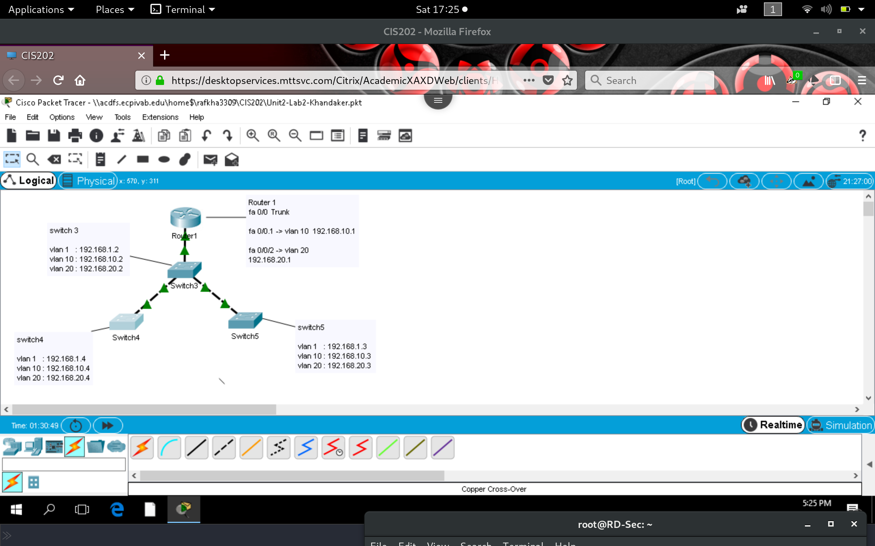

**Ping Screenshots from switch 4:**

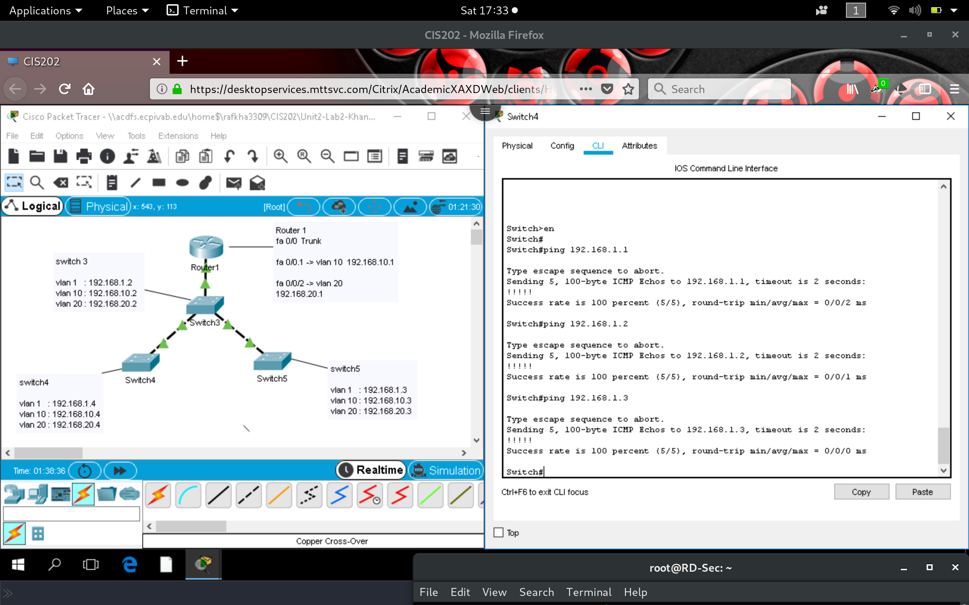

**Ping Screenshot from switch 5:**

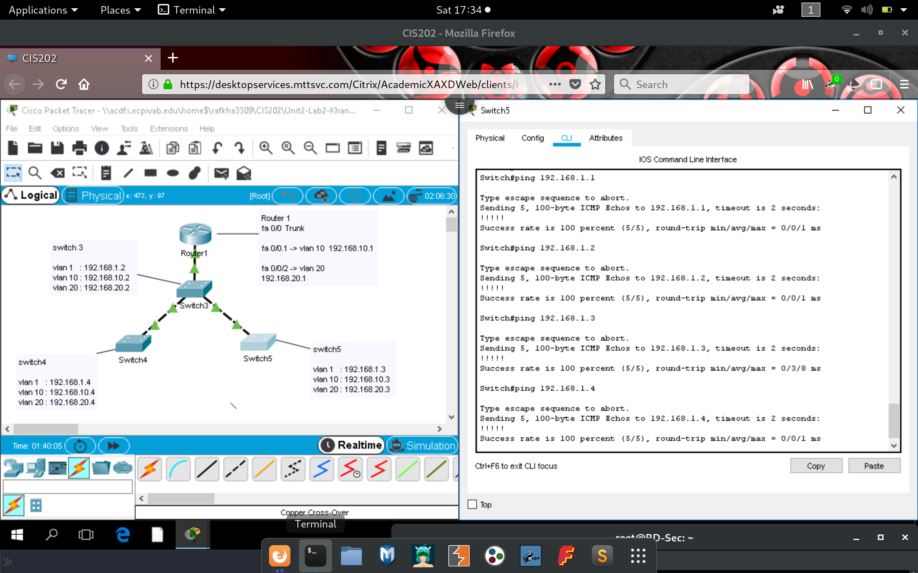

**Ping Screenshot from Switch 3:**

