**Network Cisco Switches & Routers:**

**“Lab Assignment”**

**Lab 1**

**CIS 202L**

**Rafat Khandaker**

**11/11/18**

**Objective**

Using the **NETLAB+ virtual environment**, complete the following activities.

Click on the Show Lab Content button after you schedule the lab.

It is strongly suggested that you open the Lab Content in one window and the topology image in another, and arrange them side by side so you may read the instructions in one window and enter the commands in the other.

**The physical cable connections have already been made in the NETLAB+ system. Any reference in the lab regarding connecting cables should be ignored.**

Interface names may vary among network device types. The interface names shown in the topology image are consistent with those found in the lab activity document. Use the IOS **show interface** and **show controllers** commands to determine the actual interface names for the devices used in the lab pod.

When you have completed the activities, answer the questions that are within the individual labs in a Word Document. Save and name your file, "**CIS202L_U1_LabAssignment_LastName.docx**". Submit your file using the below Upload Instructions.

You must complete the activities in the following order:

* + **Lab 1.1: Router Management Access and Preparation via a Console Port Connection**   
    [**Router Management Access and Preparation via a Console Port Connection**](https://ecpi.instructure.com/courses/34772/files/5113800/download?verifier=D0wgFfr4xChvAO4hwyQX9Ik4IIkMnV5qWE9ZFbIA)
  + **Lab 1.2 Lab: Initial Switch Startup and Configuration Clean up**
  + [Initial Switch Startup and Configuration Clean up](https://ecpi.instructure.com/courses/34772/files/5113756/download?verifier=fDOmbREdgP4QnWyDgLMpysCtQoBTjiqz0oR0odFB)
  + **Lab 1.3 Lab: Discovering the Router's Working Components**   
    [**Discovering the Router's Working Components**](https://ecpi.instructure.com/courses/34772/files/5113815/download?verifier=Yy7oCFtF6xO1uYTmiEzWt7a0OBABX2osgfoitaDr)
  + **Lab 1.4 Lab: Basic Router Navigation and Configuration**  
    [**Basic Router Navigation and Configuration**](https://ecpi.instructure.com/courses/34772/files/5113776/download?verifier=pHe1ETLQonnkOP8cXL8riwVLc08OllWRREvO0EIr)
  + **Lab 1.5 Lab: Basic Switch Configuration**  
    [**Basic Switch Configuration**](https://ecpi.instructure.com/courses/34772/files/5113818/download?verifier=4gW7IiY4DPhVfe0zXhiZ27aYEhjZX4vPcnjvgMyA)

**Lab 1.1**

**1)** Why would it be useful to erase the startup configuration during a course, but rarely in a live working environment?

* + ***It is useful to start with a fresh configuration on the device for testing purposes in a classroom environment. In a real-world example, this is a rare practice because the system may deal with so many lines of configuration that it is important to keep that configuration persistent and only make small changes to get a network configured. Each version update on a real-world environment will require a change management documentation and back-up of the existing configuration. It is a rare practice to delete the entire configuration just to configure the entire device over.***

**2)** Think about this connection process and the various instructions. Can you describe at least two reasons why a person might not have been able to access the router using the console connection and how to fix them?

* + ***Configured through the incorrect connection type: SSH with console cable. This connection will not work because the Serial port by default is 9600, while the SSH connection is port 22. Also, the same transmission types are not being used here nor the same configuration.***
  + ***Another problem with Serial cable can come from not installing the proper driver for the cable connection. The serial interface cable can now come in many forms, including USB. The connection uses a special chipset driver.***

**Lab 1.2**

**Q)** Joe arrives at work and sees a problem on the network which he is able to track down to the network switch. He types ‘show startup-config’ and it indicates that no startup-config is present. Describe at least one reason detailing how this could happen.

* + ***Maybe a user logged into the switch and deleted the startup configuration by the ‘write erase or erase startup config’ command. Another reason could be, if a new switch was configured into the network but the user forgot to copy running config to startup config and reloaded the switch. Another reason could be that the user went into the flash memory and deleted all the config files. All of this can clean the switch of any prior configuration.***

**Lab 1.3**

**Part 1: Identifying the physical components**

Closely examine the Cisco 2911 series router below and answer the questions. Note that both the front

and the back are displayed (top and bottom) If you are having problems seeing details in this image, you

can open Packet Tracer and look closely at a 2911 router, or see if you can do a little online research on

Cisco router interfaces to come up with the answers.

1. Where is the power button?

* + ***Located on a switch in the ‘lower right hand’ side next to plug.***

a. Is this router turned on or off?

* + ***The router is currently turned off***

2. Where is the Console port?

* + ***It Is located above the AUX port in the lower middle of the router module. It is next to a blue label: ‘console’ written on it.***

3. Is there an Aux port?

* + ***Yes, it is located below the console port in the lower middle of the router.***

a. What could an Aux port be used for?

* + ***DSL modem connection, maybe using PPP connection and VPN through Dial up modem connection.***

4. How many routable fast Ethernet ports are there? (this could be a trick question ☺)

* + ***19 ports:***

***-Fast ethernet ports for 10/100/1000 MB Connection (16)***

***-1GB ethernet port (1)***

***-FE 0/0 & FE 0/1 ethernet ports (2)***

5. Does this router have wireless transmission capability?

* + ***Yes, it has 2 wireless adapters connected to the router with possibly two wireless interface cards.***

6. Are there any USB ports?

* + ***There are no USB ports displayed in the picture***

a. What can a USB port on a router be used for?

* + ***IT can be used for additional file storage or to access physical backup storage from USB for small configuration files.***

7. Can you locate any Compact Flash connectors?

* + ***Compact flash connector is located on the lower left-hand side, long slot connector on the router.***

a. What is the Compact Flash used for?

* + ***The compact flash connector is used for additional storage, maybe to performance backup of the router or restore backup to a router.***

8. On the left front, there is a Network Module of 16 Fast Ethernet switch ports. If this is a router,

what are the 16 switch ports doing there?

* + ***Those are fast ethernet ports to switch packets between interface. They are similar to layer 3 switch ports but can additionally be configured with an IP address and separate broadcast traffic.***

9. Does this router have the capability to use an external power supply?

* + ***Yes, this router has a single power supply from the power cord located on the lower right most side of the router.***

10. How many other routers could be connected to this router through WAN serial ports?

* + ***It is really designed for the 2 ports on the Fa0/0 and FA0/1 on the right most side.***
  + ***The switchport fast ethernet ports can also be used but they are not really designed for it.***
  + ***The 1GBT Ethernet can also be used but this ethernet is really designed to be connected to the internet cloud, ISP provider.***

11. Do you see any LEDs that might suggest whether the router is having any problems?

* + ***The LEDS near the ethernet ports, power cable and other ports will indicate if the port is showing any problems. Also, we have the start-up system LEDS on the lower left-hand side of the router, indicating the startup power to the entire system.***

**Part 2 : Using Show commands to examine router components**

**( Using 2911 series router on packet tracer)**

(you should have previously established a console connection)

1. Enter the enable mode

Router> enable

2. Use the show version command and examine the output?

***Contains information about the system, where it was made, the components of the system and installed modules, summary of compliance, US Laws and technology packages.***

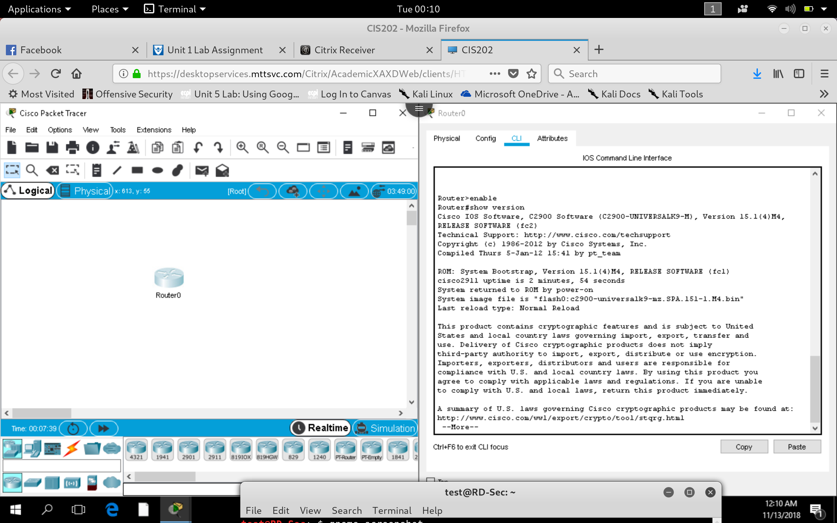

a. Do you see any references to the hardware interfaces?

***Yes, there is some information about the processor board, DRAM info, non-volatile memory information and flash information. Gigabyte ethernet interface.***

b. How is this output different than what you see in the figure in Part 1?

***This output shows us the internal hardware of the system, vendor information and where the device was manufactured.***

c. Do you see information on the internal components that were not visible in Part 1?

a. DRAM? ***Yes, DRAM is the dynamic ram, 512MB : 64 bits with parity disabled.***

b. Flash memory? ***About 250MB of Flash Memory***

i. How much of it is currently in use? ***0 was used***

c. IOS version? ***Version 15.1***

i. IOS filename? ***Flash0:c2900-universalk9-mz.SPA.151-1.M4.bin***

d. What is the current configuration register? ***0x2102***

a. Note: if it is anything other than 0x2102, you may need to inform your instructor

3. Use the ‘show ip interface brief’ command and examine the output?

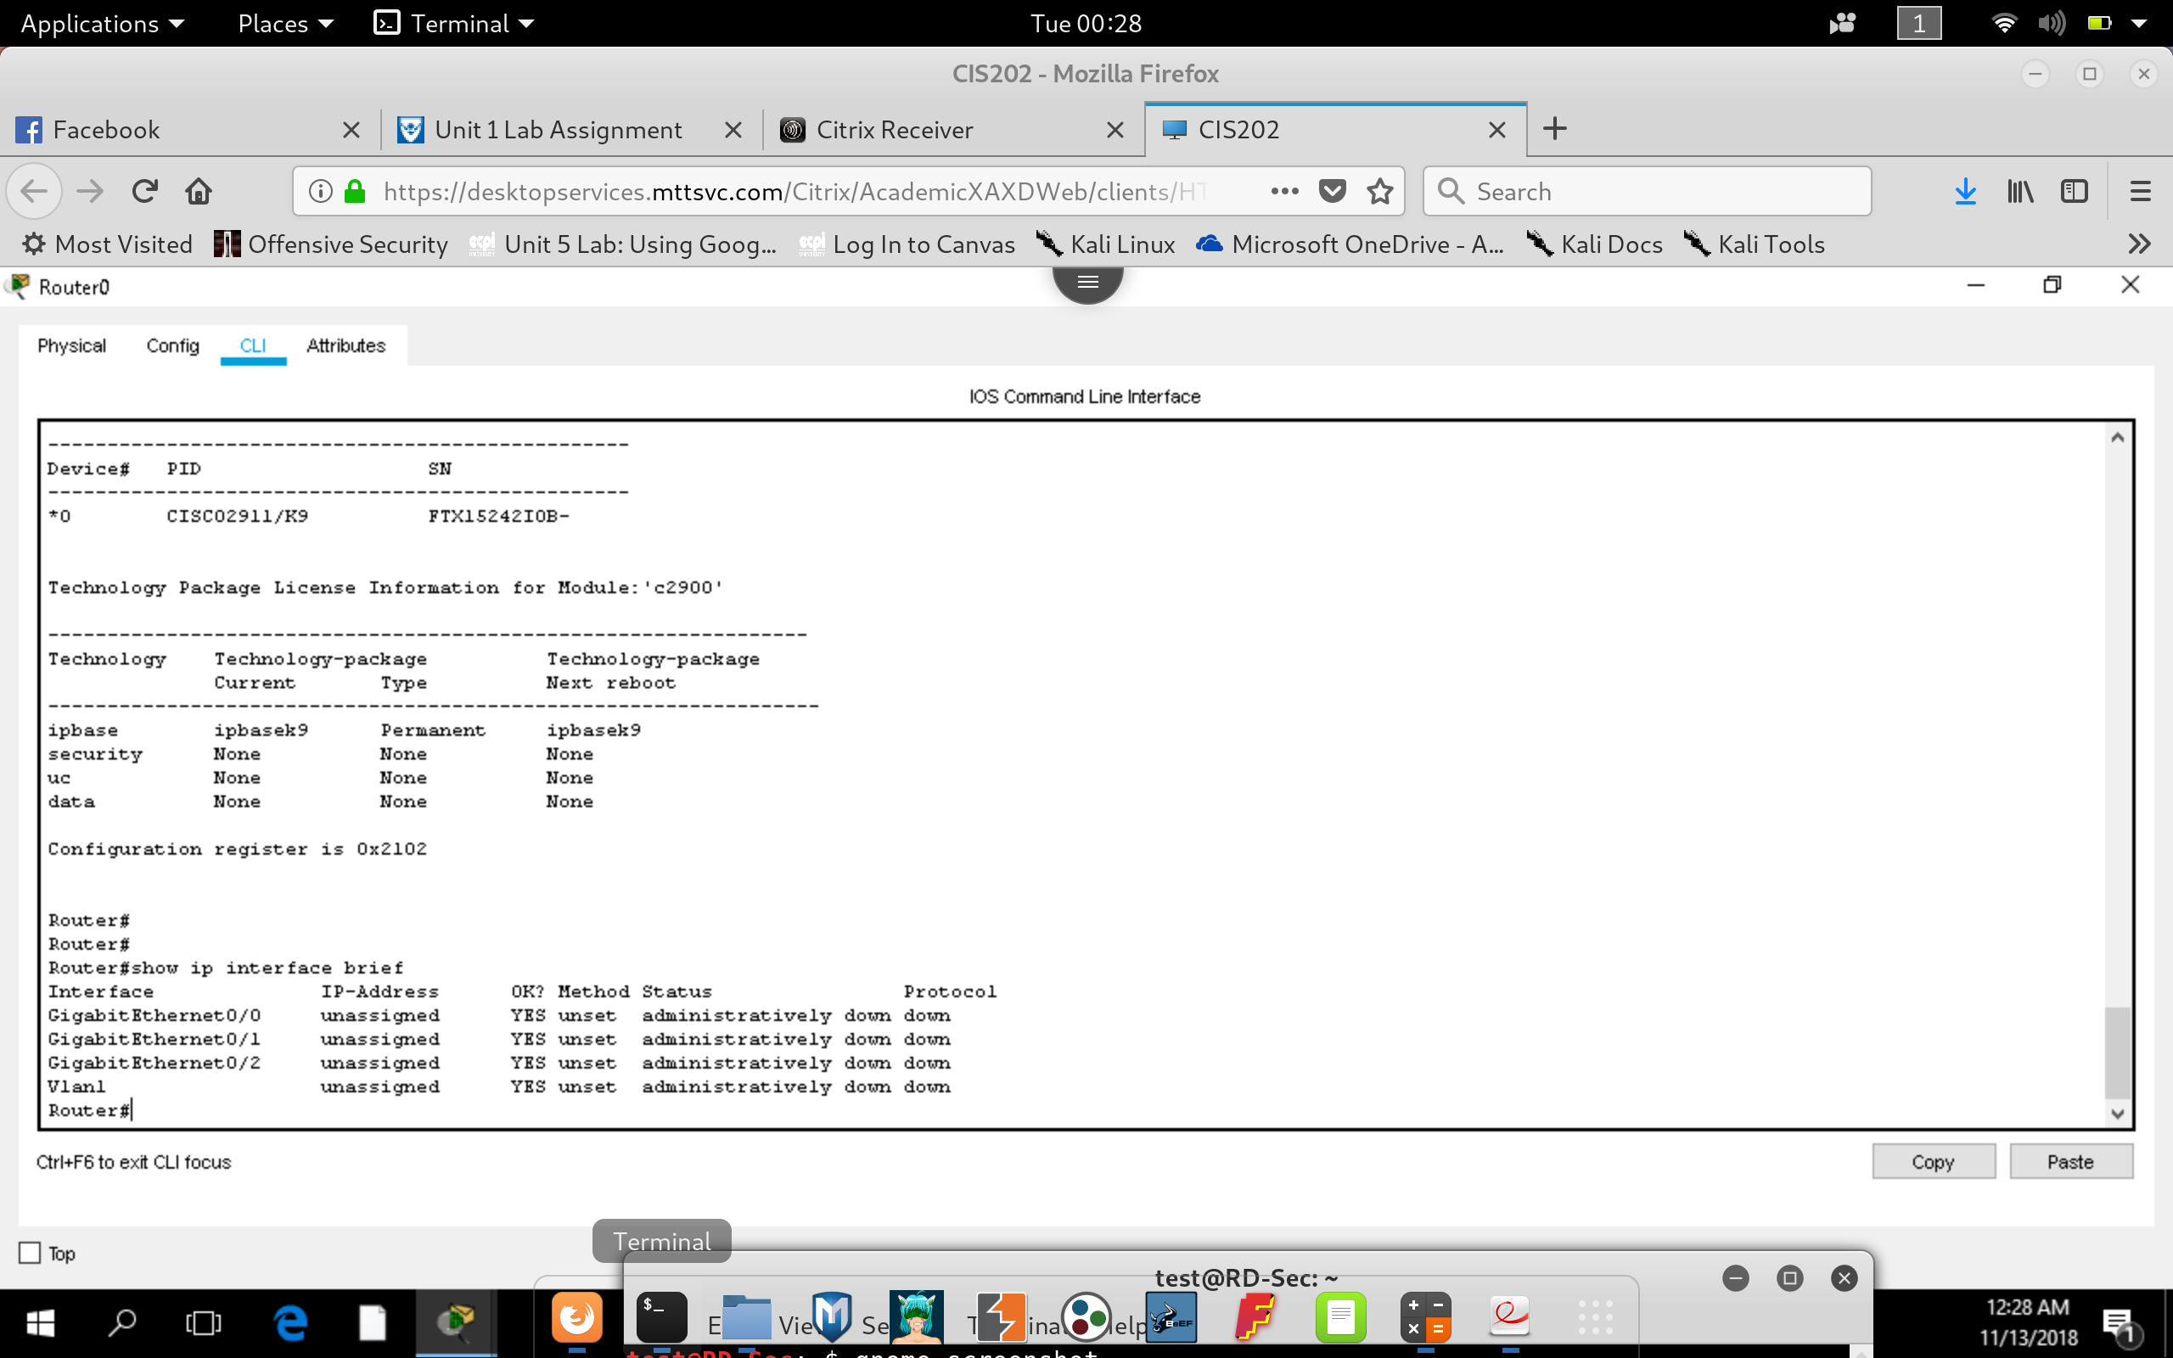

a. How many interfaces total are shown? ***4 Total***

b. How many interfaces are Ethernet based? ***3 Total***

c. How many interfaces are of the serial type? ***None***

d. Do any of the interfaces have an IP Address assigned? ***None***

e. Are any of the interfaces showing as ‘Administratively down’? ***All***

i. What could this mean? ***Not Configured***

4. Issue the command ‘show interface’. Examine the first interface that shows up.

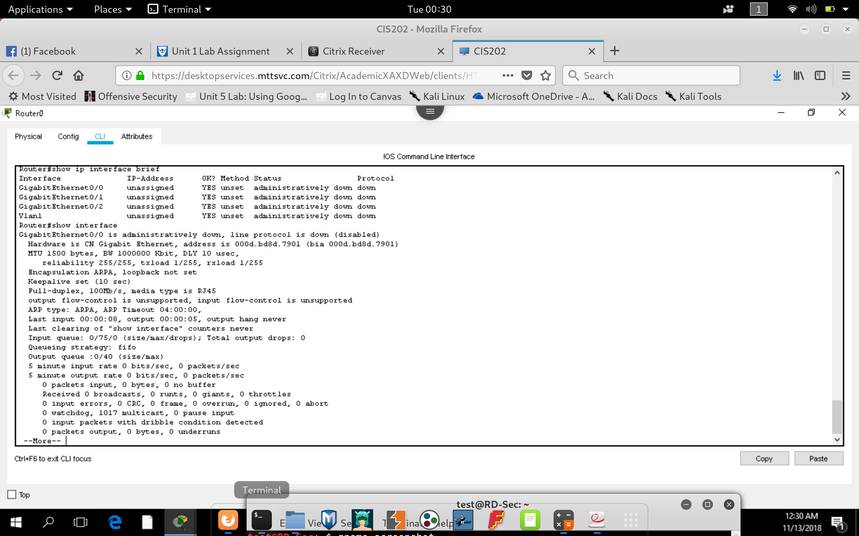

a. What type of interface is this? (Serial, Ethernet, other?)

***Gigabyte Ethernet***

b. What is the module/slot/port # of the interface?

***GigabyteEthernet 0/0***

c. What is its bandwidth capability?

***1_000_000 KB***

d. Is the interface down or up?

***Administratively Down***

e. What is the default encapsulation?

***ARPA, with loopback not set***

f. Does this interface have a MAC address?

***Yes, 000d.bd8d.7901***

**Part 3 Reflect on what you have learned to answer the following questions:**

**1)** Based on the flash memory used and available, what is your assessment of the upgrade

potential of this router to accommodate a new IOS?

* + ***Based on the configuration, We can only store upto 250MB worth of updates and upgrades to the flash memory. Which means that our upgrade should be within that limit for internal memory before external memory storage should be used.***

**2)** Obviously the router depicted in Part 1 has all of its available slots in use. Comparing what you

learned in Part 2 from combining show version and show interfaces, is there any indication that

you have room to add more interface modules?

* + ***Since I am using configuration from two different router diagrams and configuration. I will say that based on the image in part one , all the modules are used up. In order to upgrade, we must replace a module with a new one. Based on the configuration in part 2, it seems that there are no existing modules detected. (may not contain all modules in part 1). We can physically inspect the capabilities of the router and the show IP interface command may tell us if the module is detected or not.***

**A)** Based on what you learned, do you have any suggestions for Cisco that might improve this output?

***We can recommend Cisco to give us more information on expansion slots of the cisco switch on the show version command. This will tell us the capabilities of the device with a IOS interface output & tell us if the module was in working mode or not.***

**Lab 1.4**

**1)** You have finished configuring a router and you wish to see the results using the command ‘show

run’. The router prompt ECPI-A(config)# comes up and you enter ‘show run’. An error message

follows indicating invalid input with the ^ symbol on the letter ‘h’. What went wrong?

* + ***The user is in Global configuration mode and he can only use the show run command in privilege exec mode. So, he has to exit out of global config to run the command. He can use the ‘?’ to check the command list or run a ‘do show run’ to execute the exec command from configuration.***

**Lab 1.5**

What reason can you think of for configuring this device with a default gateway? Keep in mind that this device is not itself the default gateway.

* + ***A switch does not understand layer 3 requests, so when a request is being sent to a router or outside a router VIA IP address, the switch needs to forward the packet to the default gateway & request the mac address of the default gateway.***