**ECPI University**

Unit 2 Research

**"Network Security Design”**

**CIS 212**

**Rafat Khandaker**

**10/22/18**

**Proposal Design**

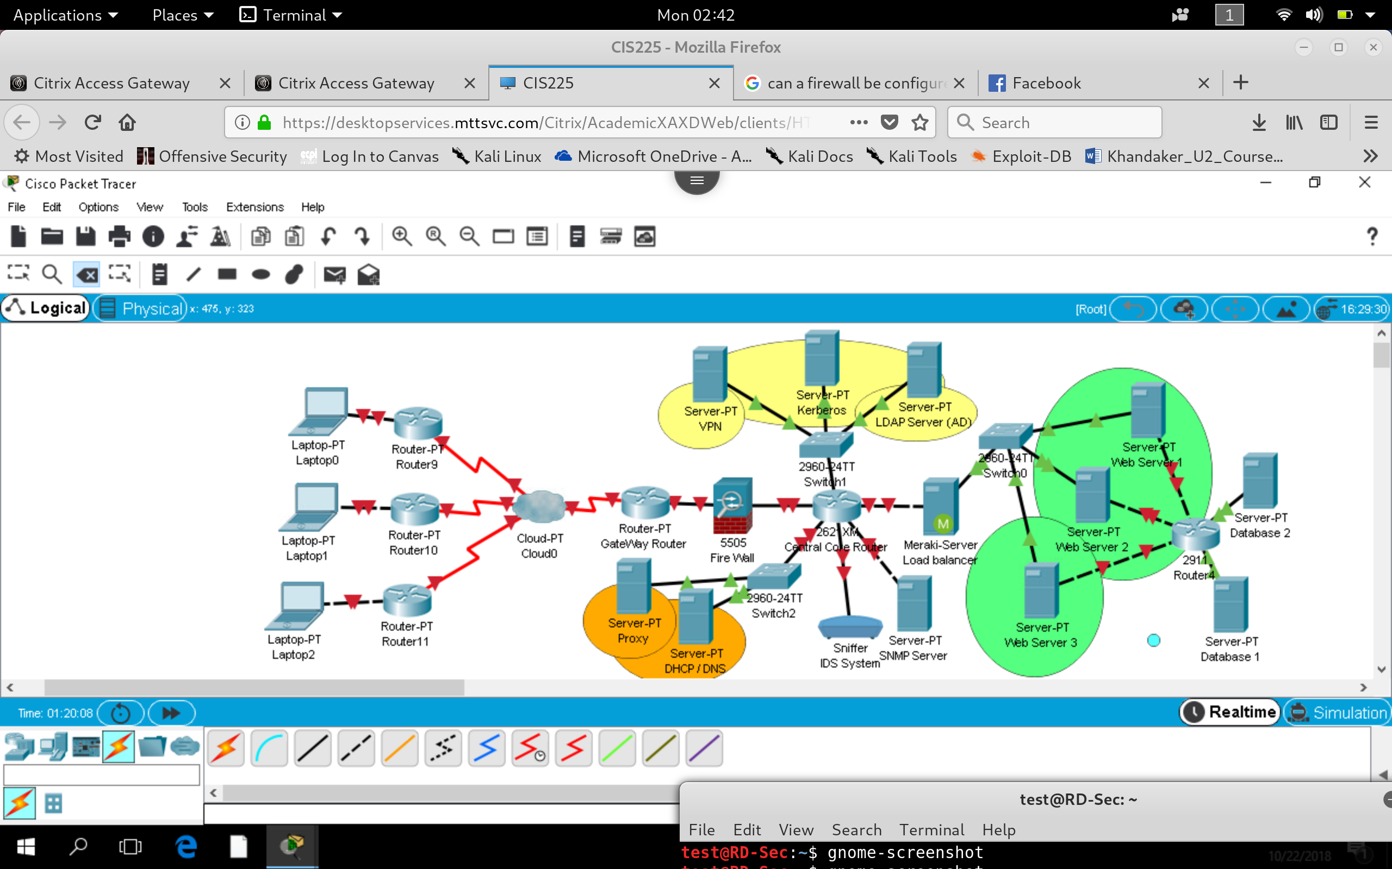

**References**

**(1)** Ciampa, M.(2016). *CompTIA Security+ Guide to Network Security Fundamentals.* Cengage