**ECPI University Rafat Khandaker**

**CIS-225 08/30/18**

**CIS225: Unit 1 Lab 2: Configuring Ipv6 Protocol**

**Objective:**

Demonstrate the ability to configure a VPN client.

**Topology:**

Students do not need a specific connection, but should have an active installed interface.

**Instructions and Background:**

For an entry level technician, configuring a VPN server is not as common a task as configuring a VPN

client connection. For this exercise, assume that the server is already configured.

If you are a MAC user and want to use that for this lab, please check the following link that will help you

with this lab:

<https://support.apple.com/kb/PH25513?LOCAL=EN_US>

If you are using Windows 10 for this lab:

<https://support.microsoft.com/en-us/help/20510/window-10->

For a Linux user:

VPN Server:

<https://www.digitalocean.com/community/tutorials/how-to-set-up-an-openvpn-server-on-debian-8>

VPN Client:

<https://torguard.net/knowledgebase.php?action=displayarticle&id=53>

Detailed Instruction:

I will be configuring a VPN connector on a Linux based system. This is a Kali-Linux-Rolling distribution of Debian Linux Operating system. Full support for this operating system can be found on <https://www.kali.org/>

**Step 1**

We must install a network VPN client in order to connect to VPN service. Following the example for a Debian based Linux system. We can add a new VPN connector to our network-manager with this command on terminal: ( **apt-get install network-manager-openvpn** ) we can also add the **–gnome** tag to the command if we are running our Linux distribution in the gnome desktop environment.

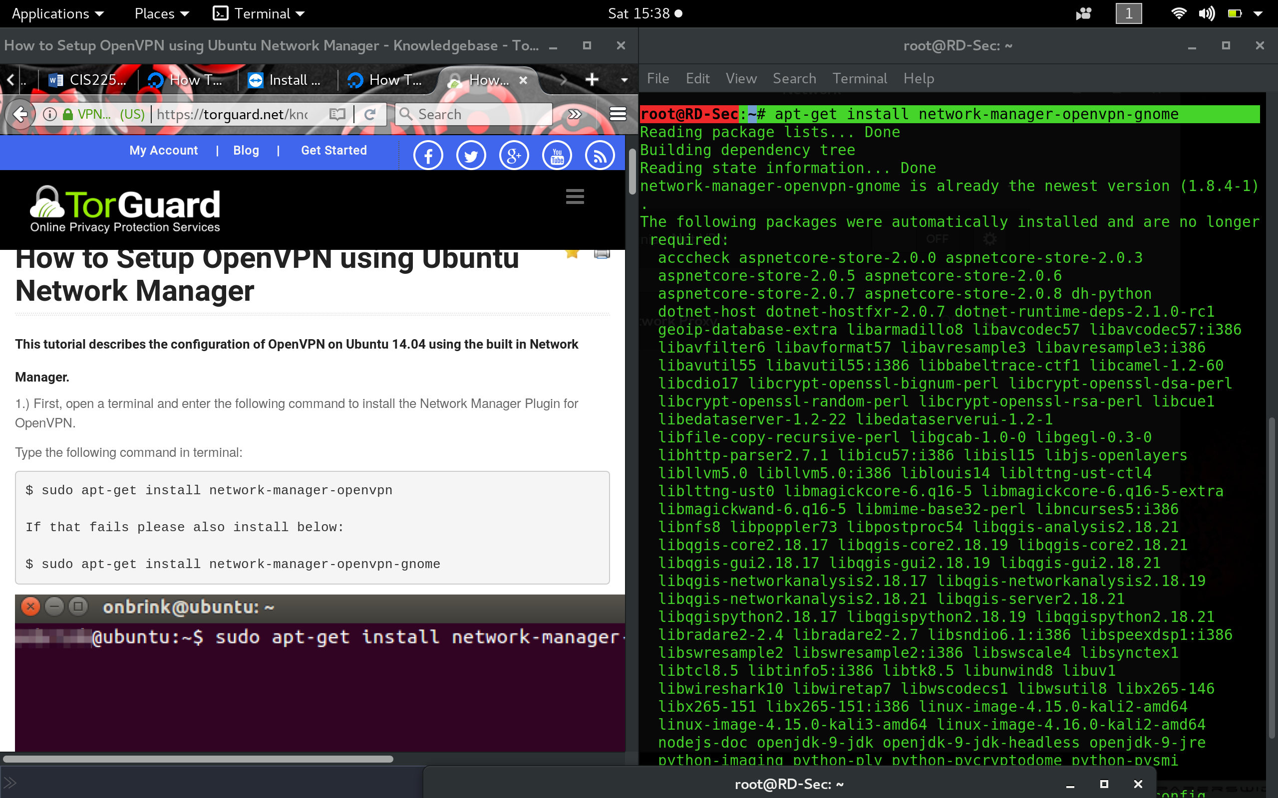

**Step 2:**

Follow the Instructions to configure a local VPN-Server from the documentation.

( Long process & may require external documentation. OPEN-VPN service contain many configuration settings that can be complex depending on the needs of an organization infrastructure. )

On Linux Server:

(<https://www.digitalocean.com/community/tutorials/how-to-set-up-an-openvpn-server-on-debian-8>)

The following configurations look like this:

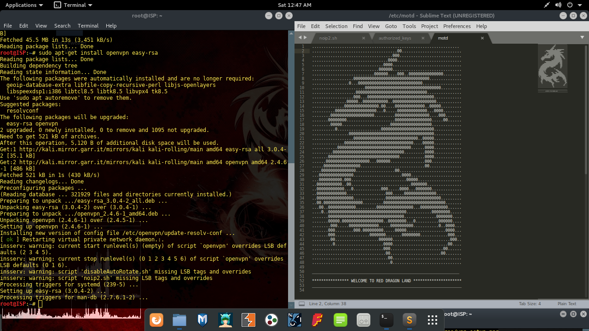

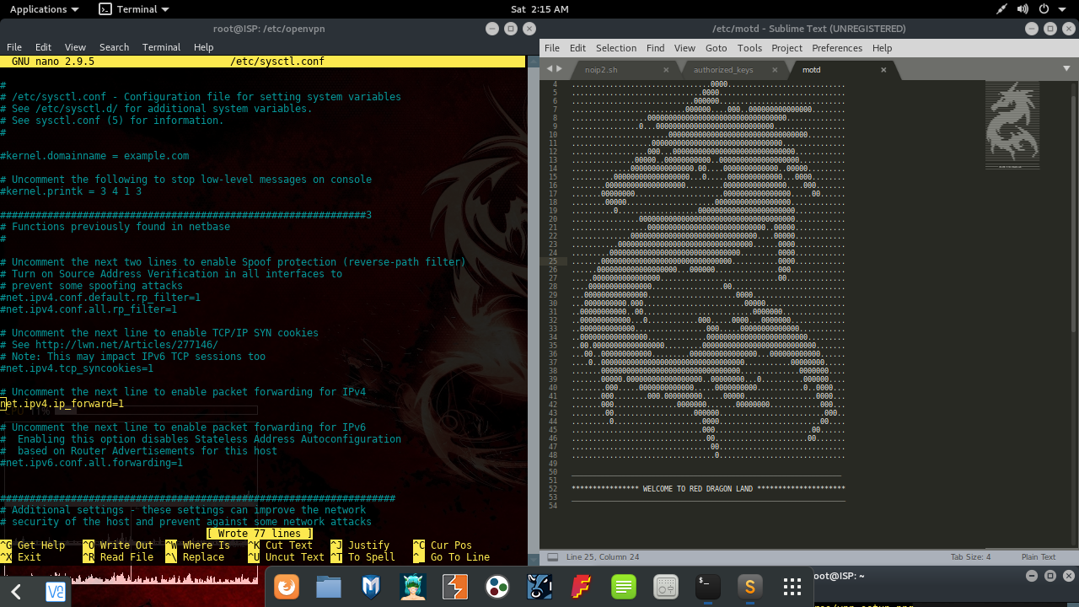

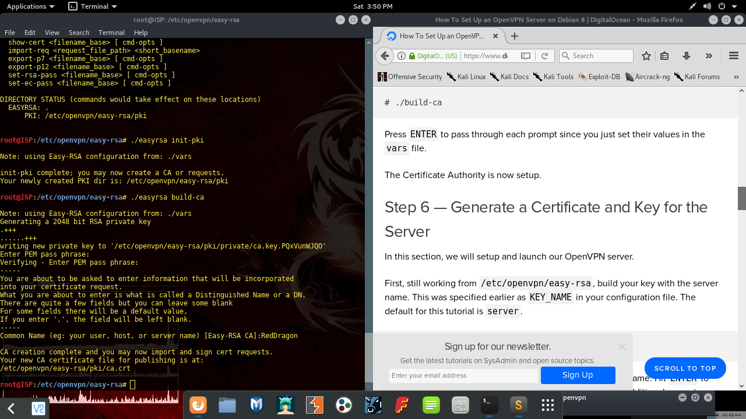

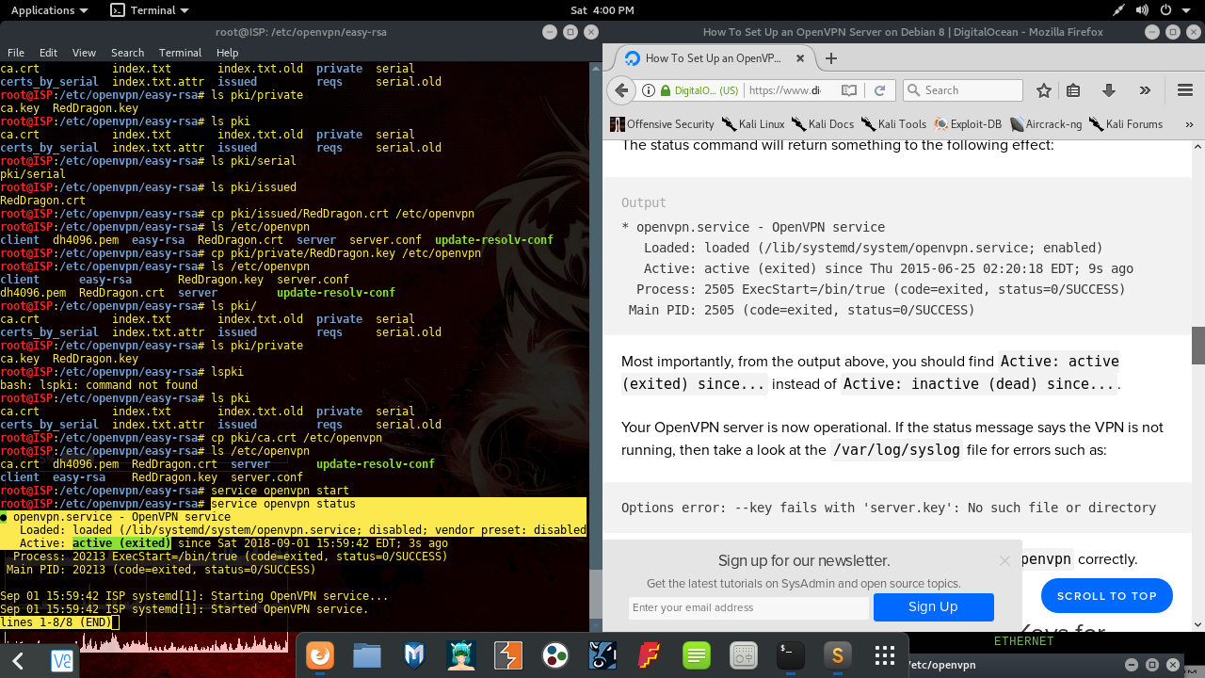

**Step 3:**

In this step, we need to import the following certs & keys from the server. We can directly import these files however way we want. I chose to use an SSH session & Secure copy the files into my local client.

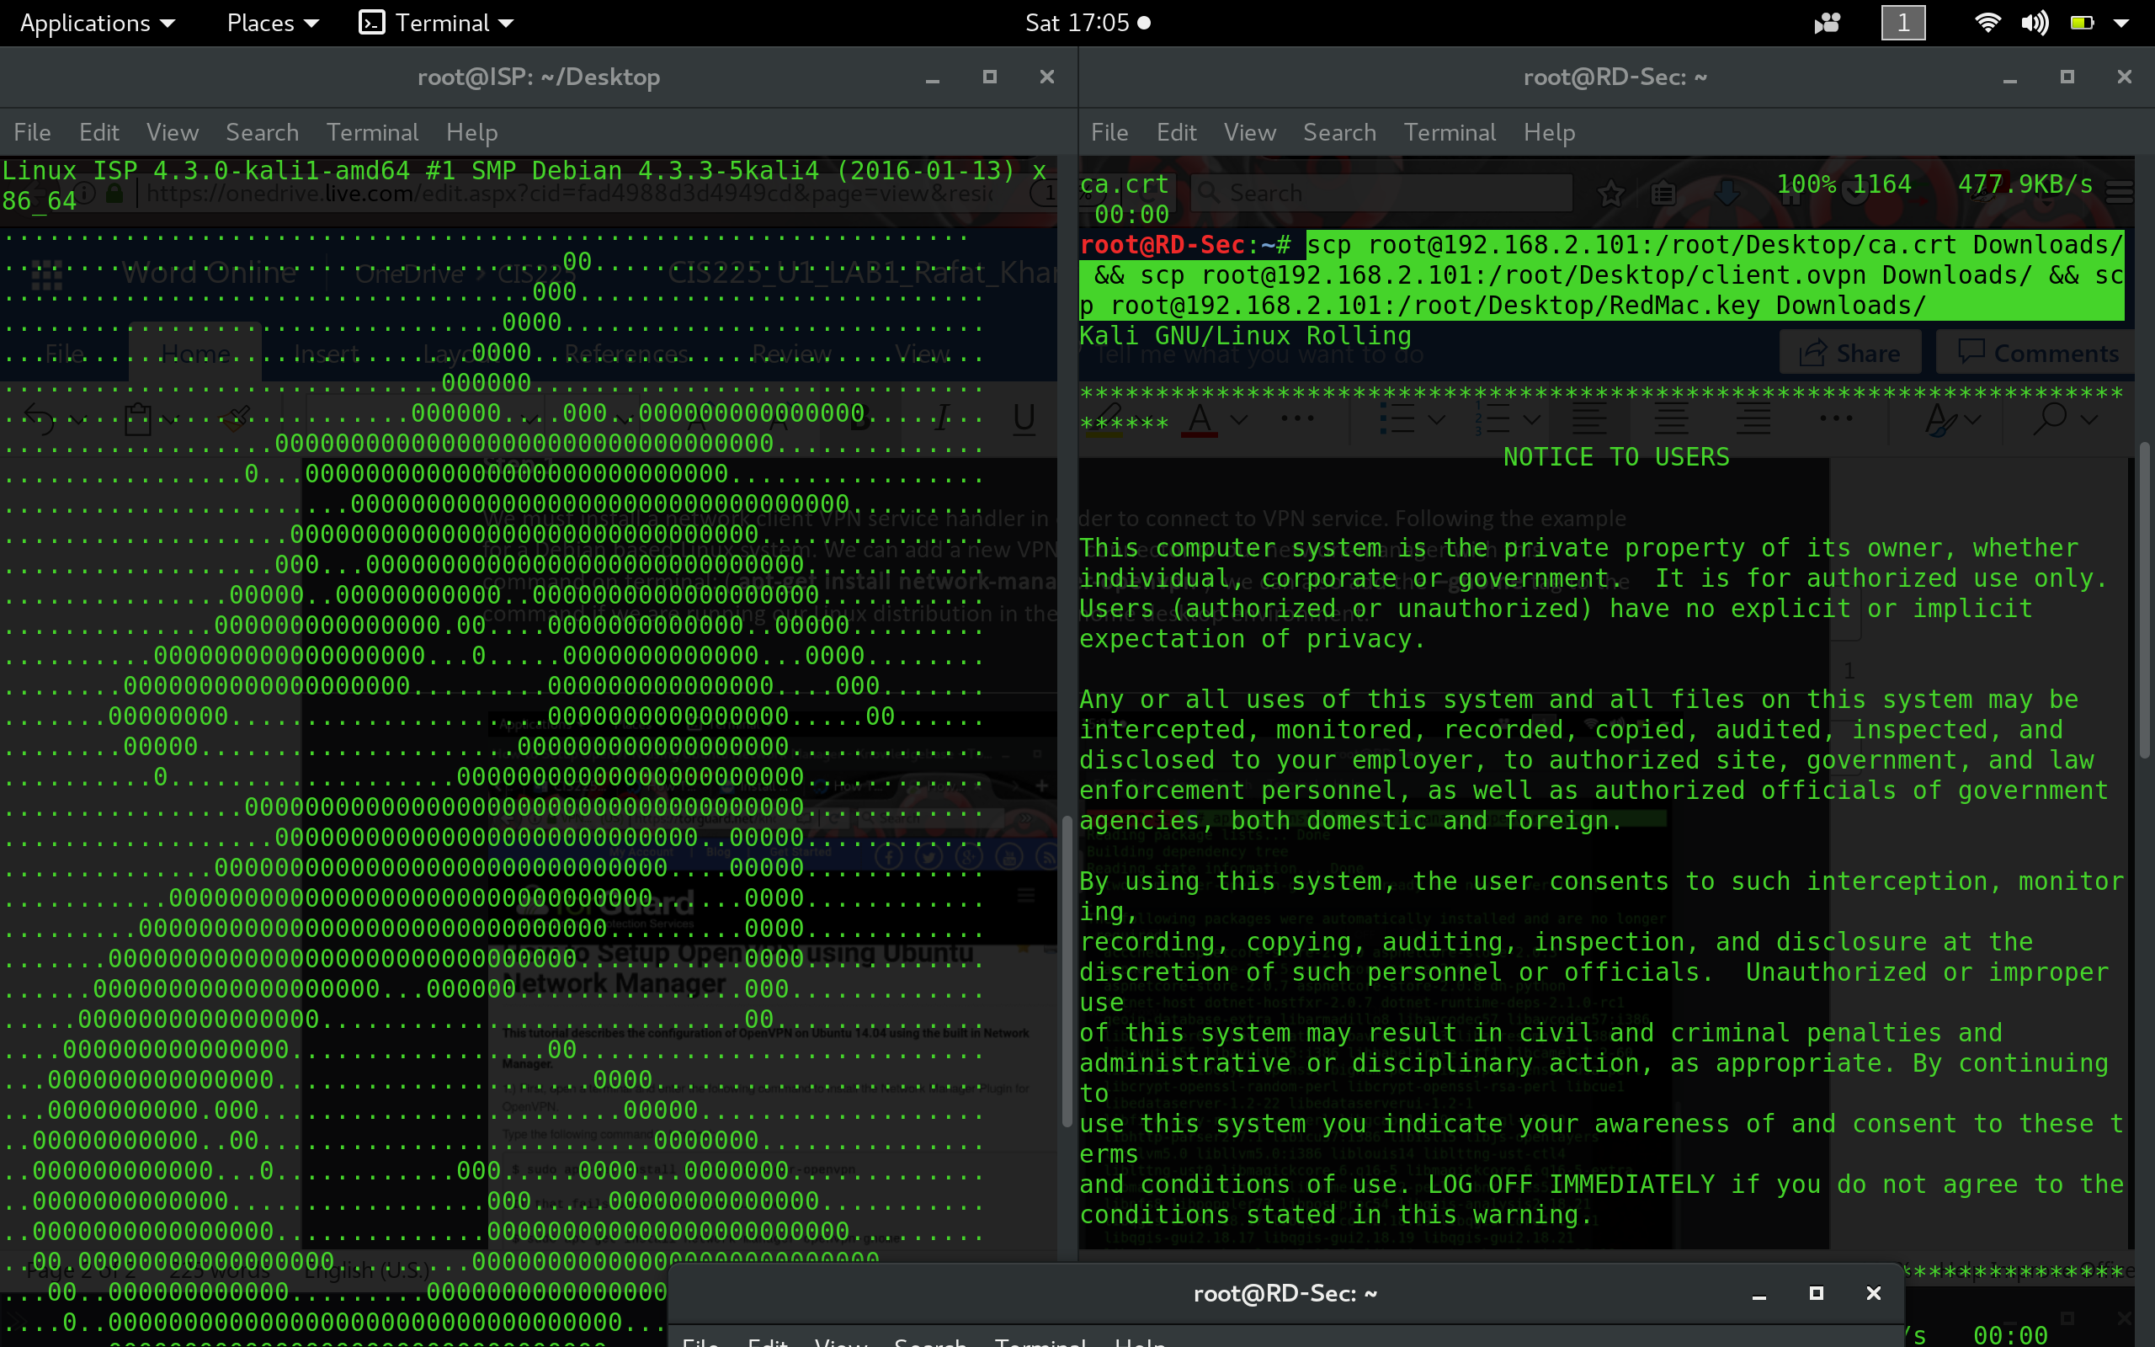

**Step 4:**

Finally, we will import these files into our connection settings from connection-manager & connect to our VPN server.

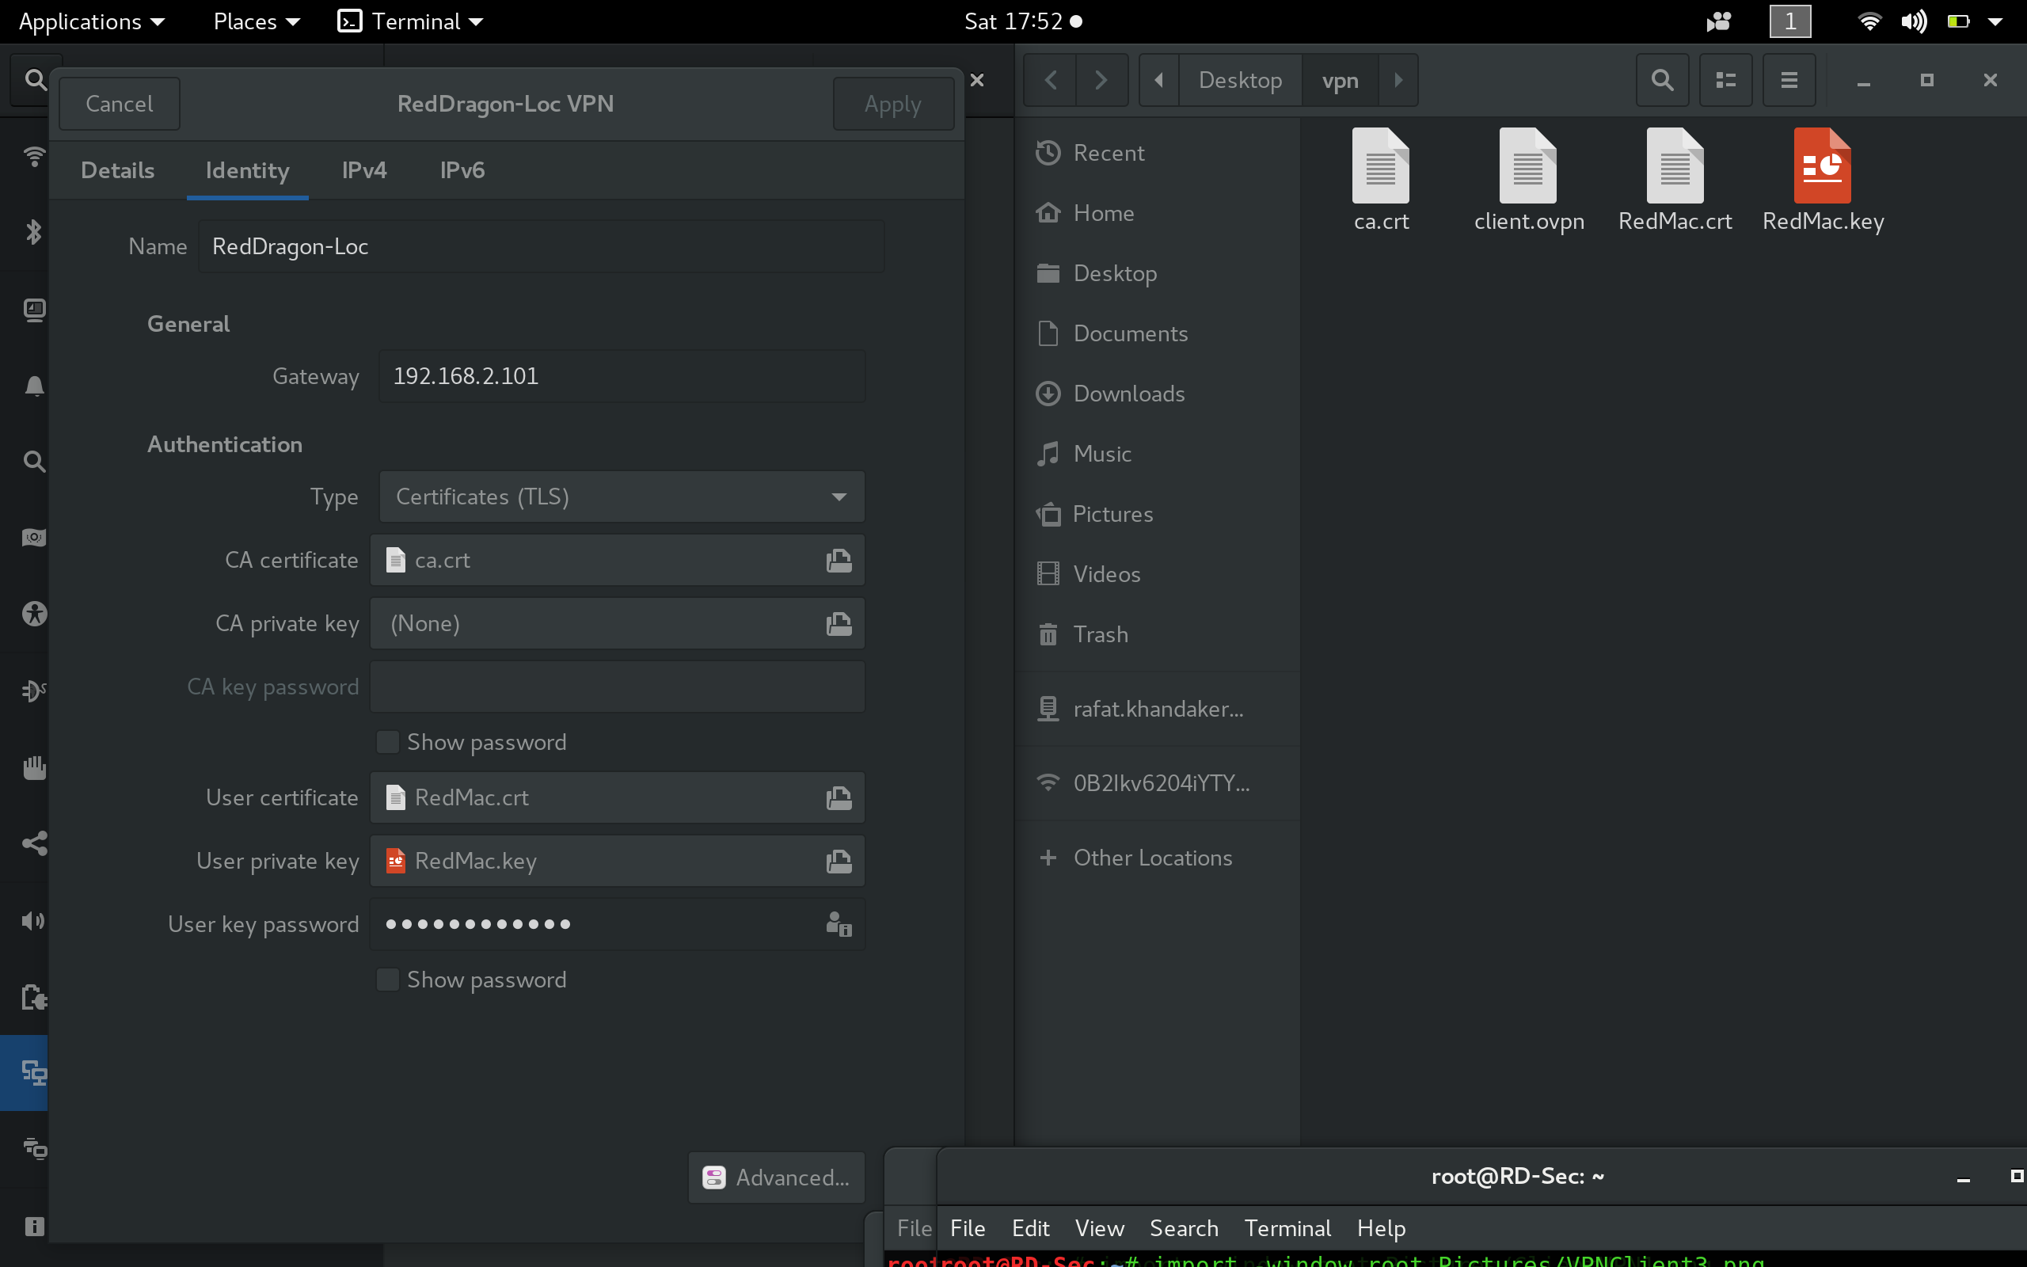

**Step 5:**

Finally, we will connect & establish session to our vpn-server.

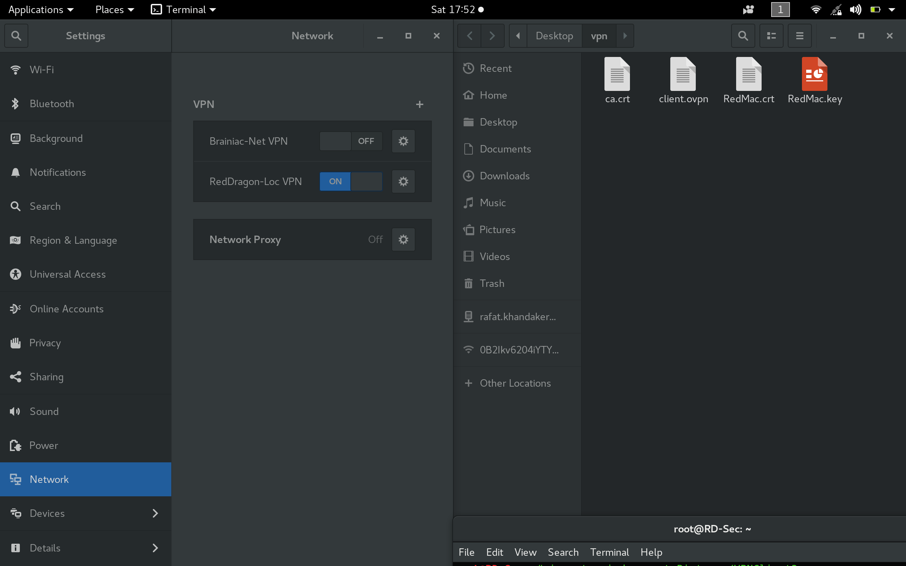

**Summary:**

In summary, the purpose of this lab was to work through the technical procedure of attempting a connection into a VPN-service. The VPN protocol has many configuration settings on a server side. To establish a service on a professional level, we must be familiar with all the advantages & protocols of a VPN service. As professionals we also have to review the documentations of the best service to use in implementation. VPN also offers many integrated services, such as windows LDAP authentication settings through user groups. Our two common VPN protocols are PPTP or OpenVPN, in this example I chose to use the Open-VPN protocol to exchange authentication through pub-certificates & private keys.