# CIS225 Networking II Rafat Khandaker

# 09/09/18

# Unit 2 Lab Assignment 2

# Planning a Network Topology (SOHO)

**Objective:**

Draw a network. Demonstrate your current knowledge of networking as compared to the knowledge at the beginning of Networking I.

**Scenario:** The Smallish Company has a 20-30 people in each of three networks and a separate network for the IT servers and services needing 6 nodes. Additionally the southern branch office has 14 employees and there needs to be a dialup connection to the home office.

**IP Address Configuration**

In this diagram, a SOHO topology was constructed. Using an efficient classless IP addressing scheme. IP address are assigned to each host on the network. The network devices in green represent a small company with 3 network segments, each containing 20 – 30 host addresses. Ip addresses in that network are configured, in summary (.1 to .30). The yellow diagram represents 6 IT server nodes on the SOHO network. Each will have address assigned from (.105 to .110). The Southern branch office contains 14 hosts between (.97 to .110) and is highlighted in orange. The routing subnet for this super-net of the entire SOHO network can be represented with the summary of:

(192.168.1.0 /25 or 255.255.255.128 Network)

Topology of the network are shown. Internal networks, highlighted in color, are contained inside a single broadcast domain. These networks are configured in a star topology to multi-layered, nested star topology (green network). While the Routers connected on serial line are configured in a direct-line mesh topology.

***(Routers & switches are currently not configured & are currently neglected for this purpose)***

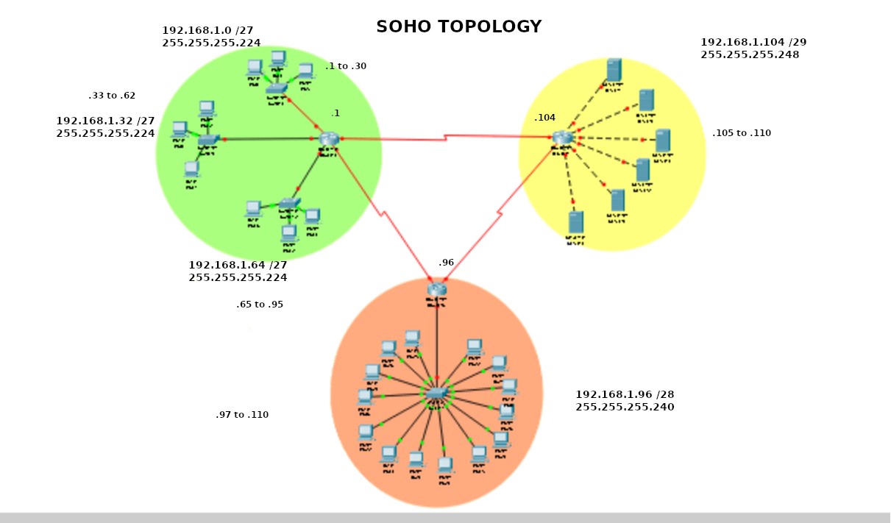

**(Modification of the Network using Packet tracing to implement security & DHCP Servers, more detailed OS systems in play. Also describing connection to the internet )**

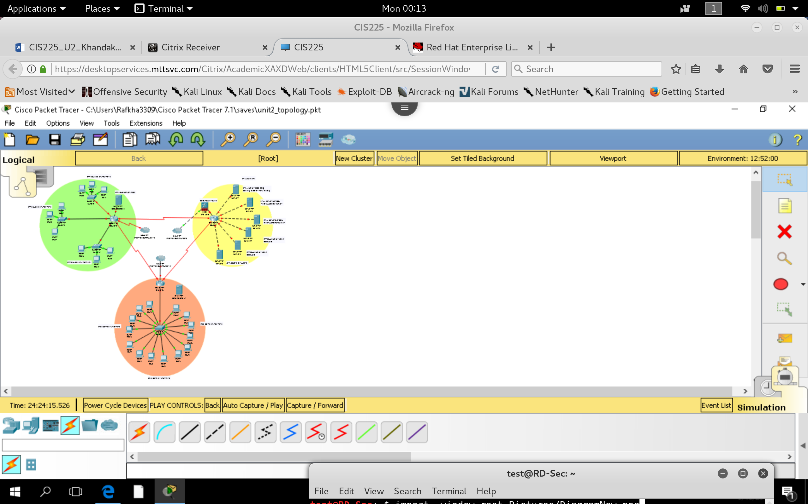

**Security & Automation Explained**

In this configuration, I have implemented a DCHP server in each of the office branches of the Network. The DCHP servers will be connected to the router, where all subnetworks can communicate with the DHCP. DHCP, will allow flexible automation of assigning IP address to the hosts. Same server hosting DHCP can be configured with DNS to provide names for servers located on the Internetwork, this will bypass having to register SSL or DNS providers on the Internet. In the server branch, we have an ASA firewall between the Router and Internet to provide port security & management to our server network. This will provide additional configuration to protect internal servers from outside WAN attacks. Other IP security settings can be configured on the routers, like ACL (access control list) to filter ports or service accessibility for restricted user-groups & etc.

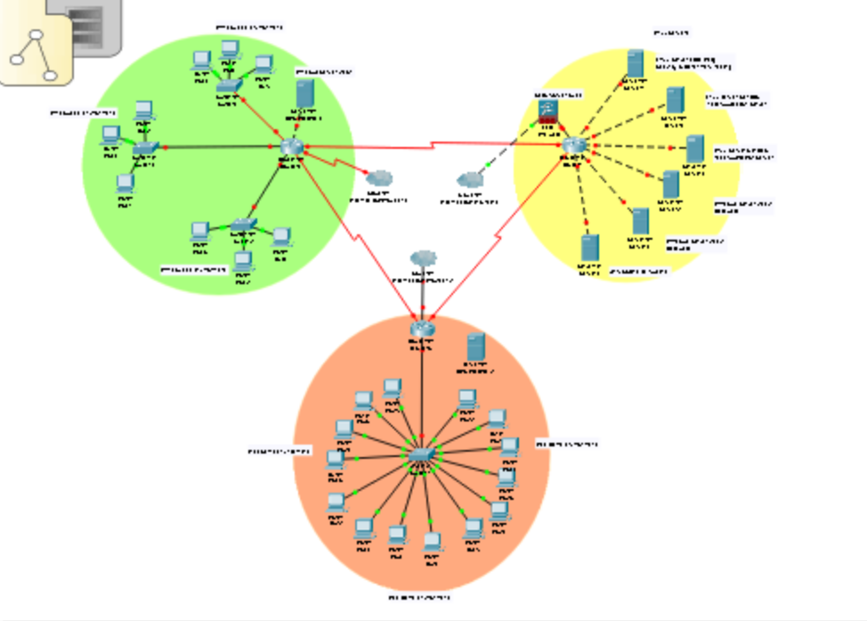

**Operating Systems**

Taking a closer look into the network, we can see that the northern office network is configured with windows devices for both server-side & client side. I chose windows 10 for client-side technology & Windows server 2012 for internal servers. This is because Windows 10 is fairly secure, allowing us to configure LDAP services and user-group security. Also, Server 2012 is a good compatible server that is back-ward compatible with many services that has been maintained inside companies for years. It is also a good integration with windows services.

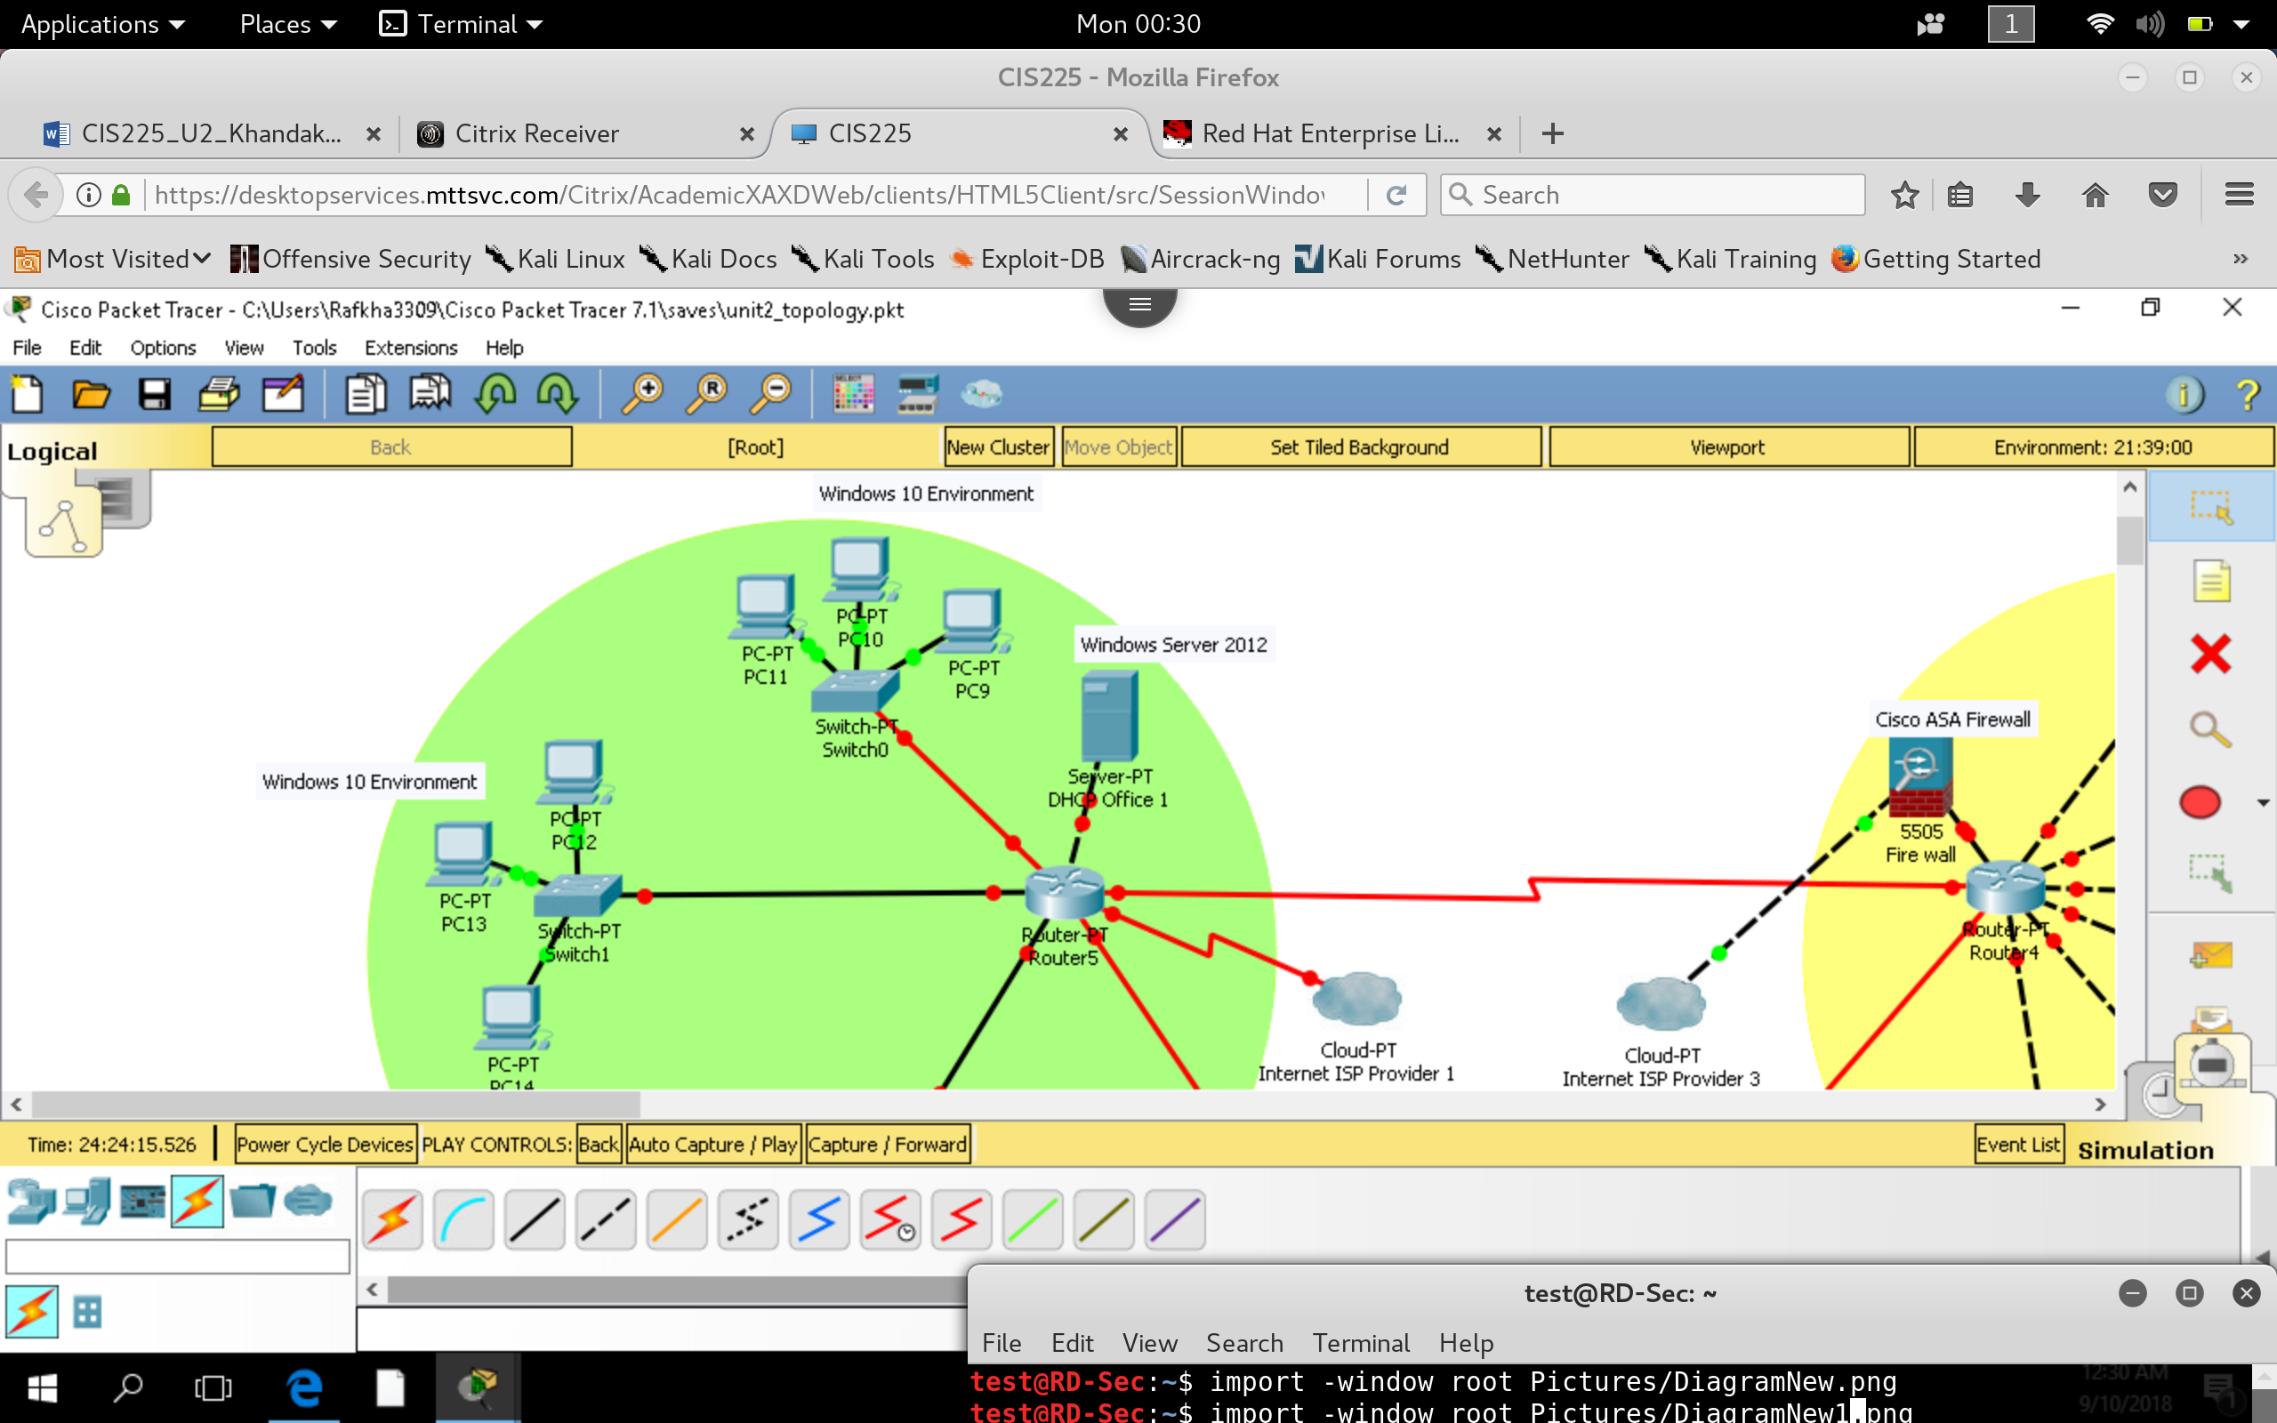

Taking a closer look into the server farm, I am using a cisco ASA firewall to connect our servers to the internet. This is allow us to configure and manage a deeper security configuration for our server access into the Internet, including services we want to expose & restrict. I chose a hybrid of operating systems inside our internal server farm. I chose Linux Red Hat server, for the purpose of application load testing. Red hat servers have a good reputation for maintaining application up-time & is also security compatible. I chose Linux CentOs operating systems for the case of Pre-deployment application testing. Linux CentOS are pretty stable and can function pretty well without going through frequent updates. I chose Windows Server 2012 to host SQL instances, for the purpose of internal databases. I have a Unix Server Solaris 11, for the purpose of hosting on the Internet for Customer facing applications. Unix is a simple Operating system with high performance & capabilities for hosting large services.

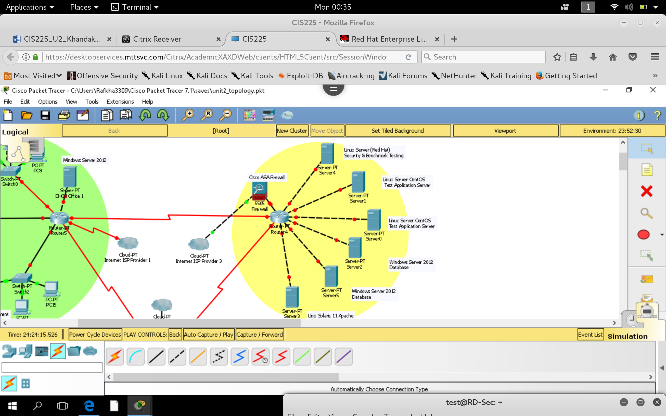

In the southern office, I decided to implement higher quality devices for clients, running mac Sierra OS. I decided to implement a Linux DHCP service, mainly because Linux is in-expensive & for such a small network, it is not necessary to configure large settings. Linux can be used with low-end hardware & does not need to be too complex in this configuration. The DHCP is also connected to the router (not clearly shown below). I chose to implement these operating systems to create a hybrid style network with new quality of services. 14 work stations in a single department will not require complicated user-group settings, the users in this company can work with more quality of services on more personal device, Mac is best for this.

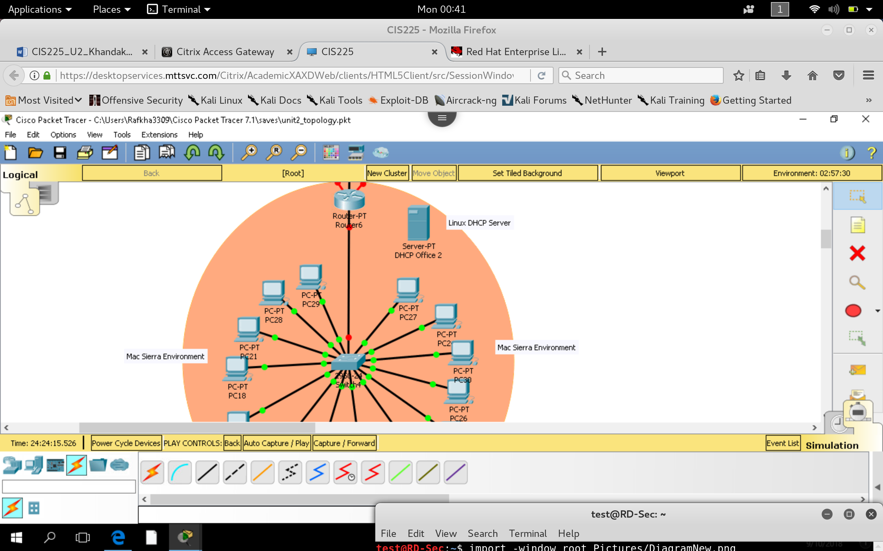

**Admin Group Controls**

Last but not least, I will implement admin controls on the North office. I will add another Server hosting LDAP, domain controller services. Admin computer can connect to the router and manage user accounts and have power-access into services using LDAP configuration.

I chose Admin controls on the Northern office because they have a larger department & may have more business resources. Applications on Server side can also access LDAP to check user groups for hosting application services.

