**ECPI University Rafat Khandaker**

**CIS_225 09/23/18**

**WAN Infrastructure**

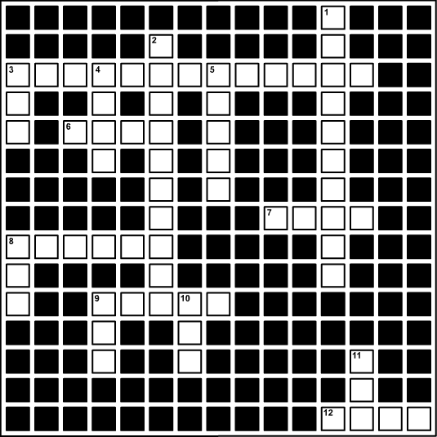 **ACROSS**  
  
3. A hierarchy of different digital signals that transfer data at different rates. (7,6)  
**Digital Signal**

6. A technology that allows more downstream traffic than upstream. (4)  
**ADSL**

7. A high-performance, multi-service switching technology defined by a set of IETF specifications that establishes and manages network traffic. (4)  
**MPLS**

8. A segment of the satellite system that provides access from Earth stations. (6)   
**GROUND**

9. A packet-based wireless telecommunication technology that provides wireless broadband access over long distances. (5)  
**WiMAX**

12. A telecommunication Earth station that consists of an antenna to transmit and receive signals from satellites. (4)  
**VSAT**

**DOWN**  
  
1. The packet-switched technology that allows stations to share the network medium. (5,5)  
**Frame Relay**

2. A hardware device that connects subscribers to the service provider's cable. (5,5)

**Modem**

3. The way a computer connects to the Internet using telephone lines at high speeds (3)

**WAN**  
  
4. A digital circuit switching technology that carries both voice and data over digital phone lines or PSTN wires. (4)

**VOIP**  
  
5. A standard for synchronous data transport over a fiber optic cable. (5)  
**SONET**

8. A navigational system that consists of a network of 24 active satellites and 3 satellites in the standby mode. (3)  
**GPS**

9. This protocol enables you to access the Internet from your mobile device. (3)  
**WAP**

10. The cell-switching network technology designed for the high-speed transfer of voice, video, and data. (3)  
**ATM**

11. A connectivity service for computer systems that connects multiple computers to the Internet by using a single Internet connection. (3)

**ICS**