**ECPI University**

# CIS225

# Unit 5 Lab Assignment 2

**By: Rafat Khandaker**

# Networking II: Using the ‘Hosts’ File

**Objective:** Students will gain an appreciation for the Name Resolution process by creating a manual name resolution.

**Resources**: Should have a Windows computer installed on a network with an ip Address. The student should know how to access and use the “ping utility”.

**Lab Tasks**

**Part I: The Hosts File**

1. Log on as Administrator to Win Xp Professional or similar
2. Point to Start🡪Programs🡪Accessories🡪Command Prompt
3. Type Ipconfig and make a note of the ip address. **192.168.1.6_**
4. Using Windows Explorer, navigate to the C:\\winnt\system32\drivers\etc’ folder. This directory contains the hosts file
5. To modify the hosts file, open with notepad. Press Enter. Notepad opens with the text of the hosts file
6. Locate the bottom of the file, place the cursor at the end of the line for the sample entry for localhost and press enter to create a new line. Type your ip address from step 3. Press the tab key then type the word ‘me’ This entry should be on a line by itself with no # sign before it and will look something like the following when done

127.0.0.1 localhost

10.90.9.222 me (note, you will put the ip address from step 3 here)

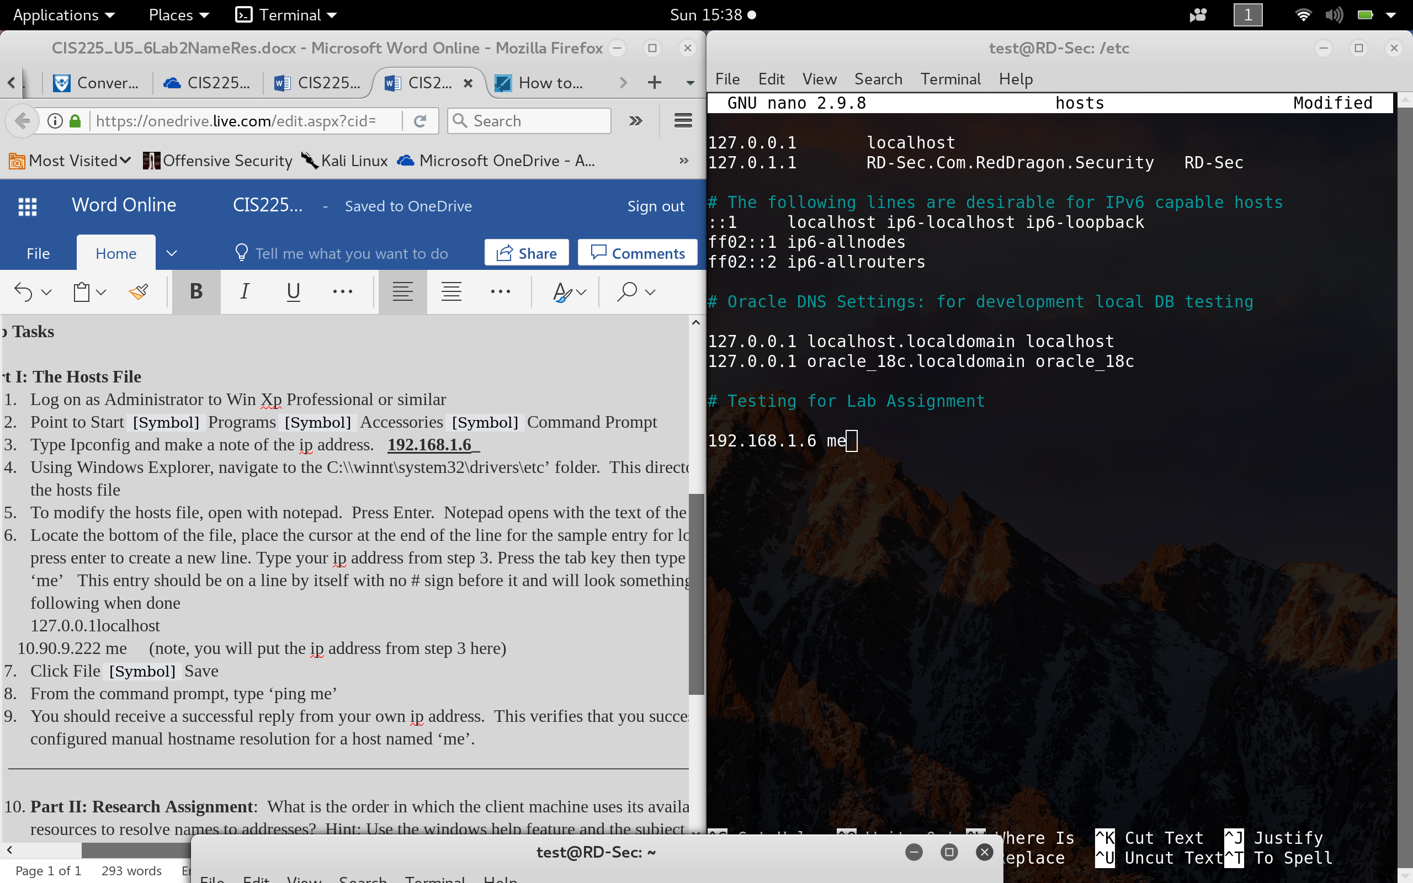

1. Click File🡪Save
2. From the command prompt, type ‘ping me’
3. You should receive a successful reply from your own ip address. This verifies that you successfully configured manual hostname resolution for a host named ‘me’.

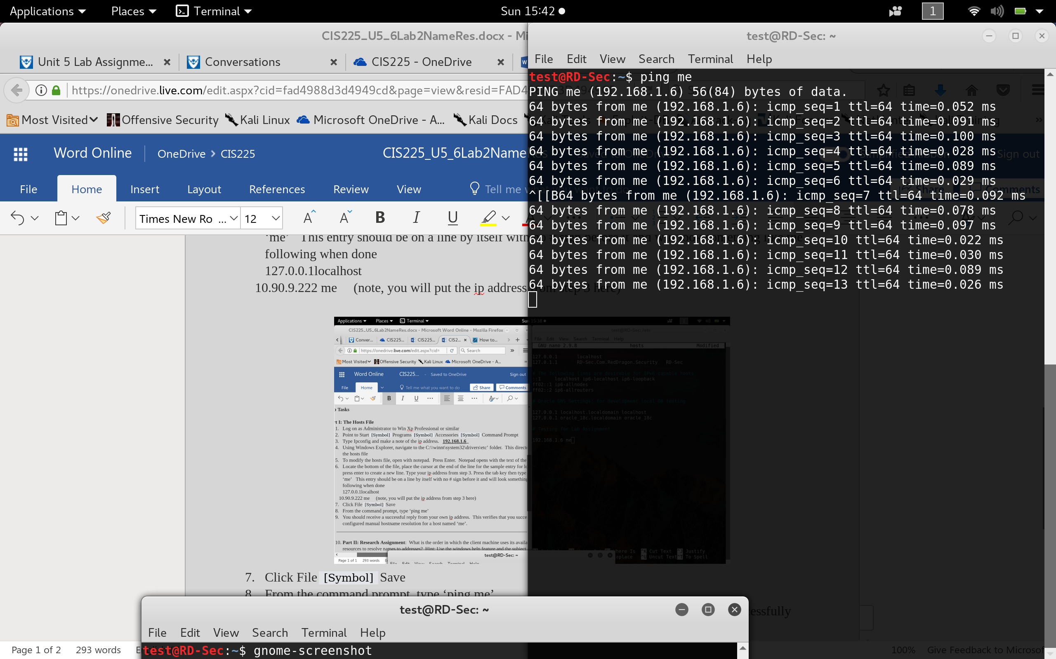

1. **Part II: Research Assignment**: What is the order in which the client machine uses its available resources to resolve names to addresses? Hint: Use the windows help feature and the subject “name resolution”

1 Client Checks if the query is its own

*2 Checks* ***Hosts*** *file*

*3 Domain Name Syste (****DNS****) server is Queried*

*4 If the name is not resolved,* ***NetBIOS*** *name resolution sequence is used as backup*

*5 NetBios is used with* ***WINS***

**References:**

Sichao. (2018). *Name Resolution & Domain Name System*. Retrieved From: <https://notes.shichao.io/tcpv1/ch11/>