**ECPI University Rafat Khandaker**

**CIS 225 09/30/18**

**Unit 5 Case Study 2**

Canyon College began strictly as a liberal arts college, but for the past five years has been developing programs for business and professional students, including outreach programs to new areas within the same region. The college hired the company you work for, Network Design Consultants, to provide help with emerging WAN needs as they are developing these new programs.

**Task 1: Providing WAN Services to Remote Cities**

Canyon College plans to offer night classes for business school students, paralegal students, and nurses, in five remote cities. Their plan is to have professors offer the classes from the main site, and to use video conferencing and multimedia options at the remote sites. At the main site, they have a TCP/IP Ethernet network. The remote sites, which are not yet set up, will also have TCP/IP Ethernet networks. The Canyon College director of information technology is asking you to recommend two WAN options to connect the remote sites to the main campus, and to provide a rationale for the options you recommend.

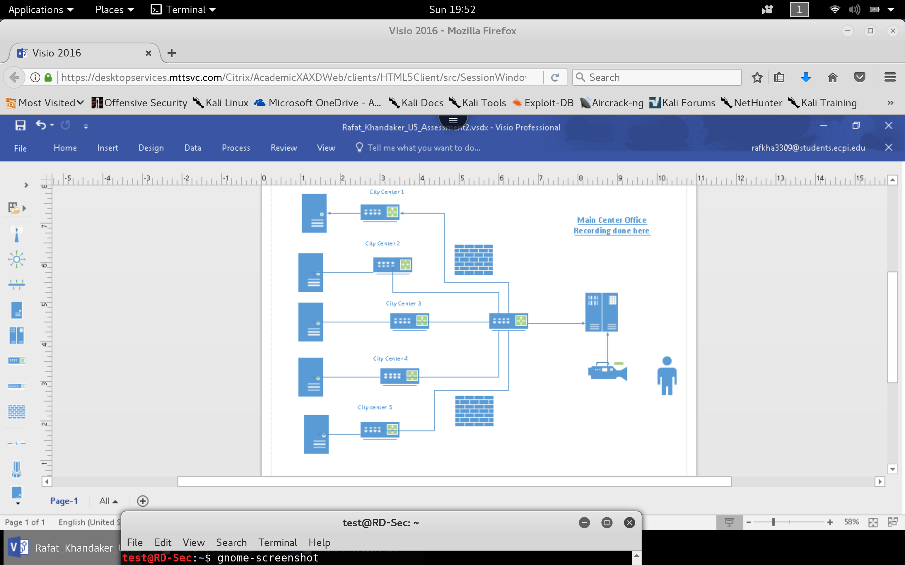

**WAN Options:**

*Because we will be separating the main – Central network traffic between multiple nodes on our network, we will use a tree like structure separation of bandwidth traffic.*

* 1. **SONET Leased Lines:** *First WAN option I will provide is 1 SONET OC-48 filter into 5 OC-3 dedicated Leased Lines. Because we will be filtering video- live streaming into the classrooms on far cities, we need to provide* ***QOS (quality of service)***. *The best technology that provides long distance leased lines with disaster & EMI proof quality are fiber-optic technology. Fiber optic allows long distance transmission, High band-width & security from eavesdropping, cross talk or external hazards. Also, leased lines are dedicated & permanent lines to handle traffic.*
  2. ***T3 Leased Lines using PVC:*** *Alternatively, we can save money by using T3 Lines on a PVC circuit. This will ensure permanent connection on a scalable bandwidth, saving money. We lose some quality in bandwidth & potential quality of the connection. If the network is proving to have strong up-time percentage, it may be negligible.*

**Task 2: Teaching Classes from Home**

The Canyon College president enjoys participating in several classes once a week as a guest lecturer or tutor, but she wants to do this from home, so she can spend more time with her family instead of driving back to the college, which is about two miles away. One of the requirements is that she needs to be able to use the telephone in her home office at the same time that she is connected to the main college network.

* + **T1 Direct Service Line:** The president can be allowed to actively be connected into her office network through a T1 Direct service line into the office, Her modem can split the phone line, using VOIP & QOS.
  + **POTS with VPN through Internet:** The President can use a direct POTS/ ISDN connection into her office phone while her network access into the office is configured with VPN through internet.
  + **ISDN with VOIP:** The president can use a digital line into the office, using VOIP configured through a cisco phone. Her intranetwork can be connected through VPN and home internet.

**Task 3: Troubleshooting Connectivity**

The Canyon College president calls you in a panic to report she cannot access the school's Web server from her office on campus, but she wants to troubleshoot the problem herself. Is there is a quick way she can test the Web server's connectivity?

* + To test her connection to the Web-Server. We will first do a ping test into the web-server's ip-address. If the IP address is successful than we will go ahead and do a NS-lookup. We will do an ipconfig to see if her computer network has changed. If the test has failed than we will do a ping test from our computer. If we can access the server, than the web server is up. We will proceed to test her connection. We will do a traceroute from her terminal and work our way to isolating the network node or her computer, itself.