ECPI University Rafat Khandaker

CIS_126 08/09/18

Unit 3 Guided Assignment 1

Part 1

1. Open your Visual Studio 2015 Xen-Desktop image, create a new project, and type the coding segments down below into the compiler. Run the program(s) (Debug > Start without debugging). If you are asked to re-build, select yes to ensure that you are compiling the latest typed code. If you are asked to run your last successful build, check the box not to ask you again, and select No. Make sure that your output details box is open so that you can see where any errors may have occurred. See screen shot below:

**Incorrect**

*In this example, we have a syntax error after the commented line. Our program fails to recognize the ending block after failing to close the comment.*

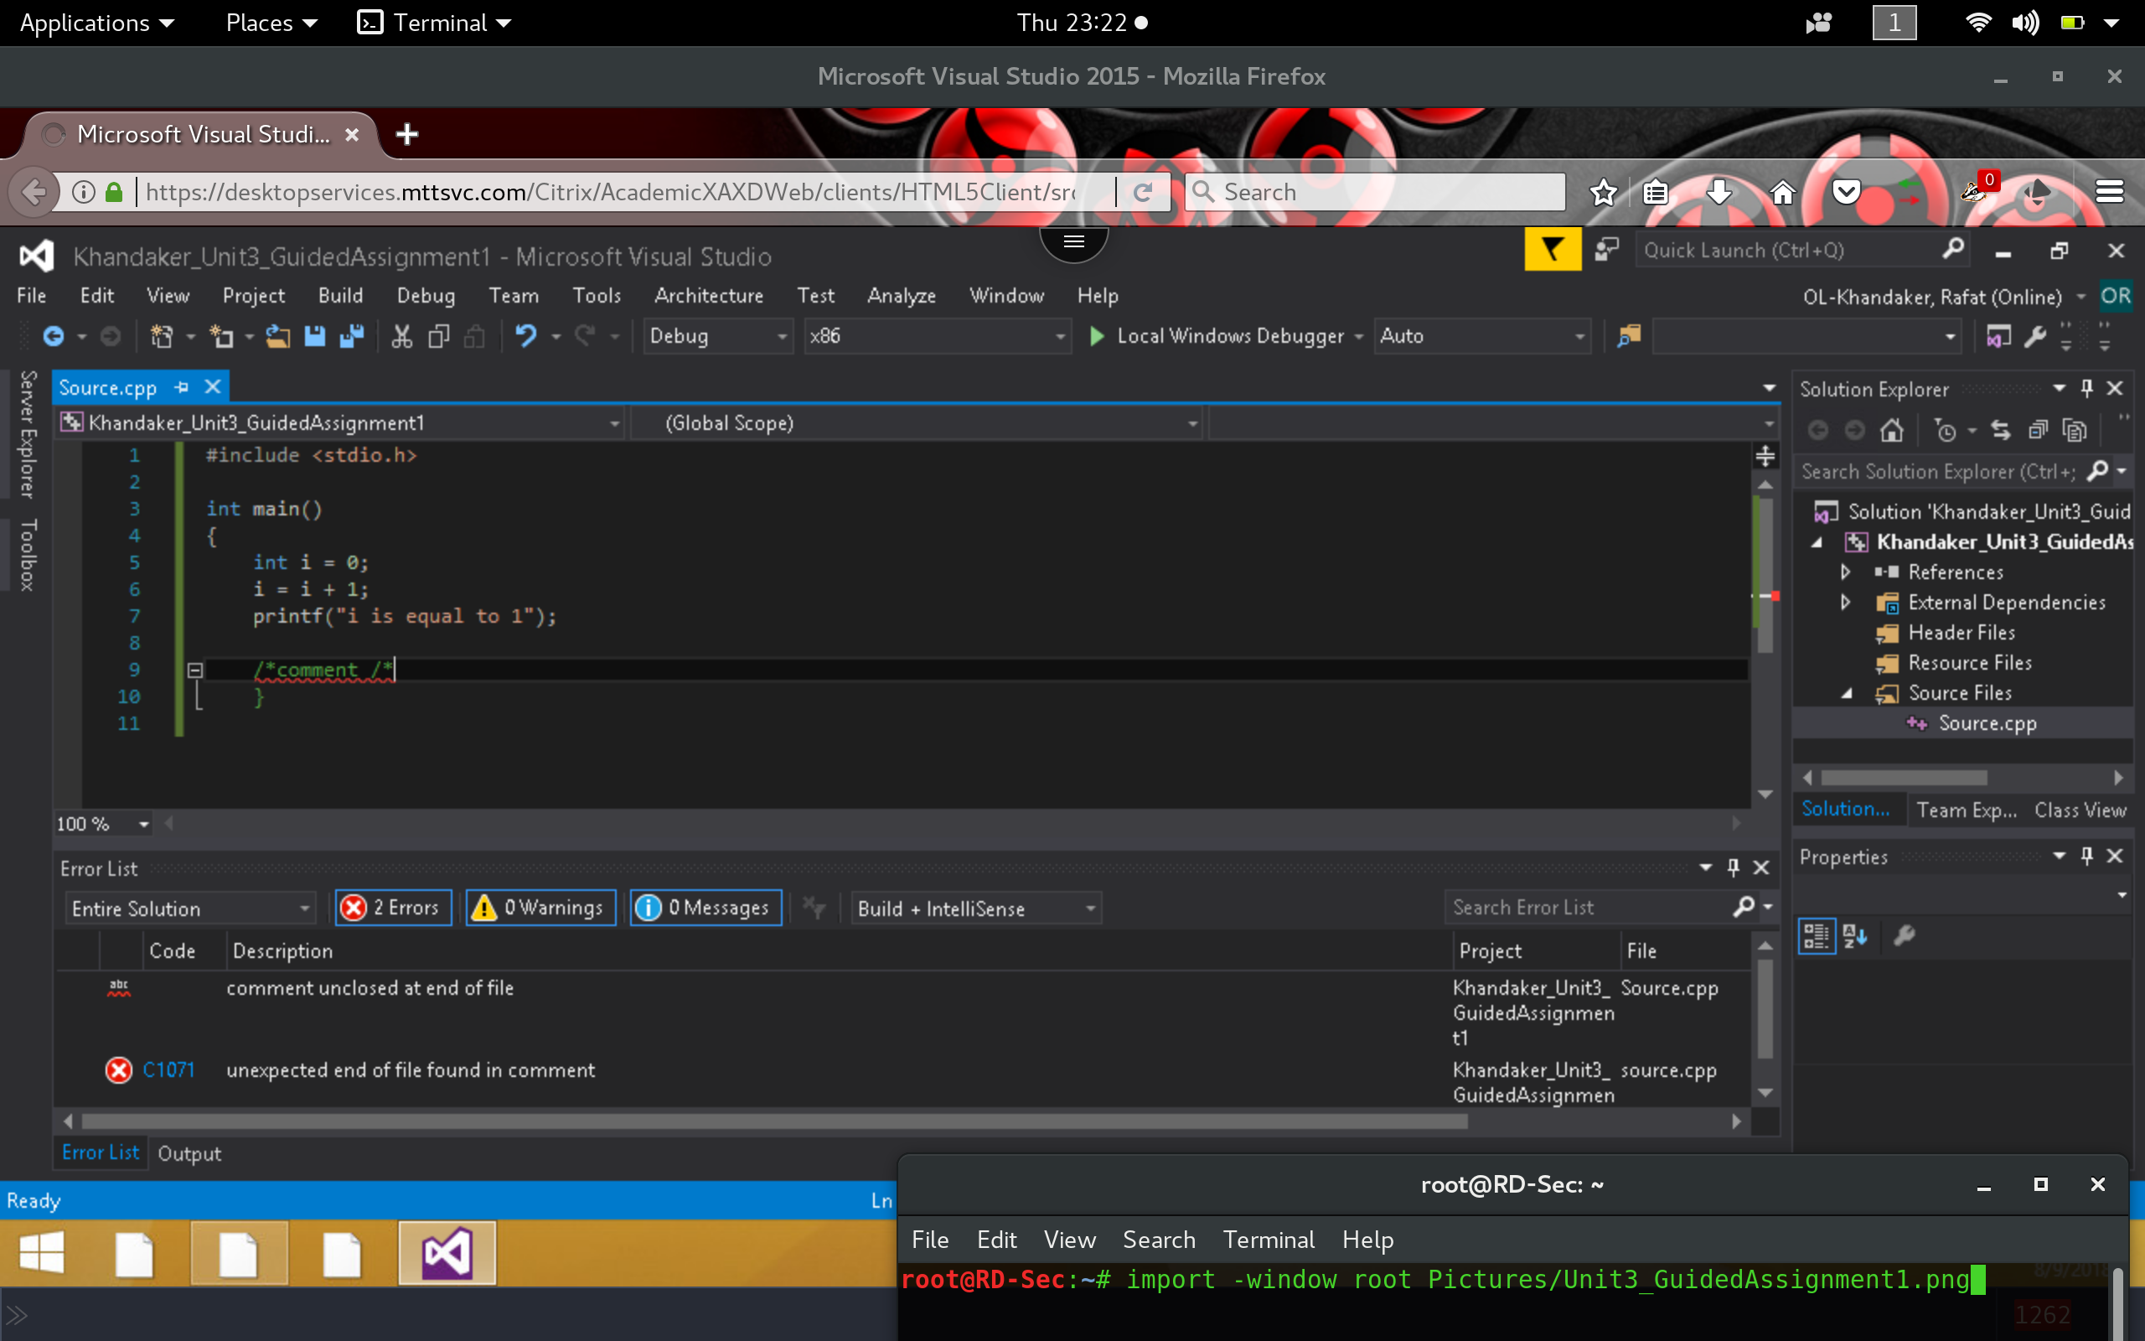

**Correct**

*After closing the comment correctly, our syntax error disappear & our build succeeds with 0 errors.*

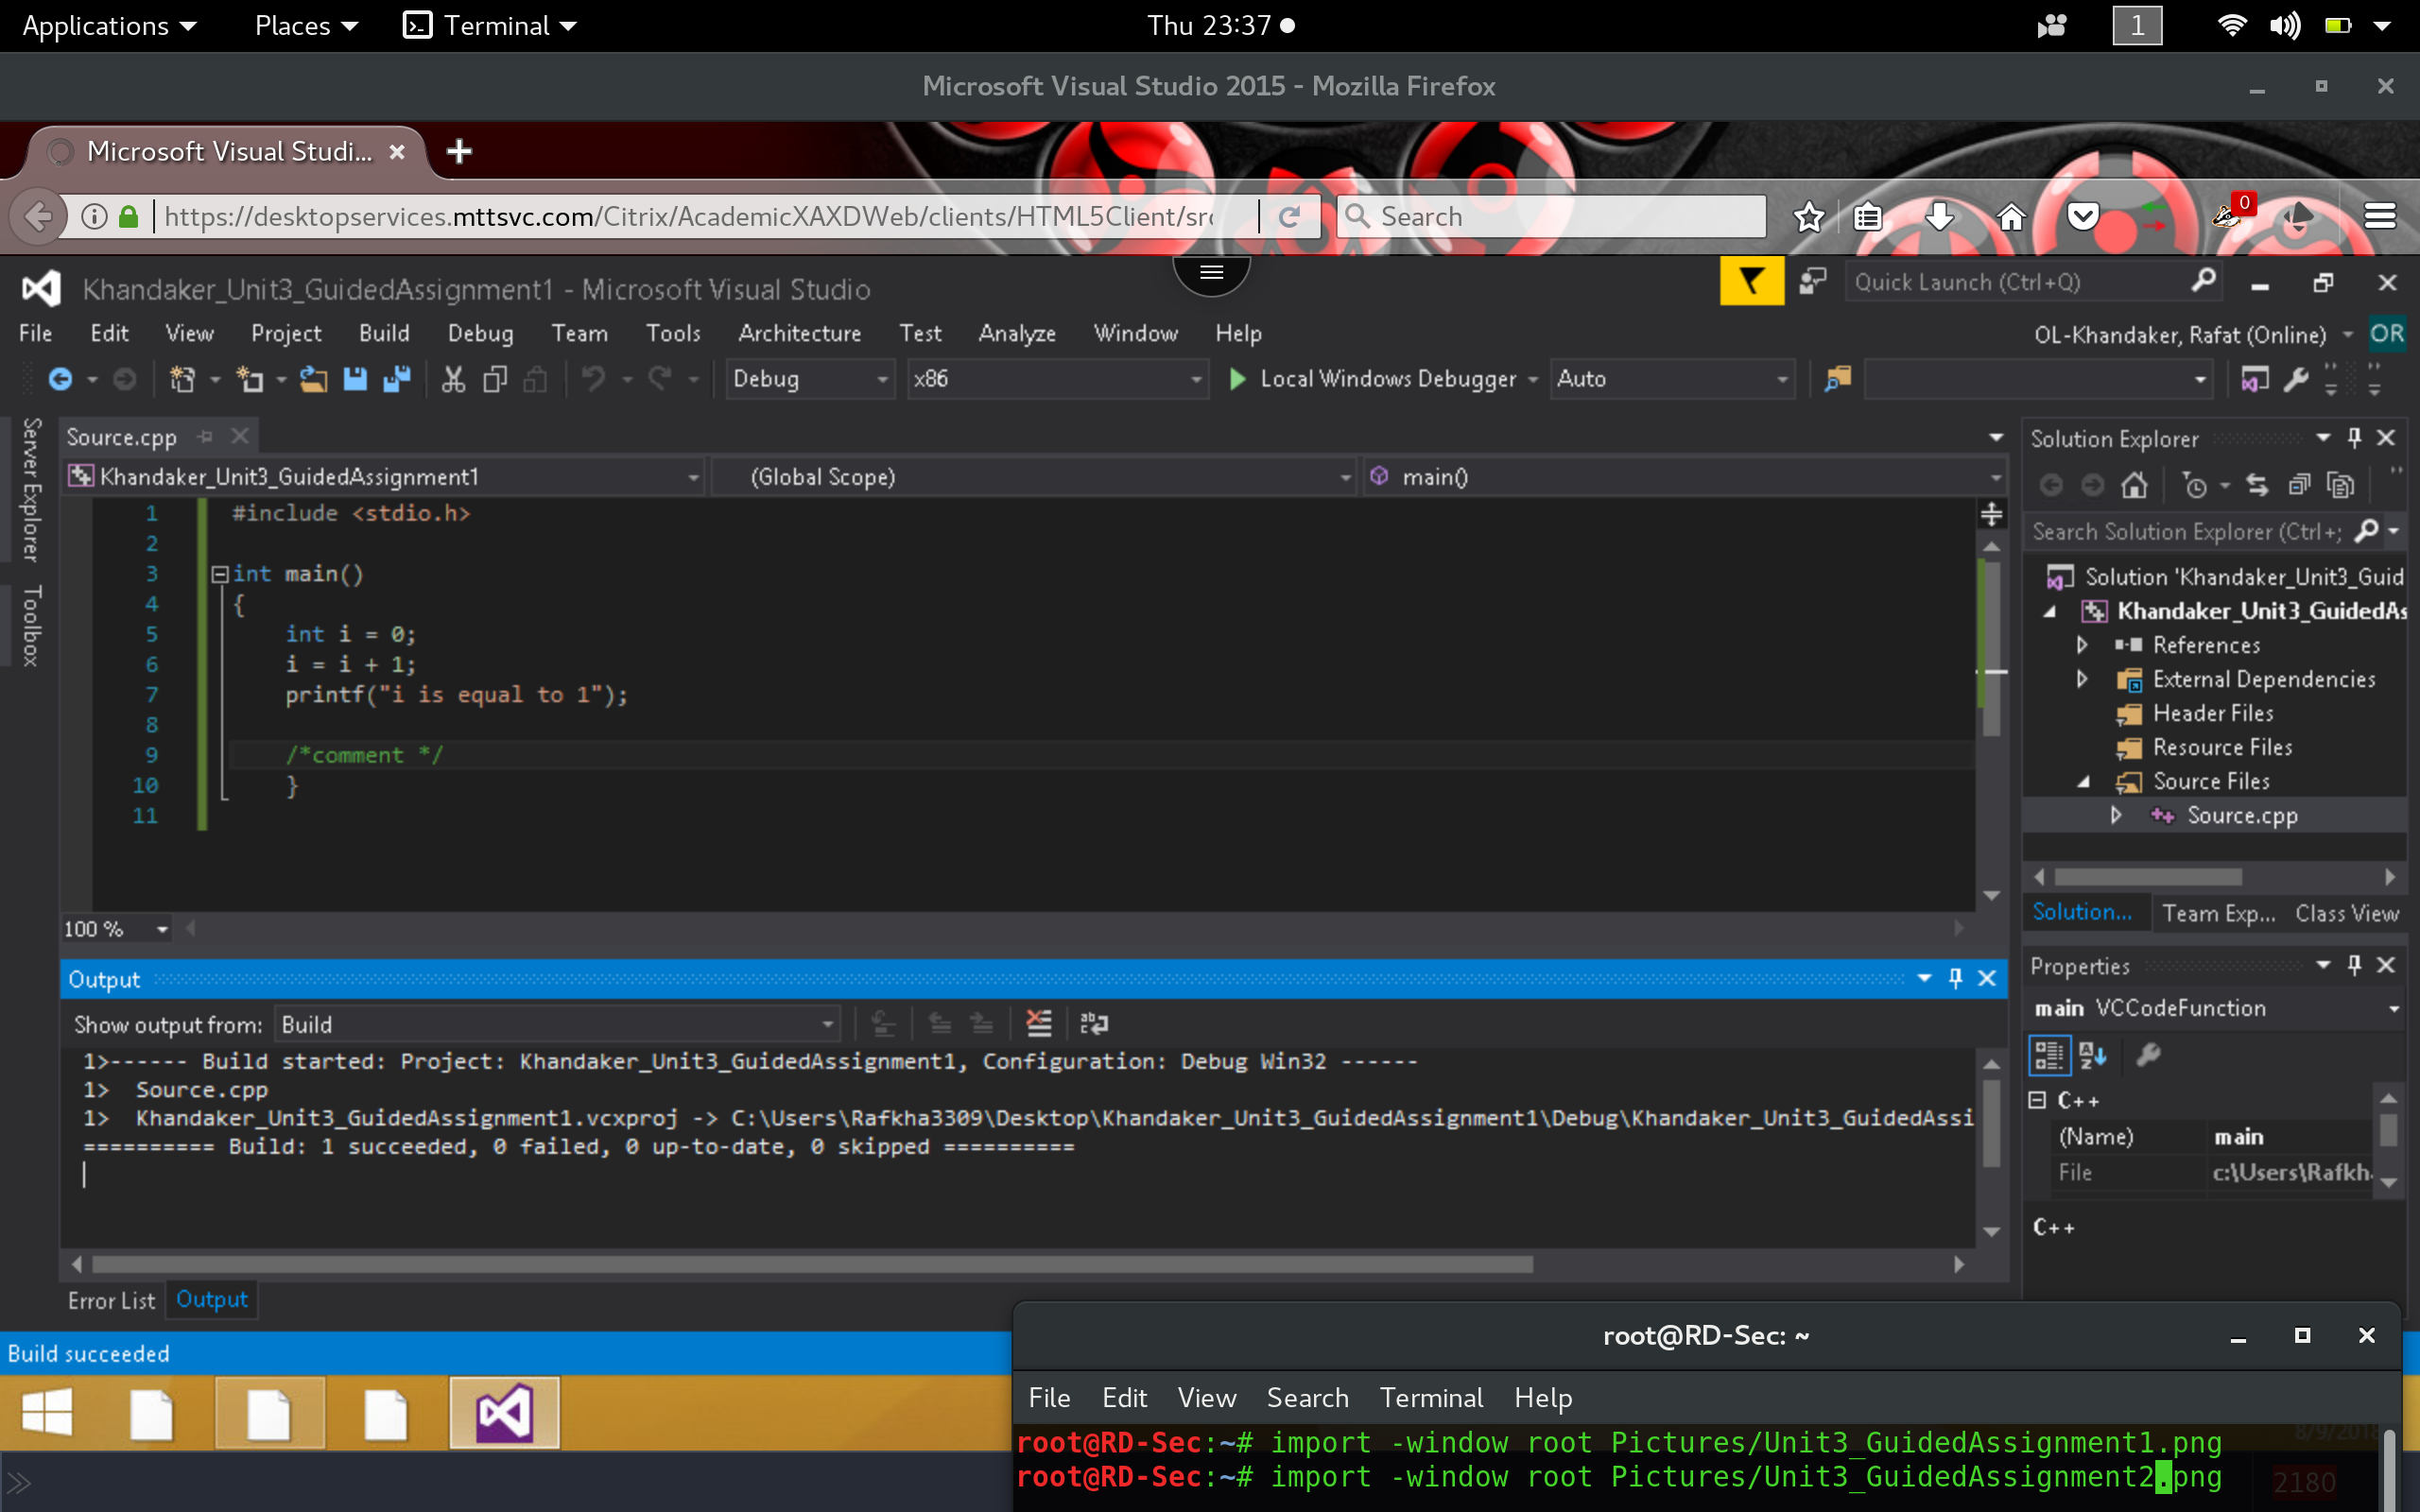

Part 2

1. Execute the following coding segment and identify the errors in the program. Debug the program and provide the correct version of the code. Note: The errors can be syntactical or logical.

*The following code contains no errors & executes with the correct output results.*

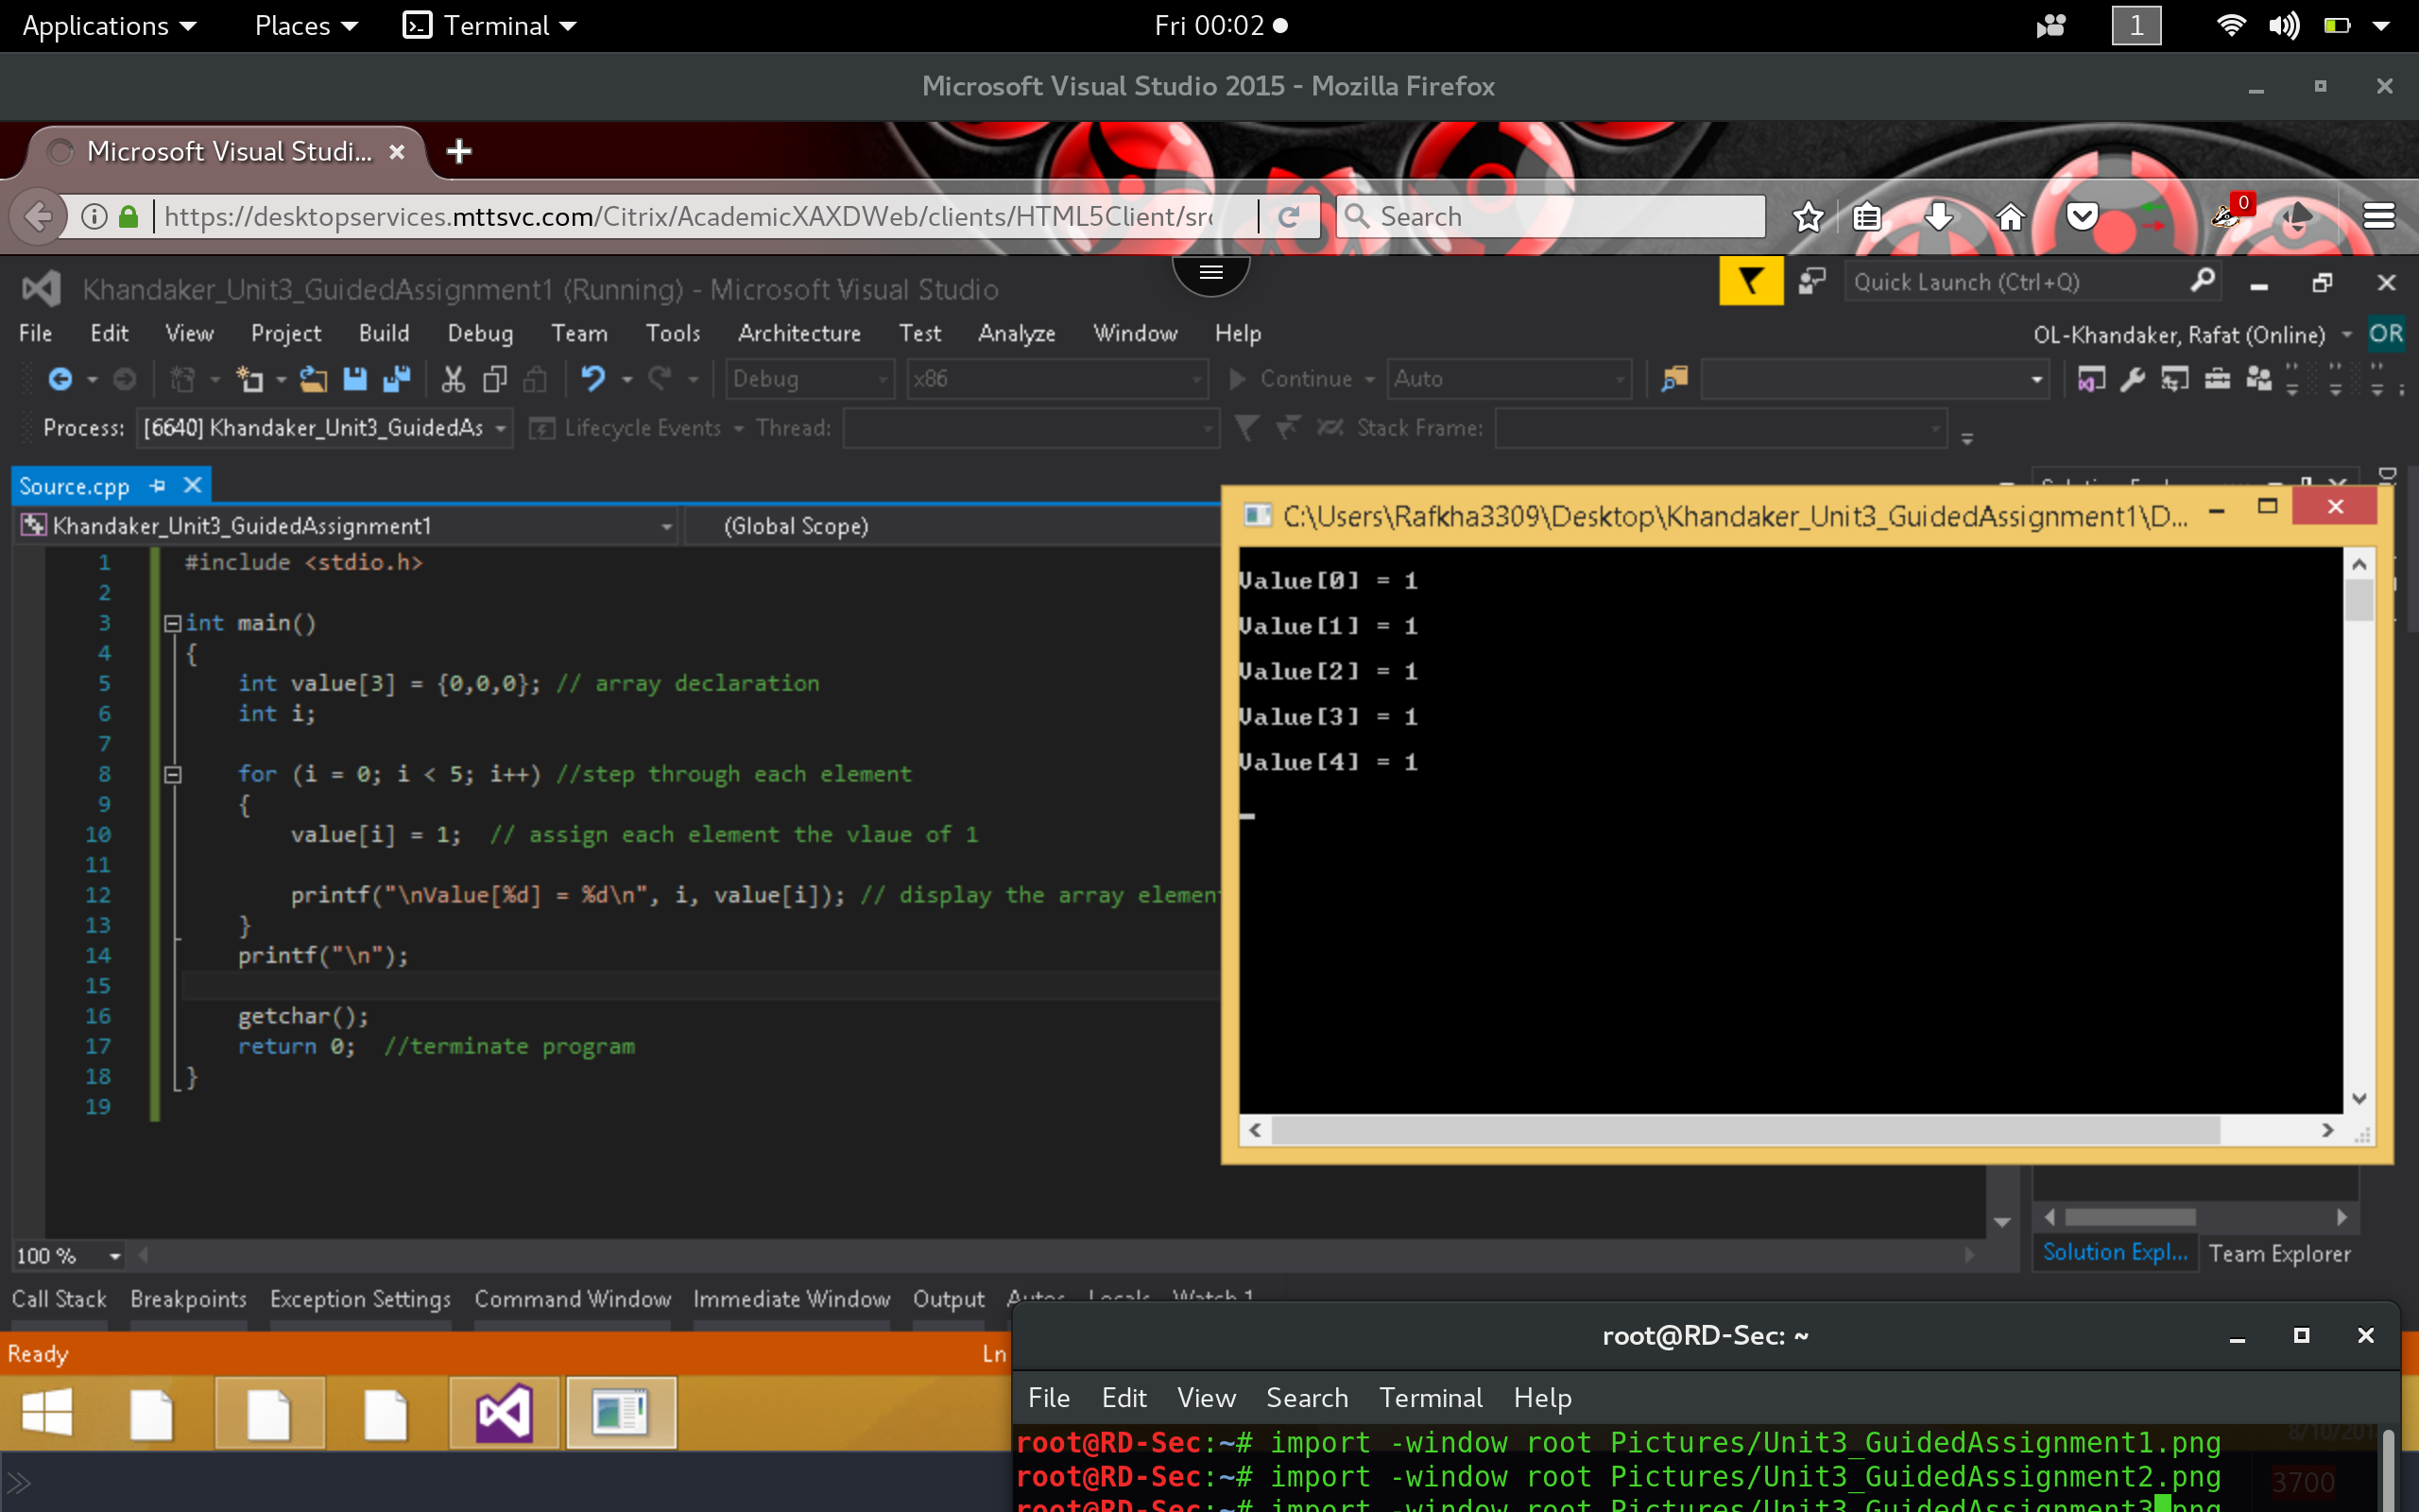

1. Adjust the program to hold 10 elements in the array and store the value of 100 in each. Submit the new code for review?

*The adjusted code contains 10 arrays with value of 100 at each value.*

