ECPI University Rafat Khandaker

CIS_126 07/26/18

Unit 2 Assignment

1) Copying the example into our IDE project file.

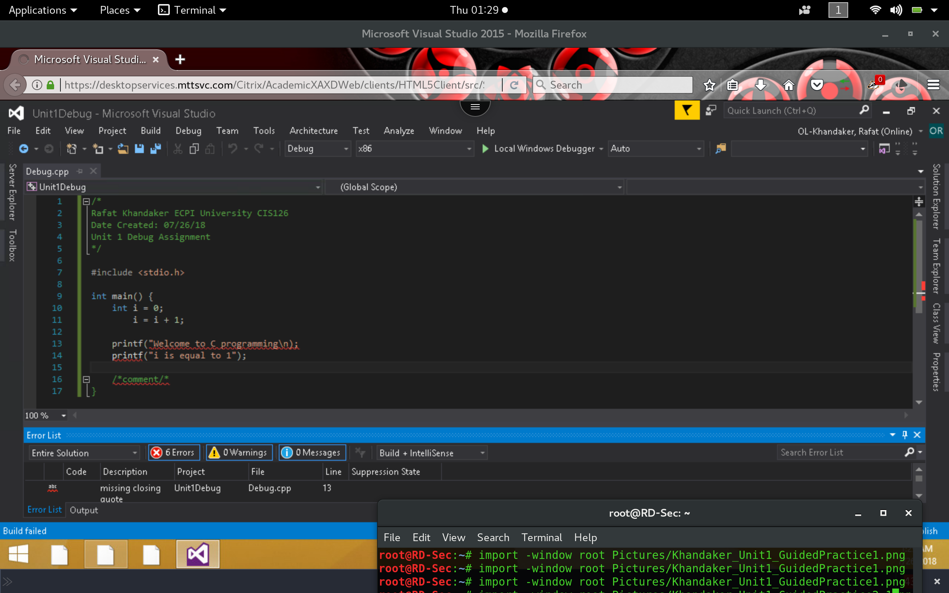

2) 6 Errors were discovered by our compiler after building the project. Errors are related to syntax errors in line 13, 14 & 16. Because the Program in C will run in sequential order, the syntax error in 13 will cascade down to lines 13 & afterwards. Missing quotation in line 13 will not allow the compiler to read line 14. The compiler finds a bug in line 16, related to an unclosed comment. Error in line 13 cascades to unable to find a closing tag for lines 14 & 18.

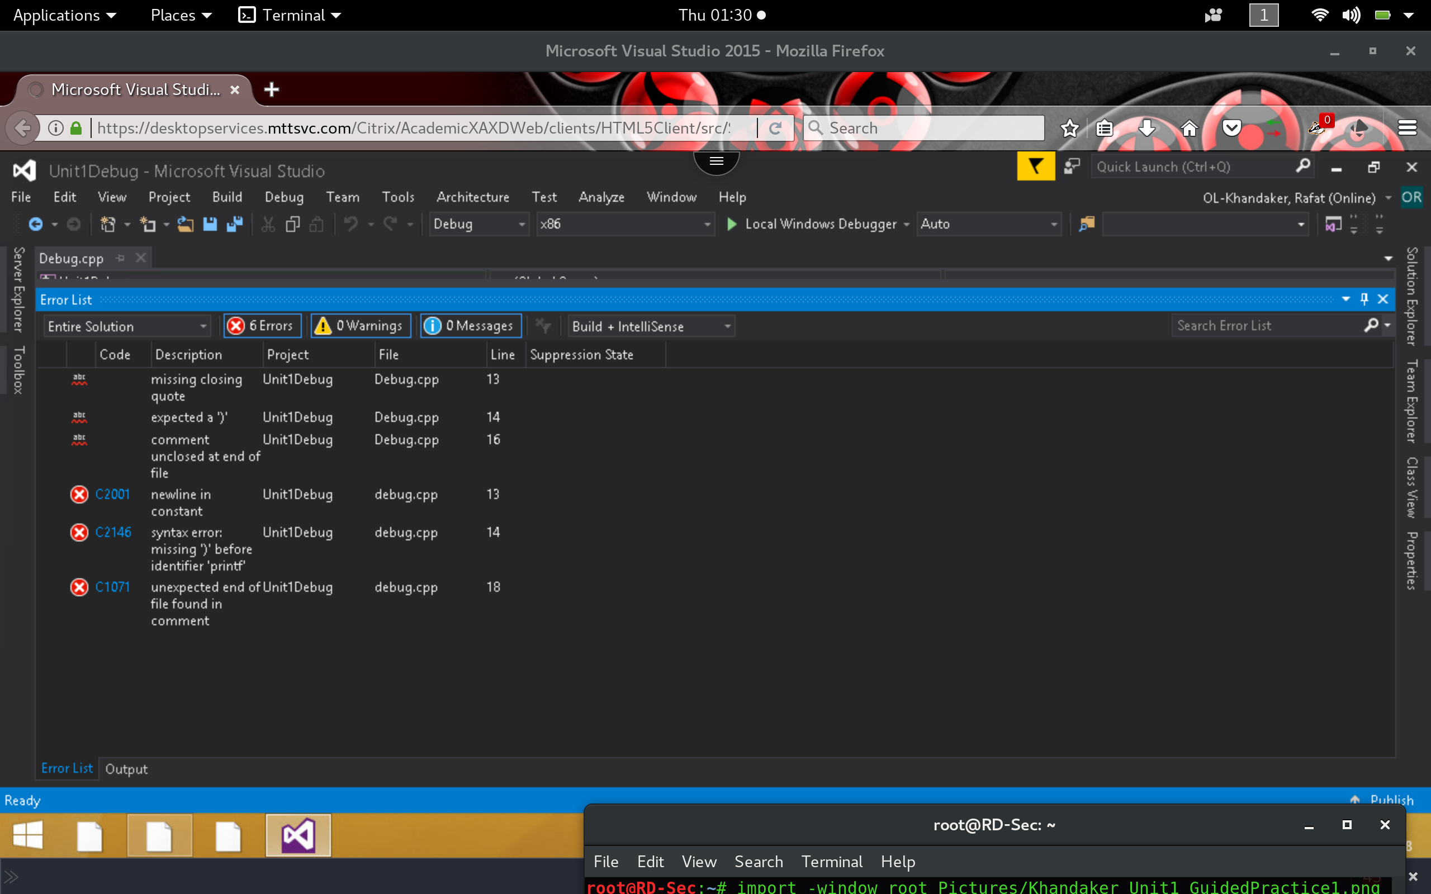

3) Fixing the errors & re-building the project will produce 0 errors & build the project successfully.

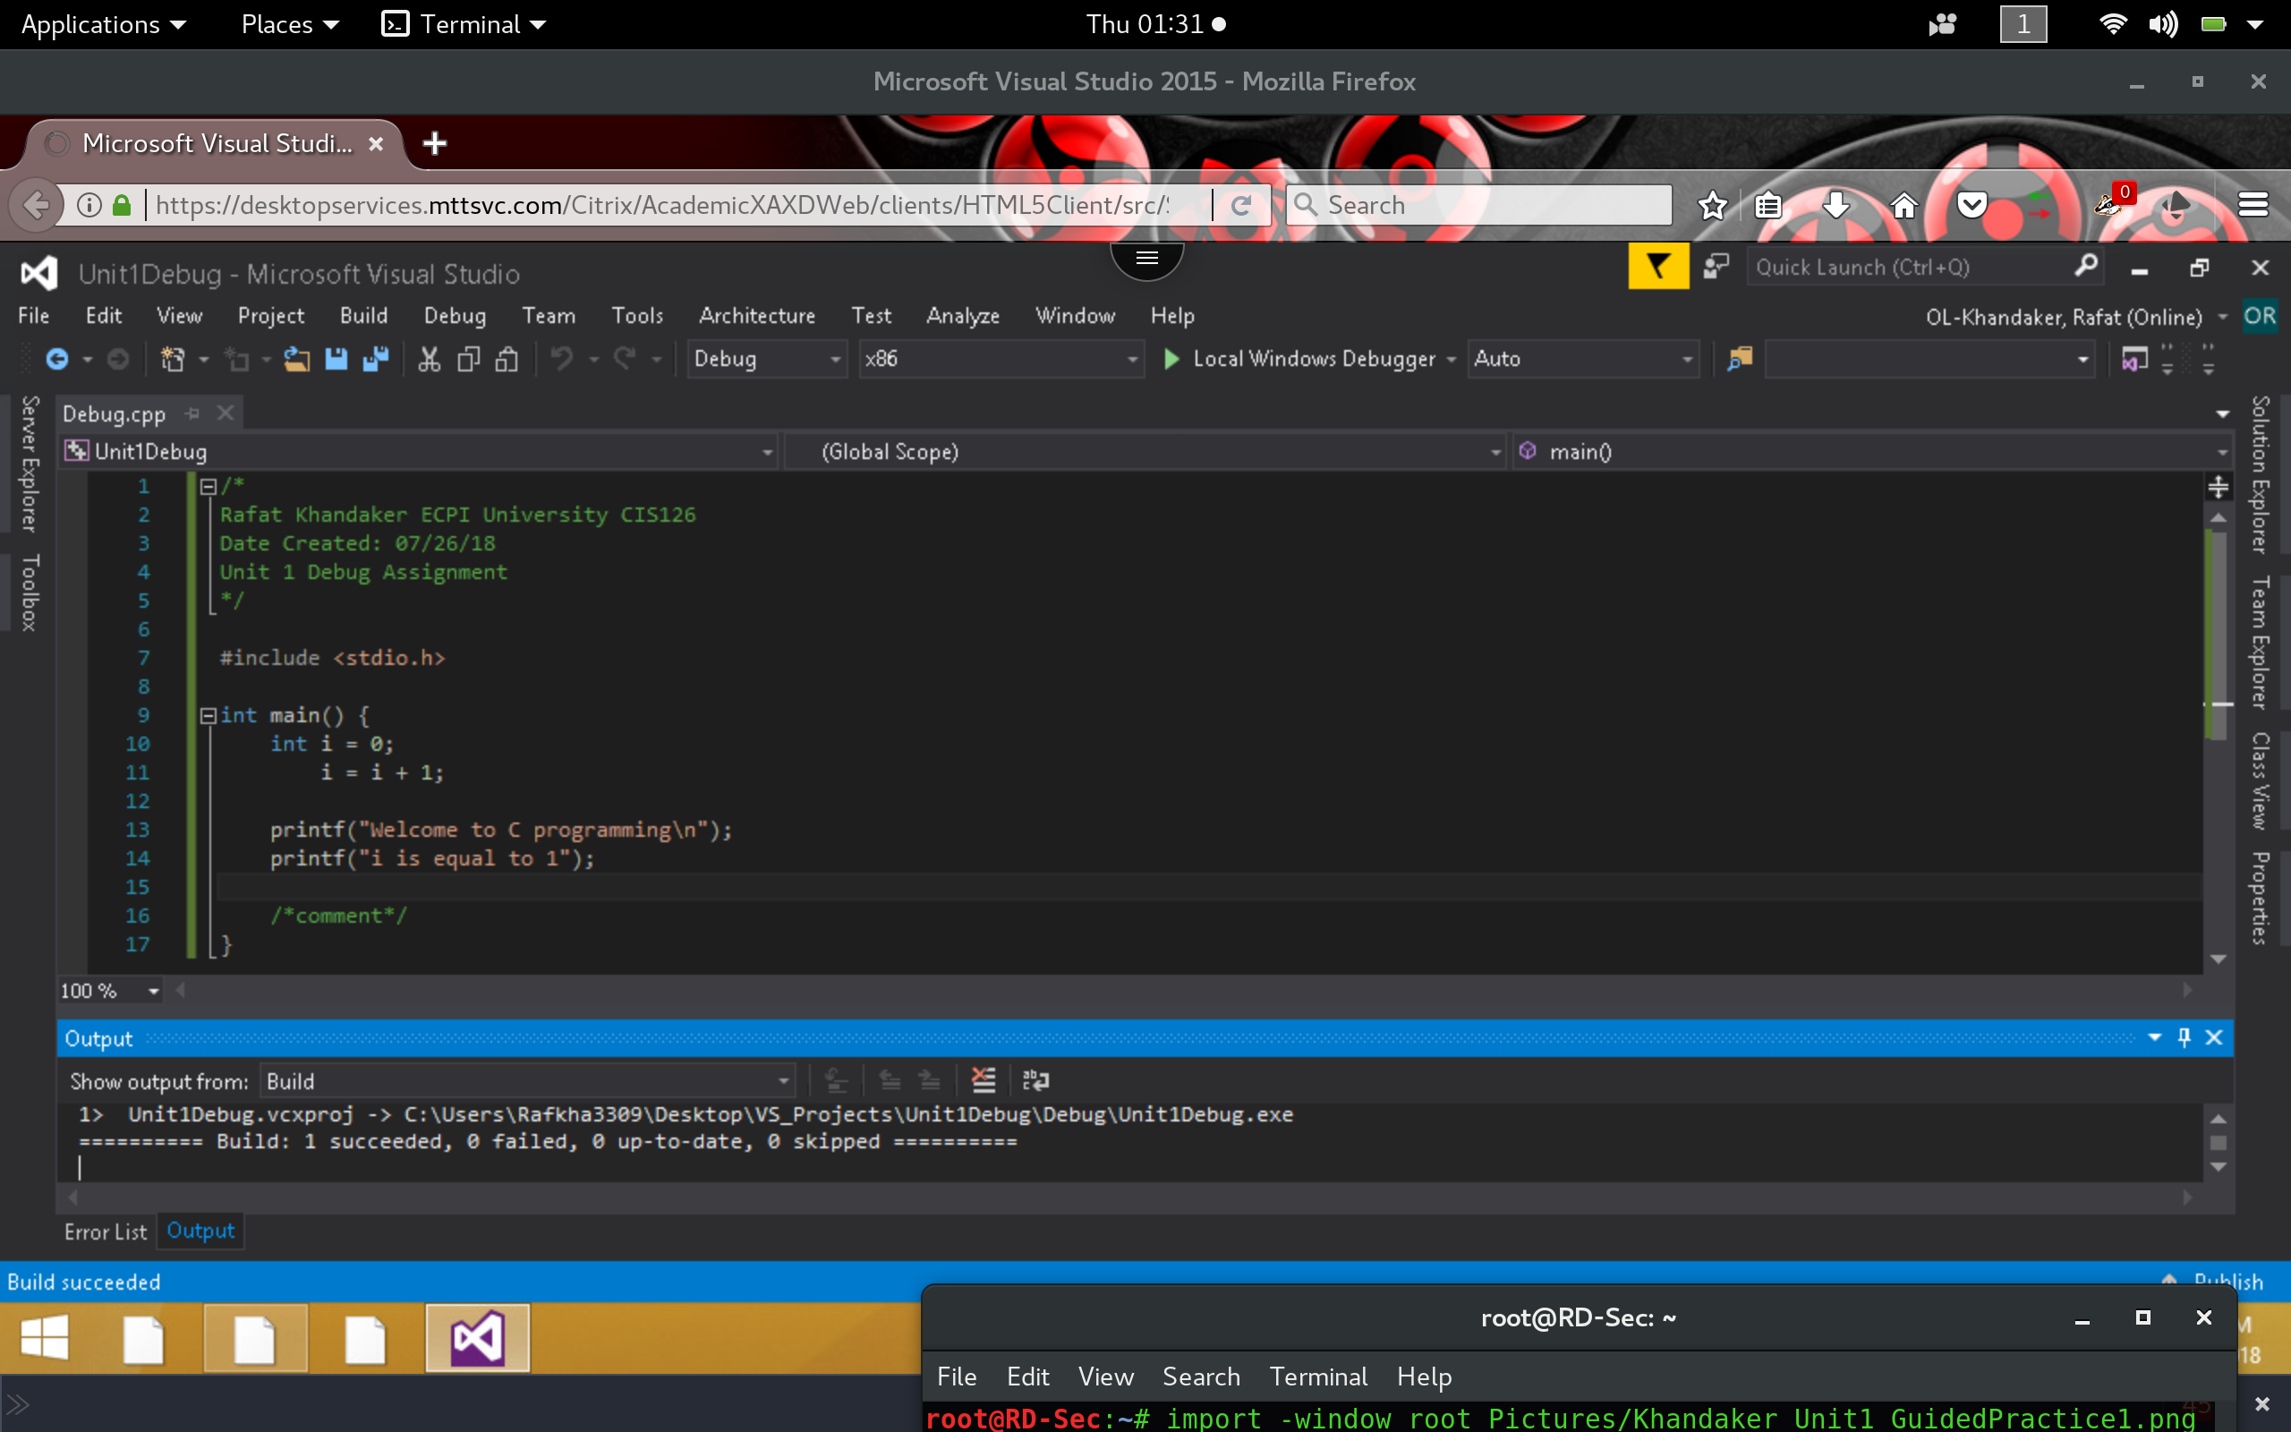

4) Running the application will show the command output.

