ECPI University Rafat Khandaker

CIS_126 08/04/18

Unit 2 Guided Assignment

*Step 1* :

Open your Visual Studio 2015 Xen-Desktop image, create a new project, and type the coding segments down below into the source file. Run the program(s) (Debug > Start without debugging). If you are asked to re-build, select yes to ensure that you are compiling the latest typed code. If you are asked to run your last successful build, check the box not to ask you again, and select No. Make sure that your output details box is open so that you can see where any errors may have occurred.

*After building the project we can clearly see that syntactical errors exist in the project with the “red line” & error list output.*

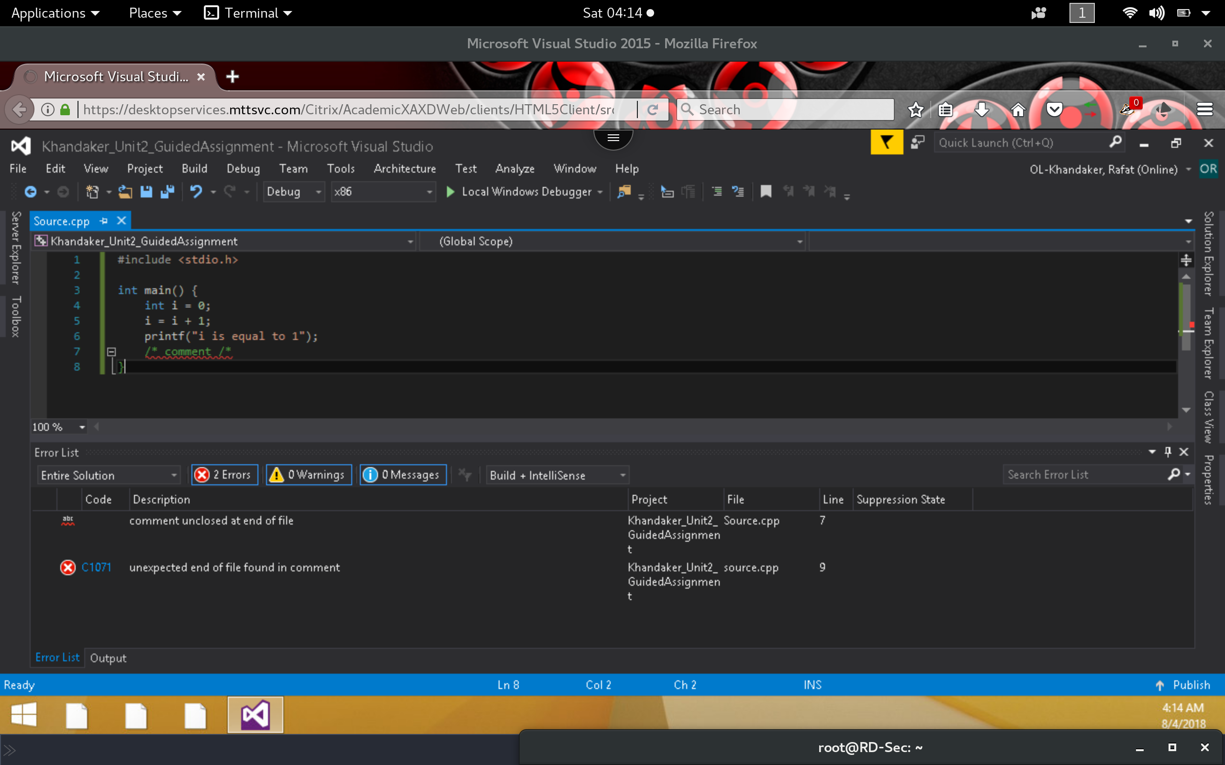

*After fixing the errors, our error output disappear.*

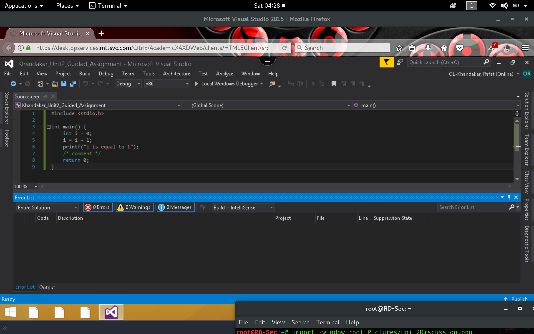

*Step 2* :

Execute the following coding segment and identify the errors in the program. Debug the program and provide the correct version of the code. Note: The errors can be syntactical or logical.

*In here, we see the syntactical error in line 6 that is described in the error list output*

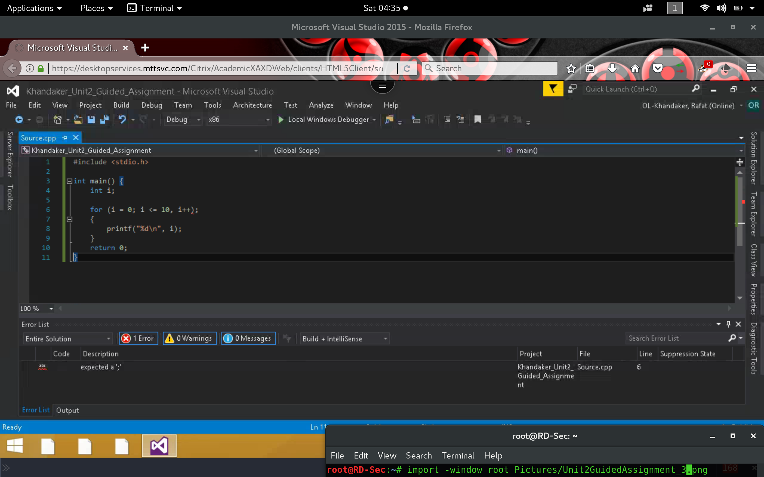

*Removing the ‘;’ & replacing the comma with semi-colon will remove the error list.*

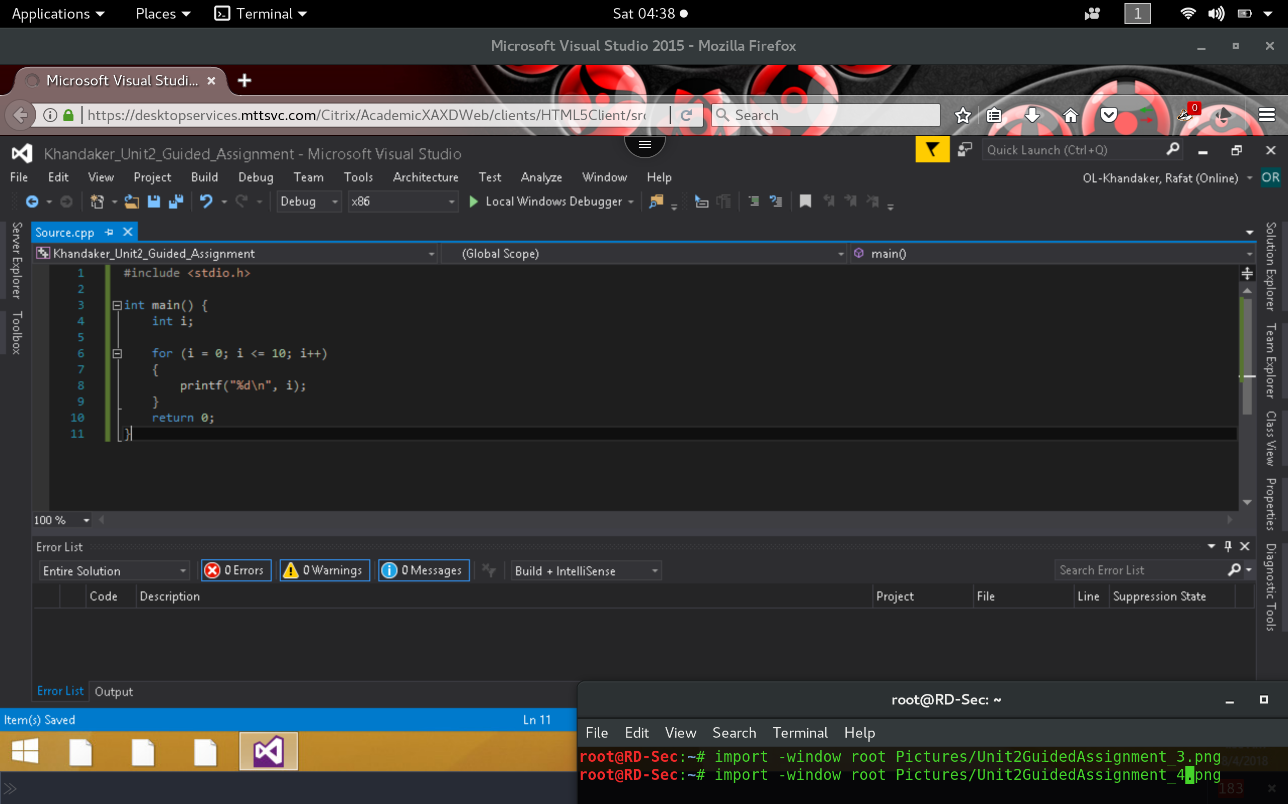

*Output of program*

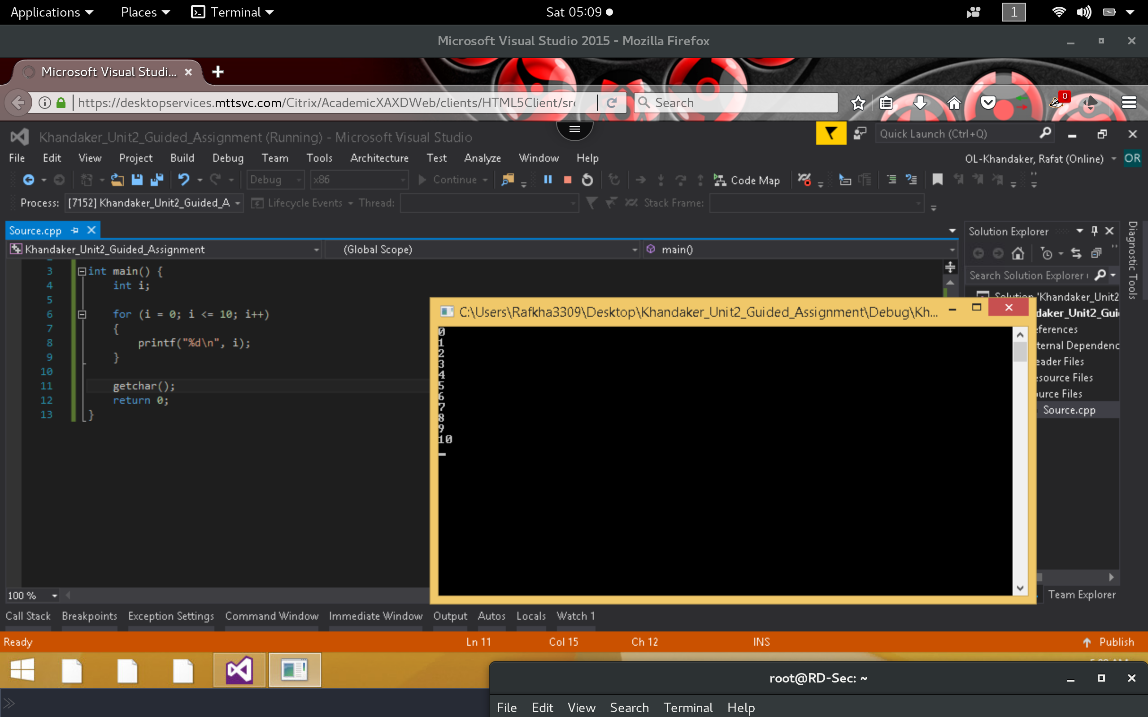

*Part 2:*

*In this program, a counter was initialized to 1. A while loop will run through the counter until the value is incremented to 5 (4 times). The while loop is exited & prints the value of the counter.*

