ECPI University Rafat Khandaker

CIS_126 08/17/18

Unit 4 Guided Practice

Step 1

1. Open your Visual Studio 2015 Xen-Desktop image, create a new project, and type the coding segments down below into the compiler. Run the program(s) (Debug > Start without debugging). If you are asked to re-build, select yes to ensure that you are compiling the latest typed code. If you are asked to run your last successful build, check the box not to ask you again, and select No. Make sure that your output details box is open so that you can see where any errors may have occurred. See screen shot below:

**Incorrect**

*Output of compiler has caught 2 errors & one warning on build. This is because we have not imported the location of the isdigit() method. (cType.h)*

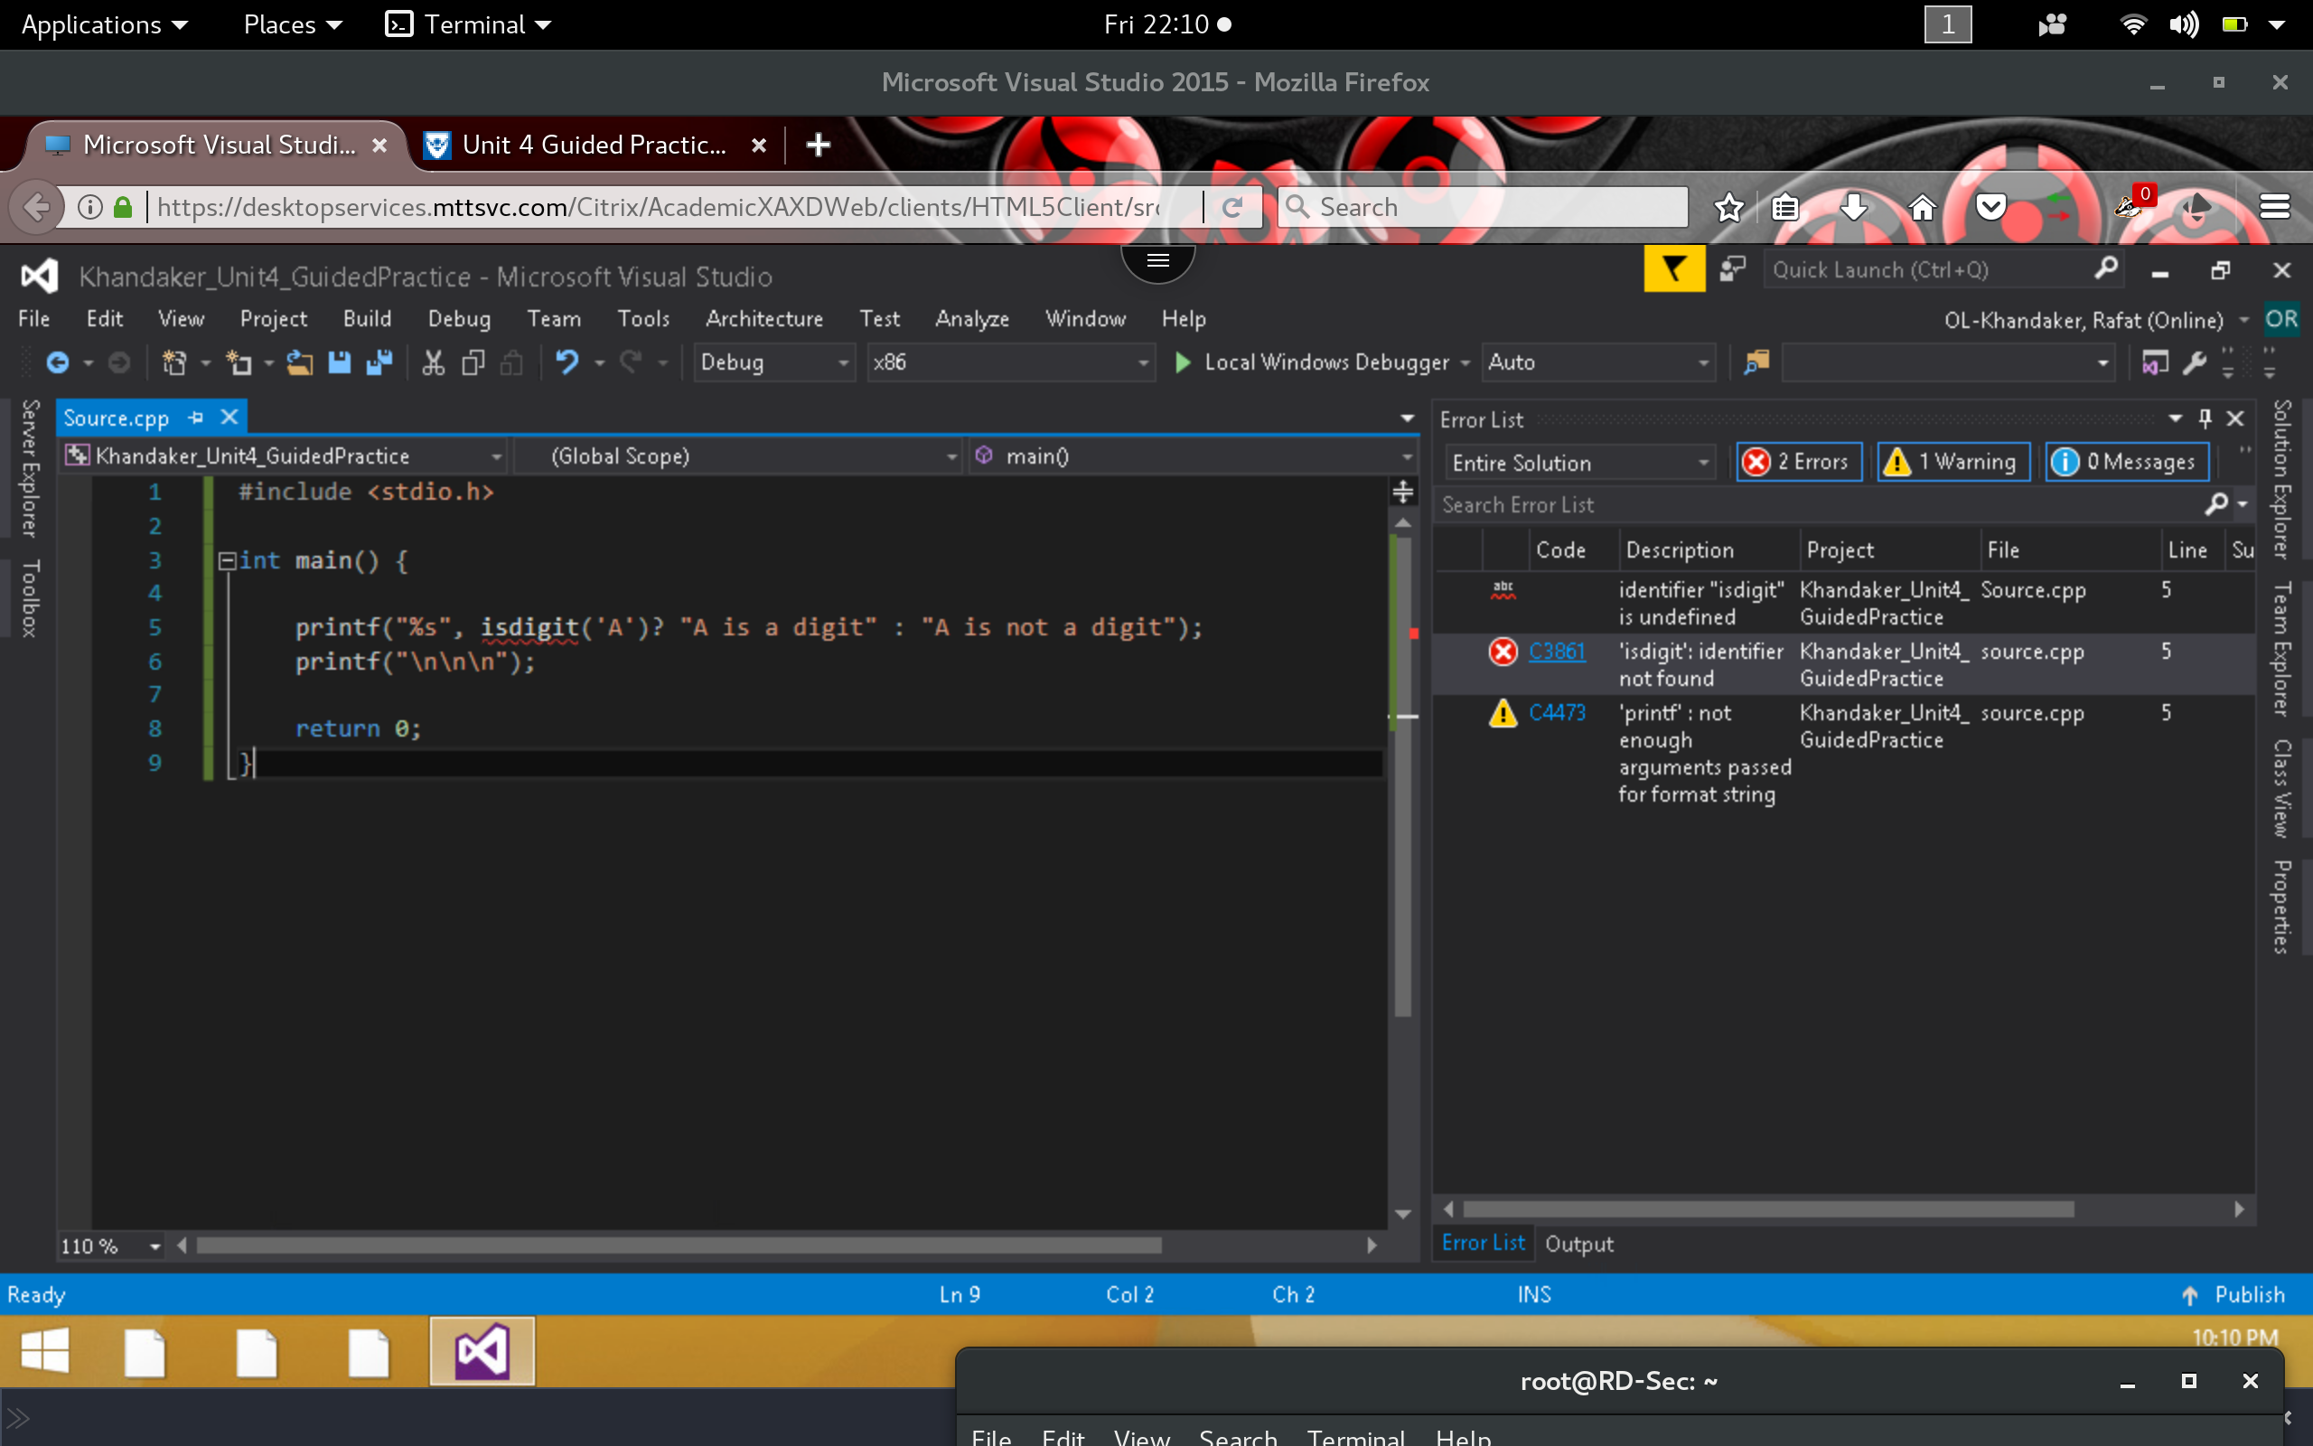

**Correct**

1. *After importing the <cType.h> library into program, we have gotten rid of our compiler warning, errors & successfully is able to execute our code into command prompt.*

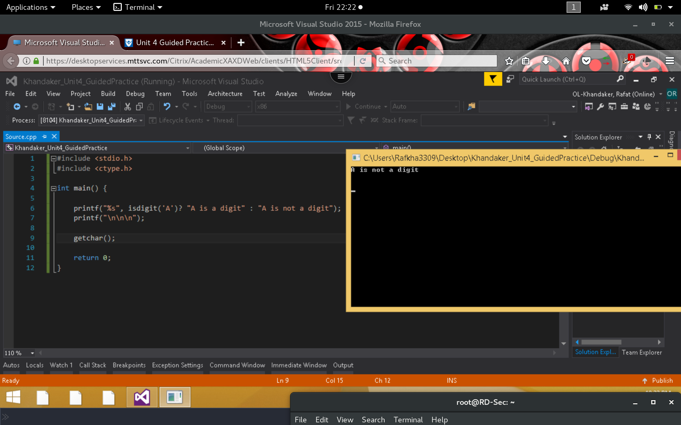

1. The isdigit() function reads a character and tells us whether the representation of the character contains 0 to 9. One could use this function to verify user input. Perhaps the user data is coming from a file that needs to contain numbers to do some calculations. Only those lines containing numbers can be included. How might you use this function in a real-world scenario?

*In a real world example, we can create a program that can separate characters from numbers using the validator isdigit() method. For example, we can read a stream of data using the scanf function, then we can, iterate through this string as a char[], evaluate each value and add it to a sum . We can place a condition: “if contains a digit” or read next character.*

Code Example: *in here char is converted to int by subtracting ‘0’ from char*

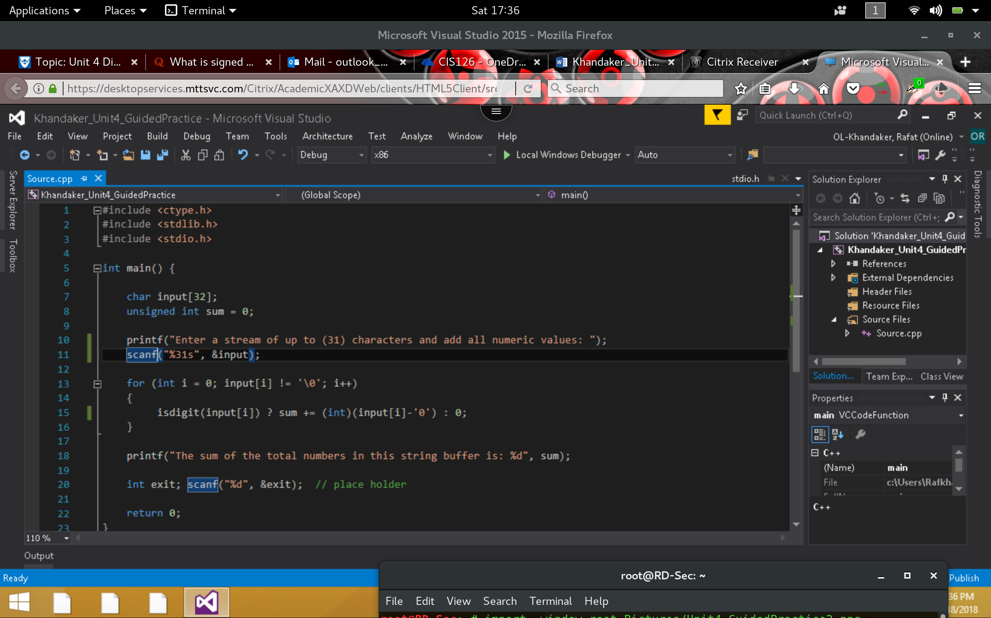

Output:

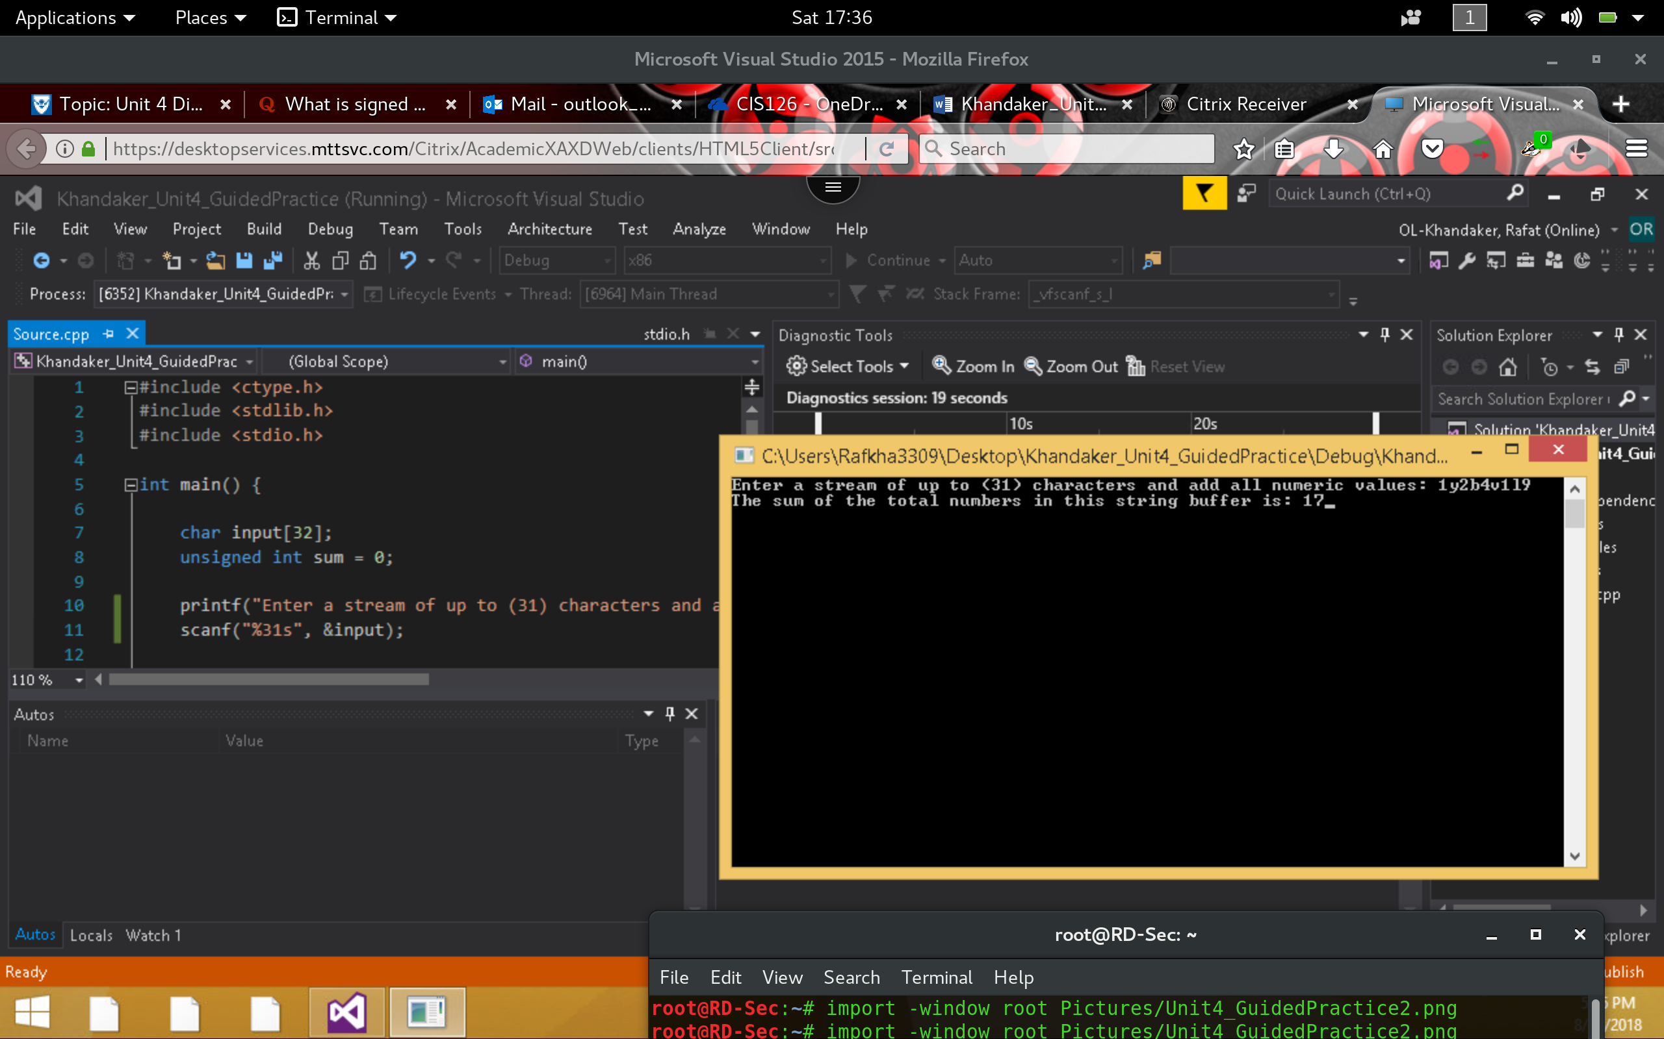

1. Change the three characters from A to 5 and be sure to keep the single quotes. Remember, the isdigit needs a character, not a number as an argument.

printf("%s", isdigit('5') ? "5 is a digit" : "5 is not a digit");

The output should now resemble this:

Current output of printf:

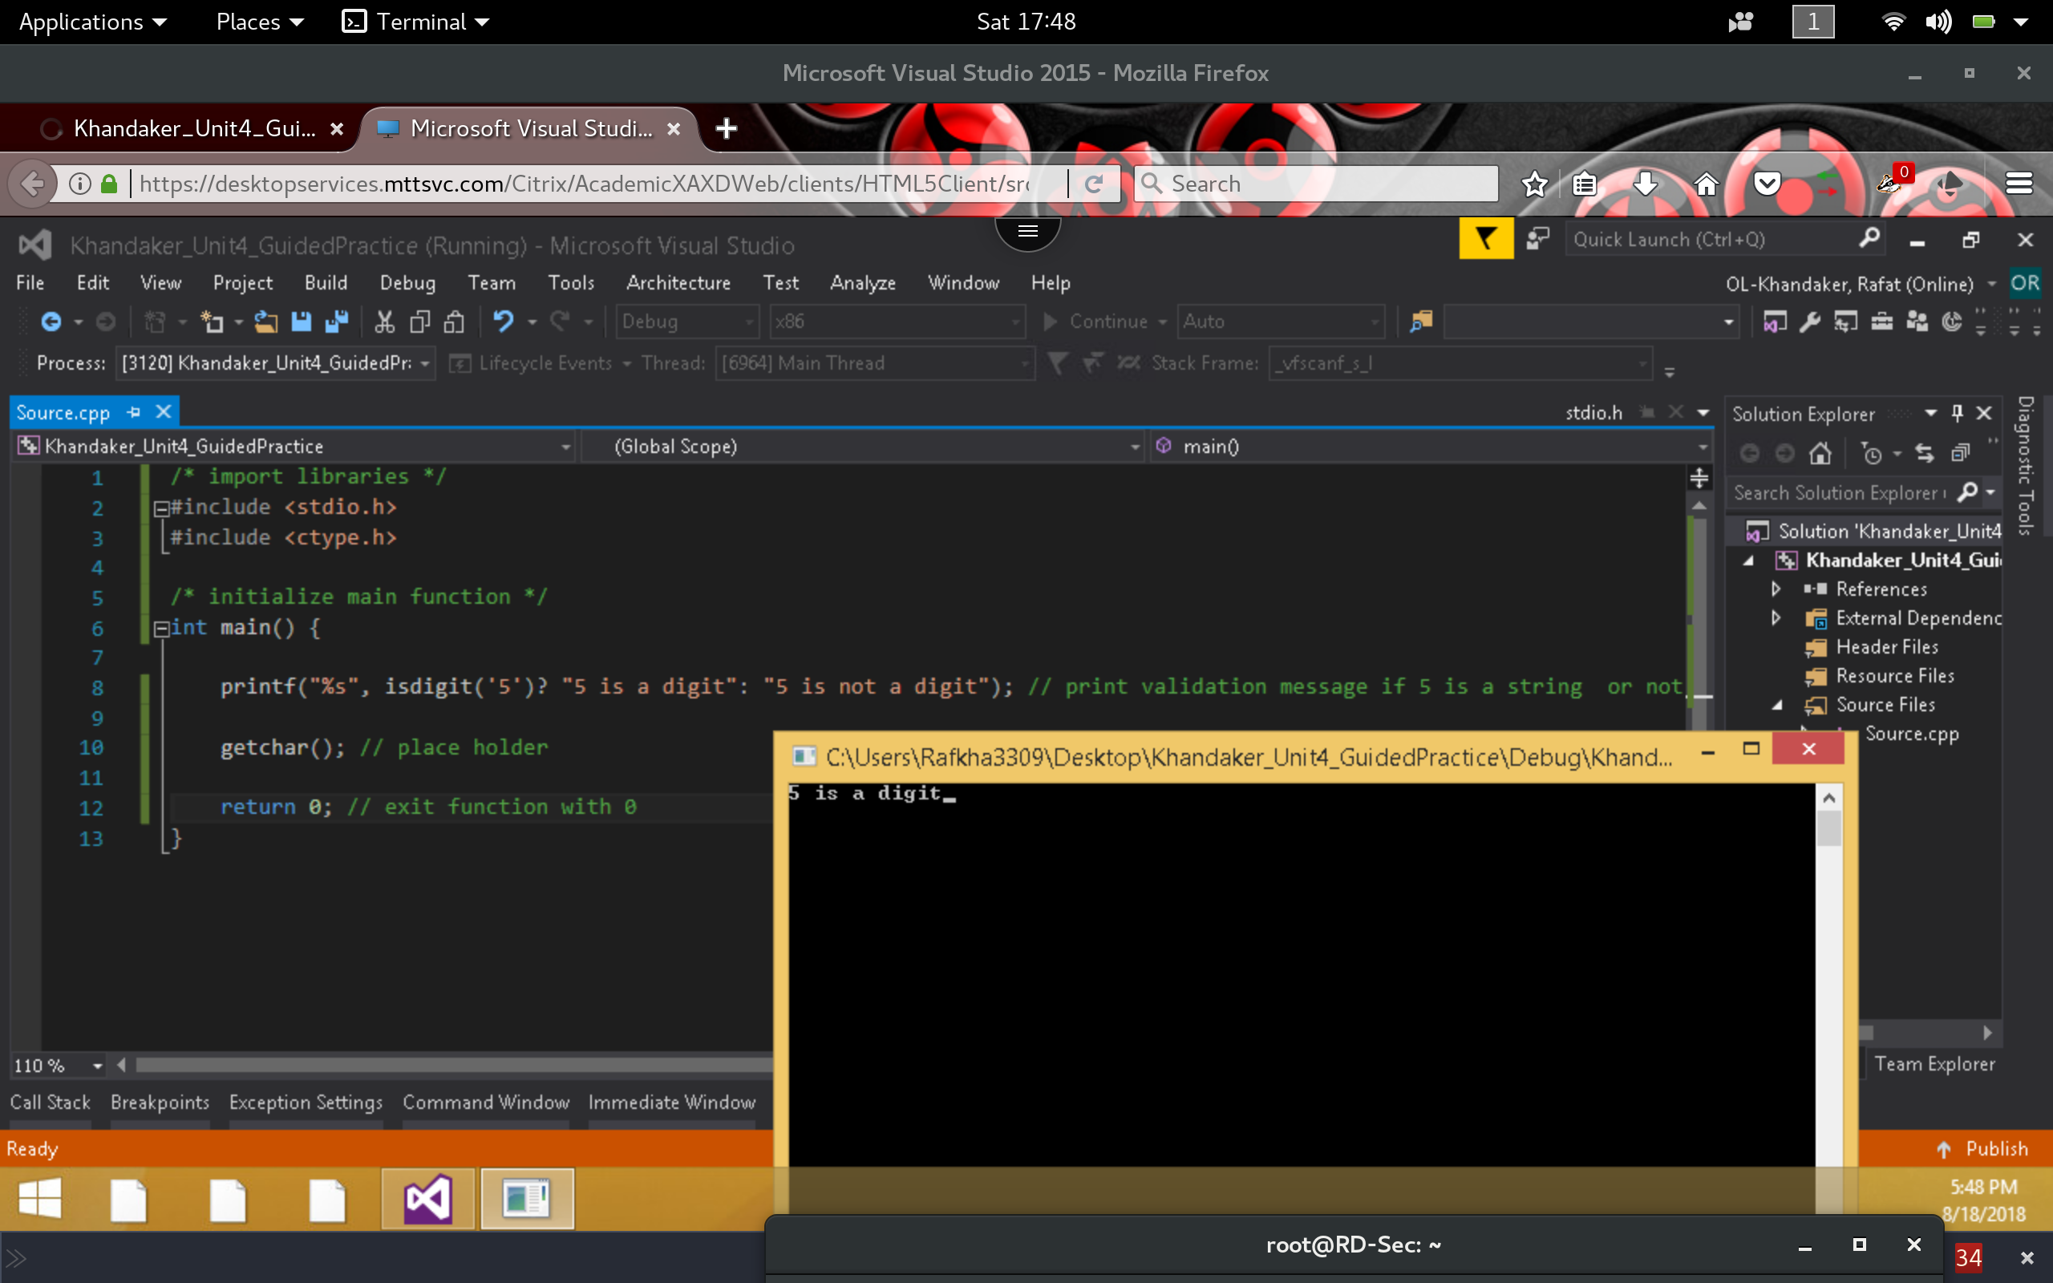

After Changing Values:

In this program I am altering the values in the isdigit() function by iterating through an array of values and validating if the character is a digit or not.

