|  |  |
| --- | --- |
| Lab Report No: | 02 |
| Lab Report Name: | Basic command of Linux operating system |
| ID: | IT-17037 |

**Objective**: The objective of these class sessions is to introduce participants to the Linux computing environment, command line system, some basic command of Linux operating system. This lab session on key elements of Linux architecture and computing exercise to provide experience in using command-line utilities to navigate the file system, manage files and directories and carry out basic file processing tasks.

**Linux-command:** A command is an instruction given by a user telling a computer to do something, such a run a single program or a group of linked programs. Commands are generally issued by typing them in at the command line and then pressing the ENTER key, which passes them to the shell.

A shell is a program that reads commands that are typed on a keyboard and then executes them. Every Unix-like operating system has at least one shell and must have several. The default shell on most Linux systems is bash.

Linux is a Unix-like operating system. All the Linux/Unix commands are run in the terminal provided by the Linux system. The terminal can be used to accomplish all administrative tasks.

**Basic commands of Linux:**

**1.ls**:- The command “ls” stands for(list Directory contents), List the contents of the folder ,be it file or folder, from which it runs.

G:\Screenshot from 2019-09-04 21-48-21.png

**2.uname:-** The “**uname**” command stands for (**Unix Name**), print detailed information about the machine name, Operating System and Kernel.

**G:\Screenshot from 2019-09-04 21-49-56.png**

**3.history:-** The “**history**” command stands for **History Record**, it prints the history of long list of executed commands in terminal.

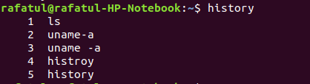

**4.cal:-** The “**cal**” (**Calendar**), it is used to displays calendar of the present month or any other month of any year that is advancing or passed.

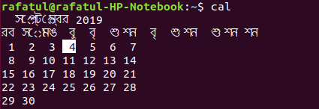

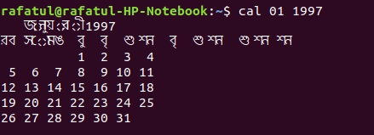

**5.date:-** The “**date**” (**Date**) command print the current date and time on the standard output, and can further be set.

**G:\Screenshot from 2019-09-04 23-11-30.png**

**6.pwd:-** The command “**pwd**” (**print working directory**), prints the current working directory with full path name from terminal.

**G:\Screenshot from 2019-09-04 21-57-54.png**

**7.mkdir:-** The “**mkdir**” (**Make directory**) command create a new directory with name path. However is the directory already exists, it will return an error message “**cannot create folder, folder already exists”**.

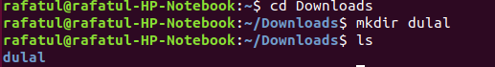

**8.rmdir:-** The “rmdir” (remove directory) command allows the user to remove an existing command using the Linux CLI. An example of the rmdir command.

**G:\Screenshot from 2019-09-04 22-05-50.png**

**9.touch:-** The “**touch**” command stands for (Update the access and modification times of each **FILE** to the current time). For creating an empty file, use the touch command.

**G:\Screenshot from 2019-09-04 22-07-53.png**

**10.mv:-** The “**mv**” command moves a file from one location to another location.

**G:\Screenshot from 2019-09-04 22-14-23.png**

**11.df:-** The “**df** “command stands for (short for disk free), is used to display information related to file systems about total space and available space.

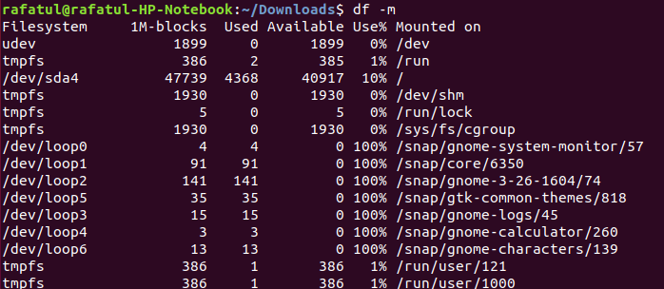

**12.cd:-** The “**cd**” command stands for (**change directory**), it change the working directory to execute, copy, move write, read, etc. from terminal itself.

**G:\Screenshot from 2019-09-04 22-00-46.png**

**13.tty:-** The “tty” command stands for Displays current terminal.

**G:\Screenshot from 2019-09-04 23-12-43.png**

**14.id:-** This command prints user and groups (UID and GID) of the current user.

**G:\Screenshot from 2019-09-04 23-13-29.png**

**15.clear:-** The “clear” command stands for (clear screen).This command clears the screen.

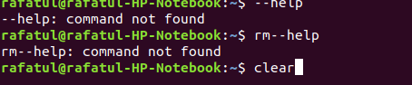

**G:\Screenshot from 2019-09-04 23-15-45.png**

**Conclusion:** The title of this chapter is "Basic Commands of Linux operating systems," and that's what we've covered. By now, you've seen that there are a variety of ways to find out more about your options on the command line. The two big dogs are man and info, with their volumes of data and descriptions about virtually all the commands found on your Linux computer.