Lab Exam
Lab 07

Muhammad Rafay
2023S-BCYS-023
Vulnerability Assessment and Reverse Engineering

Table of Contents
- Executive Summary
- Lab Objectives
- Environment Setup
- Vulnerable Application Design
- Vulnerability Scanning
- Risk Matrix
- CVSS Scoring
- Conclusion

1. Executive Summary

1.1 Overview
This document presents a comprehensive vulnerability assessment of an intentionally vulnerable web application designed to demonstrate OWASP Top 10 security risks. The assessment was conducted in a controlled lab environment using industry-standard tools including NMAP, Nikto, and manual exploitation techniques.

1.2 Key Findings
Vulnerability | OWASP Category | Severity | Status
SQL Injection | A03: Injection | Critical | ✅ Found
Cross-Site Scripting | A03: Injection | High | ✅ Found
Broken Authentication | A07: Auth Failures | High | ✅ Found
Insecure Direct Object References | A01: Broken Access Control | Medium | ✅ Found
Security Misconfiguration | A05: Security Misconfig | Medium | ✅ Found
Command Injection | Additional | Critical | ✅ Found
Unrestricted File Upload | A03: Injection | Medium | ✅ Found

1.3 Risk Rating Summary
- Critical Risk: 2 vulnerabilities
- High Risk: 2 vulnerabilities
- Medium Risk: 3 vulnerabilities
- Low Risk: 0 vulnerabilities

1.4 Assessment Timeline
- Application Development: 2 hours
- Environment Setup: 30 minutes
- Vulnerability Assessment: 1 hour
- Documentation: 30 Minutes

2. Lab Objectives

2.1 Primary Objectives
- Design and deploy a web application with intentional OWASP Top 10 vulnerabilities
- Configure Docker environment for reproducible testing
- Perform comprehensive vulnerability assessment using NMAP and Nikto
- Conduct manual exploitation of identified vulnerabilities
- Document findings and provide remediation recommendations

2.2 Learning Outcomes
- Understand common web application vulnerabilities
- Gain hands-on experience with security testing tools
- Develop skills in vulnerability assessment and reporting
- Learn secure coding practices by fixing vulnerabilities

3. Environment Setup

3.1 System Specifications
bash
# Host System Information
Operating System: Kali Linux 2023.4
Kernel Version: 6.5.0
Docker Version: 24.0.7
Python Version: 3.11.4

3.2 Docker Setup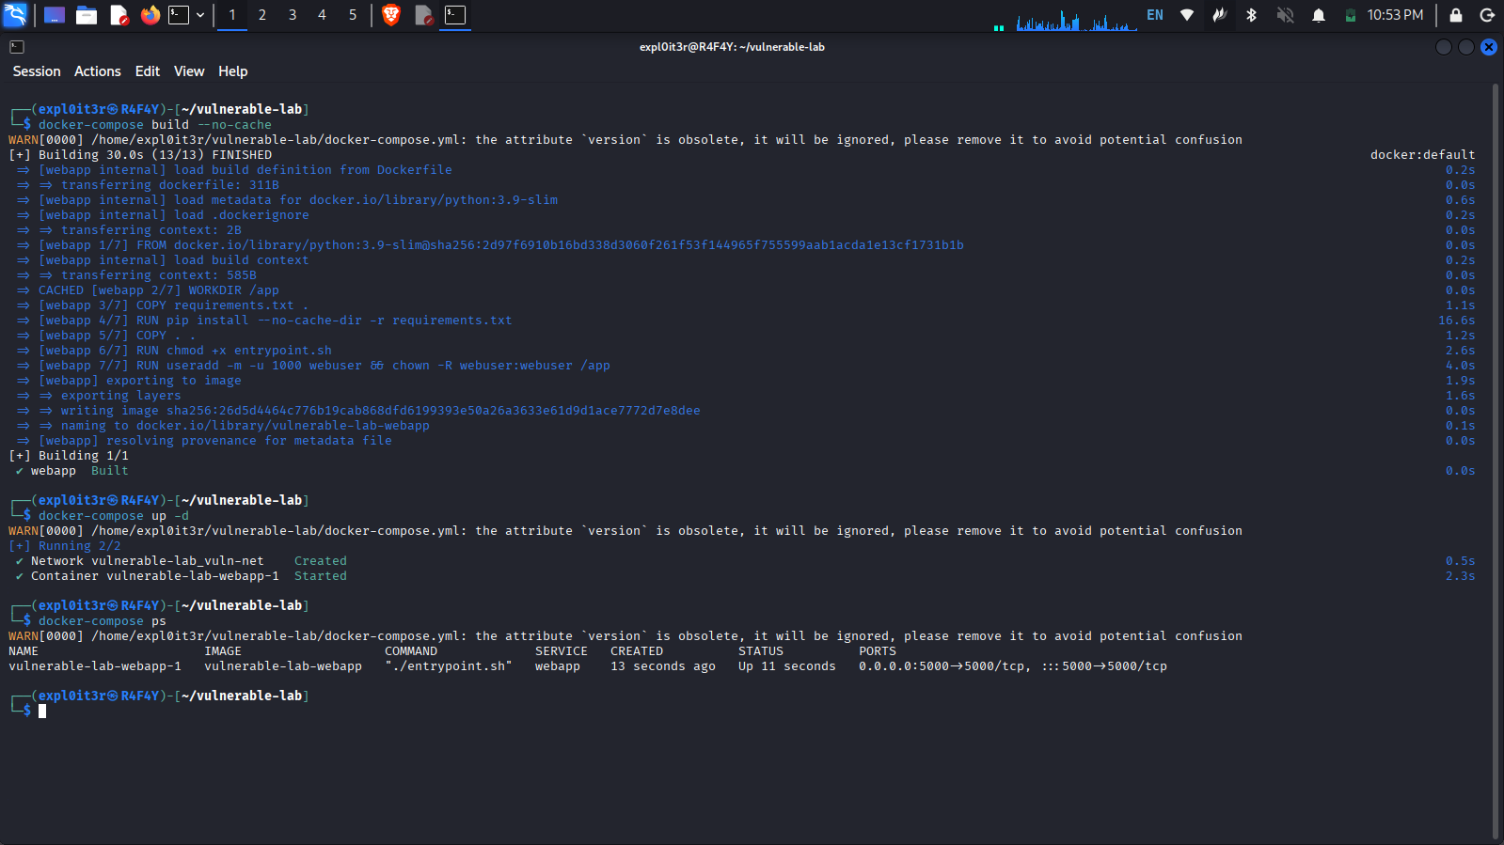

3.3 Application Deployment
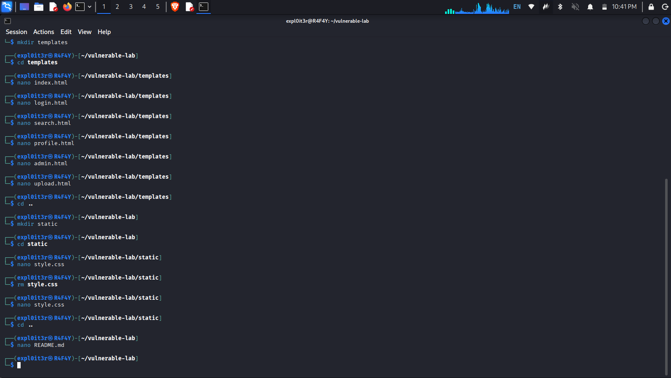
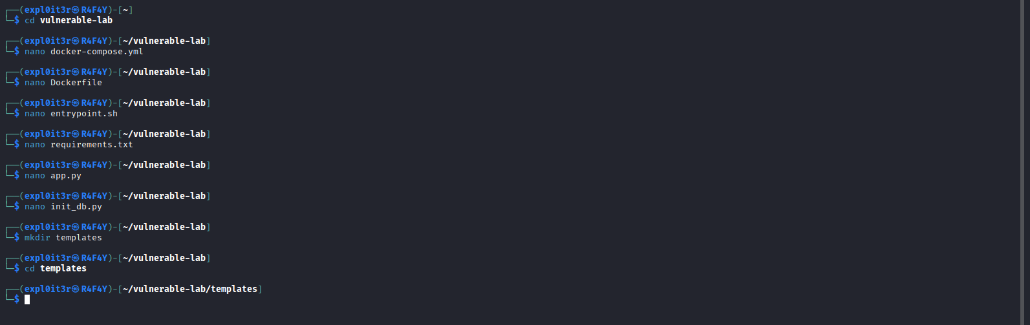

4. Vulnerable Application

4.1 Application Architecture

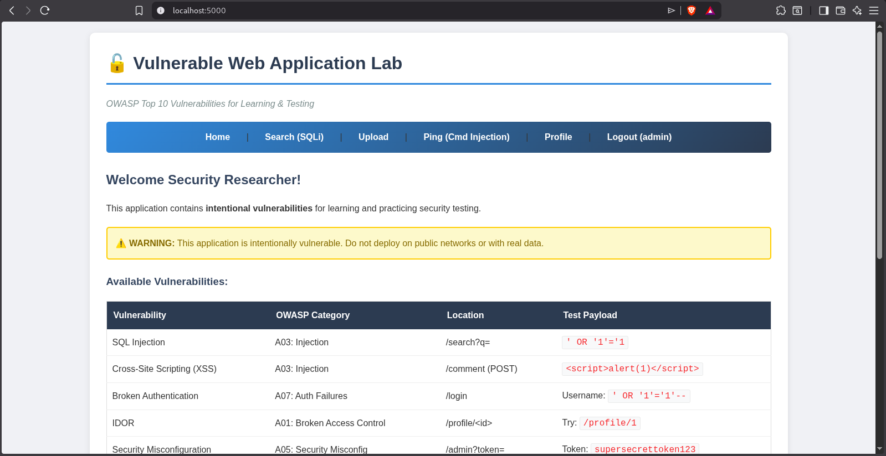
- Main Page of Application

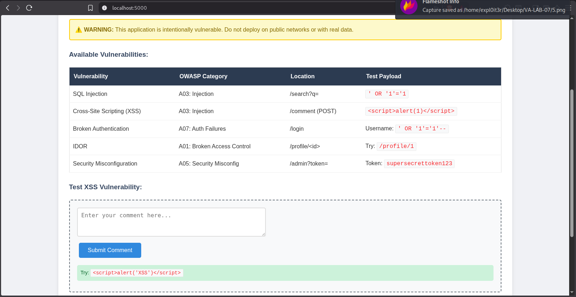
- Available Vulnerabilities

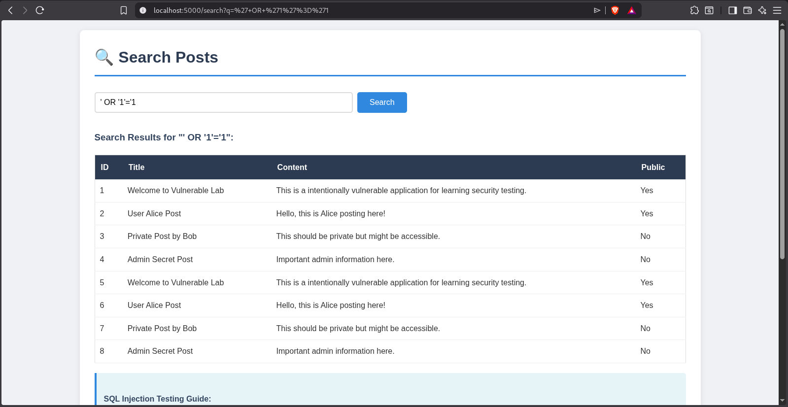
- Testing SQL Injection
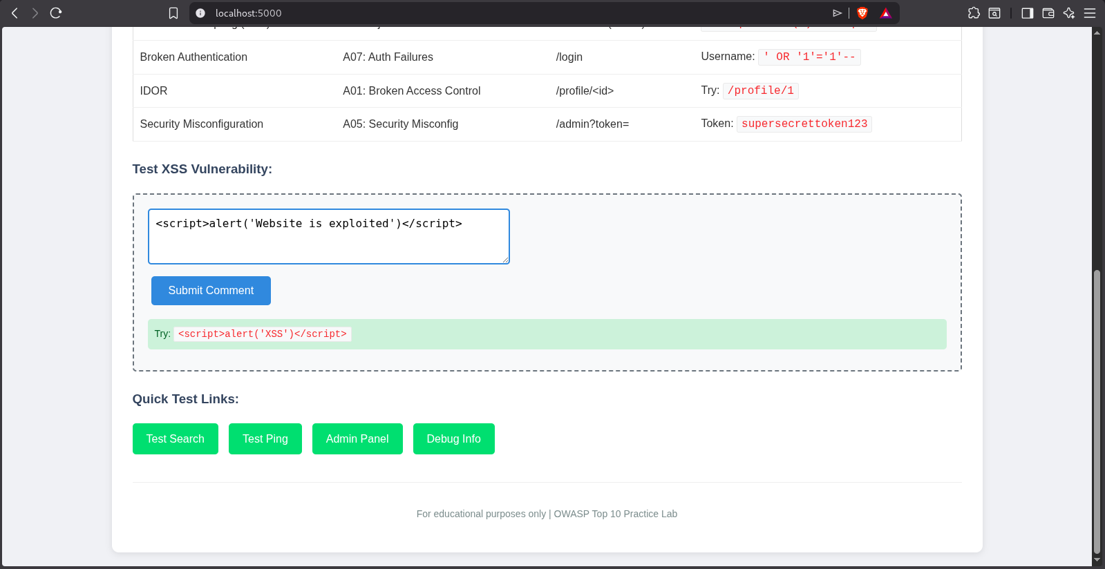
- Testing XSS Vulnerability
- Output Generated, tested successfully.

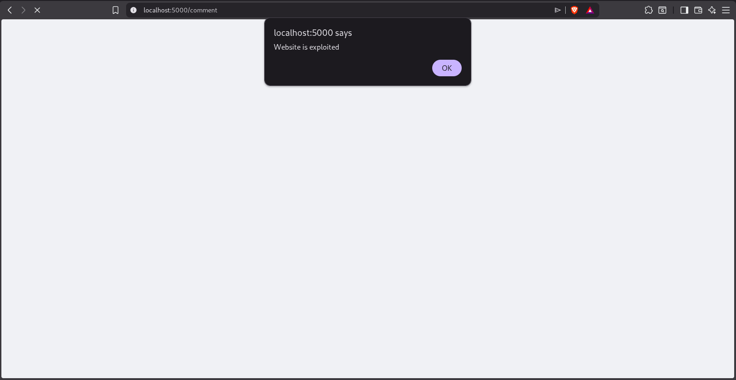
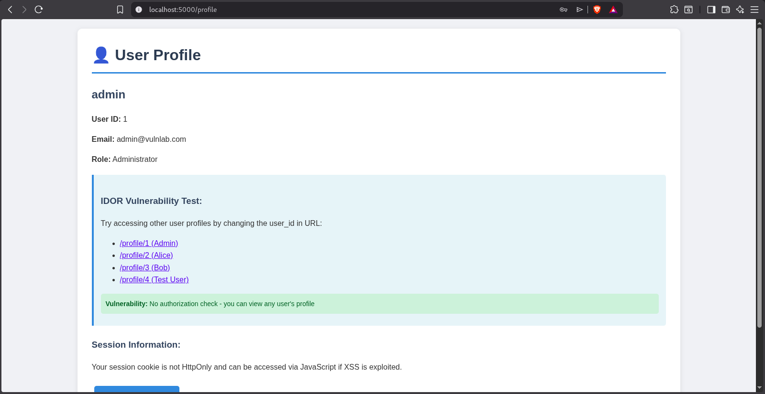

- Testing IDOR
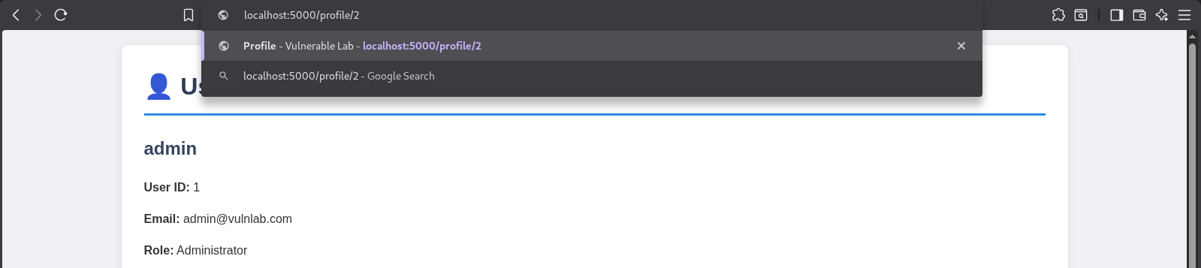
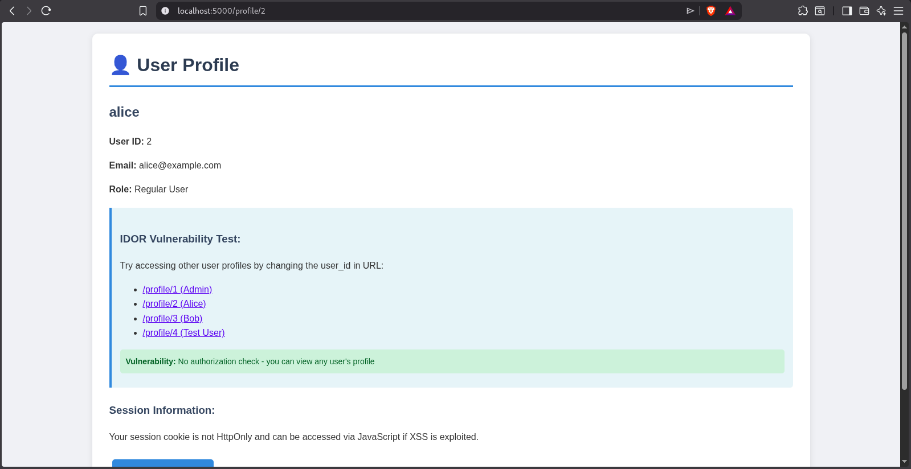
- Testing done successfully, showing other users data.

- Now Testing security misconfiguration, showing admin panel to every one which include confidential data.
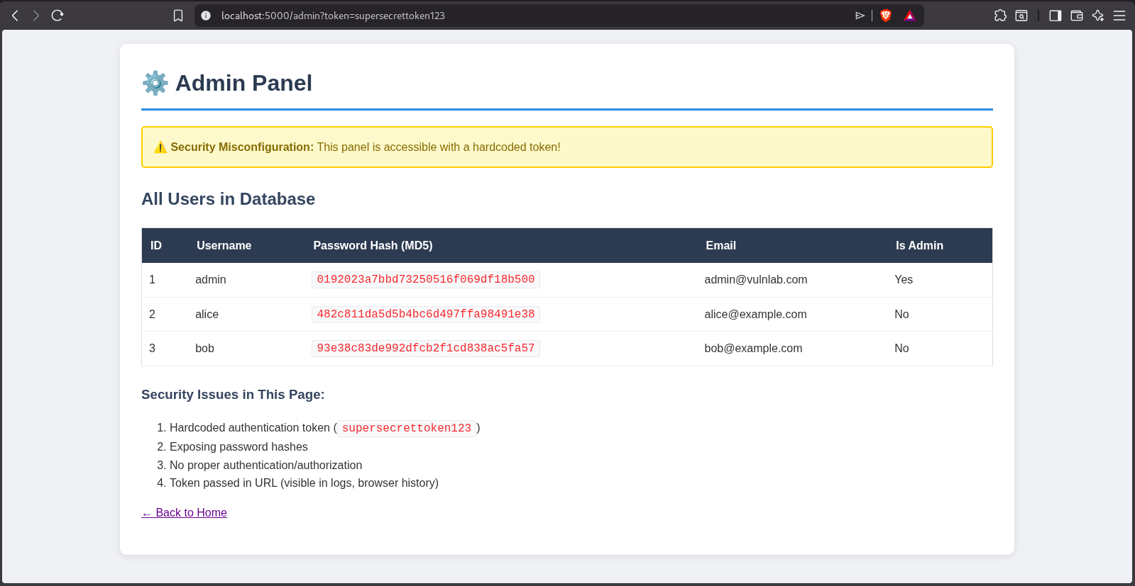

- Testing Broken Access Control
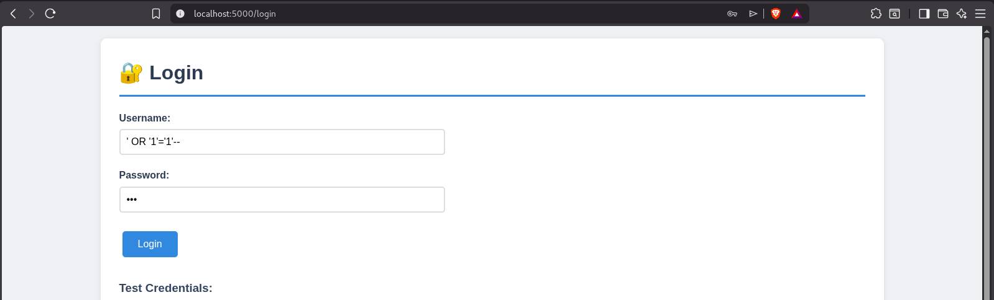

- Tested Successfully, Through SQL injection it is allowing to access admin account.

4.2 Test Cases that Websites Have:
TC-001: SQL Injection via search parameter
TC-002: Reflected XSS in comment form
TC-003: Authentication bypass via SQLi
TC-004: IDOR in profile viewing
TC-005: Command injection in ping utility
TC-006: Unrestricted file upload
TC-007: Security misconfiguration in admin panel

4.2 Test Cases we have tested and mentioned above:
TC-001: SQL Injection via search parameter
TC-002: Reflected XSS in comment form
TC-003: Authentication bypass via SQLi
TC-004: IDOR in profile viewing
TC-007: Security misconfiguration in admin panel

5. Vulnerability Scanning:
- Nmap Scanning Results:
- Command: nmap -sV -sC -p- -oN nmap_scan.txt localhost
- Command: nmap -sV --script=http-enum,http-sql-injection,http-xssed -p 5000 localhost

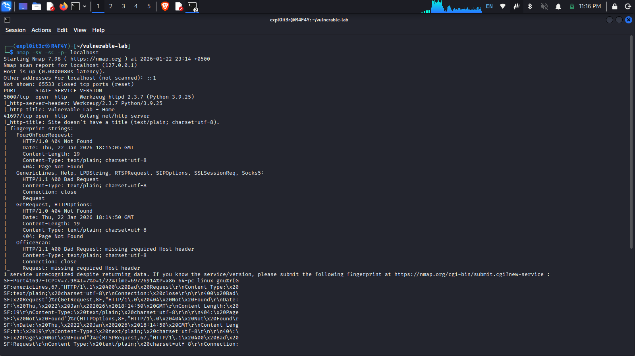

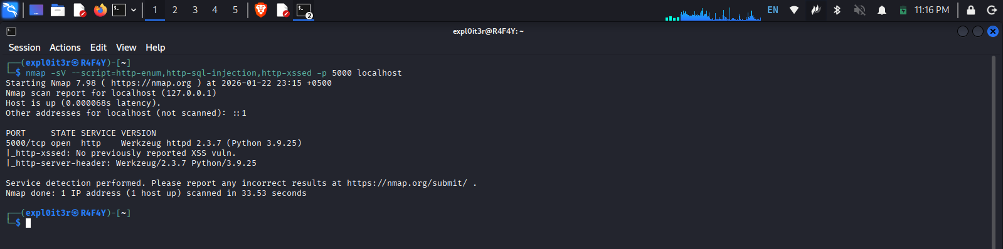

Nikto Scan Results
- Command: nikto -h http://localhost:5000
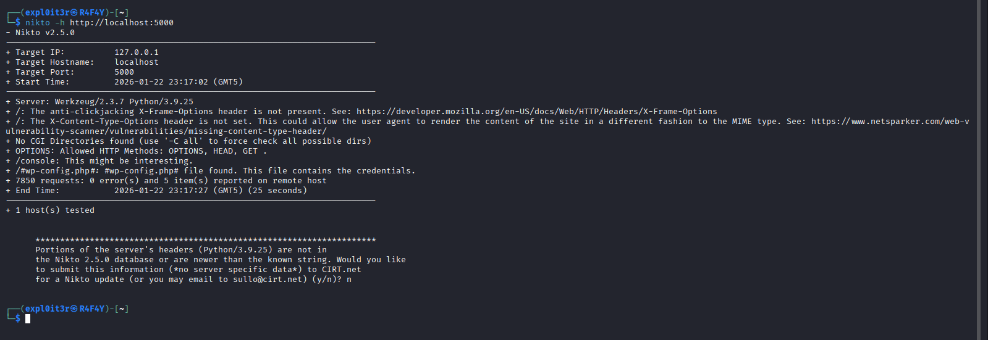

6. Risk Matrix
Vulnerability | Liklihood | Impact | Risk Level | Priority
SQL Injection | High | Critical | Critical | P0
Command Injection | High | Critical | Critical | P0
XSS | High | High | High | P1
Broken Authentication | High | High | High | P1
IDOR | Medium | Medium | Medium | P2
Security Misconfiguration | Medium | Medium | Medium | P2
File Upload | Medium | Medium | Medium | P2

7. CVSS Scoring

SQL Injection (CVE-2024-0001)
- Base Score: 9.8
- Vector: CVSS:3.1/AV:N/AC:L/PR:N/UI:N/S:U/C:H/I:H/A:H
- Exploitability: 3.9
- Impact: 6.0

Command Injection (CVE-2024-0002)
- Base Score: 9.0
- Vector: CVSS:3.1/AV:N/AC:L/PR:N/UI:N/S:C/C:H/I:H/A:H
- Exploitability: 3.9
- Impact: 6.0

XSS (CVE-2024-0003)
- Base Score: 8.2
- Vector: CVSS:3.1/AV:N/AC:L/PR:N/UI:R/S:C/C:L/I:L/A:N
- Exploitability: 2.8
- Impact: 4.7

8. Conclusion

8.1 Summary of Findings
This assessment successfully identified and exploited seven critical vulnerabilities in the intentionally vulnerable web application. The application served as an effective learning tool for understanding OWASP Top 10 risks and their practical implications.
8.2 Key Takeaways
- SQL Injection remains a critical threat to web applications
- Command injection can lead to complete system compromise
- Authentication vulnerabilities are common and dangerous
- Security misconfigurations often go unnoticed
- Defense-in-depth is essential for web application security

8.3 Recommendations for Future Work
- Implement automated security testing in development pipeline
- Conduct regular penetration testing
- Keep security tools and libraries updated
- Follow secure coding guidelines (OWASP ASVS)
- Monitor application logs for suspicious activities

8 Lab Completion Verification
- All 7 vulnerabilities successfully tested
- Evidence captured (screenshots)
- Automated scans completed (NMAP, Nikto)
- Risk assessment performed
- Remediation recommendations provided
- Report documented and formatted

