

***Assignment 3***

***Muhammad Rafay***

***20P-0018***

***Computer Networks LAB***

***Sec A***

**FILE SHARING BETWEEN TWO COMPUTERS**

**USING LAN CABLE**

**Step 1: Connecting Both PCs With our LAN Cable**

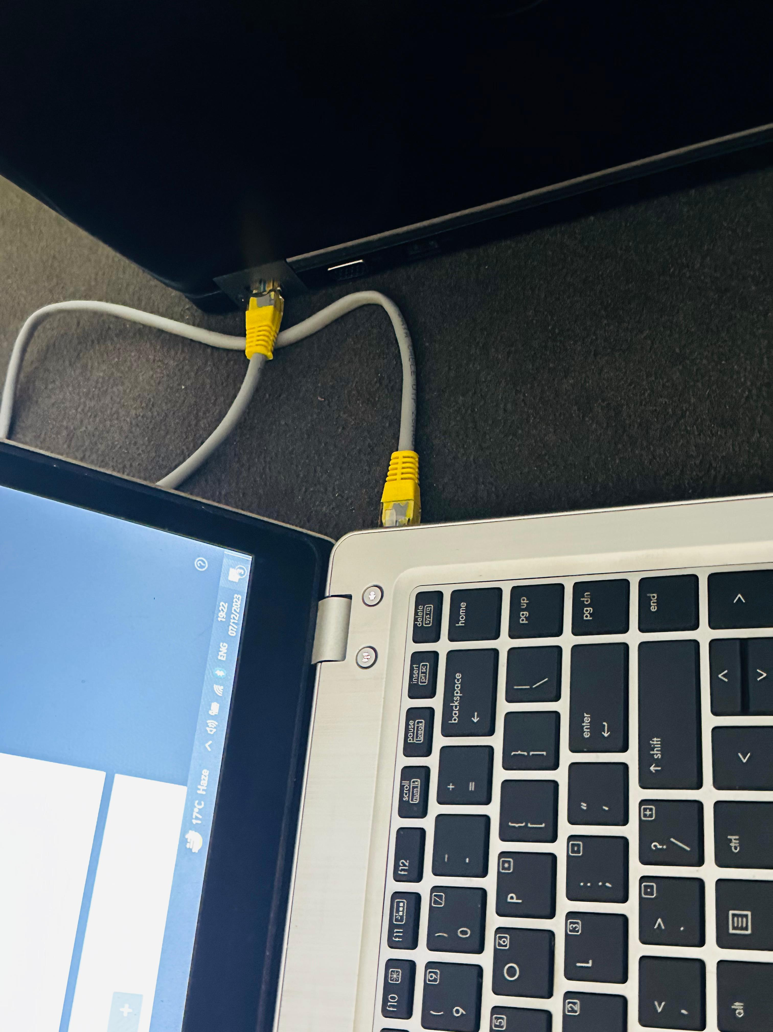

Using Qasim’s PC as a 2nd Computer . 20P-0070

**STEP 2: Enable Network Sharing on Both PC’s**

Opening Control Panel

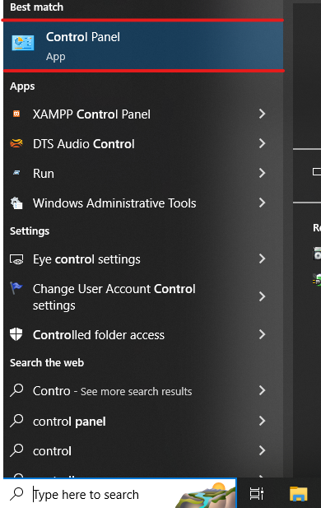

Entering Network and internet from Control panel

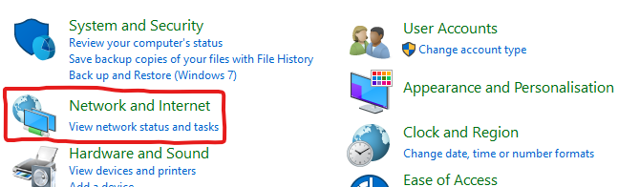

Now to Network Sharing Centre

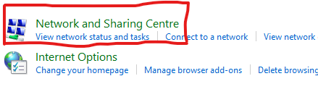

From Left Side of the Window entering “Advanced Sharing Setting”

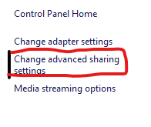

After Entering we expand All Networks and turn on the Following Settings

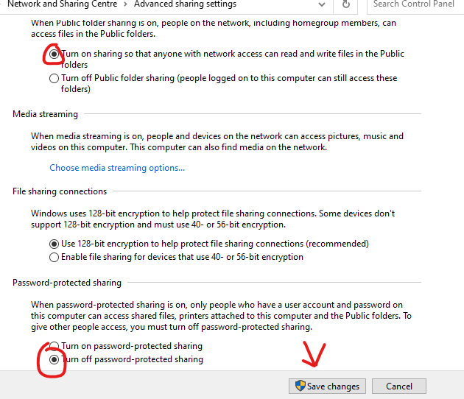

**STEP 3: Setup Static IP**

Again Entering Network and Sharing Centre

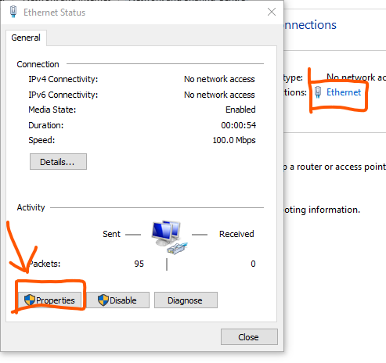

Clicking Ethernet and Entering Properties in from the dialog box just opened

SELECTING IPv4 and Entering Properties

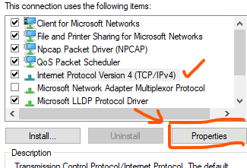

Then Entering Static IP to mine Computer i.e. PC 1

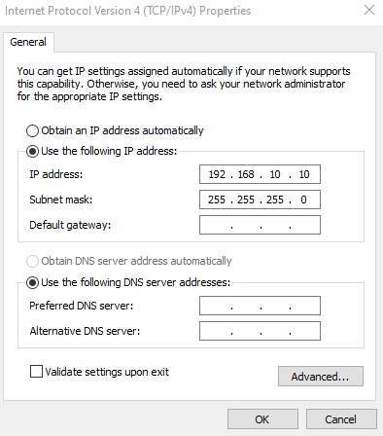

After Saving the Setting Opening our window File Explorer and Clicking on Network tab from the Left side

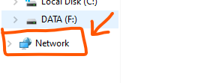

Both PC’s are now discovered to Each other

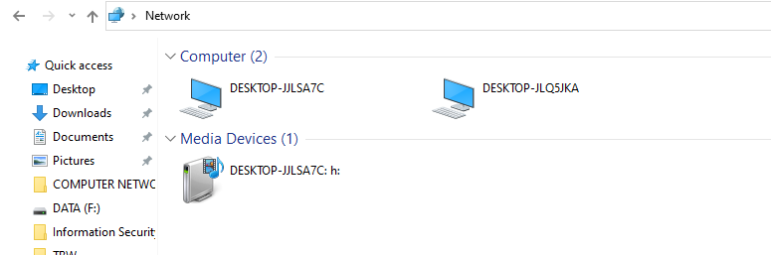

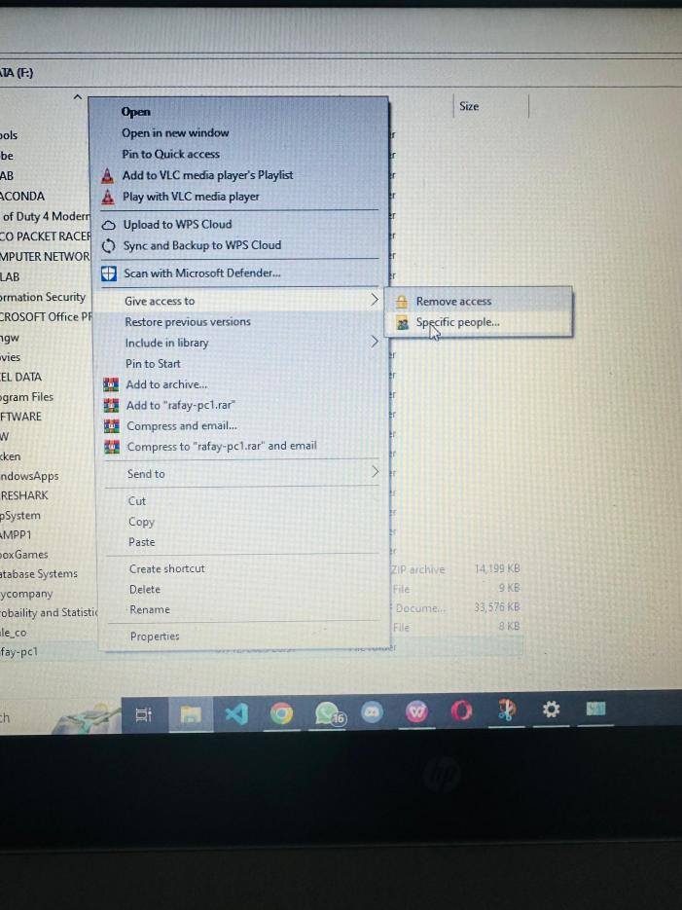

Have Created a new folder and changed its access Setting to Everyone.

Allowing Access to everyone of my New Folder

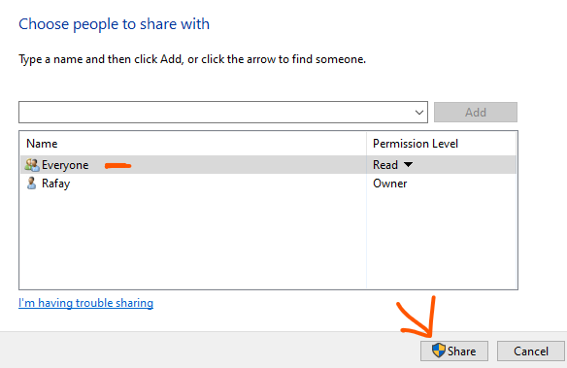

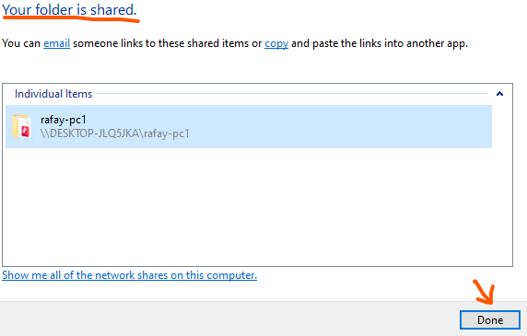

Entering My PC from Network TAB

