CL30001 – Computer Networks

Quiz 01

**Student Name :** Muhammad Rafay **Roll No. :** 20P-0018

Time Allowed: **30 minutes** **Total Marks: 20 Weightage: 2**

Q1: Consider the following topology and populate the tables:

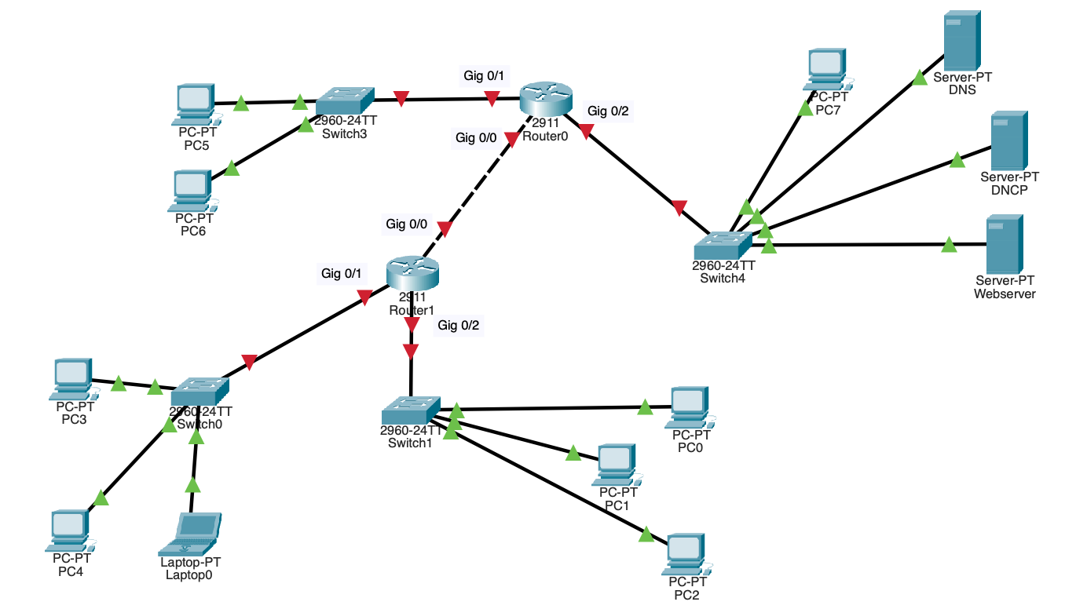

**DHCP Pools:**

|  |  |  |  |  |  |
| --- | --- | --- | --- | --- | --- |
| **Pool Name** | **Default Gateway** | **DNS** | **Start IP address** | **Subnet Mask** | **Max User** |
| serverPool | 192.168.4.1 | 192.168.4.5 | 192.168.4.11 | 255.255.255.0 | 245 |
| N1 | 192.168.1.1 | 192.168.4.5 | 192.168.1.11 | 255.255.255.0 | 245 |
| N2 | 192.168.2.1 | 192.168.4.5 | 192.168.2.11 | 255.255.255.0 | 245 |
| N3 | 192.168.3.1 | 192.168.4.5 | 192.168.3.11 | 255.255.255.0 | 245 |
|  |  |  |  |  |  |

**Addressing table:**

|  |  |  |  |  |  |  |
| --- | --- | --- | --- | --- | --- | --- |
| **Device** | **Interface** | **Network** | **Subnet mask** | **IPv4** | **Default Gateway** | **DNS** |
| **Router 0** | Gig 0/0 | 192.168.5.0 | **255.255.255.0** | 192.168.5.2 | 192.168.5.2 | **192.168.4.5** |
|  | Gig 0/1 | 192.168.1.0 | **255.255.255.0** | 192.168.1.1 | 192.168.1.1 | **192.168.4.5** |
|  | Gig 0/2 | 192.168.4.0 | **255.255.255.0** | 192.168.4.1 | 192.168.4.1 | **192.168.4.5** |
| **Router 1** | Gig 0/0 | 192.168.5.0 | **255.255.255.0** | 192.168.5.2 | 192.168.5.1 | **192.168.4.5** |
|  | Gig 0/1 | 192.168.2.0 | **255.255.255.0** | 192.168.2.1 | 192.168.2.1 | **192.168.4.5** |
|  | Gig 0/2 | 192.168.3.0 | **255.255.255.0** | 192.168.3.1 | 192.168.3.1 | **192.168.4.5** |
| **DNS** | Fa0 | 192.168.4.0 | **255.255.255.0** | 192.168.4.5 | 192.168.4.1 | **192.168.4.5** |
| **DHCP** | Fa0 | 192.168.4.0 | **255.255.255.0** | 192.168.4.6 | 192.168.4.1 | **192.168.4.5** |
| **Web server** | Fa0 | 192.168.4.0 | **255.255.255.0** | 192.168.4.7 | 192.168.4.1 | **192.168.4.5** |
| **Laptop 0** | Fa0 | 192.168.2.0 | **255.255.255.0** | 192.168.2.11 | 192.168.2.1 | **192.168.4.5** |
| **PC0** | Fa0 | 192.168.3.0 | **255.255.255.0** | 192.168.3.11 | 192.168.3.1 | **192.168.4.5** |
| **PC1** | Fa0 | 192.168.3.0 | **255.255.255.0** | 192.168.3.12 | 192.168.3.1 | **192.168.4.5** |
| **PC2** | Fa0 | 192.168.3.0 | **255.255.255.0** | 192.168.3.13 | 192.168.3.1 | **192.168.4.5** |
| **PC3** | Fa0 | 192.168.2.0 | **255.255.255.0** | 192.168.2.12 | 192.168.2.1 | **192.168.4.5** |
| **PC4** | Fa0 | 192.168.2.0 | **255.255.255.0** | 192.168.2.13 | 192.168.2.1 | **192.168.4.5** |
| **PC5** | Fa0 | 192.168.1.0 | **255.255.255.0** | 192.168.1.11 | 192.168.1.1 | **192.168.4.5** |
| **PC6** | Fa0 | 192.168.1.0 | **255.255.255.0** | 192.168.1.12 | 192.168.1.1 | **192.168.4.5** |
| **PC7** | Fa0 | 192.168.4.0 | **255.255.255.0** | 192.168.4.11 | 192.168.4.1 | **192.168.4.5** |

**Static Routes:**

**Router0:**

192.168.2.0 /24 via 192.168.5.1

192.168.3.0 /24 via 192.168.5.1

**Router1:**

192.168.1.0 /24 via 192.168.5.2

192.168.4.0 /24 via 192.168.5.2