**2025**



### What is the CARE Project?

**The CARE Project is an intuitive, web-based healthcare platform designed to simplify the way patients connect with doctors. In a world where long queues and manual appointment bookings still exist, CARE introduces a digital solution that brings convenience, clarity, and care into the healthcare experience.**

**Developed by the established CARE Group, the platform enables users to search for specialist doctors, view their availability, and book appointments online across multiple cities — all from the comfort of home. In addition, the website serves as an informative hub, offering curated insights into common diseases, preventive care, and the latest advancements in medical science.**

### Role-Based Functionality

The CARE platform is structured around **three user roles**, each with distinct access and responsibilities:

#### 1. **Administrator**

* Add/manage cities in the database
* Add, modify, or delete doctor and patient records
* Manage login credentials and system users
* Control and update informational content on the website

#### 2. **Doctor**

* Securely log in and manage their profile
* View and update availability (day/week/month)
* Review upcoming patient appointments

#### 3. **Patient**

* Create an account with a unique User ID
* Search for doctors by city and specialization
* Book appointments after checking real-time availability

Mandatory fields like **name, address, contact number, and email ID** ensure data completeness and communication reliability for all users.

### Summary

The CARE Project goes beyond just booking appointments — it’s a comprehensive, people-first health platform. By combining **technology, accessibility,** and **trusted medical information**, it brings healthcare into the digital age with a gentle, professional touch. Its clean UI, soft visual design, and thoughtful user experience reflect the values of **compassion, clarity, and care** — creating a seamless bridge between patients and practitioners, while promoting awareness and informed decisions for healthier lives.

**CARE Project – Theme Description**

**The visual identity of the CARE Project is crafted to reflect the very essence of healthcare — compassion, calmness, and trust. Every element in the design has been carefully chosen to ease the user’s journey, creating a sense of comfort and connection from the very first interaction.**

**The foundation is set with a clean white background (#ffffff), symbolizing purity, transparency, and simplicity — values at the heart of healthcare. The primary accent, a soft sky blue (#78c7ff), represents peace, clarity, and the reliability of medical professionals. It serves as the color of navigation and interaction, subtly guiding users through their experience.**

**A vibrant yet gentle green (#4cb28b) is used to highlight important actions and elements, symbolizing healing, renewal, and life — themes central to the mission of CARE. Meanwhile, the inclusion of a warm pink tone (#fc9bab) adds a human, emotional touch, reminding users that beyond data and appointments, healthcare is deeply personal.**

**Typography is modern and approachable with ‘DM Sans’, ensuring clarity and readability while keeping the visual language fresh and contemporary. Elements such as smooth hover effects, soft box shadows, and rounded card corners add subtle polish, reinforcing the sense of safety and care.**

**Even the interface interactions — from buttons to search fields — are designed with ease and empathy in mind, ensuring accessibility for users of all ages and backgrounds. The layout is clean yet engaging, with carefully chosen imagery and background textures that reinforce trust without overwhelming the user.**

**In short, the CARE Project’s design is more than just aesthetics — it's a visual extension of its mission: to make healthcare more accessible, more personal, and more humane in a digital-first world.**



**VOLUNTEERS**

|  |  |  |
| --- | --- | --- |
| **Supervisor** | **Miss Kiran Shakeel** | |
| **Batch** | **PR2-202407D3** | |
| **Serial No.** | **Enrollment Number** | **Student’s Name** |
| **01.** | Student1595004 | Syed Rafay Ahmed |
| **02.** | Student1595006 | Syed Moiz Ahmed |
| **03.** | Student15***** | Usaid Jeeva |
| **04.** | Student15***** | Abdullah Javed |
| **05.** | Student15***** | Rahim Muneer |
| **06.** | Student15***** | ********* |



**INDEX**

Folder………………………………………………………………………………8

Cert………………………………………………………………………………9

Acknw……………………………………………………………………………10

Stmt…………………………………………………………………………13-14

Key Ft………………………………………………………………………15-16

Root…………………………………………………………………………17

Admin…………………………………………………………………………18-22

Patient……………………………………………………………………23-24

Doctor…………………………………………………………………………25

Database…………………………………………………………………………26

GitHub……………………………………………………………………………27

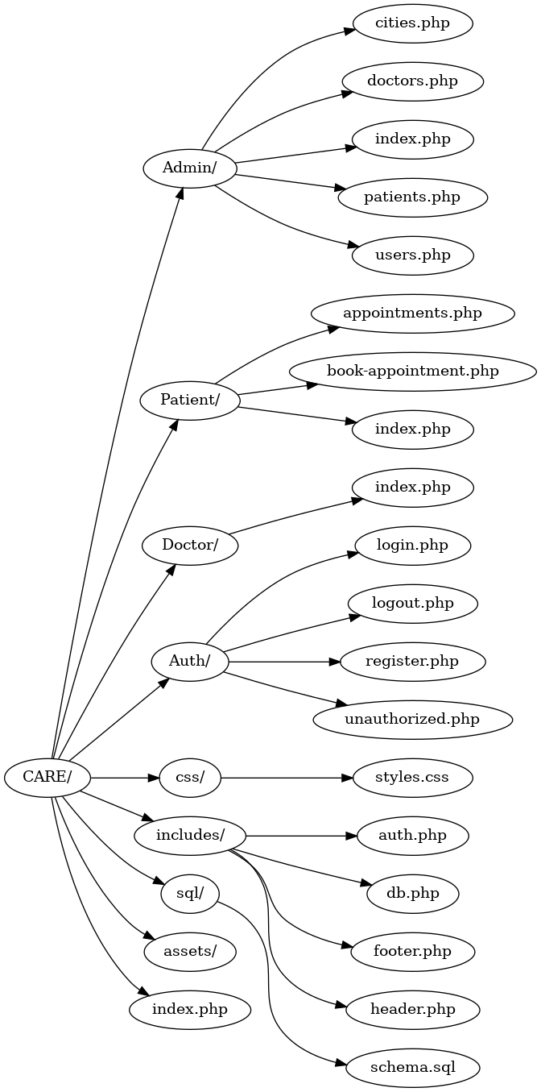

**CERTIFICATE OF COMPLETION**

This is to certify that

SYED RAFAY AHMED

SYED MOIZ AHMED

*****************

*********************

Has Successfully Completed Their

**Semester II E-Project**

Submitted To:

**Aptech Computer Education**

**ACKNOWLEDGEMENT**

**Alhamdulillahi Rabbil ‘Aalameen**, all praise is due to Allah ﷻ, the Most Merciful and the Most Generous, who granted us the ability, knowledge, and opportunity to complete this project. Without His guidance and blessings, none of this would have been possible.

We also extend our heartfelt thanks to all those who supported and guided us throughout this journey — our mentors, especially Ms. Kiran Shakeel as well as instructors, peers, and well-wishers. Their insights, encouragement, and feedback helped shape this project into what it is today.

**INTRODUCTION**

In today's fast-paced world, access to timely and reliable medical care is essential. The **CARE Project** is a web-based healthcare platform designed to streamline the process of finding doctors, learning about diseases, and booking medical appointments online. Recognizing the inconvenience of long queues and in-person bookings, this system aims to bridge the gap between patients and healthcare providers with the ease of modern technology.

Developed for patients, doctors, and administrators, CARE offers a centralized platform where users can register, manage profiles, view or provide appointment availability, and access useful health-related information. From browsing specialists in your city to staying updated with the latest in medical science, CARE ensures that quality healthcare is just a few clicks away.

This project reflects a sincere effort to simplify healthcare access while keeping data organized, interactions secure, and the experience user-friendly for all involved.

**PROBLEM STATEMENT**

We all need to visit doctors some time or the other. Sometimes it is an emergency situation, whereas most of the other time it is a planned checkup/visit. But in both the cases we have to visit the doctor to take an appointment or wait in long queues.

CARE Group is into medical services for long time and looking at the current medical scene have decided to come up with a WEBSITE, which will host the medical services available in different cities.

Individuals will be able to search for specialist doctors in their surroundings and even book online appointments.

Web site should also record the complete information regarding the Doctors and Patients.

**Customer Specifications:**

Website will host information about common Diseases, Preventions and Cures. It will also display the latest medical news and information on inventions in Medical Science.

The website will have three users/roles:

1. Administrator
2. Doctor
3. Patient

The Administrator should be able to do the following:

1. Add Cities to the master database.
2. Add Doctors to the Master database.
3. Modify Doctor Details.
4. Modify Patient Details.
5. Delete Cities
6. Delete Doctors
7. Delete Patients
8. Create/Manage Users/Logins
9. Manage information/details on the WEBSITE

The Doctor should be able to do the following:

1. Login into the system with his USER/PASSWORD
2. View his/her profile details
3. Add details to his/her profile
4. Modify his/her profile
5. View Appointments
6. Update his availability for DAY/WEEK/MONTH

The Patient should be able to do the following:

1. Register/Create Account [USERID should be unique].
2. Search Doctor based on location, Specialist
3. Book Appointment [Check Availability]

Note: Name, Address, Phone Numbers, Email-ids should be mandatory to be provided.

**Key Features**

* **Online Appointment Booking**  
  Real-time booking system allows patients to view doctor availability and schedule appointments instantly.
* **Role-Based Access System**  
  Separate dashboards and permissions for Admin, Doctor, and Patient roles.
* **Doctor & Patient Profile Management**  
  Both doctors and patients can create and update their personal and professional details.
* **City & User Management (Admin Panel)**  
  Admins can add, edit, and delete cities, doctors, and patients, and manage website content and user accounts.
* **Health Information Portal**  
  Includes sections for diseases, preventions, cures, and the latest medical news and discoveries.
* **Secure User Authentication**  
  Unique user IDs, login/logout systems, and restricted access to protect user data.
* **Clean, Responsive Interface**  
  Built with custom CSS and modern web design practices for a user-friendly experience across devices.

**ROOT UI**

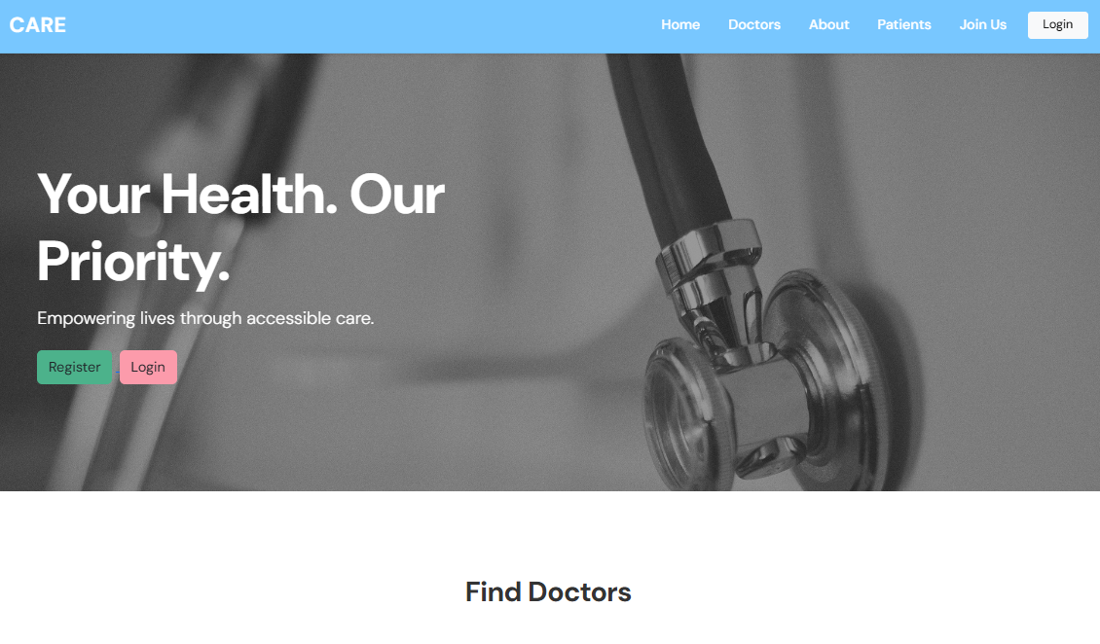

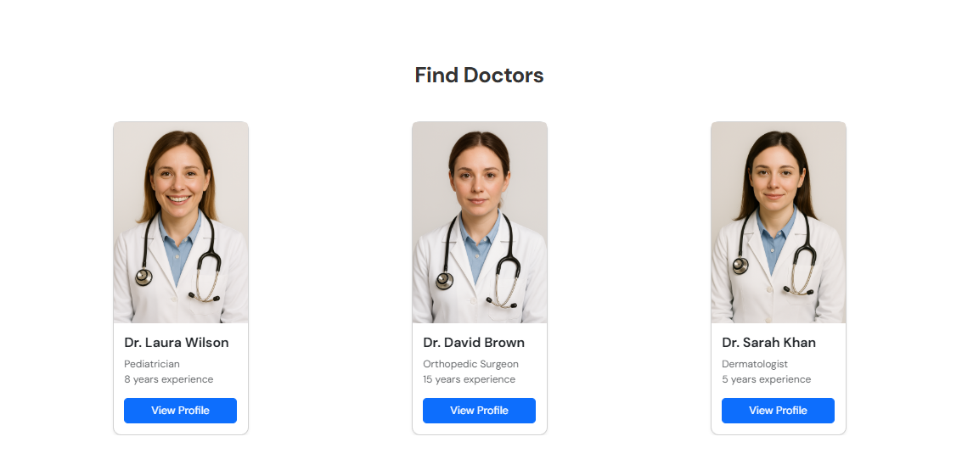

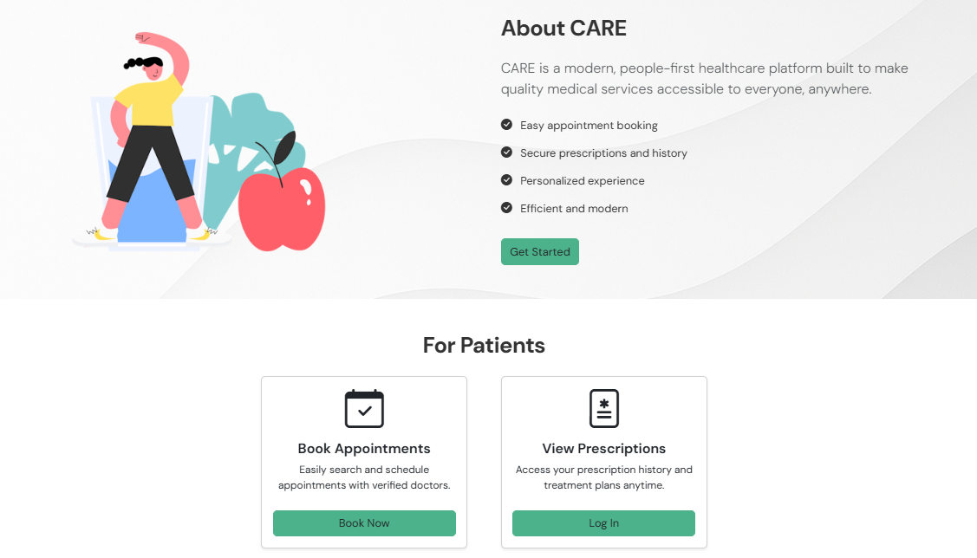

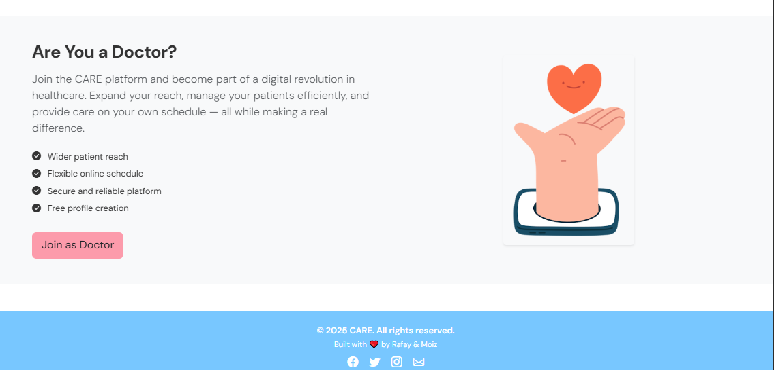

**ADMIN DASHBOARD**

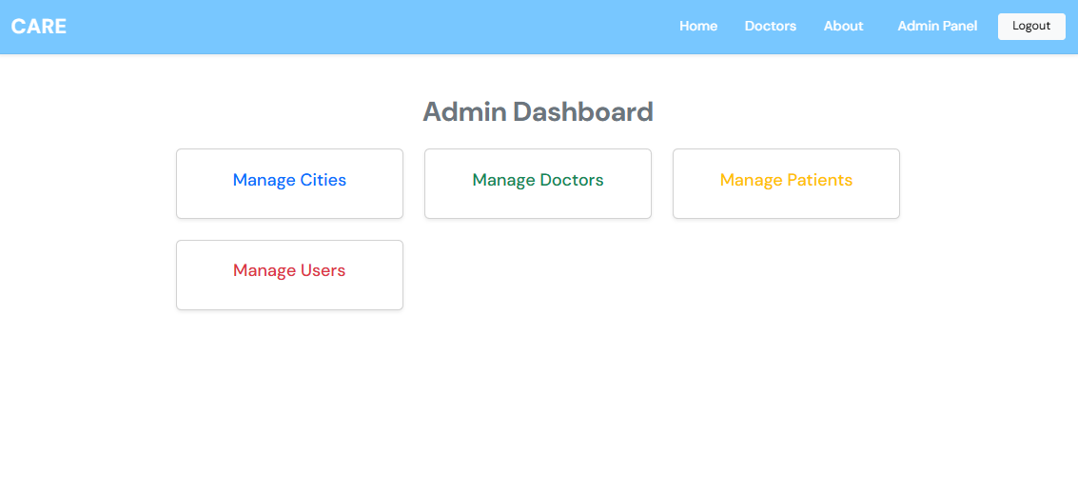 

**ADMIN/CITIES**

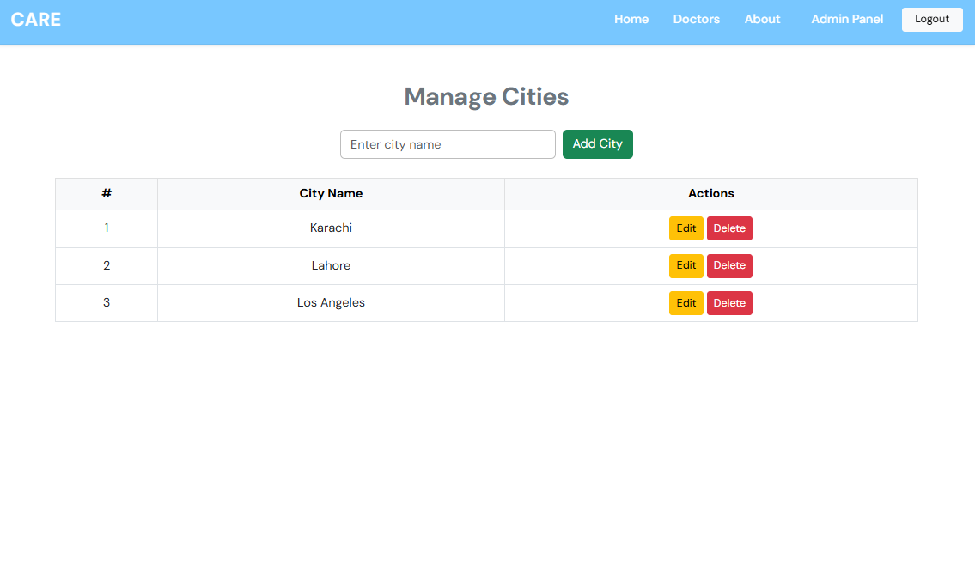 

**ADMIN/DOCTORS**

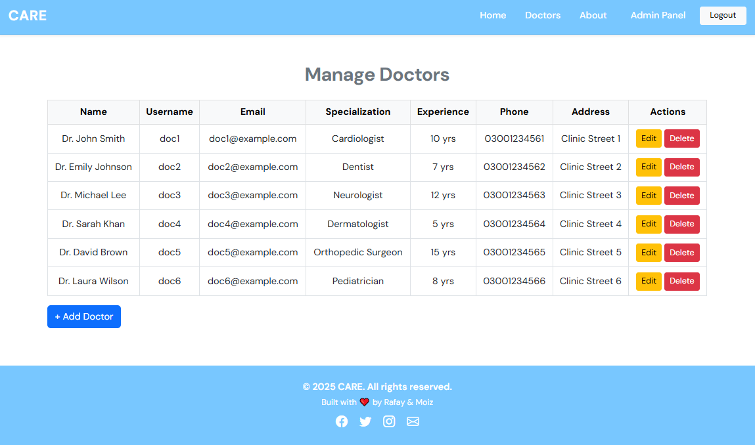

**ADMIN/PATIENTS**

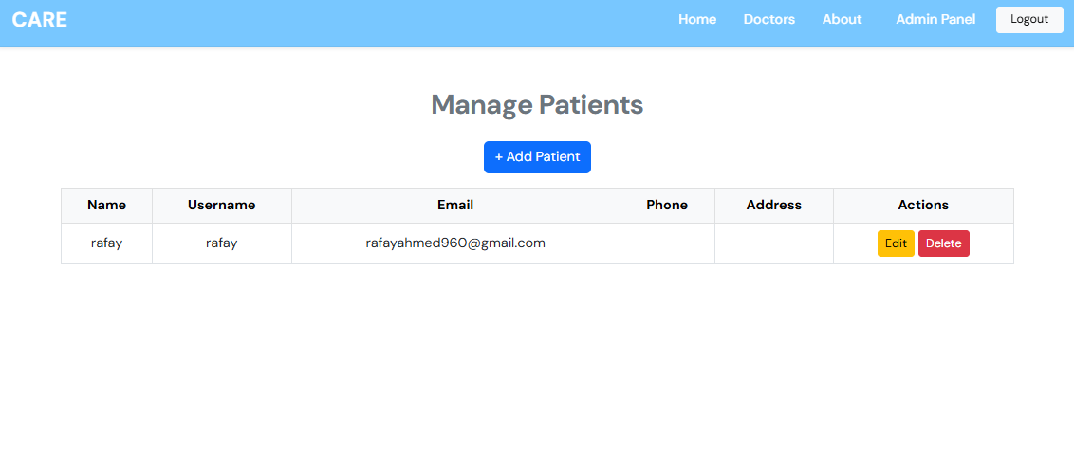 

**ADMIN/USERS**

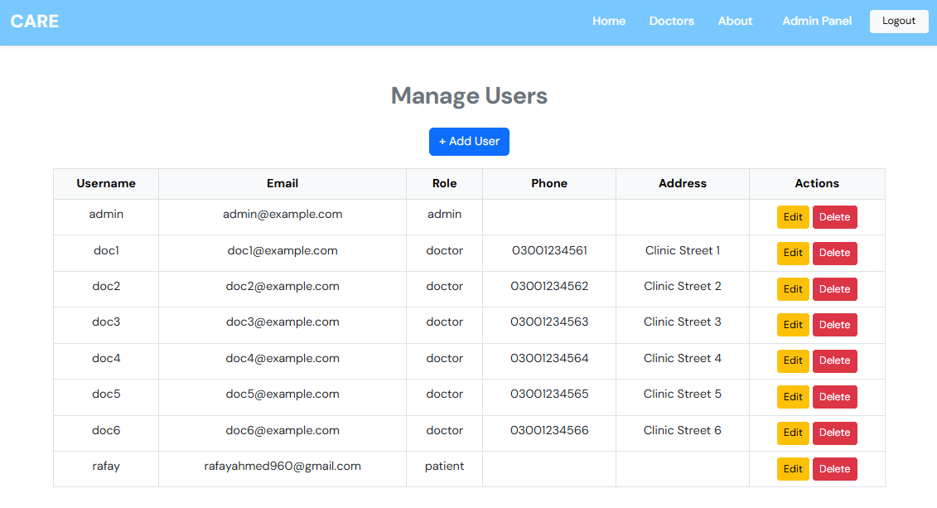 

PATIENTS DASHBOARD

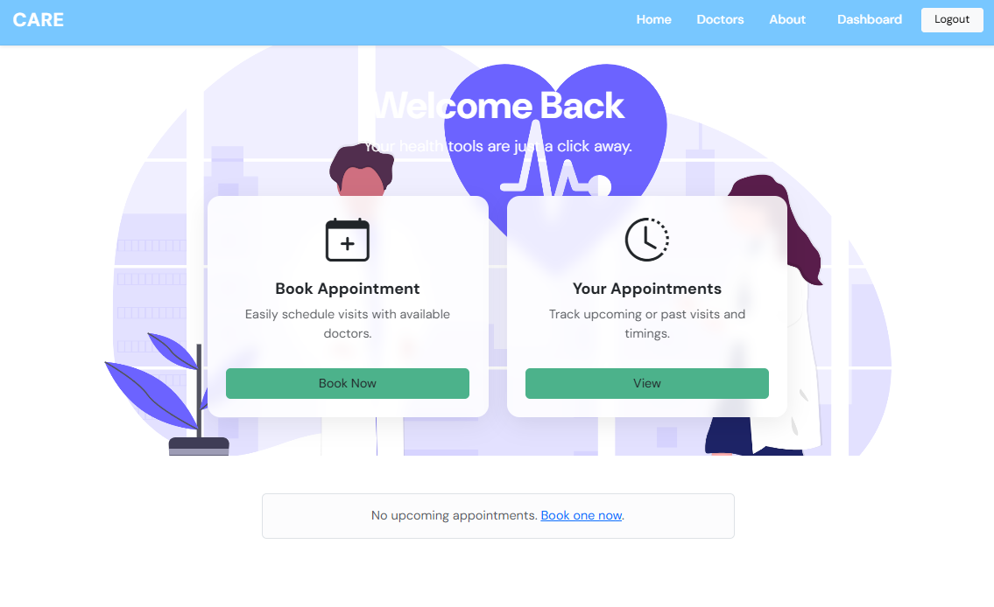 

PATIENTS/BOOK APPOINTMENT

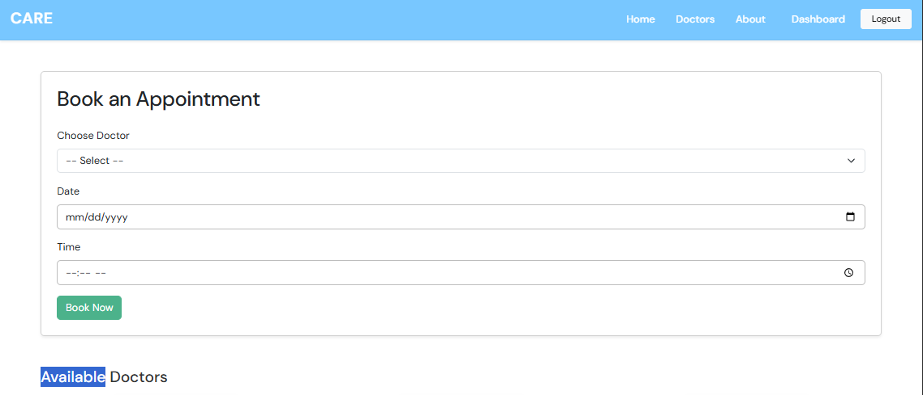

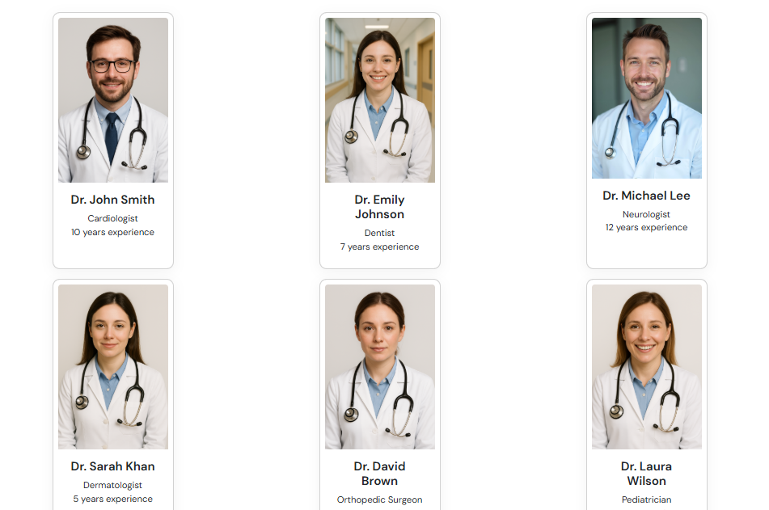



PATIENTS/APPOINTMENTS

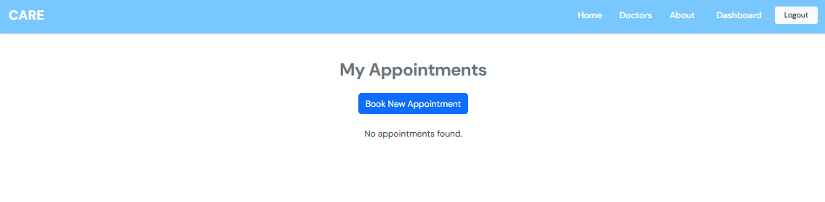 

DOCTOR DASHBOARD

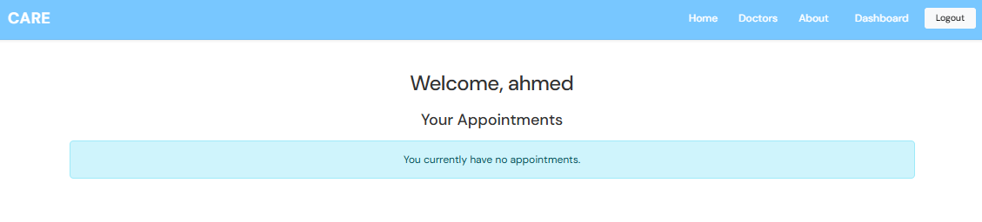 

DATABASE

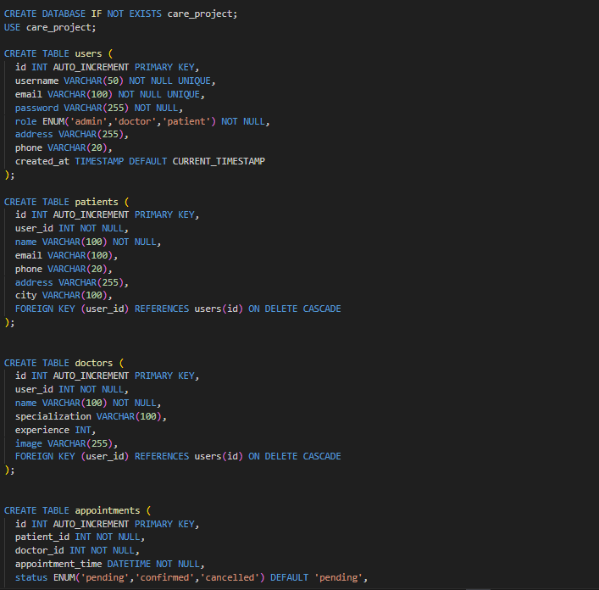

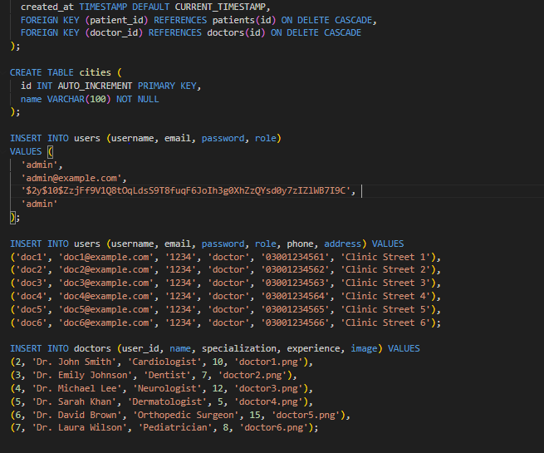

**GITHUB**

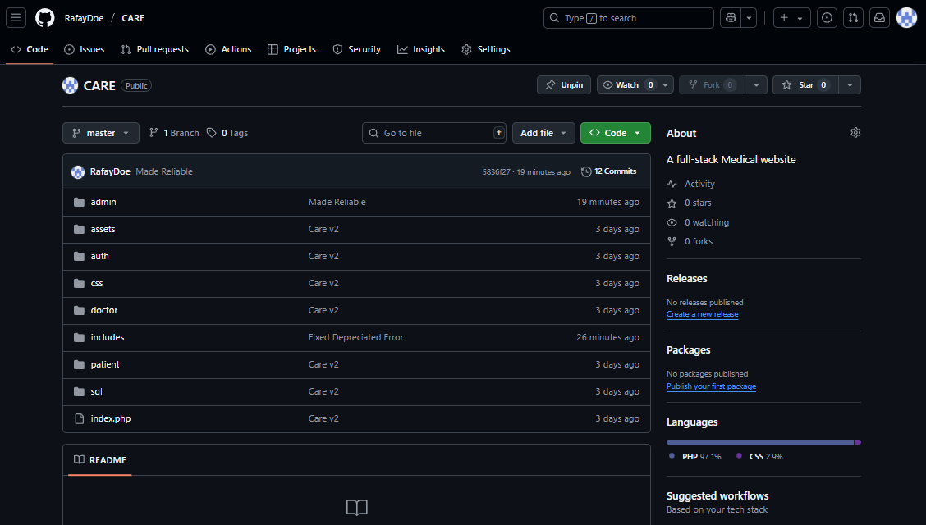

THANK YOU FOR YOUR TIME.

