**Ids assignment 04**

**Name:** Rafay Farrukh

**Registration no:** FA19-BCS-043

**Question no 1:**

**1. How many instances does the dataset contain?**

* Dataset contains 80 instances.

**2. How many input attributes does the dataset contain?**

* The dataset contains 7 input attributes which are height, weight, beard, hair length, shoes size, scarf, eye color.

**3. How many possible values does the output attribute have?**

* The output attribute has possible 2 values which are Male and female.

**4. How many input attributes are categorical?**

* 4 of the input attributes are categorical which are beard, hair length, scarf and eye color.

**5. What is the class ratio (male vs female) in the dataset?**

* There are total of 46 males and 34 females in dataset. Their class ratio is 23:17.

**Question no 2**

**1: No instances are incorrectly classified using Random Forest classifier.**

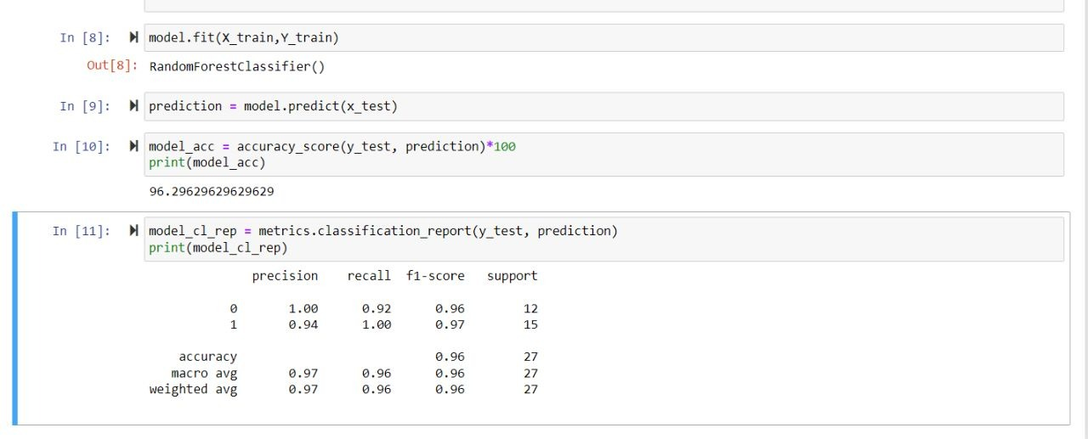

**2: 20 instances are incorrectly classified using Support Vector Machine.**

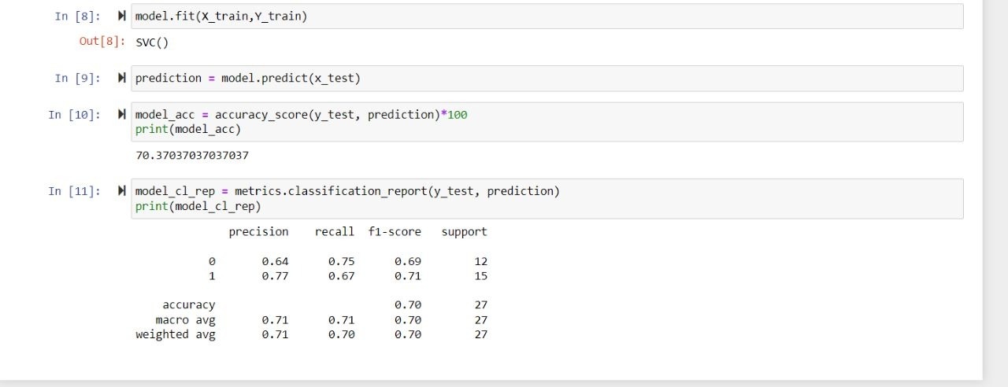

**3: at least 35 instances are incorrectly classified using MLPC.**

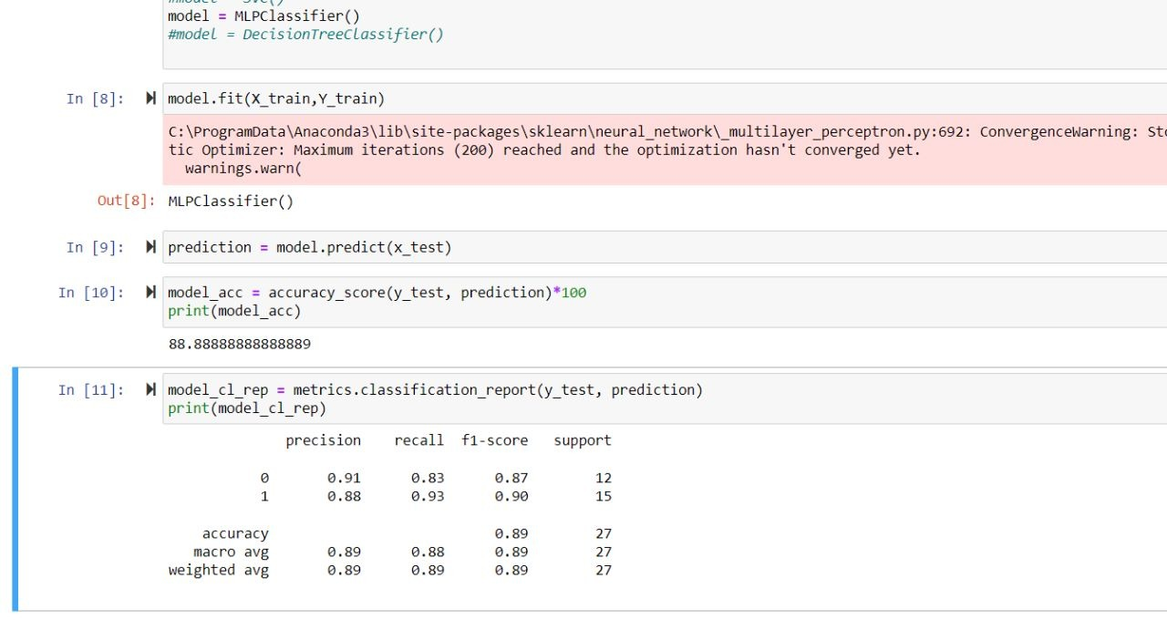

**Question no 1:**

**3: 2 attributes that you believe are the most “powerful”**

Hair length and beard are 2 most important attributes in classifying this task because these 2 distinguished most between male and female.

**Question no 1:**

**2: using train/test split ratio of 80/20**

There’s no change in Random Forrest classifier after changing to 80/20 train test split ratio. The result is same.

By using SVM classifier the accuracy decreases by approx. 10% after changing to 80/20 train test split ratio.

By using MPLC the accuracy increases by 15% when the train test split ratio is 80/20.