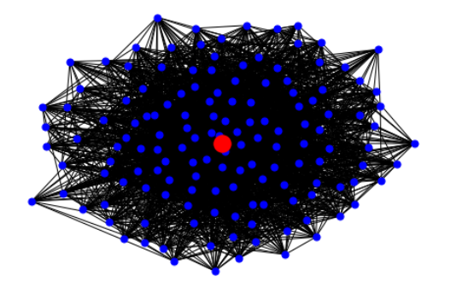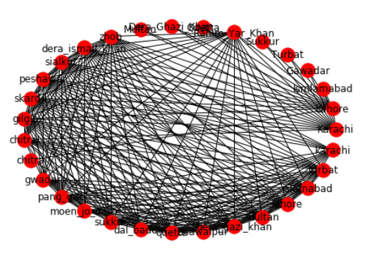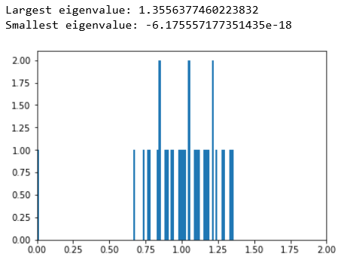

<https://github.com/Rafayjiwani/RAFAY-SIKANDER-MUSTAFA-CS112/blob/master/dicrete.ipynb>

it’s the source code of the graph of our project

ego networks uses simple graphs (i.e. graphs that are symmetric, and show only connection/not, not direction)

and it’s the EGO graph of our Project

It’s the Karate Club Graph of our project, This was first made by some students of a university known as Zachary Karate Club, it is a social network club of a karate club of that university

**The eigenvalues of a graph are defined as the eigenvalues of its adjacency matrix. ... The largest eigenvalue absolute value in a graph is called the spectral radius of the graph, and the second smallest eigenvalue of the Laplacian matrix of a graph**

The reference from where we got a little bit help are

It’s a site where a project on pia airlines

<https://www.scribd.com/doc/20490113/PIA-Project>

it’s the official flight route map of PIA

<https://www.piac.com.pk/route-map>

We are collected data of our project from Pakistan International Airlines website. In this website the Domestic routes of Pakistan airlines are shown in the form of map. So, we collected our data in this graph or this website 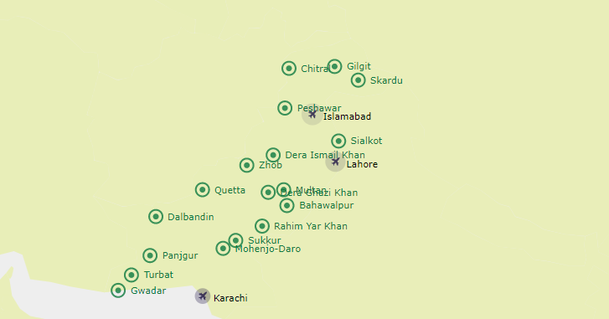

It is generally hypothesized that Domestic Airlines Routes of Pakistan is diverse and randomly distributed. We offer a different methodology, which is based upon graph properties, to study the structural dynamics in routes. The three basic questions we ask in this research are:

1: How to identify the domestic routes.

2: Are the domestics routes distributed randomly without any bias.

*SOURCE CODE*

*KARATE CLUB GRPAH*

*EGO GRAPH*

*OBJECTIVES*

USMAN INSTITUTE OF TECHNOLOGY

( BY MUSTAFA SHAHID,SIKANDER SHAKIL AND ABDUL RAFAY )

*EGO GRAPH*

*EGO GRAPH*

*EIGENVALUES*

*REFRENCES*

*DATA COLLECTION*