Hero section

- The first screen should feel like the user has entered the Arizmi Labs product archive.
- The main interaction is a rotary archive of project cards that curves into the page from the right-hand side. The cards should feel like a premium digital card system.
- The hero should fill the full first viewport.
- Top left: Use the Arizmi logo mark only
- Top right: Use a minimal menu icon.
- Headline: Welcome to Arizmi Labs. < full stop to be in mid teal colour
Copy: For founders and teams building beyond the obvious. We shape ideas, build systems and ship digital products that need more than a dev shop.
Primary CTA 1: Book a build call
CTA 2: Discover your BluePrint
- The rotary archive:
The cards should appear as if they are attached to a very large invisible wheel whose centre point sits far off-screen to the right.
The visible cards should curve in from the right-hand edge and create a sweeping arc.
The curve should feel broad and elegant, not like a tight circle.
- On mobile, these elements stack, but we still want the rotary archive to still be functional in a similar format.
- Initial card state: The first state should show the backs of the cards only. There are three types, each representing a build state.
Live build cards - Use Arizmi mid teal.
BluePrint cards - Use tech blue.
Concept cards - Use deep violet.
- Desktop behaviour
The user should be able to move through the rotary archive by scrolling, trackpad movement or dragging over the archive area.
As the archive moves:
- cards should rotate along the curved path
- the active card should become slightly more prominent
- inactive cards should remain partially visible on the right arc
- the motion should be smooth and controlled
- the wheel should not spin quickly like a prize wheel
- Hover behaviour
On hover, a card can:
- lift very slightly from the wheel
- move a few pixels toward the left/main canvas
- show a subtle foil or light glint on the border
- increase the card shadow very slightly
- Selected card behaviour
When a user clicks a card:
The selected card detaches from the rotary archive.
- It slides or glides into the main canvas area.
- The card flips from back to front.
- The rest of the archive remains visible on the right-hand side but becomes softer, dimmer or slightly out of focus.
- The user sees the project card front with key impact details.

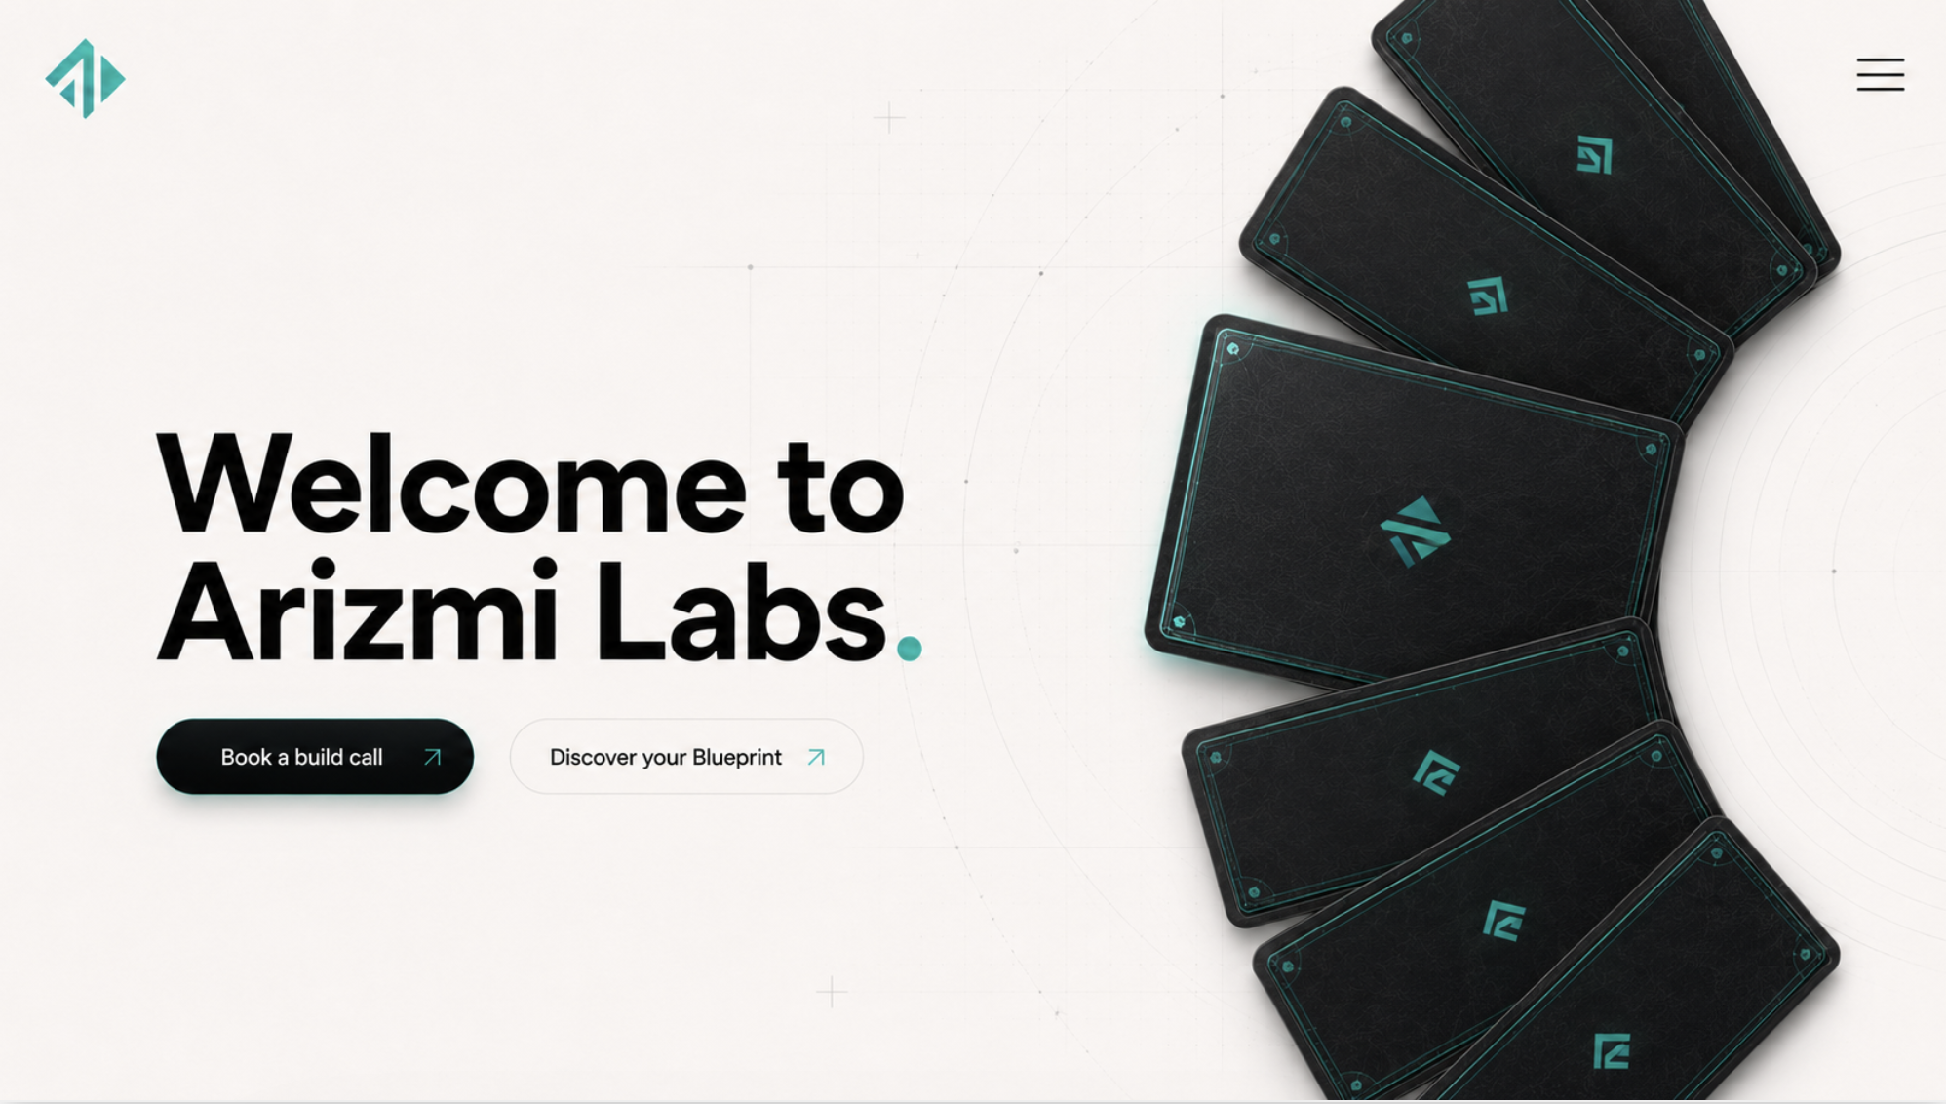

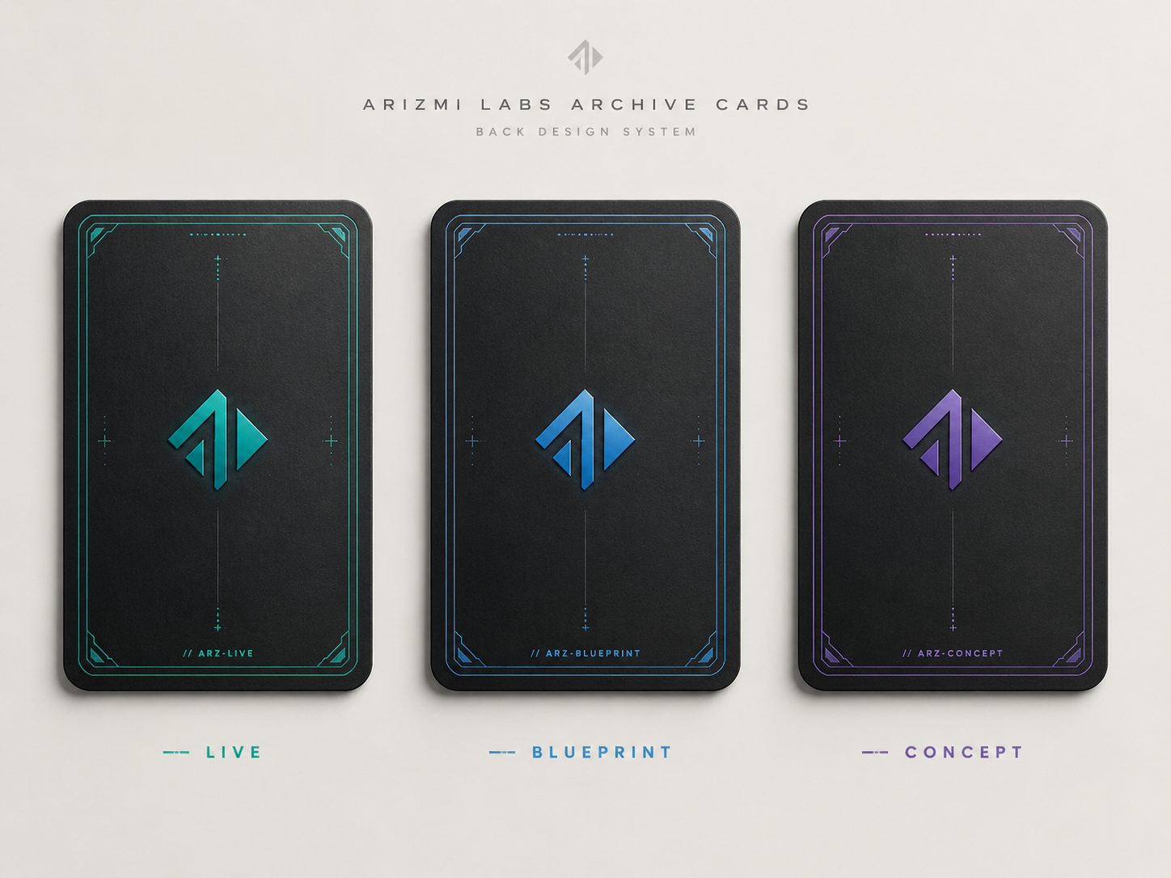

Potential framer component:
https://www.framer.com/community/marketplace/components/interactive-arc-deck/

https://www.framer.com/community/marketplace/components/arc-gallery-pro/

