Al Azhar University – Gaza



**FACULTY OF ENGINEERING AND INFORMATION TECHNOLOGY**

**DEPARTMENT OF SOFTWARE ENGINEERING**

**Software Design**

**Students Name:                                                     Students ID:**

        Rafeef Abdallah Rizg                    20191082

**SUPERVISED BY**

Eng. **Yussuf Abu Shaaban**

|  |  |
| --- | --- |
| |  | | --- | |  | |

November 2021

First Semester 2021/2022

**Index**

**TITLE         Page**

**1. Abstract 3**

1. **Introduction**  4

1. **Chapter 1: Business Requirements**
2. Functional Requirements 5-6
3. Non-functional Requirements 6-7
4. Actors    7

1. **Chapter 2: Use Cases**
2. Use case diagram 8
3. Use case details 9-14

1. **Chapter 3: Class Diagrams 15**

***Abstraction :***

At the request of the customer, a website will be built that works on all browsers to display and sell clothes imported from abroad

The online store contains imported clothes for all age groups, where each product contains details about it, pictures and an illustrative view, as well as the available sizes and colors. If the stock runs out, a quantity can be ordered again

When ordering, the product arrives at the customer's address in the shortest possible time, as the order arrives in an enclosed and arranged form to the desired address.

The website works inside the Gaza Strip and takes 30 days to build.

The project will start on 15thNov.2021

***The objectives of the project:***

- Facilitating people who are unable to shop and who do not have enough time to shop.

- Reach as many customers as possible to buy clothes without the trouble of shopping.

- Customers get the best types of imported raw materials.

Meet all customers' needs and achieve their satisfaction.-

- Deliver products safely and in a short time.

- Smooth product review.

- Shopping for all family members and all ages through this store.

***To achieve the desired goals*:**

* It will be published on social media using sponsored ads, in order to reach the largest possible number of customers.
* An explanatory video will be included explaining how to use the online store.

***Introduction***

Selling clothes is an important thing in our time and at all times, and with the development of technology, electronic clothing stores have become a noticeable and significant development. Therefore, we have built an online store to display and sell clothes imported from abroad for all age groups inside the Gaza Strip. The customer only needs to register in the store through his national number and email, then he has a personal profile in the store, and he can browse the store whenever he wants and choose the clothes he wants or which he wants to send. A gift where each product contains the details of the material manufactured, country produced, price, illustrations, product video, available colors and sizes, the customer can choose the size and color he wants, then specify the address he wants. To send the order to this address, confirm the order, and the store offers payment either by bank card or cash, so that when the courier arrives at the address specified by the customer, the order arrives at the specified address in an enclosed, tidy form and with the recommendations requested by the customer. After the order arrives, the customer can evaluate the store and write its recommendations. In the event of any default in the store, the customer has the right to file a complaint by calling the numbers in the online store.

On the opposite side, the seller adds the goods to the store, then the system sends notifications to customers of the presence of new goods, the seller adds the product with all the details, including illustrations and videos of the product, prices, colors and sizes available.

***Problems that this project helps solve:***

* Reaching the largest possible number of customers covering the entire Gaza Strip
* The speed of product arrival in case the customer wants a quick and perfect solution
* Take the stress out of shopping when you are busy or unable to go out for shopping
* Imported products make it possible to reach customers without the hassle of searching for a passenger to transport the product
* When you order a large number of one piece, it is provided in a short time

**Chapter 1:**

**Business Requirement**

1. **Business Requirement**
   1. **Functional Requirement**

|  |  |  |
| --- | --- | --- |
| **FR description** | **FR Name** | **No.** |
| Through it, the store is entered using the e-mail and password. If you do not have an account, you can register on the site using your national number and email and set a password and then you can use the login | ***login in or registering*** | 1 |
| A department is selected from the existing clothing departments, either the children's department, the women's department, or the men's department, to buy from it. | ***Choose department*** | 2 |
| The system should allow choosing the product from the available products , After choosing the department you want to buy from, you can choose the product you want to display. | ***Choose product*** | 3 |
| If the customer wants to cancel the order, he can delete the order | ***delete request*** | 4 |
| When choosing a product, you can click on the View Product Details button to view the type of material, country of manufacture, sizes, available colors and price. | ***Show product details*** | 5 |
| After choosing the product, you can choose the size you want from the available sizes. | ***choose the size of the product*** | 6 |
| You can also choose one of the available colors for the product of your choice. | ***choose the color of the product*** | 7 |
| The system allows payment either in cash with the delivery agent or payment with a bank card. | ***choose the payment method*** | 8 |
| The customer adds a review and evaluation after the order arrives | ***Add a review*** | 9 |
| after completing the selection of the product, the payment method and specifying the rest of the details, the customer can send the order to the store by clicking on “send order” or undo it | ***confirm or withdraw the order*** | 10 |

**1.2 Nonfunctional Requirement**

1) ***Usability*:**

* Web program that can be accessed at any time without the need for storage space.
* The site contains graphic icons representing each section for ease of use
* Attractive and elegant graphic interfaces
* Purchase of the product is done in one click
* A map to determine the exact location

2) ***Scalability:***

• The ability to increase the number of store members in the event of an increase in the number of customers

• The ability to add new products by the store administrator

3) ***Performance:***

• The web page should not take more than 3 seconds to load in the browser using a broadband connection.

• That the customer's request is sent within a maximum of two minutes.

• Ease and speed of movement between departments.

4) ***Reliability:***

• Automatic saving of the entered information in the event of an internet failure.

5) ***Safety :***

• Personal data and customer requests must be transferred through secure protocols.

6) ***Availability:***

• The system is available from 8:00 am until 8:00 bm.

• It works on all operating systems, that is, when moving from one operating system to another, no defect occurs.

**1.3 Actors**

|  |  |
| --- | --- |
| The person who deals with the store by buying from it or browsing its products. | ***Customers*** |
| The people who receive purchase orders and prepare them for delivery customers and are also responsible for adding new products and updating the store. | ***Store employees*** |
| Supervisors of the store and its employees, as well as receiving complaints from customers. | ***Store Manager*** |
|  |  |

**Chapter 2:**

**Use case**

**2.Use case**

* 1. **Use case diagram**

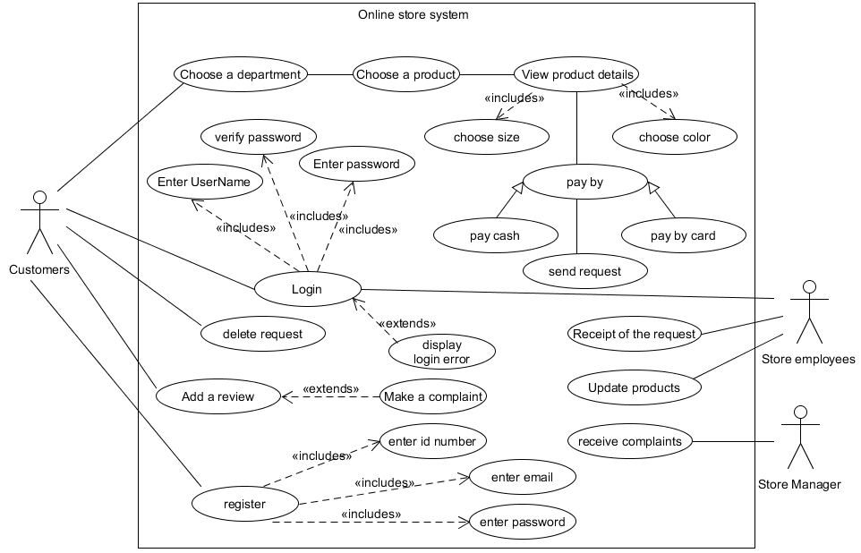

* 1. **Use case details**

**2.2.1:**

|  |  |
| --- | --- |
| **Description** | **Use case** |
| **Login system** | **Name** |
| ***Customers*** | **Actor** |
| |  |  | | --- | --- | | System | User | |  | 1- The customer opens the website on the web browser | | 2- The system displays the registration or login page |  | |  | 3- Customer clicks log in | | 4- The system moves the site to the login page |  | |  | 5- The customer enters his username and password | | 6- The system verifies the entries and confirms the entry |  | | 7- The system moves the customer to the main store page |  | | **Description** |
| Include 1 :Enter User Name  Include 2:Enter password  Include 3:Verify password  Extend 1 : display login error | **relations** |
| Step 3: If the customer presses cancel, the system will return to the start page  Step 5: If the customer enters the user name or password incorrectly, a message appears that the user name or password is wrong  Step 5: If the customer clicks on the password recovery, it will take him to the password recovery page. | **Exception** |

**2.2.2:**

|  |  |
| --- | --- |
| **Description** | **Use case** |
| **Register in the store** | **Name** |
| ***Customers*** | **Actor** |
| |  |  | | --- | --- | | System | User | |  | 1- The customer opens the website on the web browser | | 2- The system displays the registration or login page |  | |  | 3- The customer clicks to register on the site | | 4- The system moves the site to the register page |  | |  | 5- The customer enters his username ,password ,email and id number | | 6- The system saves the registration and creates a page for the customer |  | | 7- The system moves the customer to the login page |  | | **Description** |
| Include 1 :Enter Email  Include 2:Enter password  Include 3:Enter id number | **relations** |
| Step 3: If the customer presses cancel, the system will return to the start page  Step 5: If the customer enters a previously registered email, he will be sent a message that the email is already registered on the site  Step 5: If the customer enters a weak password that is not allowed and a message appears that the password is weak, please add symbols, capital letters and numbers. | **Exception** |

**2.2.3:**

|  |  |
| --- | --- |
| **Description** | **Use case** |
| **Choose department** | **Name** |
| ***Customers*** | **Actor** |
| |  |  | | --- | --- | | System | User | |  | 1-The customer logs into the store | | 2- The site moves the customer to the home page of the store |  | | 3-The system provides several sections covering all age groups |  | |  |  | |  | 5- The customer browses the sections and chooses the appropriate section for him by clicking on “Choose Section” | | 6- The system moves the site to the page of the department chosen by the customer |  | | **Description** |
| --------------------------------------------------------------------- | **relations** |
| ----------------------------------------- | **Exception** |

**2.2.4:**

|  |  |
| --- | --- |
| **Description** | **Use case** |
| **Choose products** | **Name** |
| ***Customers*** | **Actor** |
| |  |  | | --- | --- | | System | User | |  | 1- After choosing the department by the customer, the customer chooses the products he wants | |  | 2-The customer chooses the size and color he/she wants | | 3-The system displays a message confirming the selection of the product |  | |  | 4- The customer confirms the choice by clicking on Confirm | | 5- The customer saves the products chosen by the customer in the product basket |  | | **Description** |
| Include 1 :Choose color  Include 2:Choose size | **relations** |
| Step 1: If the customer chooses a product that is out of stock, a message appears that the quantity is out of stock  Step 5: If the customer chooses a color that is not available, a message appears that the color or size is not available | **Exception** |

**2.2.5:**

|  |  |
| --- | --- |
| **Description** | **Use case** |
| **View product details** | **Name** |
| ***Customers*** | **Actor** |
| |  |  | | --- | --- | | System | User | |  | 1- After the customer chooses his product, the customer can view the product information that represents the color and size chosen by the customer and the price of the final product | | 2- The system displays the details on a pop-up box |  | | **Description** |
| ---------------------------------- | **relations** |
| Step 1: If the customer does not choose a product, the system shows a message that there are no details | **Exception** |

**2.2.6 :**

|  |  |
| --- | --- |
| **Description** | **Use case** |
| **Pay by** | **Name** |
| ***Customers*** | **Actor** |
| |  |  | | --- | --- | | System | User | |  | 1- After the customer selects products, he clicks on the payment button to choose the payment method | | 2- The site calculates the products in the customer's basket |  | | 3- The site transfers the customer to the payment page to choose the payment method |  | |  |  | |  | 5- The customer chooses the payment method and makes the payment if the payment is using a card | | 6- The site sends a message to the customer if the payment process has been successfully executed |  | | **Description** |
| generalization1 :pay cash  generalization1 2:pay by card | **relations** |
| Step 5: If the customer's card does not contain the required amount, the system sends a message that the amount is not sufficient for payment | **Exception** |

**2.2.7 :**

|  |  |
| --- | --- |
| **Description** | **Use case** |
| **Send request** | **Name** |
| ***Customers*** | **Actor** |
| |  |  | | --- | --- | | System | User | |  | 1- After the customer completes the payment, he/she sends the order by clicking on the “Send Order” button | | 2- The system sends a message to the customer that you would like to confirm sending the request |  | |  | 3- The customer clicks Confirm | | 4- The system shows a message that the order has been completed successfully, please wait for the delivery service |  | | **Description** |
| -------------------------------------------------- | **relations** |
| Step 3: If the customer clicks to cancel the order, the order will be canceled. | **Exception** |

**2.2.8 :**

|  |  |
| --- | --- |
| **Description** | **Use case** |
| **Receipt of the request** | **Name** |
| ***Store employees*** | **Actor** |
| |  |  | | --- | --- | | Store employees | System | |  | 1- The system delivers orders to store employees. | | 2- Orders reach store employees |  | | 3- The store employees inspects the orders, fulfills them, and then sends them through the courier |  | |  | 4-The system sends a message to the customer that the order has been executed and that it is currently in the delivery service | | **Description** |
| -------------------------------------------------- | **relations** |
| Step 3: If the order is invalid, it sends a message to the customer that the order is invalid, please order again | **Exception** |

**2.2.9 :**

|  |  |
| --- | --- |
| **Description** | **Use case** |
| **Update products** | **Name** |
| ***Store employees*** | **Actor** |
| |  |  | | --- | --- | | Store employees | System | |  |  | | 1- The employee goes to the store additions and chooses to update the store |  | | 2- The employee enters the new database into the system |  | |  | 3-The system updates the store and updates the database currently in the delivery service | | **Description** |
| -------------------------------------------------- | **relations** |
| Step 3: If there is a defect of any kind in the database, the system sends a message to the employee that the database is invalid | **Exception** |

**2.2.10 :**

|  |  |
| --- | --- |
| **Description** | **Use case** |
| **Add a review** | **Name** |
| ***Customers*** | **Actor** |
| |  |  | | --- | --- | | System | User | |  | 1- After receiving the request to the customer, he will click on Add Review | |  | 2- The customer adds the review in a comment | |  |  | | 3- The system sends the review to the store employees |  | |  | 4- The system sends a message to the customer saying thank you for the review | | **Description** |
| Extend 1 : make complaint | **relations** |
| Step 1: If the customer does not want to add a review, this case does not work | **Exception** |

**2.2.11:**

|  |  |
| --- | --- |
| **Description** | **Use case** |
| **Receiving complaints** | **Name** |
| ***Store Manager*** | **Actor** |
| |  |  | | --- | --- | | ***Store Manager*** | System | |  | 1- The system sends the highest complaints to the store manager | | 2 The manager receives it, processes it and circulates it to the employees |  | | **Description** |
| -------------------------------------------------- | **relations** |
| Step1: If there are no complaints, this case does not work | **Exception** |

**Chapter 3:**

**Class diagram**

1. **Class diagrams**
   1. **Class diagram**

