NAMMA METRO

Smart Card Fare System
Design Implementation and Validation Report
C++ Programming Assignment 1 • 50 Marks
Student name | TO BE COMPLETED
Register number | TO BE COMPLETED
Course | C++ Programming
Compiler | GCC 16.2.0 • C++17 • x86_64-w64-mingw32
Repository | github.com/Rafeezahd/C-
Report date | 21 October 2026
Complete the two highlighted identity fields before submission.

Executive Summary
This report presents the design, implementation, and execution evidence for a C++ smart-card fare system. The solution centralizes fare rules, stores monetary values as integer paise, and keeps stored balance private inside SmartCard. The compiled examples cover the original three-zone scenario and a fourth-zone design challenge.
The validation run compiled ten standalone programs with GCC 16.2.0 and C++17. All ten compiled; the only diagnostic was the intentional signed/unsigned comparison warning in the conversion exercise. The table-driven fare suite passed 14 of 14 checks. Integer paise also handled the 6.6-billion-paise total for three million journeys without overflow; a signed 32-bit total cannot hold that amount.

Problem and scope
The base network has Inner, Middle, and Outer zones with fares of Rs 10, Rs 20, and Rs 30. Weekday peak travel adds 20%, and a stored-value journey is accepted only when at least Rs 50 remains after the debit. Tasks 1–11 analyze and implement these rules. Task 12 extends the policy with Airport, a weekend discount, and a monthly pass.

Policy assumptions used by the implementation
- Peak intervals are half-open: 08:00 through 09:59 and 17:00 through 19:59. Exactly 08:00 and 17:00 are peak; exactly 10:00 and 20:00 are off-peak.
- The brief does not specify the student or senior concession percentage. The implementation explicitly assumes 50% off the base fare and applies that concession before a weekday peak surcharge.
- The weekend discount is 10% and replaces the weekday peak surcharge. For a weekend concession fare, the discount follows the concession.
- Airport has a Rs 60 base fare. A monthly pass makes rides free and does not debit stored value; the pass entitlement is kept separate from the cash balance.
- Money remains integer paise through fare calculation and balance changes. A percentage surcharge is rounded to the nearest paise. Conversion to double is only for display or the comparison experiment.

System design
Fare calculation and card mutation have separate responsibilities. A journey supplies validated inputs; the fare policy returns a quote; SmartCard checks the minimum-balance invariant and applies an approved debit. This keeps rule arithmetic out of the console interface and prevents invalid or denied journeys from changing the stored balance.
Component | Responsibility | Key data or operations
Journey | Describes one requested trip | Zone, time, passenger kind, fare mode
FarePolicy | Applies the centralized fare rules | calculateFare → FareQuote
FareQuote | Carries the computed fare and rule flags | amountPaise, pass, peak, concession, weekend flags
SmartCard | Protects balance and approval rules | private balance/pass; canTravel, deduct, recharge

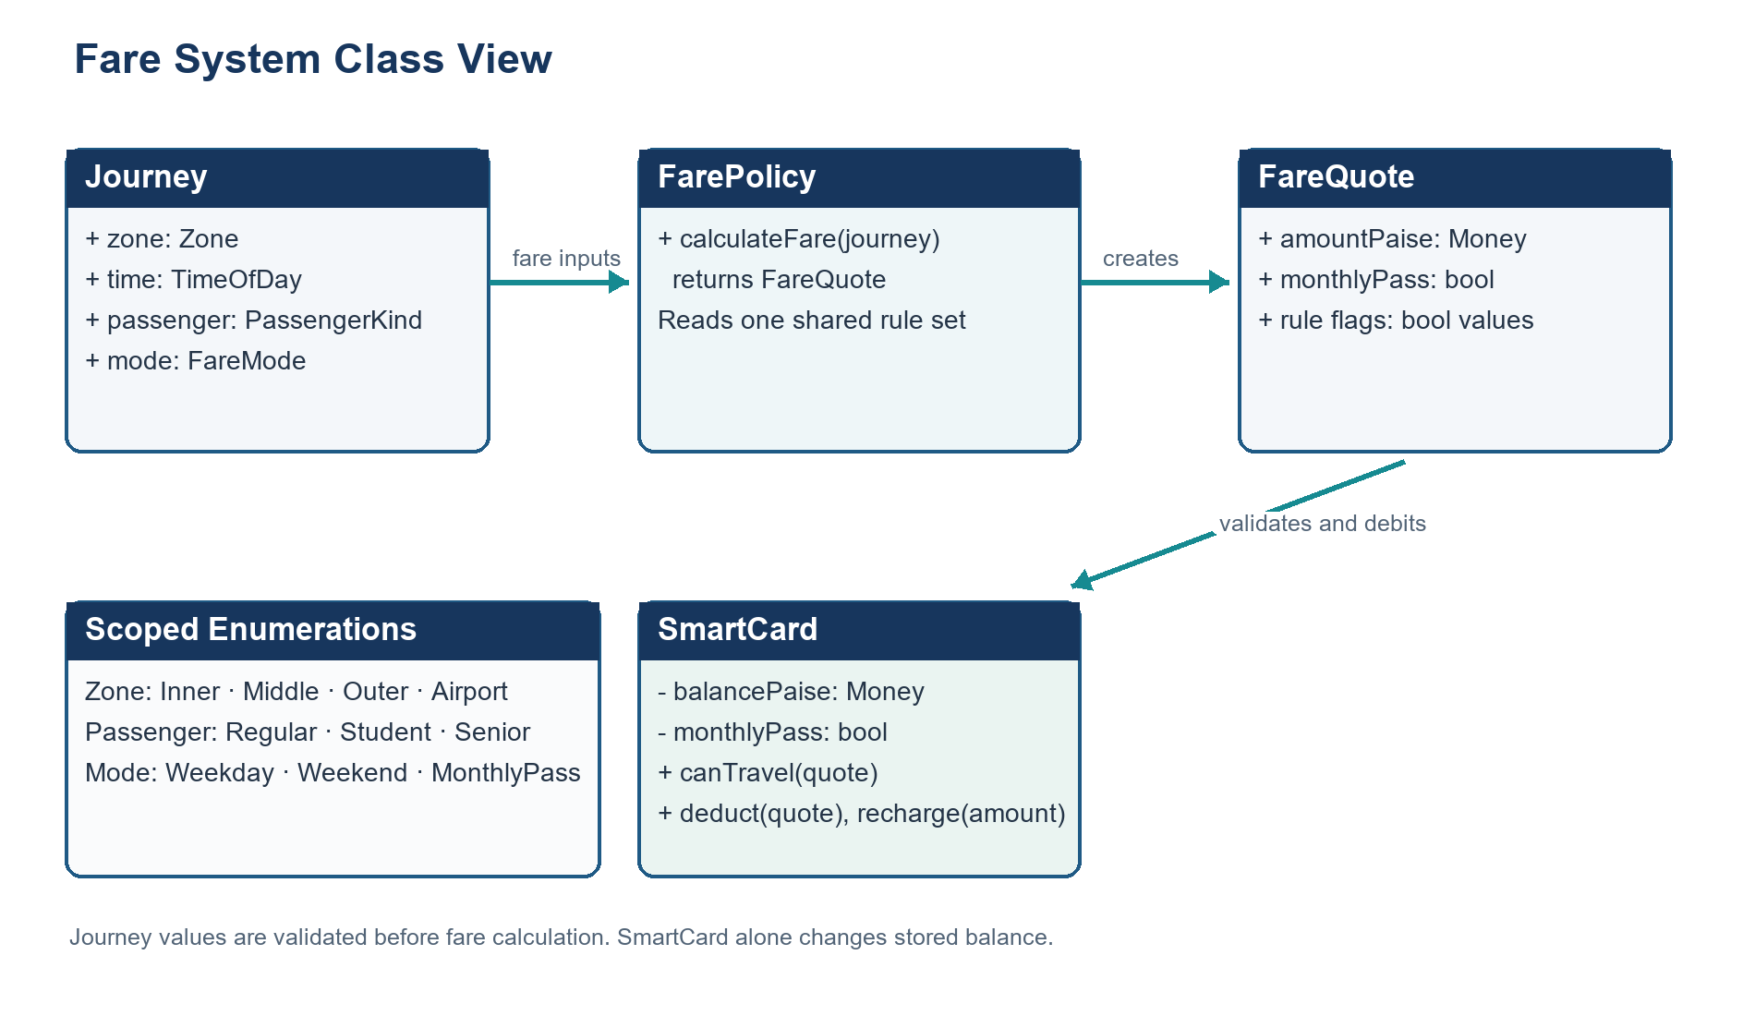
Figure 1. Class responsibilities and fare-quote flow. The fare policy is implemented as stateless functions in the shared header because it owns no per-instance data.

Tasks 1 to 4 | Design and C++ Foundations

Task 1 Object-oriented analysis
The model identifies SmartCard, Passenger, Journey, Zone, and the fare policy as separate concepts. SmartCard owns the balance and pass state; Journey carries trip inputs; the fare policy calculates a quote. Encapsulation is used to protect the minimum-balance rule. Inheritance and virtual polymorphism are omitted because the fixed passenger categories share one fare-calculation path and do not need subtype behavior.
For n journeys, both procedural and object-oriented implementations take O(n) total time and O(1) card state. A retained journey report adds O(n) storage. The class design does not improve asymptotic cost; it makes it harder for callers to bypass the balance invariant.

Task 2 Tokens names and constants
The analysis gives examples of five token categories: keywords (class, enum, switch), identifiers (SmartCard, balancePaise), literals (5000), operators (>=, *, &&), and punctuators ({}, ;, ::). Fare amounts, percentages, and the minimum balance are named in one shared location. constexpr provides typed compile-time values; enum class Zone provides scoped zone names without implicit conversion to int.
A macro has no normal C++ type or scope and may surprise through textual substitution. An indexed constexpr array and a switch are both O(1) for this fixed zone set. The array uses one 64-bit fare per zone: 24 bytes for three zones or 32 bytes for four.

Task 3 Data types and compatibility
The implementation uses bool for logical state, enum class with uint8_t for zones, int for bounded time/count values, and int64_t for balances and fares in paise. On the tested x64 compiler, bool and char occupied 1 byte, int and unsigned occupied 4 bytes, long long and double occupied 8 bytes, and the Zone enum occupied 1 byte. These sizes are target-specific except for char being at least one byte.
The report keeps double out of monetary storage. Signed/unsigned comparison can convert a negative signed value to a large unsigned value. int + double converts the integer to double; bool promotes to int in arithmetic; converting 3.7 to int narrows and discards the fraction. Brace initialization can reject narrowing at compile time.

Task 4 Implicit conversions
The predicted and observed output matched. Integer division happened before assignment to double, char promoted to int during arithmetic, a nonzero int converted to true, and comparing -1 with an unsigned value triggered the signed-to-unsigned conversion illustrated in the worksheet.
3 3.5
C 68
1 true
true true
GCC emitted the expected -Wsign-compare diagnostic for the signed/unsigned comparison. In the fare system, money is not converted to a floating type for arithmetic; only formatted output converts paise to rupees.

Tasks 5 to 8 | Expressions Control Flow and I O

Task 5 Precedence and expression results
The pre-run prediction matched the execution: multiplication precedes addition; parentheses change the result; postfix and prefix increment use different values; the conditional operator selects the larger value; / and % associate left to right and integer division truncates toward zero. The loop adds 0, 3, 6, and 9 to produce 18.
11 16
9 6 4
6 4
3 1 -3 -1
18

Task 6 Control structures
The switch selects a base fare and has a rejecting default path. An if/else handles peak surcharge and balance approval; a loop processes the journey list. This keeps a finite zone choice readable and rejects unrecognized values. A switch or validated fare array both provide constant-time lookup for a fixed number of zones.
Fare Rs 10.00 balance Rs 90.00
Fare Rs 36.00 balance Rs 54.00
Denied (low balance) balance Rs 54.00

Task 7 Procedural and object-oriented versions
The procedural version stores a local balance and calls free functions. The object-oriented version uses SmartCard with private state and a validated deduct operation. Both produced the same journey outcomes and balances. The main difference is invariant protection: public procedural state can be changed by any caller, while the class limits mutation to approved operations.

Task 8 Input and output
The gate program validates ranges and recovers from nonnumeric input by clearing the stream error and discarding the invalid line before prompting again. Its sample report rejects an unknown zone, retries after the letter x is entered as an hour, and preserves the balance on denied or invalid journeys. Rupee display uses two decimals while calculations remain in paise.

Tasks 9 and 10 | Validation and Measured Results

Task 9 Fare test suite
A table-driven executable tested base fares, peak and off-peak cases, exact time boundaries, concession, weekend behavior, monthly pass, the minimum-balance rule, invalid zone/time, and invalid recharge. Every check passed.
Check group | Observed evidence | Result
Zone fares | Inner Rs 10; Middle Rs 20; Outer Rs 30 | Pass
Peak fares | Middle Rs 24; Outer Rs 36 | Pass
Boundaries | 08:00 and 17:00 peak; 10:00 and 20:00 off-peak | Pass
Concession / weekend | Rs 15 concession fare; Rs 27 weekend fare | Pass
Pass / minimum balance | Pass fare Rs 0; journey denied if balance would fall below Rs 50 | Pass
Invalid inputs | Invalid zone/time and nonpositive recharge rejected | Pass

Test suite summary: 14 of 14 checks passed.

Task 10 Network totals and numeric precision
A six-fare cycle totals 13,200 paise. The expected totals below match the executable’s integer-paise and double totals for this whole-rupee schedule. The 32-bit overflow check detects that 6.6 billion paise exceeds signed 32-bit range. Repeated Rs 0.10 addition shows the separate rounding risk of binary floating point.
Journeys | Integer total | Double total (Rs) | Repeated Rs 0.10 error (paise) | int32 overflow
20,000 | 43,998,600 paise | 439,986.00 | -0.00000007 | No
500,000 | 1,099,998,600 paise | 10,999,986.00 | -0.00004471 | No
3,000,000 | 6,600,000,000 paise | 66,000,000.00 | +0.00019568 | Yes

Measured additions per journey were 3.15–3.41 ns for integer arithmetic and 3.34–4.30 ns for double in this run. Both operations are O(1) per journey and O(n) across n journeys; measured timing is compiler- and machine-dependent. Each 64-bit fare value occupies 8 bytes. The scheduled whole-rupee totals had zero measured double error in these test sizes, while integer paise remains exact by construction.

Compiler record
Ten standalone executables compiled successfully with GCC 16.2.0, C++17, and -Wall -Wextra -Wpedantic. Task 4’s signed/unsigned comparison warning is intentional evidence for the conversion analysis. All other recorded builds had no diagnostics.

Tasks 11 and 12 | Recommendation and Design Challenge

Task 11 Recommended design
Use a scoped Zone enum, named fare constants in one policy module, signed 64-bit integer paise, and a SmartCard with private balance and pass state. Calculate a FareQuote before asking the card to approve or deduct it. Store journey details only when the report or audit trail needs them. This design makes policy changes visible, keeps arithmetic exact, and protects the Rs 50 stored-value invariant.
The compiled fare table is a good fit for this small fixed assignment and requires a rebuild for a policy change. A validated configuration file would allow operational changes without recompiling, but adds parsing, validation, and malformed-file recovery. Four fares require only 32 bytes of raw table values; startup configuration adds little memory but more failure modes. The recommendation therefore favors centralized compile-time constants here, while a production operator workflow could justify validated external configuration.

Task 12 Fourth zone weekend discount and monthly pass
The extension adds Airport at Rs 60, a 10% weekend discount, and a monthly pass. Airport requires another enum value, fare entry, input mapping, and tests. Weekend fare mode applies the discount instead of the weekday peak surcharge. The monthly pass produces zero fare and bypasses stored-value debit while remaining an explicit card entitlement.
Challenge case | Fare or result | Balance outcome
Inner weekday peak at 08:00 | 1,200 paise | Approved; 8,800 paise
Middle weekend at 09:00 | 1,800 paise | Approved; 7,000 paise
Outer weekend with concession | 1,350 paise | Approved; 5,650 paise
Airport weekday peak at 17:00 | 7,200 paise | Denied at 5,650 paise; balance unchanged
100 Airport monthly-pass rides | 0 paise per ride | All approved; zero stored balance

The original three-zone switch is retained as the focused Task 6 exercise; the shared fare policy and Task 12 program handle the fourth zone. This preserves the earlier learning objective while keeping the revised design extensible.

Implementation Evidence and Reproduction

Key rules and invariants
- For stored value, an approved paid trip leaves at least 5,000 paise. A denied or invalid trip leaves the balance unchanged.
- Zone and time are validated before fare lookup; recharge must be positive and must not overflow int64_t.
- Monthly-pass rides are free and do not consume stored value. Pass status does not arise from selecting a journey fare mode.
- The application runs in O(1) time per fare/card operation and O(n) time for n journeys. It uses O(1) policy and card state; retained journey reports use O(n) space.

Compile commands
From the repository root, each listed source was compiled with this exact compiler option pattern; the final argument is the source file and the output path names the executable:
g++ -std=c++17 -Wall -Wextra -Wpedantic Task03/type_sizes.cpp -o Task03/type_sizes
g++ -std=c++17 -Wall -Wextra -Wpedantic Task04/predict_output.cpp -o Task04/predict_output
g++ -std=c++17 -Wall -Wextra -Wpedantic Task05/expressions.cpp -o Task05/expressions
g++ -std=c++17 -Wall -Wextra -Wpedantic Task06/complete_code.cpp -o Task06/complete_code
g++ -std=c++17 -Wall -Wextra -Wpedantic Task07/procedural.cpp -o Task07/procedural
g++ -std=c++17 -Wall -Wextra -Wpedantic Task07/object_oriented.cpp -o Task07/object_oriented
g++ -std=c++17 -Wall -Wextra -Wpedantic Task08/gate.cpp -o Task08/gate
g++ -std=c++17 -Wall -Wextra -Wpedantic Task09/test_fare.cpp -o Task09/test_fare
g++ -std=c++17 -Wall -Wextra -Wpedantic Task10/precision_benchmark.cpp -o Task10/precision_benchmark
g++ -std=c++17 -Wall -Wextra -Wpedantic Task12/design_challenge.cpp -o Task12/design_challenge

Run commands
.\Task03\type_sizes.exe .\Task04\predict_output.exe .\Task05\expressions.exe
.\Task06\complete_code.exe .\Task07\procedural.exe .\Task07\object_oriented.exe
Get-Content Task08/input.txt | .\Task08\gate.exe
.\Task09\test_fare.exe .\Task10\precision_benchmark.exe .\Task12\design_challenge.exe
Captured standard output and compiler diagnostics are included with the repository submission evidence. The PNG images under outputs/screenshots are terminal-style renderings of those captured transcripts. Benchmark nanosecond timings are measurements from this environment and should not be treated as universal performance guarantees.

Conclusion
The assignment demonstrates how type choices, centralized policy values, explicit control flow, and encapsulation work together in a small fare system. Execution evidence confirms the predicted expression outputs, the shared stored-balance rule, all 14 fare checks, and the three-million-journey total. Integer paise with a private SmartCard balance is the recommended design for exact fare and balance decisions. The Airport, weekend, and monthly-pass extension remains compatible with the same separation between fare calculation and card approval.

