SIMATS ENGINEERING (SAVEETHA SCHOOL OF ENGINEERING)
Department of Computer Science and Engineering

ASSESSMENT TOOL 2 – CASE STUDY

Course Code: | CSA06 | Course Title: | Design and Analysis of Algorithms  Assessment Tool 2 – Case Study  100
CO Assessed: | CO3: Articulation (BL4, BL5) | Assessment:
Weightage: | 20% of CIA | Total Marks:
CO3 Statement: | Design Divide and Conquer algorithms for Matrix Multiplication
Student Name: | Rafeez Ahamed SI | Reg. No.: | 192524078  10.08.2026
Section / Batch: | AIDS | Date:
Instructions to Students
- Answer the following question. Total Marks: 100.
- Carefully analyze the given case study questions.
- Explain in detail with sample code if needed.
- Clearly identify all key issues, provide an in-depth analysis, and propose innovative, feasible solutions with strong justification.

Question Type | Focus Area | Questions
Case Study | Focus on Design Divide and Conquer algorithms: Matrix Multiplication | Q1
SECTION A – CASE STUDY

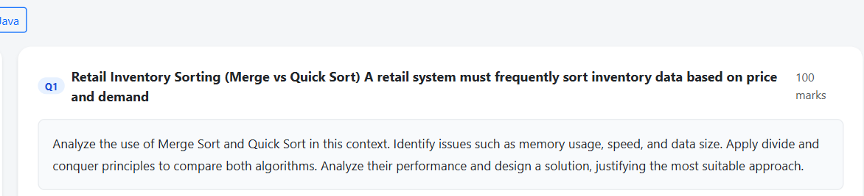

Code of Conduct
I RAFEEZ AHAMED SI/192524078(Name / Reg No) certify that this submission is my original work and that I have adhered to the guidelines specified for this assessment. I understand that any violation of academic integrity rules will result in disciplinary action.
Signature of the Student:

RUBRICS FOR CALCULATION

Case Study
Criteria | Weightage | Level 4 – Exemplary | Level 3 – Proficient | Level 2 – Developing | Level 1 – Beginning
Understanding of Case | 25% | Thorough understanding; clearly identifies all key issues | Good understanding with most issues  identified | Basic understanding; some issues missed | Poor understanding; problem not identified correctly
Application of Concepts | 25% | Effectively applies relevant concepts to analyze the case  deeply | Applies appropriate concepts with minor gaps | Limited application of concepts | Fails to apply relevant concepts
Analysis | 20% | In-depth analysis with strong reasoning and insights | Good analysis with logical reasoning | Basic analysis with limited depth | Weak or no analysis; lacks reasoning
Solution Design | 20% | Innovative, feasible solutions with strong  justification | Logical solutions with adequate justification | Basic solutions with weak justification | Incorrect or no solution provided

Clarity | 10% | Clear, wellstructured, and easy to understand | Organized and understandable presentation | Limited clarity and structure | Poor clarity; difficult to understand

Marks Evaluation:
Criteria | Wt. | Level 4 – Exemplary | Level 3 – Proficient | Level 2 – Developing | Level 1 – Beginning
Understanding of Case | 25%
Application of Concepts | 25%
Analysis | 20%
Solution Design | 20%
Clarity | 10%
Total Marks (100):

Faculty In-charge | Course Coordinator | Head of Department
Name: Name: Name:

Signature: Signature: Signature:
Date: | Date: | Date:

Algorithm –

Retail Inventory Sorting – Merge Sort vs Quick Sort

1. Introduction

A retail inventory system may contain thousands or millions of products. The products need to be sorted frequently based on price, demand, stock quantity, rating, or product ID.

Two important divide-and-conquer sorting algorithms suitable for this problem are:

Merge Sort

Quick Sort

Both have an average time complexity of O(n log n), but they differ in memory usage, stability, worst-case performance, and practical speed.

Merge Sort

Merge Sort divides the array into two equal halves repeatedly.

Example

Suppose the product prices are:

[500, 200, 800, 100, 400, 300]

First divide:

[500, 200, 800] [100, 400, 300]

Divide again:

[500] [200, 800] [100] [400, 300]

Eventually, every element becomes a separate part.

Then the parts are merged in sorted order:

[200, 500, 800] [100, 300, 400]

Finally:

[100, 200, 300, 400, 500, 800]

Code:

