SIMATS ENGINEERING (SAVEETHA SCHOOL OF ENGINEERING)

Department of Computer Science and Engineering

ASSESSMENT TOOL 1 – Constraint-Based Problem Solving

Course Code: | CSA06 | Course Title: | Design and Analysis of Algorithms
CO Assessed: | CO5– Naturalization (BL5,BL6) | Assessment: | Assessment Tool 1 – Constraint Based Problem Solving
Weightage: | 30% of CIA | Total Marks: | 100
CO5 Statement: | Analyze computational problems using backtracking techniques and complexity classes such as P, NP, NP-Hard, and NP-Complete for combinatorial problem solving.
Student Name: | RAFEEZ AHAMED SI | Reg. No.: | 192524078
Section / Batch: | 2025/AIDS | Date: | 25.08.26
Instructions to Students
- Answer the following question. Total Marks: 100.
- Apply backtracking techniques systematically for combinatorial problem solving.
- Clearly classify problems under P, NP, NP-Hard, and NP-Complete categories wherever required.
- Provide proper justification, state-space representation, and complexity analysis for all solutions.
- Neat presentation and logical explanation are mandatory.

Question Type | Focus Area | Questions
Constraint Based Problem Solving | Analyze combinatorial problems using backtracking and complexity classes such as P, NP, NP-Hard, and NP-Complete. | Q1

SECTION A – CONSTRAINT-BASED PROBLEM SOLVING

z

Code of Conduct
I RAFEEZ AHAMED SI /192524078(Name / Reg No) certify that this submission is my original work and that I have adhered to the guidelines specified for this assessment. I understand that any violation of academic integrity rules will result in disciplinary action.
Signature of the Student:

RUBRICS FOR CALCULATION

Criteria | Wt. | Level 4 – Exemplary | Level 3 – Proficient | Level 2 – Developing | Level 1 – Beginning
Problem Understanding | 25% | Clearly defines the problem and identifies all relevant constraints accurately | Identifies most constraints with minor gaps | Partial understandi ng; misses key constraints | Fails to identify constraints correctly
Constraint Analysis | 25% | Analyzes constraints effectively and prioritizes them logically | Provides reasonable analysis with some prioritizatio n | Limited analysis; weak prioritization | No meaningful analysis or prioritization
Solution Development | 25% | Develops optimal and feasible solutions satisfying all constraints | Develops workable solutions with minor limitations | Solutions partially satisfy constraints | Solutions do not meet constraints
Application of Concepts | 15% | Effectively applies appropriate concepts, methods, or tools | Applies concepts with minor errors | Limited application; requires guidance | Unable to apply relevant concepts
Justification | 10% | Provides strong justification for decisions with logical reasoning | Provides justification with some clarity | Weak or unclear justification | No justification provided

Marks Evaluation:
Criteria | Wt. | Level 4 – Exemplary | Level 3 – Proficient | Level 2 – Developing | Level 1 – Beginning
Problem Understanding | 25%
Constraint Analysis | 25%
Solution Development | 25%
Application of Concepts | 15%
Justification | 10%
Total Marks (100):

Faculty In-charge | Course Coordinator | Head of Department
Name: | Name: | Name:
Signature: | Signature: | Signature:
Date: | Date: | Date:

QUESTION AND SOLUTION

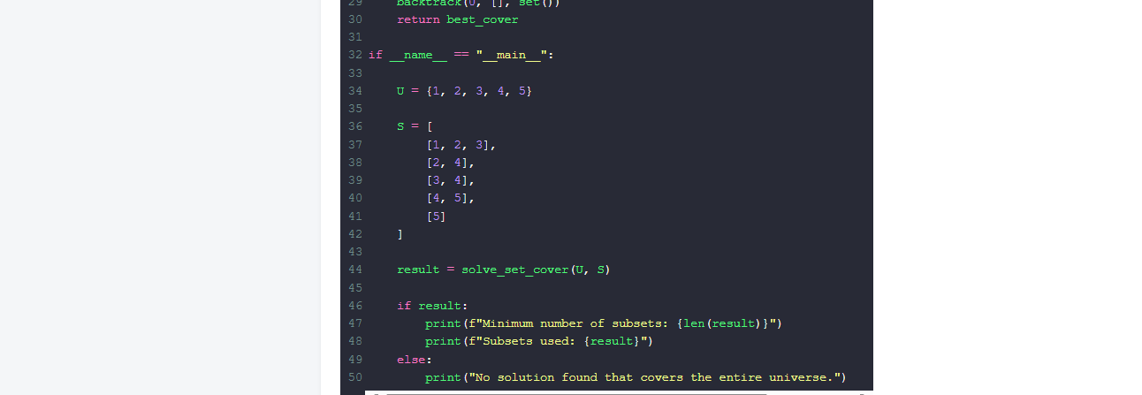
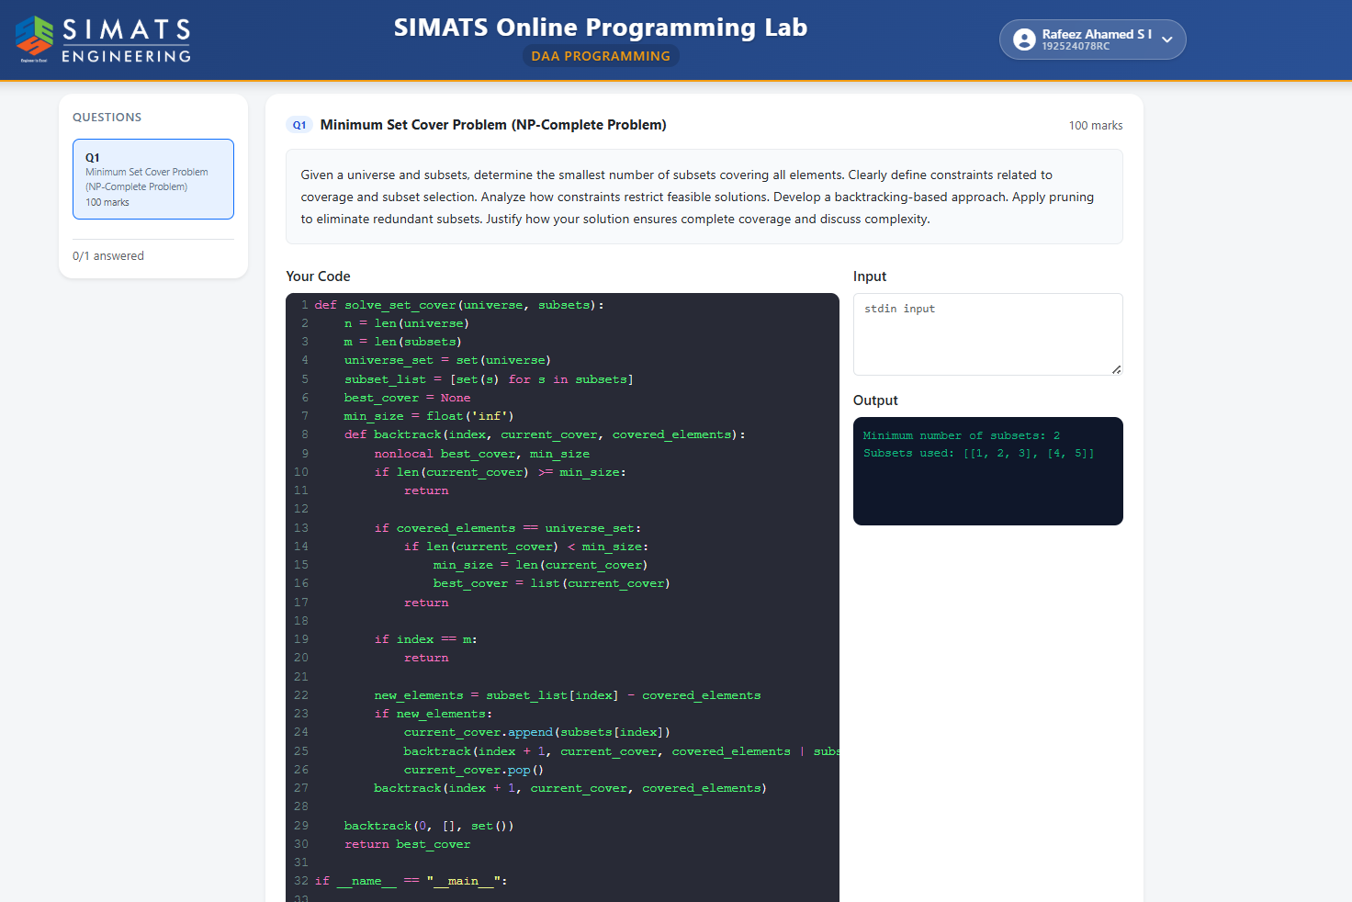

The Minimum Set Cover problem is a classic NP-Complete problem where the goal is to select the smallest possible sub-collection of subsets from a given collection "𝒮" such that their union covers every element in a defined universe "𝒰". This problem is governed by several critical constraints: the coverage constraint, which requires that every element in the universe must be present in the selected subsets; the selection constraint, which dictates that we can only choose from the provided subsets; and the minimality constraint, which requires the final collection to be the absolute smallest possible. These constraints restrict the search space by invalidating any selection that fails to cover the entire universe or any selection that is larger than a previously discovered valid cove

To solve this using a backtracking-based approach, we process subsets one by one and decide whether to include each subset or exclude it. During recursion, we maintain two key states: (1) the current set of chosen subsets and (2) the set of elements already covered by these subsets. When the recursion finds that all elements in U are covered, we have obtained a feasible cover and we compare its size with the best (minimum) cover found so far. If we reach the end of the subset list without covering the universe, then that branch does not produce a valid solution. This systematic include/exclude exploration ensures that the algorithm considers all possible subset selections, which is necessary because the problem is NP-complete and cannot be efficiently solved for all cases using simple greedy methods.

Pruning is applied to eliminate redundant or unpromising branches early. If the current number of selected subsets is already greater than or equal to the minimum size found so far, then continuing deeper into that branch cannot yield a better optimal solution. Therefore, the recursion stops immediately for that path. This pruning greatly reduces the search space in practice because many branches become irrelevant once a good solution has been found. In addition, we only include a subset when it contributes new elements that are not already covered, which prevents selecting unnecessary subsets that do not improve coverage.
The solution ensures complete coverage and correctness by explicitly tracking the covered elements and verifying completion when the covered set equals the universe set. Only when this condition is satisfied does the algorithm accept the selected subsets as a valid cover. Since the algorithm explores every include/exclude decision path (except those pruned by the correctness-preserving bound), it guarantees that the best solution among all feasible covers is found. Therefore, the final answer corresponds to a minimum set cover with complete coverage of all universe elements.

