
NED UNIVERSITY OF ENGINEERING & TECHNOLOGY
DEPARTMENT OF COMPUTER SCIENCE AND IT

COMPLEX COMPUTING PROBLEM (CCP)
R E P O R T
Course Code: CT-351 | Course Title: Knowledge Representation & Reasoning

Project Title: | CyberGuard  A Knowledge Representation & Rule-Based Reasoning System for Cybersecurity Threat Detection and Access Control
Selected Domain: | Cybersecurity: Threat Detection and Access Control in a University Network
Section: | Artificial Intelligence
Submission Date: | 9 November 2026
GROUP MEMBERS
S. No. | Student Name | Roll Number | Assigned Contribution
1 | Umair Hasan | AI-23018 | Backward chaining, decision logic, testing, report integration and references (Sections 6.2, 7.2, 8.1 and 10)
2 | Abrar Shakeel Ghoury | AI-23019 | Domain analysis, frames, script, semantic network and diagrams (Sections 2, 3 and 7.1)
3 | Amna Amjad | AI-23031 | Introduction, Horn clause knowledge base and forward chaining (Sections 1, 5 and 6.1)
4 | Mirza Abdul Raffay Baig | AI-23033 | First-Order Logic, Description Logic axioms, limitations analysis and conclusion (Sections 4, 8.2 and 9)

INSTRUCTOR  Ms. Dureshahwar Waseem | CLO  CLO-3 (Design/Analysis) | PLO  PLO-10 (Lifelong Learning)
REPORT CONTENTS
CT-351 | Knowledge Representation & Reasoning
1. Introduction 3
2. Domain Analysis 3
3. Knowledge Representation 5
3.1 Frames 6
3.2 Semantic Networks 9
4. Formal Logic Representation 12
4.1 First-Order Logic (FOL) 12
4.2 Description Logic (DL) 14
5. Horn Clause Knowledge Base 17
6. Inference and Reasoning 19
6.1 Forward Chaining 19
6.2 Backward Chaining 20
7. Implementation 24
8. Results and Discussion 30
9. Conclusion 34
10. References 34
11. Team Participation 35

1. INTRODUCTION

1.1 Selected Domain and Background
The selected domain is cybersecurity, more precisely threat detection and access control in a university network. A university network is used by students, faculty, administrators and IT staff, who log in from many devices and open resources of very different sensitivity, from a public course page to the grades database and the administrator panel. Whenever someone asks for a resource, the system must decide whether the request is normal, suspicious or dangerous. In practice this decision depends on who the person is, which device is used, how the login went and how sensitive the resource is.
CyberGuard is a rule-based Knowledge Representation and Reasoning (KRR) system [2] for this problem. It represents users, devices, resources, login events, permissions and threats as structured knowledge using Frames and a Semantic Network. It formalises the security policy in First-Order Logic (FOL) and Description Logic (DL), converts the policy into Horn clauses, and applies Forward Chaining and Backward Chaining to decide for every access request whether it should be ALLOWED, FLAGGED or DENIED. Every decision comes with an explanation of how it was derived. The reasoning engine (unification, forward chaining and backward chaining) is written in Python by the team and does not use an external reasoning library.

1.2 Problem Statement and Objectives
A security decision is not stored anywhere in the data; it is the end of a chain of derived conclusions. For the scenario of the project proposal the chain is:
Multiple failed attempts → Brute Force → Suspicious Login → High-Risk Access → Access Denied
The problem is therefore to build a system that starts from basic facts (roles, devices, failed login attempts, requested resources), derives the intermediate security concepts by logical rules, reaches an ALLOW, FLAG or DENY decision, and explains why. The main objectives of the project, which follow the CCP guidelines of the course [5], are:
- represent the domain with frames (slots, facets, default values, inheritance, a demon and a script) and a semantic network (is-a, has-a, part-of links);
- formalise the facts and rules in FOL and DL (subsumption, membership and disjointness) and analyse the trade-off between expressive power and tractability;
- convert the rules to Horn clauses and run step-by-step data-driven (forward) and goal-driven (backward) inference;
- produce an ALLOW, FLAG or DENY decision with a reason chain, and validate the system with seven scenarios and fifteen automated tests.

2. DOMAIN ANALYSIS

2.1 Domain Description and Requirements
The domain is access control in a university network. Whenever a person asks for a resource, the system looks at who the person is, which device is used, how the login went and how sensitive the resource is, and then decides what to do with the request. Table 2.1 lists the knowledge areas that the system has to represent.
Table 2.1: Knowledge areas of the CyberGuard domain
Area | Concepts | Examples in the system
Users | Student, Faculty, Administrator, IT Staff; role and failed login attempts | ali (student), sara (faculty), hamza (admin), zain (it_staff)
Devices | Trusted or unknown; managed or unmanaged | dev1 and dev2 are trusted; dev7 and dev9 are unknown
Resources | Public, internal, sensitive and critical; admin-only | course_page, student_db, grades_db, admin_panel
Security events | Login attempts, failed attempts, suspicious logins, role change attempts | login(ali, dev7), failed_attempts(ali, 4)
Threats | Brute force, unauthorized access, account compromise, privilege escalation | brute_force(ali), account_compromise(ali)

The functional requirements derived from the domain are:
- Brute force: three or more failed login attempts classify the user as a brute-force attempt.
- Unknown device: a login from a device that is not in the trusted list marks the device as unknown, and the login becomes suspicious.
- Risk: a suspicious user who requests a sensitive or critical resource is a high-risk request.
- Unauthorized access: a non-administrator who requests an admin-only resource is unauthorized.
- Threats: brute force followed by a login from an unknown device is an account compromise; unauthorized access together with a role change attempt is a privilege escalation.
- Decision: high-risk, unauthorized and compromised-account requests are denied; other suspicious requests are flagged; requests with nothing suspicious are allowed. If several decisions are derived, deny has priority over flag, and flag over allow.
- Explanation: every decision must be traceable to the rules and facts that produced it.
- What-if analysis: the user must be able to change a fact and run the reasoning again.
The non-functional requirements are explainability, deterministic traces (the same input always gives the same trace), the possibility to change rules without changing the engine, and execution with plain Python.

2.2 Entities, Relationships, and Challenges
The important entities are User (with the kinds Student, Faculty, Administrator and ITStaff), Device (trusted or unknown), Resource (public, internal, sensitive, critical and admin-only), LoginEvent and Threat (brute force, unauthorized access, account compromise and privilege escalation). They are connected by the following relationships: a user uses a device, a user requests a resource, a login event is by a user and from a device, and a threat targets a user. The kinds of user, device, resource and threat are related to their parent concept by is-a links (for example Student is-a User and CriticalResource is-a SensitiveResource). The complete structure is shown in Section 3.
Building a system for this domain raises the following challenges:
- Derived knowledge. Concepts such as brute_force, suspicious_login, high_risk and deny are never entered by a user. They have to be inferred from basic facts.
- Combination of facts. One fact alone is not enough. A login from an unknown device is only high risk when it also asks for a sensitive resource.
- Absence of information. An ALLOW decision needs the absence of suspicious signs. This requires negation as failure and the closed-world assumption, which is not pure Horn logic.
- Competing conclusions. A request can be flagged by one rule and denied by another. The rules therefore run in strata (levels) and the decision uses a priority.
- Default knowledge. An unlisted device is unknown by default, and a user without a recorded failure has zero failed attempts. Frames provide these defaults.
- Expressive power against tractability. FOL can state every rule but is only semi-decidable. Horn clauses are fast but cannot express disjunction or classical negation. The design must choose a workable balance (Section 8.2).
The project addresses the complex-problem attributes of the CCP as follows: range of resources (frames, semantic networks, FOL, DL, Horn clauses and chaining engines are used together), level of interaction (the trade-off between expressive power and tractability is analysed and resolved) and innovation (a rule-based knowledge structure for dynamic inference with automatic explanations).
A relational database is an excellent store for facts, but it is not designed to reason with them. Table 2.2 compares a traditional database with the knowledge-based approach used in CyberGuard.
Table 2.2: Traditional database compared with CyberGuard
Aspect | Traditional database | CyberGuard (KR and rules)
Derived knowledge | Returns only stored rows. high_risk or deny is not stored, so application code or views must compute it. | New facts are derived automatically by rules (for example R1 to R14).
Rules | Hard-coded in queries, triggers or application code. A policy change means changing and redeploying code. | Rules are data (Horn clauses). The engine is unchanged when a rule is added or edited.
Explanation | Gives an answer but no proof of why. | Prints a reason chain and a full forward or backward trace.
Goal-driven queries | Cannot start from a hypothesis such as “is deny justified?” and search for supporting facts. | Backward chaining starts from the hypothesis and proves it from facts.
Default values and inheritance | Column defaults only; no class hierarchy with overriding. | Frames give defaults, inheritance (Student is-a User) and demons.
Class-level reasoning | No built-in subsumption or disjointness checks. | DL axioms (Student and Administrator are disjoint) and a small DL reasoner.
Negation | Open to interpretation (NULL, NOT EXISTS). | Explicit negation as failure with stratified rules.
SQL views, stored procedures and triggers can compute some derived values, but the logic is scattered, hard to inspect and still gives no explanation. A database remains the right place to store large volumes of facts. In a complete deployment, the facts of CyberGuard would come from a database and the knowledge-based layer would reason over them.

3. KNOWLEDGE REPRESENTATION
Structural knowledge is represented in two complementary ways. Frames describe one concept in detail from the inside (slots, facets, defaults), while the semantic network shows how the concepts are connected to each other. Both are generated from the code (knowledge/frames.py and knowledge/semantic_net.py), so the diagrams always agree with the implementation.

3.1 Frames
A frame [2] is a class with slots (attributes), facets (rules about a slot: type, allowed values, range, default value, multiple values and an if-added demon) and an is-a parent from which it inherits. CyberGuard defines the frames User, Student, Faculty, Administrator, ITStaff, Device, Resource, LoginEvent and Threat. Student, Faculty, Administrator and ITStaff inherit all slots of User and only override the default of the slot role. The slot failed_attempts of User carries the demon warn_many_failures, which runs when a value is stored and reports that rule R1 (brute force) will match. Table 3.1 summarises the frames, and Figure 3.1 is the program output of Stage 1: it lists every frame with its slots and facets and shows which defaults are overridden by the child frames and which slots are inherited.

Table 3.1: Summary of the frames, slots, facets and default values
Frame | Is-a | Slots and facets | Default values
User | - | name (string); role (values: student, faculty, admin, it_staff); failed_attempts (integer, range 0..100, if-added demon warn_many_failures); uses (Device, multiple); requests (Resource, multiple) | role = student; failed_attempts = 0
Student | User | Inherits name, failed_attempts, uses, requests; overrides role | role = student
Faculty | User | Inherits all slots of User; overrides role | role = faculty
Administrator | User | Inherits all slots of User; overrides role | role = admin
ITStaff | User | Inherits all slots of User; overrides role | role = it_staff
Device | - | device_id (string); trust (values: trusted, unknown); management (values: managed, unmanaged) | trust = unknown; management = unmanaged
Resource | - | resource_id (string); sensitivity (values: public, internal, sensitive, critical); admin_only (boolean) | sensitivity = internal; admin_only = False
LoginEvent | - | user (User); device (Device); location (string); suspicious (boolean) | location = campus; suspicious = False
Threat | - | kind (values: brute_force, unauthorized, account_compromise, privilege_escalation); target (User); severity (values: low, medium, high) | severity = medium

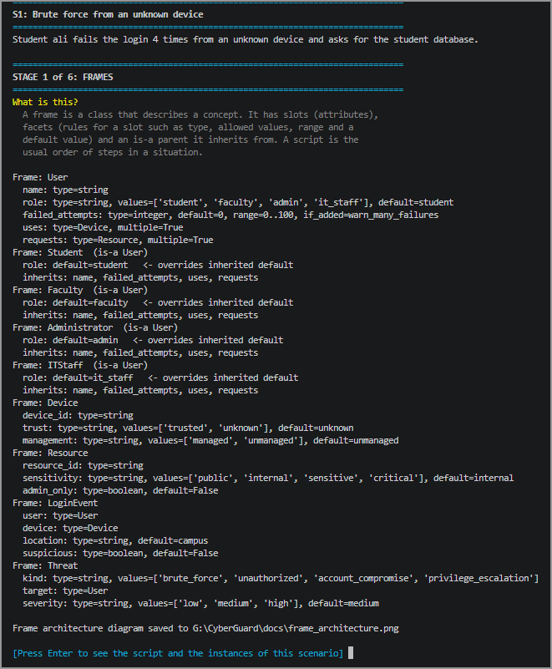

Figure 3.1: Frame definitions printed by the program (Stage 1)
A script is the standard sequence of steps in a situation. The script “Login and Access Request” has five steps, and each step names the rules that apply to it. When a scenario runs, the frames are instantiated: slots that are not given take their default values, and the demon fires for failed_attempts = 4. Figure 3.2 shows the script and the frame instances created for scenario S1.
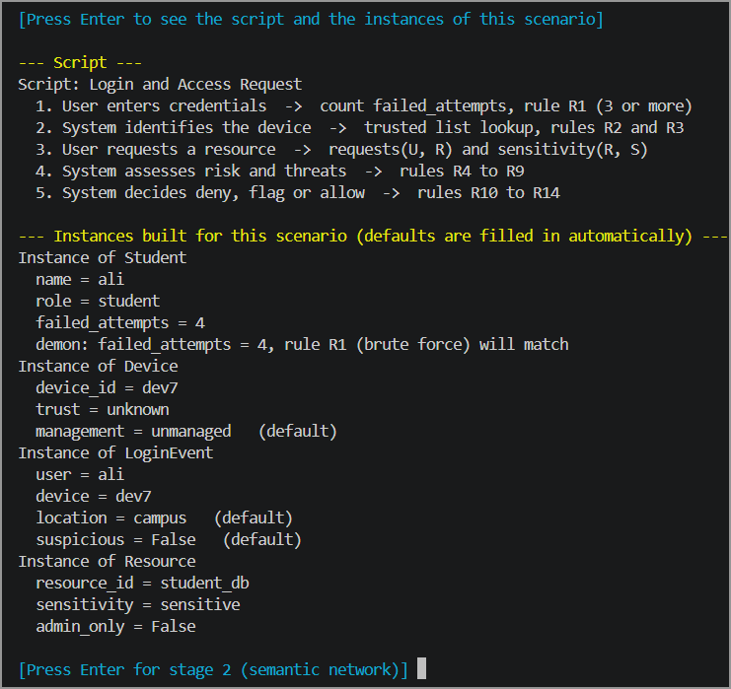

Figure 3.2: The login script and the frame instances created for scenario S1

Figure 3.3 is the frame architecture diagram: blue arrows are is-a (inheritance) links and orange arrows are slots that point to another frame, similar to foreign keys in a database.
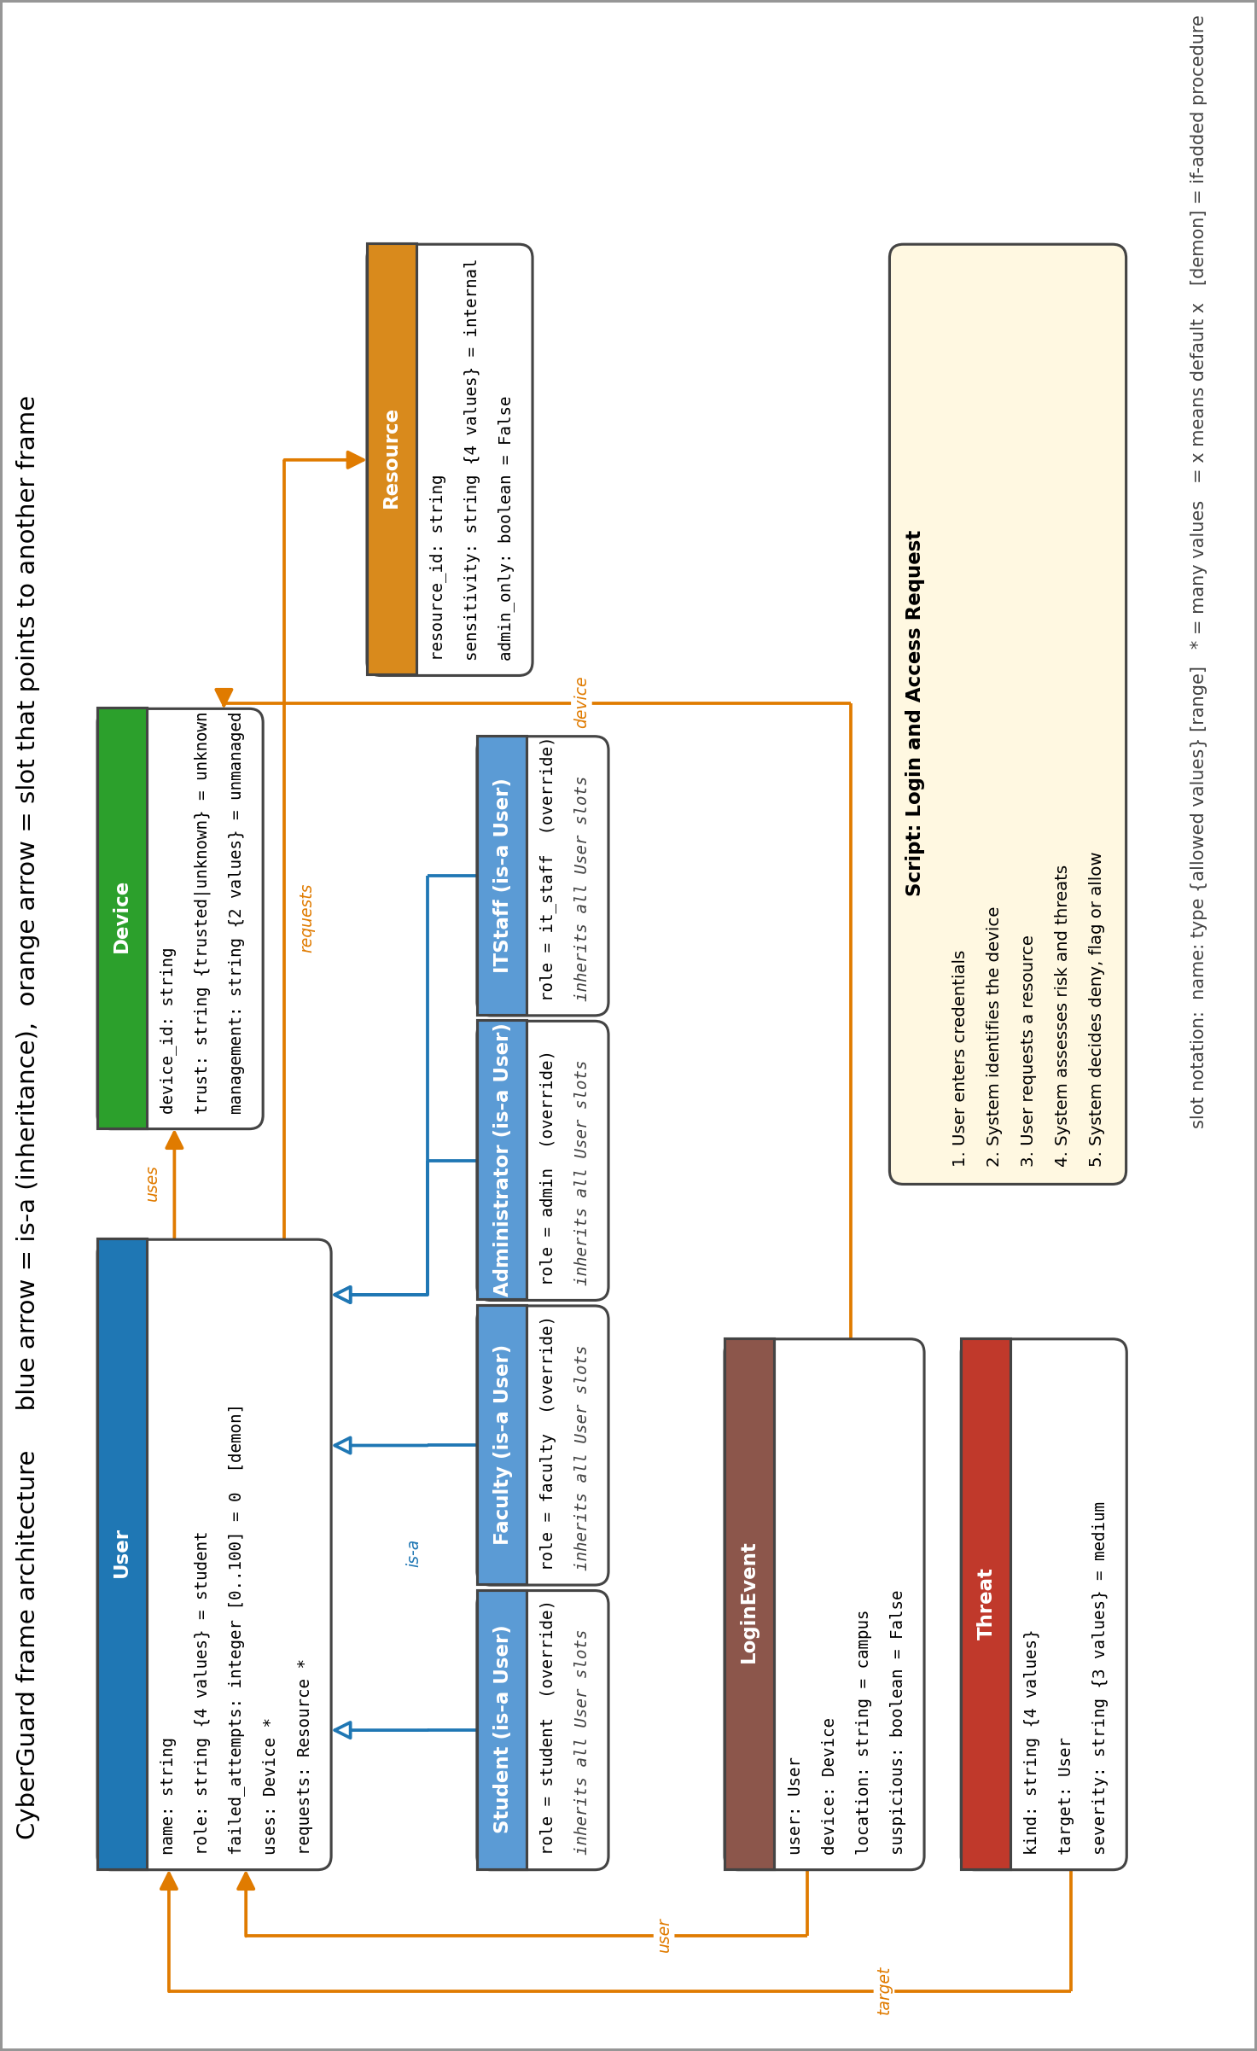
Figure 3.3: Frame architecture diagram of CyberGuard

3.2 Semantic Networks
The semantic network [2] connects concepts with labelled links: is-a (a kind of), has-a (owns a property) and part-of (belongs to a bigger whole), plus domain links such as uses, requests, by, from and targets. The is-a links are taken from the Description Logic subsumption axioms, so the network and the logic never disagree. In Figure 3.5 blue boxes are concepts, grey boxes are properties and green boxes are the individuals of scenario S1 (ali, dev7 and student_db). Purple dashed links are instance-of links. The individuals change with the scenario, while the schema stays the same. Figure 3.4 is the textual form of the same network, printed by Stage 2.
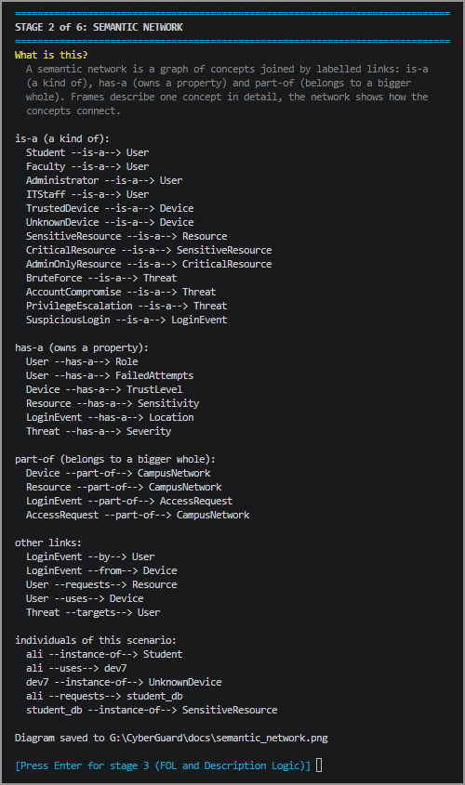

Figure 3.4: Relations of the semantic network and the individuals of S1 (Stage 2)
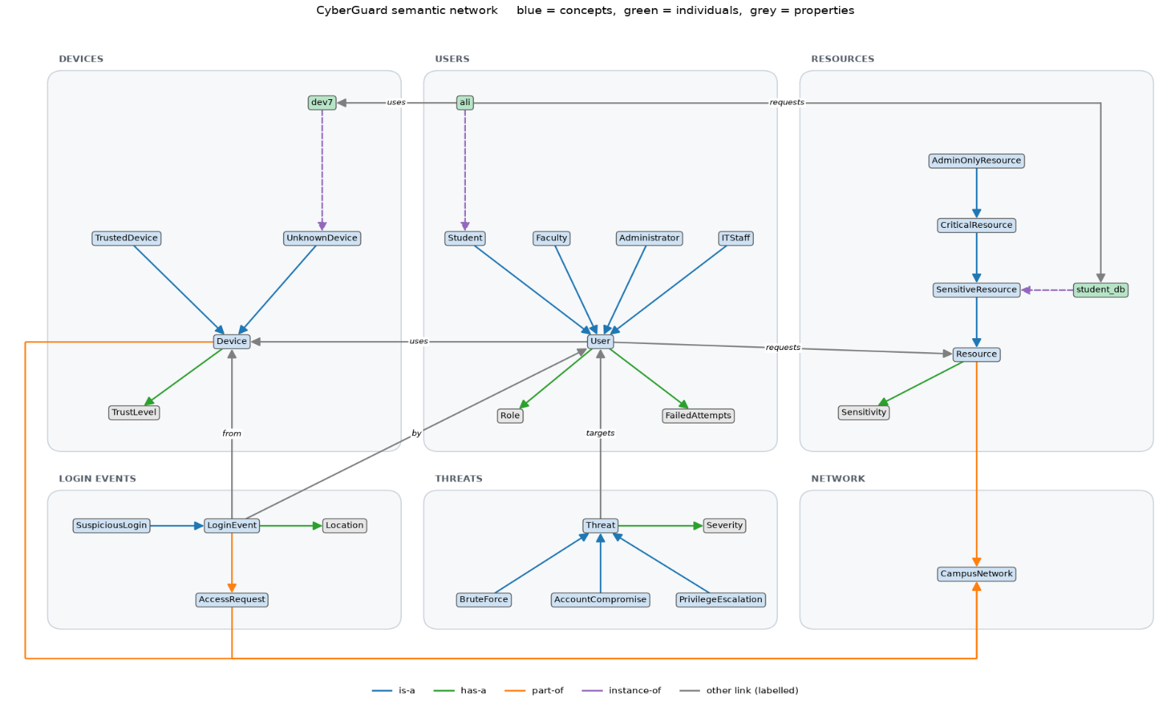

Figure 3.5: Semantic network of CyberGuard with the individuals of scenario S1

Table 3.2 compares the two structures. Neither of them derives new knowledge on its own. The value suspicious = False in the LoginEvent frame is only an initial state; the fact suspicious_login(ali) is derived later by the rules of Sections 4 and 5.

Table 3.2: Frame and semantic network
 | Frame | Semantic network
View | One concept seen from the inside | Concepts and how they connect
Content of a node | Slots, facets, default values, demons | Only the name of the concept
Links | is-a parent and slots that point to other frames | is-a, has-a, part-of and domain links
Individuals | Instances built from the frame (ali = Student) | instance-of links (ali instance-of Student)
Database analogy | Table definition with constraints and defaults | Entity-relationship diagram

4. FORMAL LOGIC REPRESENTATION

4.1 First-Order Logic (FOL)
First-Order Logic [1] states the policy with predicates, constants, variables and quantifiers. Table 4.1 defines the predicates and the constants used in the domain. The variable u stands for a user, d for a device, r for a resource and n for a number.
Table 4.1: Predicates and constants of the CyberGuard domain
Predicate | Meaning
Role(u, x) | User u has the role x
FailedAttempts(u, n) | User u has n failed login attempts
Login(u, d) | User u logs in from device d
Trusted(d) | Device d is in the trusted list
Requests(u, r) | User u requests resource r
Sensitivity(r, s) | Resource r has the sensitivity level s
AdminOnly(r) | Resource r is reserved for administrators
RoleChangeAttempt(u) | User u tries to change a role
BruteForce(u), UnknownDevice(d), SuspiciousLogin(u) | Derived: brute-force user, unknown device, suspicious login
HighRisk(u, r), Unauthorized(u, r) | Derived: high-risk request, unauthorized request
AccountCompromise(u), PrivilegeEscalation(u) | Derived threats
Decision(u, r, x) | The decision for the request of u for r is x (allow, flag or deny)

Table 4.1 (continued): Constants of the CyberGuard domain
Type | Constants
Users | ali, sara, hamza, zain
Devices | dev1, dev2 (trusted); dev7, dev9 (not in the trusted list)
Resources | course_page, student_db, grades_db, admin_panel
Roles | student, faculty, admin, it_staff
Sensitivity levels | public, internal, sensitive, critical
Decisions | allow, flag, deny
The static facts of the domain are written in FOL as Role(ali, student), Role(sara, faculty), Role(hamza, admin), Role(zain, it_staff), Trusted(dev1), Trusted(dev2), Sensitivity(course_page, public), Sensitivity(student_db, sensitive), Sensitivity(grades_db, critical), Sensitivity(admin_panel, critical) and AdminOnly(admin_panel). The scenario S1 adds Login(ali, dev7), FailedAttempts(ali, 4) and Requests(ali, student_db).
A formula is read as “for all u and r, if the conditions on the left hold, then the conclusion on the right holds”. Symbols used: ∀ (for all), ∃ (there exists), ∧ (and), ∨ (or), ¬ (not), → (implies). Table 4.2 gives one formula for every rule of the knowledge base.
Table 4.2: FOL formulas of the rule base
Rule | FOL formula | Meaning
R1 | ∀u ∀n (FailedAttempts(u,n) ∧ n ≥ 3 → BruteForce(u)) | Three or more failed attempts means brute force
R2 | ∀u ∀d (Login(u,d) ∧ ¬Trusted(d) → UnknownDevice(d)) | A login from a device that is not trusted marks it unknown
R3 | ∀u ∀d (Login(u,d) ∧ UnknownDevice(d) → SuspiciousLogin(u)) | Login from an unknown device is suspicious
R4 | ∀u (BruteForce(u) → SuspiciousLogin(u)) | A brute-force user is suspicious
R5 | ∀u ∀r (SuspiciousLogin(u) ∧ Requests(u,r) ∧ Sensitivity(r,sensitive) → HighRisk(u,r)) | Suspicious user asks for a sensitive resource
R6 | ∀u ∀r (SuspiciousLogin(u) ∧ Requests(u,r) ∧ Sensitivity(r,critical) → HighRisk(u,r)) | Suspicious user asks for a critical resource
R7 | ∀u ∀r (Requests(u,r) ∧ AdminOnly(r) ∧ ¬Role(u,admin) → Unauthorized(u,r)) | A non-admin asks for an admin-only resource
R8 | ∀u ∀d (BruteForce(u) ∧ Login(u,d) ∧ UnknownDevice(d) → AccountCompromise(u)) | Brute force followed by a login from an unknown device
R9 | ∀u ∀r (Unauthorized(u,r) ∧ RoleChangeAttempt(u) → PrivilegeEscalation(u)) | Unauthorized access with a role change attempt
R10 | ∀u ∀r (HighRisk(u,r) → Decision(u,r,deny)) | Deny a high-risk request
R11 | ∀u ∀r (Unauthorized(u,r) → Decision(u,r,deny)) | Deny an unauthorized request
R12 | ∀u ∀r (AccountCompromise(u) ∧ Requests(u,r) → Decision(u,r,deny)) | Deny every request of a compromised account
R13 | ∀u ∀r (SuspiciousLogin(u) ∧ Requests(u,r) ∧ ¬Decision(u,r,deny) → Decision(u,r,flag)) | Suspicious but not denied: flag the request
R14 | ∀u ∀r (Requests(u,r) ∧ ¬SuspiciousLogin(u) ∧ ¬Unauthorized(u,r) → Decision(u,r,allow)) | Nothing suspicious and authorized: allow
The formulas R2, R7, R13 and R14 contain ¬ in the body. Classical Horn clauses do not allow negation, so the engine reads ¬ as negation as failure (a condition that cannot be proved is treated as false), applied in strata. This is explained in Section 5. Table 4.3 lists the formulas that are outside the Horn fragment and how CyberGuard handles them.
Table 4.3: Formulas outside the Horn fragment and how CyberGuard handles them
Formula | Why it is not Horn | How it is handled
∀u (User(u) → Student(u) ∨ Faculty(u) ∨ Administrator(u) ∨ ITStaff(u)) | The head is a disjunction (more than one positive literal) | Every user gets exactly one role fact, so no disjunction is needed
∃u ∃r Unauthorized(u,r) | As a knowledge base axiom it needs Skolem constants, so it is not used as a general rule | As a query it works with backward chaining, which treats u and r as variables and searches for values
∀u (Student(u) → ¬Administrator(u)) | A negative conclusion is not allowed in a Horn head | Written as a DL disjointness axiom and checked by the DL reasoner
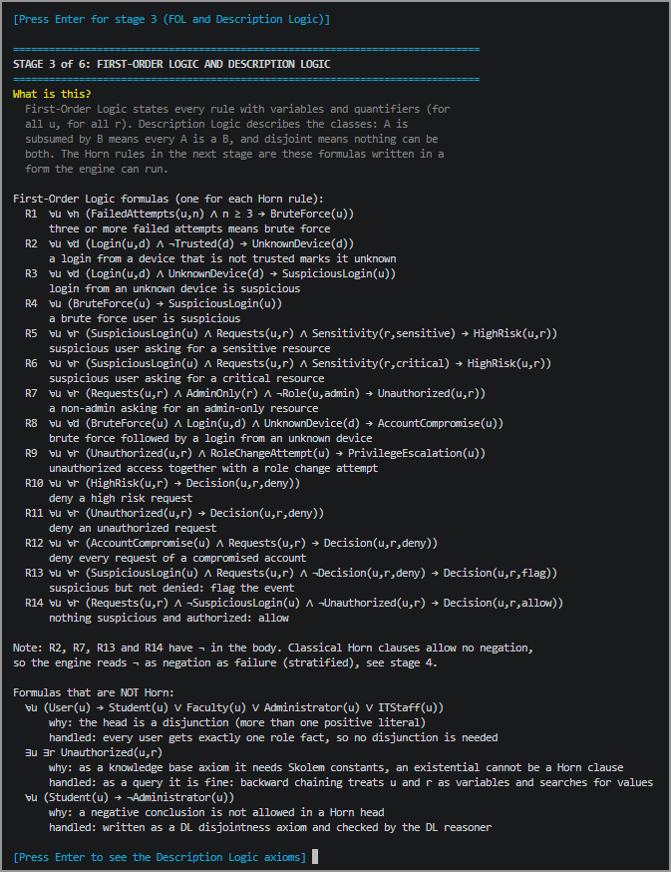
Figure 4.1: First-order logic formulas printed by the program (Stage 3)

4.2 Description Logic (DL)
Description Logic [2] describes the classes of the domain. The TBox holds the concept axioms. Subsumption A ⊑ B means that every A is a B. Disjointness A ⊓ B ⊑ ⊥ means that nothing can be both A and B. The ABox holds the memberships of individuals, such as Student(ali). The concepts are the classes of the domain (User, Student, Device, Resource, Threat and so on) and the roles are uses, requests, hasFailedAttempts, by, from and targets.
Table 4.4: Subsumption axioms (TBox)
Axiom (1) | Axiom (2)
Student ⊑ User | Faculty ⊑ User
Administrator ⊑ User | ITStaff ⊑ User
TrustedDevice ⊑ Device | UnknownDevice ⊑ Device
SensitiveResource ⊑ Resource | CriticalResource ⊑ SensitiveResource
AdminOnlyResource ⊑ CriticalResource | BruteForce ⊑ Threat
AccountCompromise ⊑ Threat | PrivilegeEscalation ⊑ Threat
SuspiciousLogin ⊑ LoginEvent

Table 4.5: Disjointness axioms (TBox)
Axiom (1) | Axiom (2)
Student ⊓ Faculty ⊑ ⊥ | Student ⊓ Administrator ⊑ ⊥
Student ⊓ ITStaff ⊑ ⊥ | Faculty ⊓ Administrator ⊑ ⊥
Faculty ⊓ ITStaff ⊑ ⊥ | Administrator ⊓ ITStaff ⊑ ⊥
TrustedDevice ⊓ UnknownDevice ⊑ ⊥ | User ⊓ Device ⊑ ⊥
User ⊓ Resource ⊑ ⊥ | Device ⊓ Resource ⊑ ⊥

Table 4.6: Defined classes and role axioms
Axiom | Reading
BruteForceUser ≡ User ⊓ ∃hasFailedAttempts.AtLeastThree | A user with at least three failed attempts
SuspiciousUser ≡ User ⊓ (∃uses.UnknownDevice ⊔ BruteForceUser) | A user of an unknown device, or a brute-force user
UnauthorizedUser ≡ User ⊓ ¬Administrator ⊓ ∃requests.AdminOnlyResource | A non-admin who requests an admin-only resource
∃uses.⊤ ⊑ User | Domain of uses is User
⊤ ⊑ ∀uses.Device | Range of uses is Device
⊤ ⊑ ∀requests.Resource | Range of requests is Resource
Note on naming. In the TBox, the concepts BruteForce, AccountCompromise, PrivilegeEscalation and SuspiciousLogin are classes of threat and login-event individuals. In the FOL and Horn rules of Sections 4.1 and 5, the predicates brute_force(u), account_compromise(u), privilege_escalation(u) and suspicious_login(u) are applied directly to the user, which keeps the rules short. The inference of Sections 5 and 6 uses only the user-level predicates, and Description Logic is used only for class-level checks (subsumption, disjointness and ABox consistency).
The memberships (ABox) of scenario S1 are Student(ali), UnknownDevice(dev7), SensitiveResource(student_db), uses(ali, dev7) and requests(ali, student_db). The reasoner adds the inherited classes (ali is also a User, dev7 a Device, student_db a Resource) and checks that no individual belongs to two disjoint classes. The consistency check passes.
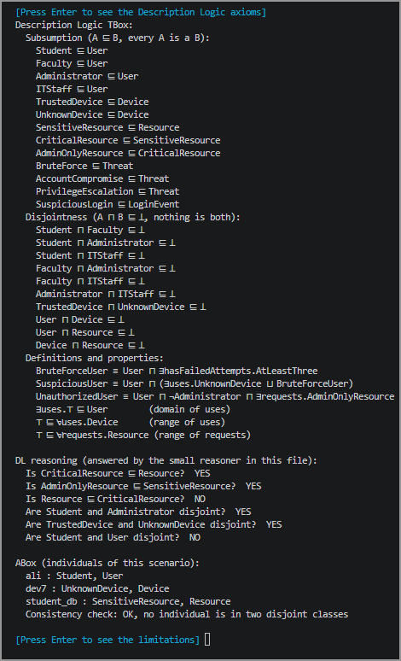
The small DL reasoner answers subsumption and disjointness questions. For example, CriticalResource ⊑ Resource is true (the chain Critical ⊑ Sensitive ⊑ Resource), Resource ⊑ CriticalResource is false, Student and Administrator are disjoint, while Student and User are not disjoint. Figure 4.2 shows the axioms, the reasoning answers and the ABox check printed by the program.

Figure 4.2: Description Logic axioms, reasoning answers and ABox check (Stage 3)

5. HORN CLAUSE KNOWLEDGE BASE
A Horn clause [1] has at most one positive conclusion: head :- condition1, condition2. It is read as “if condition1 and condition2 hold, then head holds”. The comma means “and”, and a variable starts with ?. The FOL formulas of Section 4.1 become Horn clauses in three steps: (1) drop the universal quantifiers, because every variable is universally quantified; (2) write the implication with the conclusion first; (3) read ¬ in the body as not, which is negation as failure. For example, R5 in clause form is ¬SuspiciousLogin(u) ∨ ¬Requests(u,r) ∨ ¬Sensitivity(r,sensitive) ∨ HighRisk(u,r). It has exactly one positive literal, so it is a Horn clause.
Rules are placed in three strata (levels). A rule that uses not runs only after every fact it refers to has been completely derived. Without this, the result would depend on the order of the rules. Stratum 0 classifies and assesses (R1 to R9), stratum 1 derives the deny decisions (R10 to R12), and stratum 2 derives flag and allow (R13 and R14), which use not on facts of the earlier strata. Two rules with the same head, such as R3 and R4, mean “or”. The predicate decision appears in strata 1 and 2, and R13 uses not decision(?U, ?R, deny). At predicate level this is a negative self-dependency, but the rule base is locally stratified: R13 negates only the deny value, and all deny decisions are completely derived in stratum 1 before the flag and allow decisions are derived in stratum 2.
Table 5.1: Horn clause rule base (14 rules in 3 strata)
Rule | Horn clause | Stratum
R1 | brute_force(?U) :- failed_attempts(?U, ?N), ?N >= 3 | 0
R2 | unknown_device(?D) :- login(?U, ?D), not trusted(?D) | 0
R3 | suspicious_login(?U) :- login(?U, ?D), unknown_device(?D) | 0
R4 | suspicious_login(?U) :- brute_force(?U) | 0
R5 | high_risk(?U, ?R) :- suspicious_login(?U), requests(?U, ?R), sensitivity(?R, sensitive) | 0
R6 | high_risk(?U, ?R) :- suspicious_login(?U), requests(?U, ?R), sensitivity(?R, critical) | 0
R7 | unauthorized(?U, ?R) :- requests(?U, ?R), admin_only(?R), not role(?U, admin) | 0
R8 | account_compromise(?U) :- brute_force(?U), login(?U, ?D), unknown_device(?D) | 0
R9 | privilege_escalation(?U) :- unauthorized(?U, ?R), role_change_attempt(?U) | 0
R10 | decision(?U, ?R, deny) :- high_risk(?U, ?R) | 1
R11 | decision(?U, ?R, deny) :- unauthorized(?U, ?R) | 1
R12 | decision(?U, ?R, deny) :- account_compromise(?U), requests(?U, ?R) | 1
R13 | decision(?U, ?R, flag) :- suspicious_login(?U), requests(?U, ?R), not decision(?U, ?R, deny) | 2
R14 | decision(?U, ?R, allow) :- requests(?U, ?R), not suspicious_login(?U), not unauthorized(?U, ?R) | 2

The static facts of the knowledge base are given in Table 5.2. The scenario S1 adds three input facts: login(ali, dev7), failed_attempts(ali, 4) and requests(ali, student_db). Figure 5.1 shows the knowledge base as printed by Stage 4.
Table 5.2: Static facts of the knowledge base
Group | Facts
Roles | role(ali, student), role(sara, faculty), role(hamza, admin), role(zain, it_staff)
Resources | sensitivity(course_page, public), sensitivity(student_db, sensitive), sensitivity(grades_db, critical), sensitivity(admin_panel, critical), admin_only(admin_panel)
Trusted devices | trusted(dev1), trusted(dev2). Any other device is unknown (rule R2).

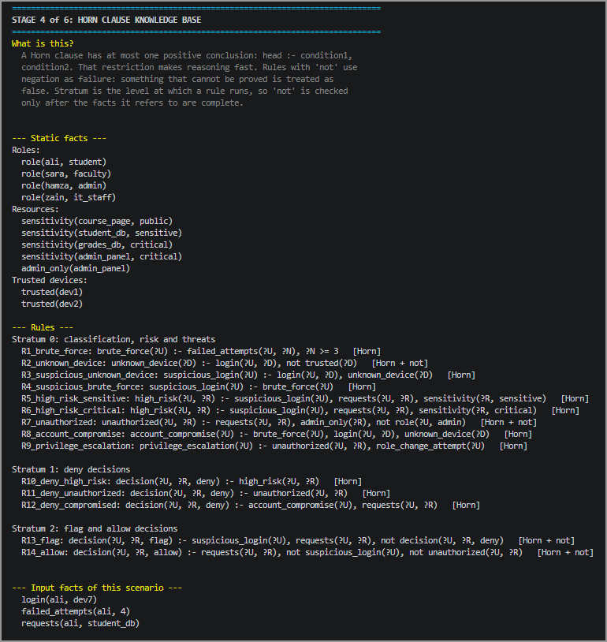

Figure 5.1: Horn clause knowledge base printed by the program (Stage 4)

6. INFERENCE AND REASONING

6.1 Forward Chaining
Forward chaining [1] starts from the known facts. It fires every rule whose conditions are true, adds the new fact, and repeats until no new fact can be derived (a fixpoint). It runs stratum by stratum. Scenario S1: student ali fails the login four times from the unknown device dev7 and asks for the sensitive student database. The knowledge base starts with 14 facts (11 static and 3 from the scenario). Table 6.1 shows the rules activated and each newly derived fact.
Table 6.1: Forward chaining trace of scenario S1
Step | Rule fired | Conditions that hold | New fact derived
1 | R1_brute_force | failed_attempts(ali, 4) and 4 >= 3 | brute_force(ali)
2 | R2_unknown_device | login(ali, dev7) and not trusted(dev7) | unknown_device(dev7)
3 | R3_suspicious_unknown_device | login(ali, dev7) and unknown_device(dev7) | suspicious_login(ali)
4 | R5_high_risk_sensitive | suspicious_login(ali), requests(ali, student_db), sensitivity(student_db, sensitive) | high_risk(ali, student_db)
5 | R8_account_compromise | brute_force(ali), login(ali, dev7), unknown_device(dev7) | account_compromise(ali)
6 | R10_deny_high_risk | high_risk(ali, student_db) | decision(ali, student_db, deny)
No new fact can be derived after step 6, so the process stops with six new facts and the final conclusion deny. R4 does not appear in the trace because suspicious_login(ali) had already been derived by R3. R12 does not appear because decision(ali, student_db, deny) already existed after R10. Neither rule produced a new fact.
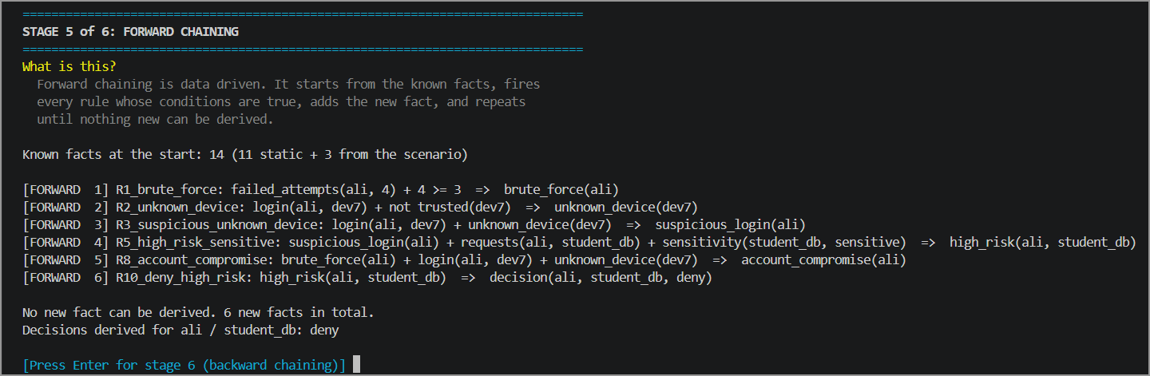

Figure 6.1: Forward chaining trace of scenario S1 (Stage 5)
Scenario S3 is a normal case: the administrator hamza logs in from the trusted device dev1 and opens the student database. It shows how the system reaches an ALLOW decision, which depends on negation as failure. Only one rule fires (Table 6.2).

Table 6.2: Forward chaining trace of scenario S3
Step | Rule fired | Conditions that hold | New fact derived
1 | R14_allow | requests(hamza, student_db), not suspicious_login(hamza), not unauthorized(hamza, student_db) | decision(hamza, student_db, allow)

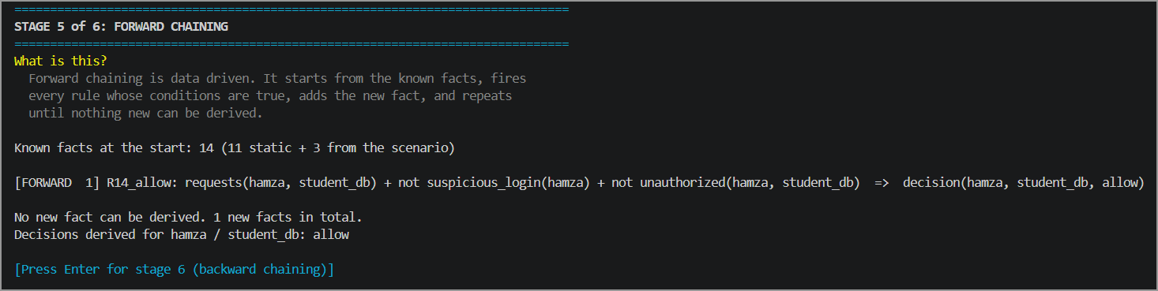

Figure 6.2: Forward chaining trace of scenario S3 (Stage 5)

6.2 Backward Chaining
Backward chaining starts from a hypothesis. For the goal decision(ali, student_db, deny) it finds a rule whose head matches the goal, makes each condition of that rule a sub-goal, and repeats until every branch ends in a known fact. A not condition succeeds when the negated goal cannot be proved. The engine renames the variables of a rule at every use (for example ?U becomes ?U_1), so bindings from different uses of the same rule do not clash. Table 6.3 shows the proof tree.
Table 6.3: Proof tree of the goal decision(ali, student_db, deny)
Level | Goal | Proved by | Sub-goals and facts
1 | decision(ali, student_db, deny) | Rule R10 | high_risk(ali, student_db)
2 | high_risk(ali, student_db) | Rule R5 | suspicious_login(ali); requests(ali, student_db) [fact]; sensitivity(student_db, sensitive) [fact]
3 | suspicious_login(ali) | Rule R3 | login(ali, dev7) [fact]; unknown_device(dev7)
4 | unknown_device(dev7) | Rule R2 | login(ali, dev7) [fact]; not trusted(dev7)
5 | not trusted(dev7) | Negation as failure | trusted(dev7) cannot be proved (FAILED), so the “not” holds
Every branch ends in a given fact, so the goal is proved. The engine stops at the first successful rule (R10), which is why R11 and R12 are not tried. The backward decision (deny) is equal to the forward decision, so the two methods agree. The reason chain at the end of Figure 6.3 is the explanation of the decision. It is built from the forward trace by following every derived fact back to the rule and the conditions that created it, until only given facts are left.

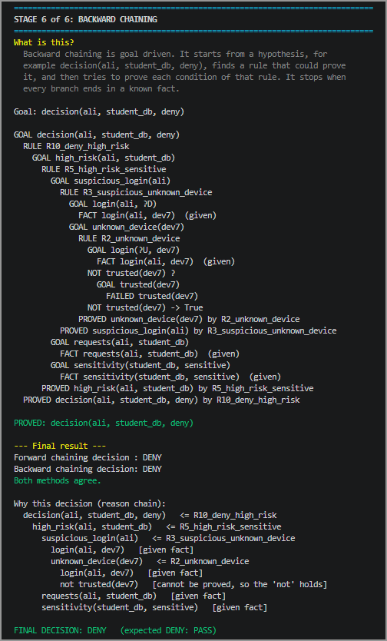

Figure 6.3: Backward chaining proof tree, final result and reason chain of scenario S1 (Stage 6)
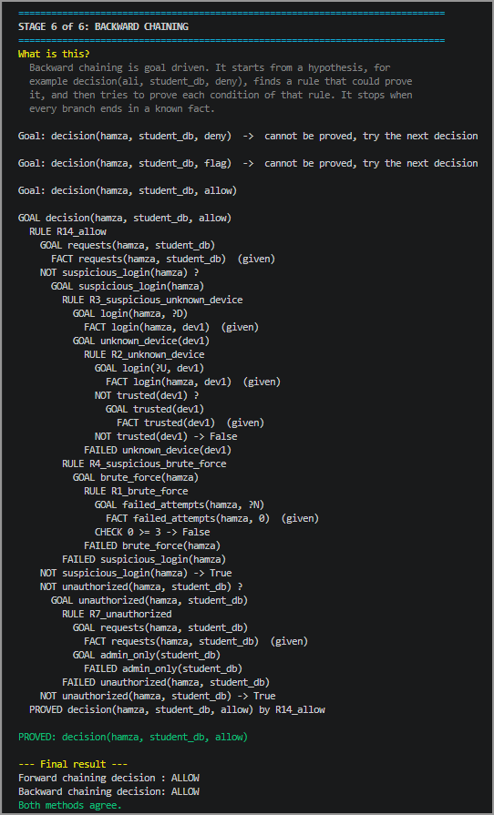

Figure 6.4: Backward chaining trace of scenario S3 (Stage 6)

For scenario S3, the engine tries the decisions in priority order. The goals deny and flag cannot be proved, and the goal allow is proved by R14:
- Deny fails: there is no high_risk, unauthorized or account_compromise fact for hamza.
- Flag fails: suspicious_login(hamza) cannot be proved. R3 fails because dev1 is trusted, so unknown_device(dev1) fails. R4 fails because brute_force(hamza) cannot be proved: R1 fails, since failed_attempts(hamza, 0) does not satisfy 0 >= 3.
- Allow succeeds with R14: not suspicious_login(hamza) holds and not unauthorized(hamza, student_db) holds, because admin_only(student_db) fails.

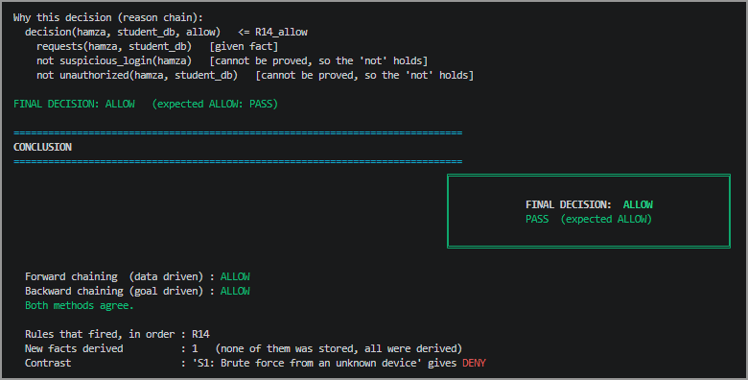

Figure 6.5: Reason chain, final decision and conclusion of scenario S3

Scenarios S1 and S3 show that the system denies risky requests and allows normal ones. Both forward and backward chaining produce the same decisions.

7. IMPLEMENTATION

7.1 Tools and Technologies
The system is implemented as a Python rule engine [3]. Facts are tuples, for example ("role", "ali", "student"), and a rule is an object with a head, a body, a stratum and a documentation string. The engine consists of unification (unify), forward chaining, backward chaining and a decision module. The program requires only Python 3 and the library matplotlib [4] (for the two diagrams). The inference is done by the team’s own engine and not by an external reasoning library. Figure 7.1 shows how the facts flow through the system: the scenario and the static facts become frame instances, which are put into the fact base together with the default values. Forward chaining derives all consequences with the Horn rules, and backward chaining proves the same decision from the goal. Both engines share the helper functions of terms.py, and the decision module picks the result with the priority deny, flag, allow.
Table 7.1: Project structure
CyberGuard/
|-- main.py demo menu, stage 0 and conclusion
|-- requirements.txt matplotlib
|-- make_architecture.py draws the system architecture diagram
|-- demo/
| |-- runner.py the six demo stages
| |-- ui.py colours, headings and pauses
| +-- whatif.py change a fact and reason again
|-- knowledge/
| |-- frames.py frames, script, instances, frame diagram
| |-- semantic_net.py semantic network and its diagram
| |-- logic_formulas.py FOL formulas, DL axioms, DL reasoner
| |-- facts.py static facts
| +-- rules.py 14 Horn rules in 3 strata
|-- engine/
| |-- terms.py Rule class, unification, helpers
| |-- forward_chaining.py data-driven reasoning
| |-- backward_chaining.py goal-driven reasoning
| +-- decision.py ALLOW / FLAG / DENY and the explanation
|-- scenarios/ seven scenario files (s1 to s7, JSON)
|-- tests/test_scenarios.py 15 automated checks
+-- docs/ generated diagrams

Table 7.2: How to run the system
Command | Purpose
pip install matplotlib | Install the only required library
python main.py | Open the menu and choose a scenario
python main.py 1 | Run scenario 1 through all stages (pauses after every stage)
python main.py 1 --auto | Run scenario 1 without pauses (for the report output)
python main.py all | Check all seven scenarios and print a summary table
python tests/test_scenarios.py | Run the 15 automated tests

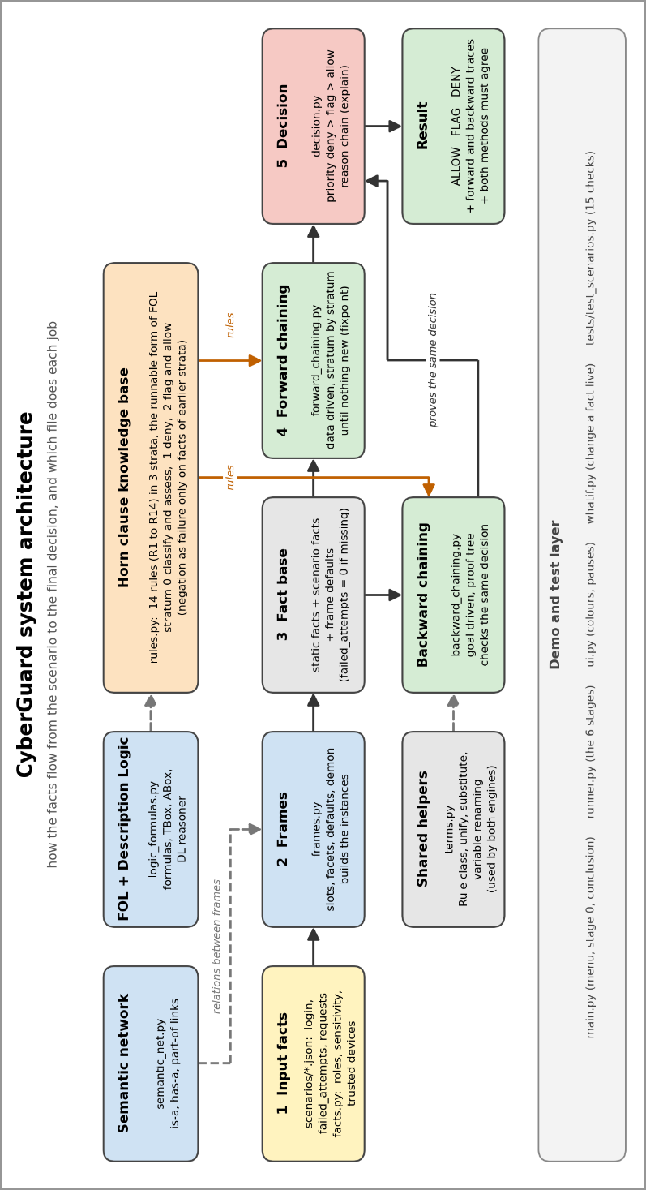

Figure 7.1: System architecture of CyberGuard

7.2 Code / Execution
This section shows the execution of the program and the key parts of the rule engine. The complete source code is part of the submitted project folder. The program opens with a menu of the seven scenarios (Figure 7.2). Each scenario shows its expected decision in colour (red for DENY, yellow for FLAG and green for ALLOW). Before the six reasoning stages, Stage 0 states the domain, the problem, why a normal database is not enough, and who explains which stage (Figure 7.3). The output of the stages of scenario S1 is shown in Figures 3.1, 3.2, 3.4, 4.1, 4.2, 5.1, 6.1 and 6.3.

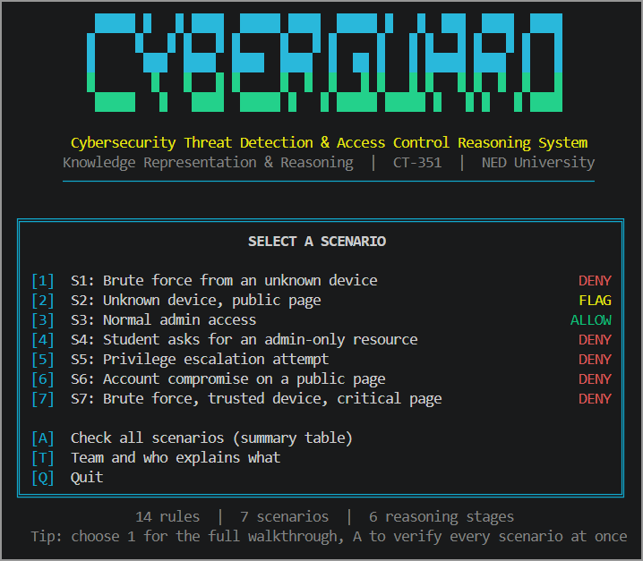

Figure 7.2: Main menu of CyberGuard

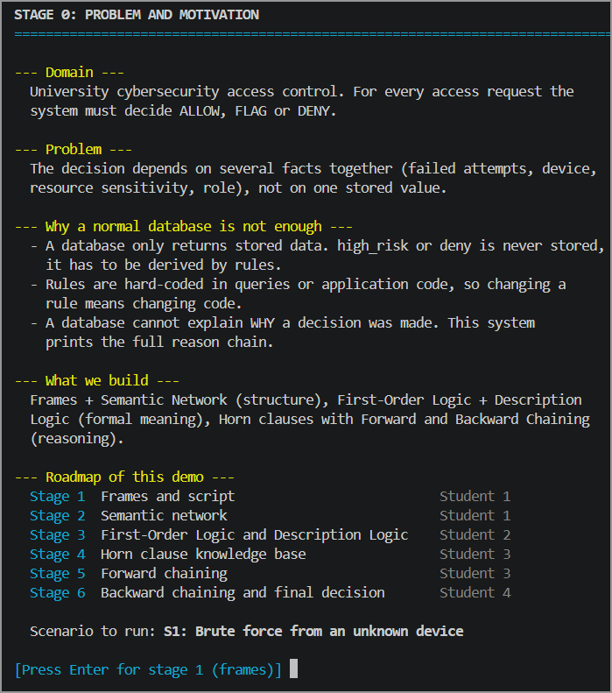

Figure 7.3: Stage 0 - problem and motivation, with the roadmap of the demo
Rule representation (knowledge/rules.py). A rule is written as data. The head is a tuple, the body is a list of conditions, and “not” marks negation as failure.

Rule("R1_brute_force",
("brute_force", "?U"),
[("failed_attempts", "?U", "?N"), (">=", "?N", 3)],
stratum=0,
doc="3 or more failed attempts means brute force"),

Rule("R5_high_risk_sensitive",
("high_risk", "?U", "?R"),
[("suspicious_login", "?U"), ("requests", "?U", "?R"),
("sensitivity", "?R", "sensitive")],
stratum=0,
doc="suspicious user asking for a sensitive resource"),

Rule("R14_allow",
("decision", "?U", "?R", "allow"),
[("requests", "?U", "?R"),
("not", ("suspicious_login", "?U")),
("not", ("unauthorized", "?U", "?R"))],
stratum=2,
doc="nothing suspicious and the user is authorized"),

Unification (engine/terms.py). Unification makes two terms equal by binding variables. The bindings are copied and never changed in place, so backtracking is safe.

def unify(x, y, b):
x = walk(x, b)
y = walk(y, b)
if x == y:
return b
if is_var(x):
return {**b, x: y}
if is_var(y):
return {**b, y: x}
if isinstance(x, tuple) and isinstance(y, tuple) and len(x) == len(y):
for a, c in zip(x, y):
b = unify(a, c, b)
if b is None:
return None
return b
return None

Forward chaining (engine/forward_chaining.py). The loop runs stratum by stratum and repeats until no rule adds a new fact (fixpoint). Every new fact is saved in the trace together with the rule and the conditions that produced it.

def forward_chain(rules, initial_facts, strata=None):
if strata is None:
strata = group_by_stratum(rules)
facts = dict.fromkeys(initial_facts)
trace = []
for group in strata:
changed = True
while changed:
changed = False
for rule in group:
for bindings in match_conditions(rule.body, facts, {}):
new_fact = substitute(rule.head, bindings)
if new_fact not in facts:
facts[new_fact] = None
used = [substitute(c, bindings) for c in rule.body]
trace.append((rule.name, [fmt(u) for u in used],
new_fact, used))
changed = True
return facts, trace

Backward chaining (engine/backward_chaining.py, excerpt). A not goal succeeds when the negated goal cannot be proved. For other goals, the engine tries every rule whose head unifies with the goal, using fresh variable names.

if is_not(goal): # negation as failure
target = substitute(goal[1], bindings)
proved = any(True for _ in self.prove(target, bindings, depth + 1))
if not proved:
yield bindings
return
...
for rule in self.rules: # try each rule
self.rename_count += 1
fresh = rename_rule(rule, self.rename_count)
new_bindings = unify(goal, fresh.head, bindings)
if new_bindings is None:
continue
for final_bindings in self.prove_all(fresh.body, new_bindings, depth + 2):
yield final_bindings # all sub-goals proved

Final decision (engine/decision.py). If several decisions are derived for the same request, the one with the highest priority is chosen.

PRIORITY = ["deny", "flag", "allow"]

def final_decision(facts, user, resource):
derived = {f[3] for f in facts
if f[0] == "decision" and f[1] == user and f[2] == resource}
for level in PRIORITY:
if level in derived:
return level
return None

8. RESULTS AND DISCUSSION

8.1 Results
The complete output of scenario S1 is shown in the previous sections. Figure 8.1 shows the closing screen of the demo: the verdict, the decisions of both methods, the rules that fired in order, and a contrast with an ALLOW scenario.
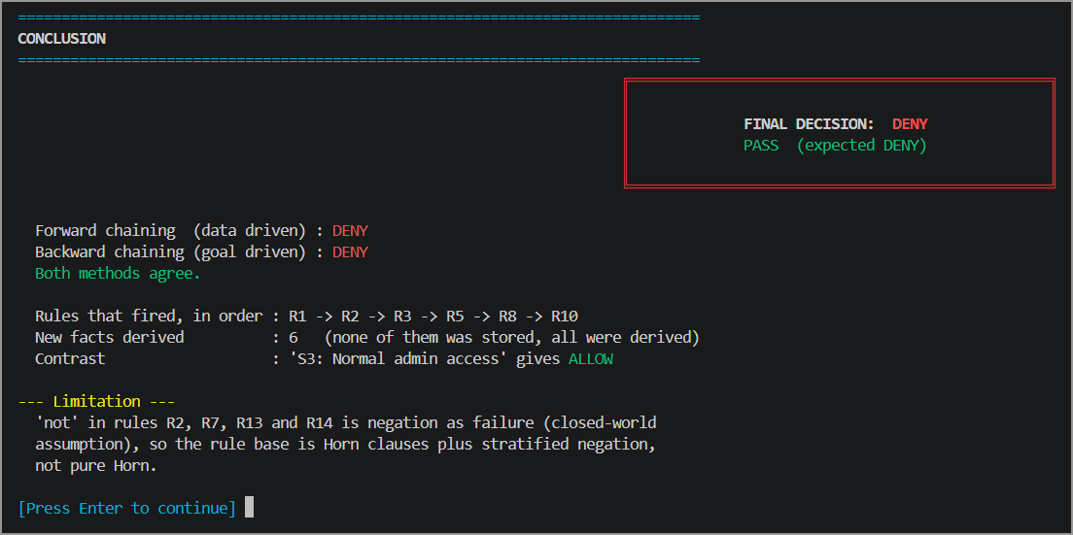
Figure 8.1: Conclusion screen of scenario S1
Seven scenarios were designed so that every one of the 14 rules fires in at least one scenario. Table 8.1 lists them with the rules that fired and the decision; the output of python main.py all is shown in Figure 8.2. All seven scenarios give the expected decision, and in each scenario forward and backward chaining agree.
Table 8.1: Test scenarios, rules fired and decisions
No | Scenario | Rules fired | Expected | Result
S1 | ali fails the login 4 times from an unknown device and asks for the student database | R1, R2, R3, R5, R8, R10 | DENY | PASS
S2 | sara (faculty) logs in from an unknown device and opens a public page | R2, R3, R13 | FLAG | PASS
S3 | Admin hamza logs in from a trusted device and opens the student database | R14 | ALLOW | PASS
S4 | Student ali, trusted device, no failed attempts, asks for the admin panel | R7, R11 | DENY | PASS
S5 | Student ali asks for the admin panel and tries to change his own role | R7, R9, R11 | DENY | PASS
S6 | sara fails 5 times, then logs in from an unknown device to open a public page | R1, R2, R3, R8, R12 | DENY | PASS
S7 | ali fails 5 times from a trusted device and asks for the grades database | R1, R4, R6, R10 | DENY | PASS
Two scenarios are interesting beyond the main case. In S6 the requested page is harmless, but five failed attempts followed by an unknown device make the account look stolen, so rule R12 denies even a public page. In S7 the device is trusted, so only the failed attempts make the login suspicious (R4), and the critical resource makes the request high risk (R6).
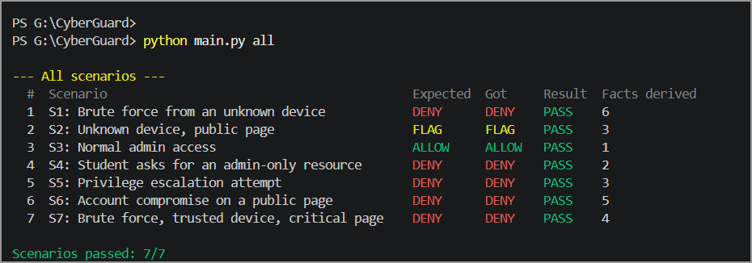

Figure 8.2: Verification of all seven scenarios (python main.py all)
The what-if step changes input facts and runs the reasoning again with the same rules. In Figure 8.3, the failed attempts of ali are changed from 4 to 2 and the device dev7 is made trusted. Rule R1 no longer fires, dev7 is no longer unknown, so no suspicious login is derived and R14 allows the request: the decision changes from DENY to ALLOW. This shows that the decision is reasoned from the facts and is not hard-coded.

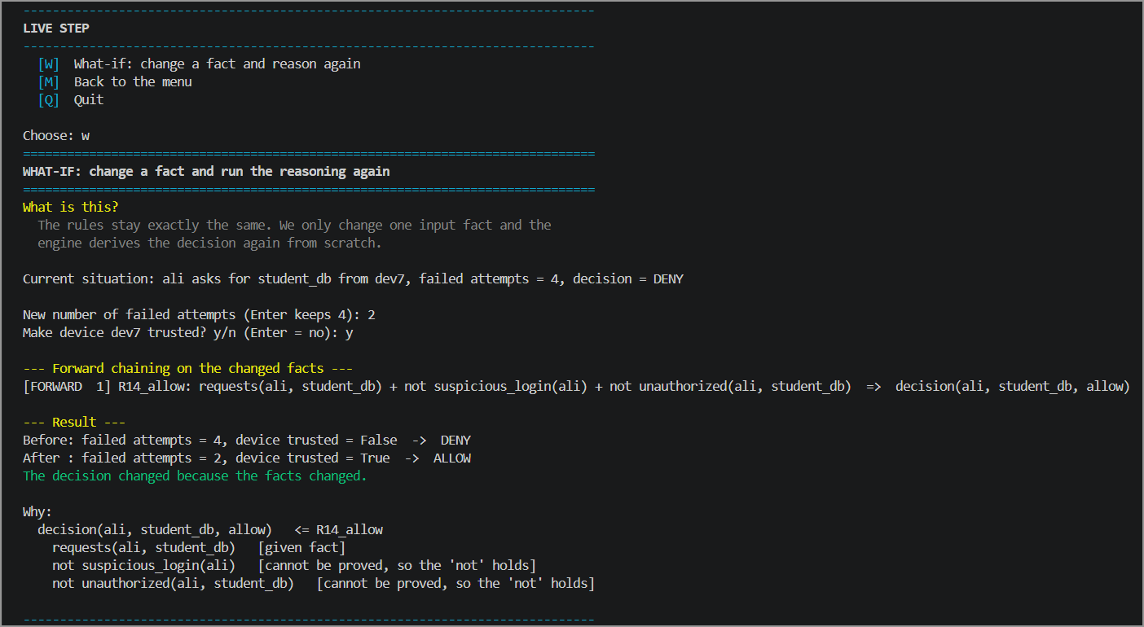

Figure 8.3: What-if analysis on scenario S1 (DENY changes to ALLOW)
The file tests/test_scenarios.py contains 15 automated tests (Python unittest), summarised in Table 8.2. All 15 pass (Figure 8.4).
Table 8.2: Automated tests
Group | Tests | What is checked
Scenario tests | 4 | Forward decision equals the expected decision; backward decision equals forward decision; every rule fires in some scenario; scenarios exist
Frame tests | 5 | Default reaches the engine; range facet rejects a bad value; values facet rejects a bad role; child frames inherit and override; demon fires for many failures
Logic tests | 3 | Subsumption follows the chain; disjointness is inherited; ABox conflict is detected
Engine tests | 3 | Trace is identical on every run; unsafe negation raises an error; what-if changes the decision
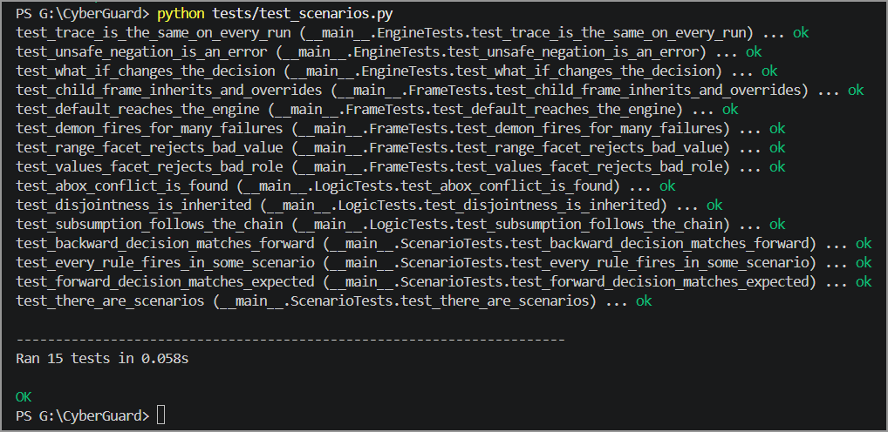
Figure 8.4: Output of the automated tests (15 tests, all ok)

8.2 Discussion
Objectives. The system meets its objectives. The domain is represented with frames and a semantic network, the policy is formalised in FOL and DL and converted into 14 Horn rules, and both chaining methods produce an ALLOW, FLAG or DENY decision with a reason chain. All seven scenarios give the expected decision, forward and backward chaining agree in every case, and all 15 automated tests pass.
Effectiveness of the KR approaches. Frames give defaults, facets and inheritance, and the semantic network gives an overview of how the concepts are connected. FOL is expressive enough to state every rule, and DL answers class-level questions (subsumption and disjointness) in a decidable way. Horn clauses make the policy executable. Forward chaining is data-driven: it derives every consequence of the facts and is the natural choice when all facts of a login are known. Backward chaining is goal-driven: it proves one hypothesis, such as “is deny justified?”, and looks only at the facts that matter. Both give the same decision, and both produce a trace that explains it.
Each formalism offers a different balance between what can be expressed and how efficiently conclusions can be computed. Table 8.3 summarises the limitations that we met in this domain.
Table 8.3: Limitations of the formalisms in the CyberGuard domain

Formalism | Strength | Limitation in this domain
Propositional logic | Simple and decidable | No variables. One rule per user and resource would be needed (brute_force_ali, brute_force_sara, ...). It cannot say “for every user”.
First-Order Logic | Variables, quantifiers and relations; can state every rule | Entailment is only semi-decidable: a proof may never finish for a false goal.
Description Logic | Decidable; good for classes (subsumption, disjointness) | Cannot express rules that join several facts, such as R5 (user + resource + risk). Such rules are executed as Horn clauses.
Horn clauses | Only one positive literal per rule; fast (polynomial forward chaining without function symbols) | Cannot express disjunction or classical negation. We use negation as failure, which assumes that what is not known is false.
How the design resolves the trade-off. FOL is used as the specification language because it is the most expressive. The executable knowledge base is restricted to Horn clauses with stratified negation as failure. Because the facts are finite and the rules contain no function symbols, forward chaining always terminates. The rules are also not recursive, so backward chaining always terminates as well. Description Logic is used only for class-level reasoning (subsumption and disjointness), where it is decidable. The price of this choice is the closed-world assumption: a device that is not in the trusted list is treated as unknown, and a user who is not proved suspicious is treated as not suspicious.

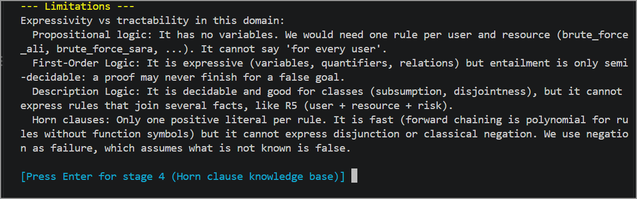

Figure 8.5: Limitations printed by the program (Stage 3)
Limitations. The main limitations are the closed-world assumption behind negation as failure, the absence of disjunctive reasoning in Horn clauses, and the small, hand-written knowledge base of four users, four devices and four resources.

9. CONCLUSION

9.1 Conclusion and Future Improvements
CyberGuard shows how several knowledge representation paradigms work together on one real-world problem. Frames and the semantic network structure the domain; First-Order Logic and Description Logic give the policy a formal meaning; Horn clauses turn the policy into executable rules; and forward and backward chaining derive decisions with a complete explanation. Seven scenarios cover all 14 rules, all of them give the expected decision, forward and backward chaining agree in every case, and 15 automated tests pass.
Possible improvements and extensions are reading real login logs from a database, adding time-based rules (for example failed attempts within ten minutes), using a full Description Logic reasoner for the class hierarchy, and adding probabilistic risk scores next to the logical rules.

10. REFERENCES
[1] S. Russell and P. Norvig, Artificial Intelligence: A Modern Approach, 4th ed. Hoboken, NJ, USA: Pearson, 2020.
[2] R. J. Brachman and H. J. Levesque, Knowledge Representation and Reasoning. San Francisco, CA, USA: Morgan Kaufmann, 2004.
[3] Python Software Foundation, “Python 3 documentation.” [Online]. Available: https://docs.python.org/3/ (accessed Nov. 3, 2026).
[4] J. D. Hunter, “Matplotlib: A 2D graphics environment,” Computing in Science & Engineering, vol. 9, no. 3, pp. 90-95, 2007.
[5] NED University of Engineering & Technology, CT-351 Knowledge Representation & Reasoning, course lecture notes and CCP report template, Department of Computer Science and IT, 2026.

11. TEAM PARTICIPATION
The project was carried out by a team of four students. The work was divided as follows, and each member presents and explains the part marked below during the viva. All members took part in the design discussions, in the testing of the scenarios and in the preparation of this report, and every member is able to explain every stage of the complete system.
Student Name | Roll Number | Contribution / Responsibilities
Umair Hasan | AI-23018 | Backward chaining, decision logic, testing, report integration and references (Sections 6.2, 7.2, 8.1 and 10)
Abrar Shakeel Ghoury | AI-23019 | Domain analysis, frames, script and frame instances, semantic network, and all diagrams (Sections 2, 3 and 7.1)
Amna Amjad | AI-23031 | Introduction, Horn clause knowledge base and forward chaining (Sections 1, 5 and 6.1)
Mirza Abdul Raffay Baig | AI-23033 | First-Order Logic, Description Logic axioms, limitations analysis and conclusion (Sections 4, 8.2 and 9)
Declaration: We confirm that the submitted report represents our group’s work and that each member has contributed as stated above.
Group Representative: ____________________________ Date: ______________

