Project Proposal & Requirements Document

For

Pharmacy Management System

Prepared By

Name: Rafflesia Khan
Student ID: 130233
Name: Rilus Mahmud
Student ID: 130239

Computer Science and Engineering Discipline ,Khulna University , Bangladesh
Sher-E-Bangla Rd, Khulna 9208, Bangladesh

Revision History

Version | Description | Modified By | Approved By | Issue Date
1.0 | Initial version | Rafflesia Khan  Rilus Mahmud | Dr. Md. Anisur Rahman  Professor , Computer Science and Engineering Discipline, Khulna University | 25th February , 2016
2.0 | 2nd version | Rafflesia Khan  Rilus Mahmud | Dr. Md. Anisur Rahman  Professor , Computer Science and Engineering Discipline, Khulna University | 28th March, 2016
3.0 | Final Version | Rafflesia Khan  Rilus Mahmud | Dr. Md. Anisur Rahman  Professor , Computer Science and Engineering Discipline, Khulna University | 3rd^{th} May, 2016

Table of Contents
List of Figures 5
1 Introduction 6
1.1 Problem Statement 6
1.2 Objective 7
2 Project Scope 7
3 User Requirement Analysis 8
3.1 User group 8
3.2 Use Case for Internal User 9
3.3 User Requirements 10
3.4 User Requirement for External User 11
4 Data Model and Description 12
4.1 Entity 12
4.1.1 Patient 12
4.1.2 Customer 12
4.1.3 Staff 12
4.1.4 Supplier 13
4.1.5 Physician 13
4.1.6 Account 13
4.1.7 Prescription 13
4.1.8 Drug 13
4.1.9 Order 13
4.1.10 Medical History 13
4.1.11 Shopping Cart 13
4.2 Entity and Attributes 14
4.3 Relational Schema 16
5 Targeted Interesting Queries 20
5.1 Queries about sell at any time: 20
5.2 Queries for medicine detail: 20
5.3 Queries for analyzing Patient: 21
5.4 Queries for Doctors: 21
5.5 Queries for stock detail: 21
6 Functional Implementation 21
7 Query Implementation 23
8 Additional Important Code Implementation 28
8.1 Creating a Data Connection to a SQL Server Database using C# 28
9 Technology Used 29
9.1 DOTNET 29
9.2 C# DOT NET 29
9.3 6.2 SQL SERVER: 29
10 Conclusion and Discussion 30
11 Reference 30
12 Appendices 31
12.1 Login User account 31
12.2 As an admin Add New Staff 32
12.3 As a Staff/Admin update Staff 33
12.4 As an Admin/ Staff add new Doctor 34
12.5 Updae Doctor Information 35
12.6 As Staff / Admin Add New Supplier 36
12.7 Update Supplier information 37
12.8 Add New Drug 38
12.9 Search Drug 38
12.10 Edit /Update Drug 39
12.11 As a Stuff Order for Drug to Supplier 39
12.11.1 Select Supplier 39
12.11.2 Select Drug 40
12.11.3 Give Quantity 41
12.11.4 Finally Place Order 42
12.12 As a Customer Order for Drug to Pharmecy 43
12.12.1 Select Drug 43
12.12.2 Give Quantity 44
12.12.3 Place Order 45

List of Figures

Figure 1: Use Case for internal user: 8
Figure 2: Use Case for coustomer: 9
Figure 5.2.11: E-R Diagram: 15

Introduction
This document records the product requirements and the project scope for a Pharmaceutical Management Information System (PMIS). The purpose of the project is to automate and provide a user friendly interface to pharmacy workers and administrative personnel of any medicine pharmacy for data collection as well as all related information management. The requirements are noted by recording the current business flow, actors, and core activities between the actors and the system and use cases of the system.
A good PMIS stores and manages all necessary information related to availability of medicines and their supplies, patient adherence, patient safety and security, drug resistance, post-market intelligence, product registration , product quality, financing and program management. It will also must keep accurate count of medicines in the inventory and real time update of every approved transaction.
The main information analysis job for a good PMIS is to process customer’s request by searching most appropriate drugs and deliver it to the customer. At the same time this should update the stock balance in the inventory system, supplier system, finance and management. A PMIS also requires some automated alerts, for example when a particular medicine reach the minimum quantity, it requires to set an automated alarm to inform the pharmacists.
This document consist of an overview of problem domain, current PMIS, proposed project scope, requirement analysis and database design followed by data model ERD.

Problem Statement
Information analysis is very sensitive in case of PMIS, for example, expiry date of any drug, availability of them, patience information security need to be taken care of with utmost care. Lets take a look at the definition of a PMIS.
The PMIS helps to integrate data collection and processing along with presentation of information that helps pharmacists to make evidence based decisions making for pharmaceutical services.
The features that distinguished a PMIS from a logistic management information system include
- Patient-specific data
- Product-centered data
- A focus on decision making for pharmaceutical services
- Variety of data sources
However, currently most of the pharmaceutical services are manual. For example, if the pharmacy department wanted to know the expired date of the certain drugs the pharmacist itself must go and check on the paper, so this is take a lot of time. There are still in minimum quantity of system that able to give an alert message or reminder for the expired date for each drug in the stock. With the pharmacy system, we had access to real-time and accurate information.
With the PMIS, the accurate information could be retrieved, therefore, efficient decision could be made. This propose system will tookaway a lot of manual tasks, and it will help to get rid of as much paper as we possibly could. In addition, the web based or windows based system is user-friendly; the point-and-click graphic display is easy to navigate. Sometimes pharmacist can not realize the inaccurate distribution of expenses and the inventory level is not known. Besides that, pharmacist also always do the common mistake which is they will make the multiple orders for the same product. Therefore, the main problem of legacy PMIS are as following
  - A lot of manual task.
  - No alert message to remind for the critical quantity of each drug.
  - No alert message to remind for the expired date of each drug.
  - No automated process in manipulating data such as add, insert, delete and search.
  - There is a difficulty on store the data which wastes resources as well as time to retrieve the necessary data from the manually based data system.

Objective
In this document, we are proposing a PMIS with the following feature
- To develop a prototype of pharmacy management Information system.
- To computerized the manual task in term of pharmacy stock inventory
- To apply string match searching algorithm technique in order to search
- The appropriate drugs based on the description of drugs.
- To analysis large volume of data regarding medicines, patients and supply chain.
- A summarized list of drugs dispensed to patient can be viewed for monitoring purposes.
- To generate report on the list of drugs dispensed in the polyclinic for a given time period.
- Automated decision based on data and automated alert for different notification required for Pharmacists.
- To ensure that the system is user friendly.
- To be able to generate report within a specified period of time.
- To ensure the expiry date of medicines.
- To give the facility to the customer to order medicine online.
- To maintain a timely selling amount.
- To provide the main use of a medicine
- To provide functions on identify medication usages instruction, minimize human errors in medication safety, facilitate accessibility of drugs’ information and information management among employees, providing optimal drugs movement in pharmacy unit, enable reports with in significantly short period of time, despite simultaneous usage of database for the purpose stated above.

Project Scope
The scope of the project is to automate the Clinical Demonstration Project of Mayo Clinic. This project will collect patients’ data and their medical test results from local clinics by means of web interface and mobile devices. The collected patients’ data then can be used later for further data analysis. The finished product will run on any mobile devices, except the low end mobile devices, and browsers. The healthcare worker is considered as system user who primarily will input data to the system via different channel, J2ME, WAP, and Web. The following is the list of identified modules that are required for the project:
- Login of User
- Inventory Management
- New Drug
- Update Drug
- Advanced Search
- Finance Management
- New Transaction
- Advanced Search
- Supply Management
- New Supply Agent
- Update Supply Agent
- Advanced Search
- Staff Management
- New Staff
- Update Staff
- Advanced Search
- Place Order
- Utilities
- Audit
The defined modules will be regulated by roles and permission of an individual and deployment platform.

User Requirement Analysis

User group
The user group may be divided into two categories.
- Internal users: pharmacists who take customer orders and inquiries over the phone. Finally, internal system users are IT personnel responsible for the maintenance of the database
- External users: customers who are ordering drugs. This could be any clinic or any walk in customer to buy drugs for patient.

Use Case for Internal User

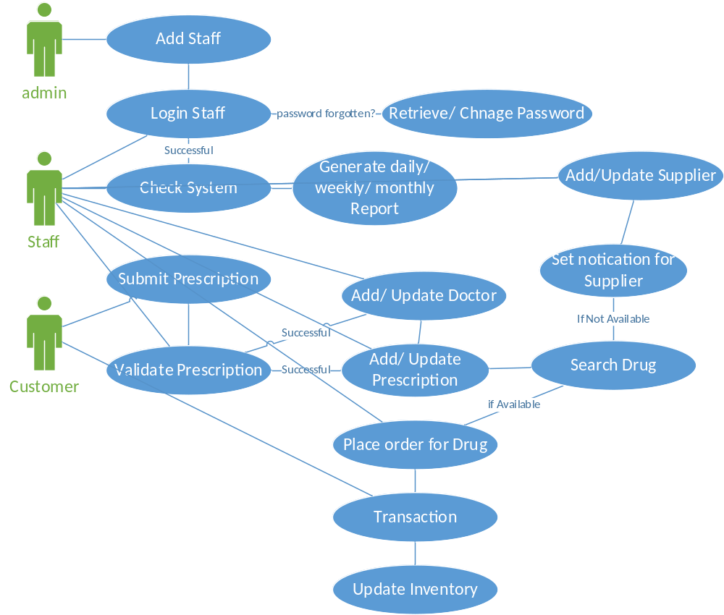

Figure 1: Use-cases for Internal User

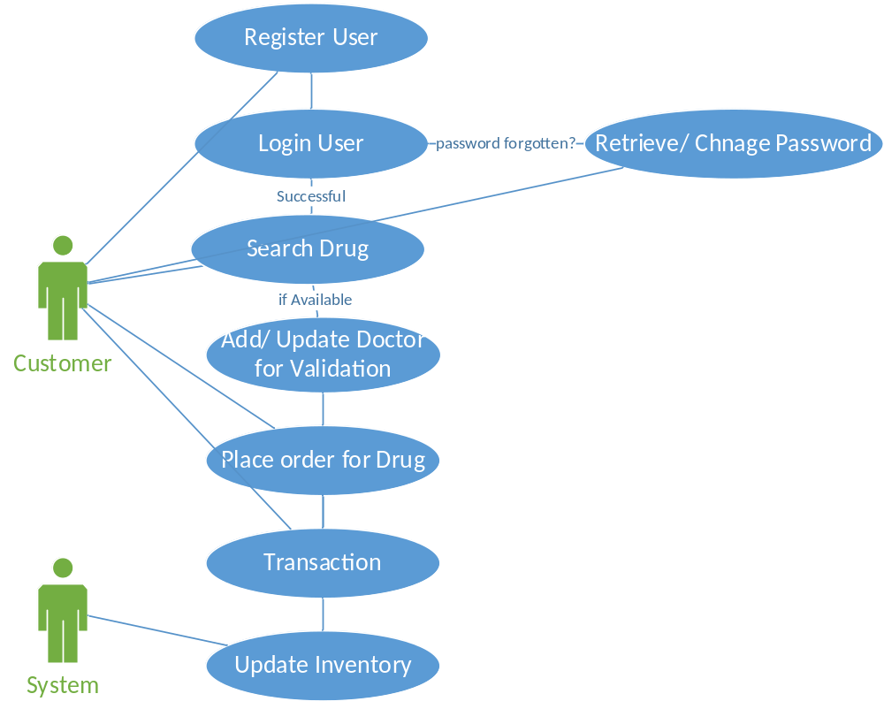
Figure 2: Use Cases for Customer

User Requirements
Table 1 shows the icon for priority of every user requirements.
Table 1: Requirement Priority
Icon | Requirement | Category Priority
US | User specified | Customer required, must deliver
A | Advanced | Nice to Have but not mandatory

User Requirement for External User
Table 2: User Requirements for Customer/Patient
ID | Category | Description
ER1 | US | User Profile Add/Update
ER2 | US | Identification of User through user id and password
ER3 | US | Retrieve Password
ER4 | US | Change password
ER5 | US | To maintain (enter/update/delete) prescription and doctor information for patients
ER6 |  | To maintain patient information including name, age, address, phone etc
ER7 | US | To maintain customer information (if customer is not the patient ) including name, age, address, phone etc
ER8 | US | To maintain (enter/update/delete) patient medical and drug histories
ER9 | US | To be able to use shopping cart when making orders
ER8 | US | To be able to search for drugs based on partial/complete name (common/medical), disease prescribed for, doctor’s favorite, suppliers
ER10 | US | To perform quick browsing using the first letter of drug names
ER11 | US | To implement credit card processing that allows credit cards to be processed on a web site
ER12 | US | To allow for online entry of drug orders and tracking of order shipping status
ER13 | A | To allow a user to place one order for multiple people at the same shipping address
ER14 | A | To produce a patient report listing all the orders/prescriptions they have made over a given timeframe

Table 3: User Requirements for Pharmacists
ID | Category | Description
IR1 | US | User Profile Add/Update
IR2 | US | Identification of Staff through user id and password
IR3 | US | To maintain information on prescription drugs including suppliers, prices, description and recommended dosages by manually modifying using the interface
IR4 |  | To allow a user to enter patient information to the database given over the phone indirectly through Internal User
IR5 | US | To produce a report on all customers currently in the system
IR6 | US | To produce a report on all order totals on a daily, weekly, monthly, and annual basis
IR7 | US | To produce a report on revenues on all orders on a daily, weekly, monthly, and annual basis
IR8 | US | To produce a sales report that lists the top selling drugs
IR9 | US | To perform quick browsing using the first letter of drug names
IR10 | US | To be able to search for drugs based on partial/complete name (common/medical), disease prescribed for, doctor’s favorite, suppliers
IR11 | US | To maintain information regarding doctor
IR12 | US | To allow maintain supplier Information e.g. contact number, company, address
iR13 | US | To maintain information regarding drug
IR14 | US | Retrieve Password
IR15 | US | Change password

Data Model and Description

Entity

Patient
They will use the medicine. They can be also customer to buy medicine.

Customer
To be able to use this system the customer must first register with a user name and password online i.e. fill in all their information about prescription, doctor information and order drugs online. For the purpose of verification they will have to mail in their prescription. Customer can update, delete all their information including password, address and phone number, etc.

Staff
This is usually pharmacists. They sell medicine, place orders on behalf of customer, contact supplier.

Supplier
A supplier is a company who supplies drugs. One supplier can supply more than one drug. And one drug can be supplied by more than one company.

Physician
Each Customer will have one or more doctors. A doctor can give more than one prescription. All the information about a doctor is very important because the pharmacy staff have to confirm with the doctor, that the customer has filled in the right prescription and the right amount of refills.

Account
This includes Account Number, Password and the Type. Type of account includes "Customer", "Staff", "Doctor" and "Administrator".

Prescription
This is filled by the customer and confirmed by the pharmacy staff. It can also be filled in by a pharmacy staff over phone. A prescription should have doctor’s confirmation, the drug name, refills if any, and customer's name.

Drug
The main data stored for this table is all the information about the drugs. Some drugs have other medical names, side effects etc. So before any customer orders the drug online he or she can read all the description that is provided along with the drug name. Any customer can also find out about any drug that is new in the market.

Order
Each customer can place an order online by signing in or also place an order via a staff member (administrator, also known as internal user) by phone. They can fill in the prescription and order for the required drugs. All the members of a single family can place a single order (several orders shipped to one address). Additional data stored will include Date (on what date it was placed), Tracking number, which will help the customer to track their orders, Total, Shipping Status, which will be helpful to find the current status of the order, Shipping Date (when it was shipped out ), Shipping Fees, the Address where the order was shipped etc.

Medical History
This will be helpful for the staff to look for any particular drug, if they knew about a customer’s medical background, i.e what drug he was taking or what illness he was suffering from

Shopping Cart
Whenever a customer logs in his account and starts to order the drugs, it should be easy for him to remember what all he wants to order. So use of a shopping cart will make order entry easier for the customer. Note: the shopping cart referred here is not a whole bunch of drugs that customer “bought” but not paid; instead, for every kind of drug the customer “bought” yet paid, there is a shopping cart constructed for this particular product containing the exact information about this drug (unit price, quantity) when the customer added it to the shopping cart. Each time a customer finishes with his order, goes to the checking out page and makes the payment, the shopping cart information is saved in Order and Order Details.

Entity and Attributes

Entity | Attributes
Customer | cID, cName, sex, birthdate, cHome, cOffice, cCell, cStreet, cCity, cState, cZIP,  cEmail
Staff | aID, aName, aPhone, aStreet, aCity, aState, aZIP, aEmail
Supplier | sID, sName, sPhone, sWebsite, sStreet, sCity, sState, sZIP, sEmail
Doctor | docID, docName, docAffiliation, docPhone, docStreet, docCity, docState, docZIP,docEmail
Patient | patientId, name, age, date, disease, address,
Account | acNumber, acPasswd, acType
Prescription | pID, cID, docID, pDate, pDisease, pConfirm
Drug | dID, upc, dName, dMedName, dDiscription, dRecDosage, dUnitPrice
Order | oID, oDate, oTrack, oTotal, oShStatus, oShDate, oShFee, oStreet, oCity, oState,  oZIP, oName
MedicalHistory | mID, mDate, mDisease
ShoppingCart | odName, odUnitPrice, odQuantity, odSubtotal

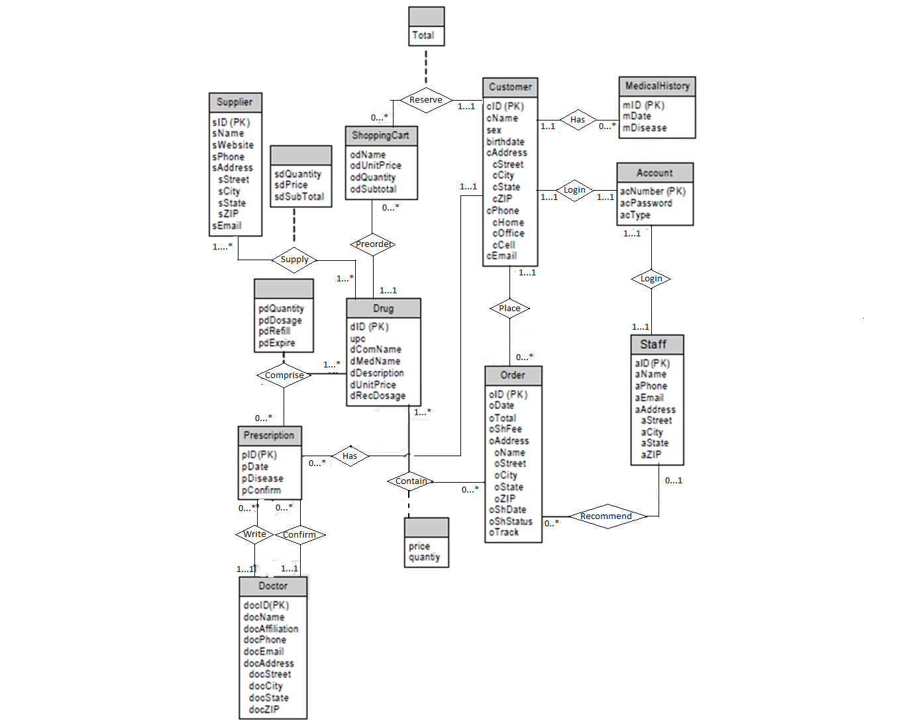
Figure 3: E-R Diagram

Relational Schema

Fig [4] shows the relation schema diagram for our project.

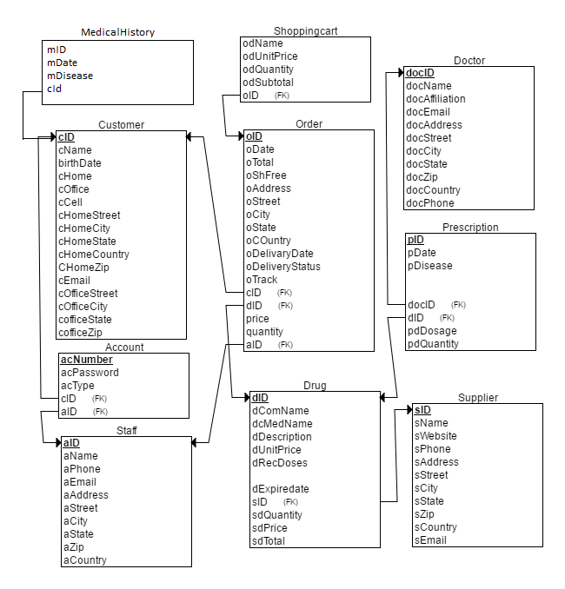
Figure 3: Relational Schema
From The Relation Schema depicted in Fig [3], the schemas are derived as following
Schemas derived from relationship sets in the E-R diagram in Figure 1.

Account
(
[acNumber] INT NOT NULL,
[acName] NVARCHAR (MAX) NULL,
[acPassword] NVARCHAR (MAX) NULL,
[acType] NVARCHAR (50) NULL,
[aID] INT NULL,
[cID] INT NULL,
PRIMARY KEY CLUSTERED ([acNumber] ASC),
FOREIGN KEY ([cID]) REFERENCES [dbo].[tbl_Customer] ([cID]),
FOREIGN KEY ([aID]) REFERENCES [dbo].[tbl_Staff] ([aID])
)

Customer
(
[cID] INT NOT NULL,
[cName] NVARCHAR (50) NULL,
[cSex] NVARCHAR (50) NULL,
[cDOB] DATETIME NULL,
[cHome] NVARCHAR (50) NULL,
[cOffice] NVARCHAR (50) NULL,
[cCell] NVARCHAR (50) NULL,
[cStreet] NVARCHAR (50) NULL,
[cCity] NVARCHAR (50) NULL,
[cState] NVARCHAR (50) NULL,
[cZIP] INT NULL,
[cEmail] NVARCHAR (MAX) NULL,
PRIMARY KEY CLUSTERED ([cID] ASC)
)

Doctor
(
[docID] INT NOT NULL,
[docName] NVARCHAR (50) NULL,
[docAffiliation] NVARCHAR (MAX) NULL,
[docPhone] NVARCHAR (50) NULL,
[docStreet] NVARCHAR (50) NULL,
[docCity] NVARCHAR (50) NULL,
[docState] NVARCHAR (50) NULL,
[docZIP] INT NULL,
[docEmail] NVARCHAR (MAX) NULL,
PRIMARY KEY CLUSTERED ([docID] ASC)
)

Drug
(
[dID] INT NOT NULL,
[upc] NCHAR (10) NULL,
[dName] NVARCHAR (50) NULL,
[dMedName] NVARCHAR (MAX) NULL,
[dDiscription] NVARCHAR (MAX) NULL,
[dRecDosage] NVARCHAR (MAX) NULL,
[dUnitPrice] FLOAT (53) NULL,
[sID] INT NULL,
PRIMARY KEY CLUSTERED ([dID] ASC),
FOREIGN KEY ([sID]) REFERENCES [tbl_Supplier]([sID])
)

MedicalHistory
(
[mID] INT NOT NULL,
[mDate] DATE NULL,
[mDisease] NVARCHAR (MAX) NULL,
[cID] INT NULL,
PRIMARY KEY CLUSTERED ([mID] ASC),
FOREIGN KEY ([cID]) REFERENCES [tbl_Customer]([cID])
)

Order
(
[oID] INT NOT NULL,
[oName] NVARCHAR (50) NULL,
[oDate] DATE NULL,
[oTrack] NCHAR (10) NULL,
[oTotal] FLOAT (53) NULL,
[oShStatus] NCHAR (10) NULL,
[oShDate] DATE NULL,
[oShFee] FLOAT (53) NULL,
[oStreet] NVARCHAR (50) NULL,
[oCity] NVARCHAR (50) NULL,
[oState] NVARCHAR (50) NULL,
[oZIP] INT NULL,
[aID] INT NULL,
[cID] INT NULL,
[dID] INT NULL,
PRIMARY KEY CLUSTERED ([oID] ASC),
FOREIGN KEY ([aID]) REFERENCES [tbl_Staff]([aID]),
FOREIGN KEY ([cID]) REFERENCES [tbl_Customer]([cID]),
FOREIGN KEY ([dID]) REFERENCES [tbl_Drug]([dID])

)

Prescription
(
[pID] INT NOT NULL,
[cID] INT NULL,
[docID] INT NULL,
[pDate] DATETIME NULL,
[pDisease] NVARCHAR (MAX) NULL,
[pConfirm] INT NULL,
[dID] INT NULL,
PRIMARY KEY CLUSTERED ([pID] ASC),
FOREIGN KEY ([docID]) REFERENCES [dbo].[tbl_Doctor] ([docID]),
FOREIGN KEY ([dID]) REFERENCES [dbo].[tbl_Drug] ([dID])
)

Shoppingcart
(
[dName] NVARCHAR (50) NULL,
[odUnitPrice] FLOAT (53) NULL,
[odQuantity] INT NULL,
[odSubtotal] FLOAT (53) NULL,
[oID] INT NULL,
FOREIGN KEY ([oID]) REFERENCES [tbl_Order]([oID])
)

Staff
(
[aID] INT NOT NULL,
[aName] NVARCHAR (50) NULL,
[aPhone] NVARCHAR (50) NULL,
[aStreet] NVARCHAR (50) NULL,
[aCity] NVARCHAR (50) NULL,
[aState] NVARCHAR (50) NULL,
[aZIP] INT NULL,
[aEmail] NVARCHAR (MAX) NULL,
PRIMARY KEY CLUSTERED ([aID] ASC)
)

Supplier
(
[sID] INT NOT NULL,
[sName] NVARCHAR (50) NULL,
[sPhone] NVARCHAR (50) NULL,
[sWebsite] NVARCHAR (50) NULL,
[sStreet] NVARCHAR (50) NULL,
[sCity] NVARCHAR (50) NULL,
[sState] NVARCHAR (50) NULL,
[sZIP] INT NULL,
[sEmail] NVARCHAR (MAX) NULL,
PRIMARY KEY CLUSTERED ([sID] ASC)
)

Targeted Interesting Queries

Queries about sell at any time:
In this system we can make queries to collect information about the selling condition of a pharmacy.
Like:
- How many medicine have been sold at a period?
- Which medicine have sold most?
- The earned money in total at a period of time?

Queries for medicine detail:
In this system one of the best thing is that we can make queries about the medicine information.
Like:
- How many medicines are of X company?
- What is the best use of the medicine?
- Search medicine giving description as input.
- Which are the cheapest medicines.
- Which medicines have been produced in X year?
- Which medicines will expire soon?

Queries for analyzing Patient:
Using our proposed System we can make query to have information about
- Detail About patient who have taken medicine from our pharmacy
- Prizes of medicines having same description but of different company.

Queries for Doctors:
- Which doctor is seeing more patient now a days?
- Which kind of medicines are suggested by doctor much?

Queries for stock detail:
- How many medicines are left in stock?
- Which medicines are at large amount?

Also here we can make queries about Staff, Owner, Suppliers and many other attributes.

Query Implementation

# | Query Goal | Query Code | Query parameter
1 | Insertion of a new Staff  INSERT | Insert into Staff(aID, aName, aPhone, aStreet, aCity, aState,aZIP,aEmail) values (1, ‘name, ‘phone, ‘city’, ‘state’,’zip’,’email’) | [aID] - Id of Staff; This is the primary key of the table Staff  [aName]– Name of Staff  [aPhone]– Phone of Staff  [aStreet]– Street address of Staff  [aCity]– City of Staff’s address  [aState] – State address of the Staff  [aZIP]– Zip address of the Staff  [aEmail]– Email address of the Staff
2 | Update of Staff  UPDATE | UPDATE Staff  SET aPhone=’+880xxxx', aCity='Khulna'  WHERE aName='Alfreds Futterkiste'; | Same as 1
3 | Delete Staff  DELETE | DELETE FROM Staff  WHERE aName='Alfreds Futterkiste'; | Same as 1
4 | Insertion of a new Customer INSERT | Insert into Customer(cID, cName, cSex, cDOB, cHome, cOffice, cCell, cStreet, cCity, cState, cZIP, cEmail) values (1, ‘cName’, ‘cSex’, ‘cDOB’, ‘cHome’, ‘cOffice’, ‘cCell’, ‘cStreet’, ‘cCity’, ‘cState’, ‘cZIP’, ‘cEmail’) | [cID] - Id of Customer; This is the primary key of the table Customer  [cName]– Name of Customer  [cSex] – Sex of Customer  [cCell]– Phone of Customer  [cHome] – Home address of Customer  [cOffice] – Office address of Customer  [cStreet]– Street address of Customer  [cCity]– City of Customer’s address  [cState] – State address of the Cutomer  [cZIP]– Zip address of the Customer  [cEmail]– Email address of the Customer
5 | Update Customer UPDATE | UPDATE Customer  SET cCell=’+880xxxx', cCity='Khulna'  WHERE cName='Alfreds John'; | Same as 4
6 | Delete Customer DELETE | DELETE FROM Customer  WHERE cName='Alfreds John; | Same as 4
7 | Insertion of a new Doctor INSERT | Insert into Doctor(docID, docName, docAffiliation, , docPhone, docStreet, docCity, docState, docZIP, docEmail) values (1, ‘docName’, ‘docAffiliation, ‘docPhone’, ‘docStreet’, ‘docCity’, ‘docState’, ‘docZIP’, ‘docEmail’) | [docID] - Id of Doctor; This is the primary key of the table Doctor  [docName]– Name of Doctor  [docAffiliation]– Affiliation of Doctor  [docPhone]– Phone of Doctor  [docStreet]– Street address of Doctor  [docCity]– City of Doctor’s address  [docState] – State address of the Doctor  [docZIP]– Zip address of the Doctor  [docEmail]– Email address of the Doctor
8 | Update Doctor UPDATE | UPDATE Doctor  SET doccCell=’docCell’, docCity='Khulna'  WHERE docName='Dr. John Smith'; | Same as 5
9 | Delete Doctor DELETE | DELETE FROM Doctor  WHERE docName =’ 'Dr. John Smith’;
10 | Insertion of a new Supplier INSERT | Insert into Supplier(sID, sName, sPhone, sWebsite, sStreet, sCity, sState, sZIP, sEmail) values (1, ‘sName’, ‘sPhone, ‘sWebsite’ ‘sStreet’, ‘sCity’, ‘sState’, ‘sZIP’, ‘sEmail’) | [sID] - Id of Supplier; This is the primary key of the table Supplier  [sName]– Name of Supplier  [sWebsite]– Website of Supplier  [sPhone]– Phone of Supplier  [sStreet]– Street address of Supplier  [sCity]– City of Supplier’s address  [sState] – State address of the Supplier  [sZIP]– Zip address of the Supplier  [sEmail]– Email address of the Supplier
11 | Update Supplier UPDATE | UPDATE Supplier  SET sPhone=’sPhone’, sCity='Khulna'  WHERE sName=sName'; | Same as 10
12 | Delete Supplier DELETE | DELETE FROM Supplier  WHERE sName =’name’; | Same as 10
13 | Insertion of a new Account for customer INSERT | Insert into Account(acNumber, acName, acPassword, acType, aID, cID) values (1, ‘acName’, ‘acPassword, ‘acType, null, ‘cID’) | [acNumber] – account number  [acName]– user name  [acPassword]– password  [acType]– admin or non admin type  [aID]– Staff ID  [cID]– Customer ID
14 | Insertion of a new Account for staff INSERT | Insert into Account(acNumber, acName, acPassword, acType, aID, cID) values (1, ‘acName’, ‘acPassword, ‘acType, ‘aID’, null) | [acNumber] – account number  [acName]– user name  [acPassword]– password  [acType]– admin or non admin type  [aID]– Staff ID  [cID]– Customer ID
15 | Change password {UPDATE,WHERE} | UPDATE Account  SET acPassword =’acPassword’  WHERE cID= ‘cId’; | [acPassword]– password  [cID]– Customer ID
16 | Delete Account {DELETE,WHERE} | DELETE FROM Account  WHERE cID =’cId’; | [cID]– Customer ID
17 | View Drug those are supplied by a supplier  {SELECT,INNER JOIN, ON} | SELECT Drug.dID, Drug.dUnitPrice, Drug.dName, Supplier.sName, Drug.dAvailableQuantity  FROM Drug  INNER JOIN Supplier  ON Drug.sID= Supplier.sID; | [dID]– Drug ID  [sID]– Supplier ID  [dUnitPrice]– unit price of drug  [dAvailableQuantity] ]– available quantity of drug in store  [sName]– Supplier name
18 | View Drug those are Supplied by a supplier  {SELECT,INNER JOIN, ON} | SELECT Drug.dID, Drug.dUnitPrice, Drug.dName, Supplier.sName, Drug.dAvailableQuantity  FROM Drug  INNER JOIN Supplier  ON Drug.sID= Supplier.sID; | [dID]– Drug ID  [sID]– Supplier ID  [dUnitPrice]– unit price of drug  [dAvailableQuantity] ]– available quantity of drug in store  [sName]– Supplier name
19 | View customer who orders in last 5 days order by customer name  {SELECT,LEFT JOIN, WHERE, BETWEEN, AND, ORDER BY} | SELECT Customer.cName, Order.oID,Order.oDate, Order.oTrack, Order.oStatus  FROM Order  LEFT JOIN Customer  ON Customer.cID=Order.cID AND  WHERE Order.odate BETWEEN #07/04/1996# AND #07/09/1996#  ORDER BY Customers.cName; | [cName]– Name of Customer
20 | View Customer who orders a drug  [JOIN 3 TABLES] | SELECT Customer.cName, Orders.oID,oDate, oTrack, oStatus,Drug.dName  FROM Order  JOIN Customer ON Order.cID = Customer.cID  JOIN Drug ON Drug.dID = Order.dId  ORDER BY Drug.dNumbe; | [cName]– Name of Customer
21 | View Available quantity for a drug  {SELECT,WHERE } | SELECT Drug.dAvailableQuantity, Drug.dName  FROM Drug  WHERE Drug.dName =’zimax’; | [dName]– Name of Drug
22 | View unit price for a Drug  {SELECT,WHERE } | SELECT Drug.dUnitPrice, Drug.dName  FROM Drug  WHERE Drug.dName =’zimax’; | [dName]– Name of Drug
23 | View Supplier for a Drug  {SELECT,INNER JOIN, WHERE} | SELECT Drug.dName, Supplier.sName  FROM Drug  INNER JOIN Supplier  ON Drug.sID= Supplier.sID  WHERE Drug.dName =’zimax’; | [sID]– ID of Supplier  [dName]– Name of Drug  [sName]– Name of Supplier
25 | Place an order  INSERT | Insert into Order(oID, oDate, oAddress, oStreet, oCity, oState, oZIP,oCountry, oTrack, dID, cID, dprice, dquanty,oTotal, oDeliveryDate, oDeliveryStatus) values (1, ‘1/1/2001’, ‘oAddress, ‘oStreet’, ‘oCity’, ‘oState’, ‘oZIP’, ‘oCountry’, ‘oTrack’, “dID”, “cID’, ‘dprice’, dquanty, ‘oTotal’, ‘oDeliveryDate’, ‘oDeliverysDtatus’) | [oID] – Id of the order  [oName]- unique Name,  [oDate] - date of order placement  [oTrack]-Track number for the order  [oTotal] - total amount for pyment  [oStreet]- street address of the customer,  [oCity]- city address of the customer  [oState]- state address of the customer  [oZIP]- zip address of the customer  [dquanty]- quantity of drug  [oDeliveryDate]- delivery date  [oDeliveryStatus]- delivery status  [aID] –Staff ID,  [cID]- Customer Id,  [dID]- Drug ID,
26 | Update Delivery Status for order  {UPDATE,WHERE} | UPDATE Order  SET oDeliveryDate =’oDeliveryDate’ AND oDeliveryStatus=’Shipped’  WHERE oID = ‘oId’; | [oDeliveryDate]- delivery date  [oID] – Id of the order  [oDeliveryStatus]- delivery status
27 | Cancel Order  {UPDATE,WHERE} | UPDATE Order  SET oDeliveryStatus=’CANCELLED’  WHERE oID = ‘oId’; | [oDeliveryStatus]- delivery status  [oID] – Id of the order
28 | View delivery status of an Order by track number  {SELECT,WHERE} | SELECT oDeliveryDate, oDeliveryStatus  FROM Order  WHERE Order.oTrack = ‘oTrack’; | [oDeliveryStatus]- delivery status  [oID] – Id of the order
29 | Select top 5% sold Drug in store  {TOP} | SELECT TOP 5 dID , sum(quantity)  FROM Order  GROUP BY oName  ORDER BY sum(quantity) DESC
30 | Create Database  CREATE DATABASE | CREATE DATABASE dbname;
31 | Create Table | CREATE TABLE MedicalHistory  (mID INT NOT NULL, mDate DATE NULL, mDisease NVARCHAR (MAX) NULL, cID INT NULL, PRIMARY KEY CLUSTERED (mID ASC),  FOREIGN KEY (cID) REFERENCES tbl_Customer(cID));
32 | View Doctor list who live in a city that’s’s name end with ‘na’ | SELECT * FROM Customer  WHERE cCity LIKE '%na'; | [cCity]– City of Customer’s address
33 | Insertion of a new Drug  INSERT | Insert into Drug(dID, dName, dMedicalName, sID, dQuantity, dDescription, dDisease) values (1, ‘dName’, ‘dMedicalName’, ‘dSupplier’ 500, ‘dDescription’, ‘dDisease’); | [dID] - Id of Drug; This is the primary key of the table Drug  [dName]– Name of Drug  [dMedicalName]– Medical Name of Drug  [sID]– ID of Supplier  [dDescription]– Description of Drug  [dDisease]– Disease for which the drug is
34 | Update Supplier UPDATE | UPDATE Supplier  SET dQuantity=1000 WHERE dName=’dName'; | Same as 33
35 | Delete Supplier DELETE | DELETE FROM Supplier  WHERE dName =’name’; | Same as 33

Functional Implementation
This section contains a table which list all the needed functions with steps that the scripts needs to take and what DB steps are required. Another table contains the actual DB queries describes in table []
# | Goal | Use Case | Steps | Query + UI
1 | Login |  | 1. User open the application  2. On login Screen [Appendix : ] User input userName and password  3. User click Login button | UI: Appendix :12.1
2 | Create new Pharmacists/ Staff | ER1 | 1. Admin click “Add New Stuff” from Home Screen  2. Admin input all required information  3. Click Add button | Query: Q .1  UI: Appendix :12.2
3 | Edit Staff Information |  | 1. Admin click “Staff Information” from Home Screen  2. Admin input all required information on the Search Block  3. Matched result are view on list box  4. Every row on the list view has an Edit button and a Delete Button  5. Click Edit button  6. List view has been replaced by new form View  7. Admin input all required information  8. Click Update button | Q.2  UI: Appendix :12.3
4 | Delete Staff Information |  | 1. Admin click “Staff Information” from Home Screen  2. Admin input all required information on the Search Block  3. Matched result are view on list box  4. Every row on the list view has an Edit button and a Delete Button  5. Click Delete button | Q.3  UI: Appendix :12.3
2 | Create new Doctor | IR11 | 1. Admin click “Add New Doctor” from Home Screen  2. Admin input all required information  3. Click Add button | Q .7  UI: Appendix :12.4
3 | Edit Doctor Information | IR11 | 1. Admin click “Doctor Information” from Home Screen  2. Admin input all required information on the Search Block  3. Matched result are view on list box  4. Every row on the list view has an Edit button and a Delete Button  5. Click Edit button  6. List view has been replaced by new form View  7. Admin input all required information  8. Click Update button | Q.8  UI: Appendix :12.5
4 | Delete Doctor Information | IR11 | 1. Admin click “Doctor Information” from Home Screen  2. Admin input all required information on the Search Block  3. Matched result are view on list box  4. Every row on the list view has an Edit button and a Delete Button  5. Click Delete button | Q.9  UI: Appendix :12.5
2 | Create new Supplier | IR12 | 1. Admin click “Add New Stuff” from Home Screen  2. Admin input all required information  3. Click Add button | Q .10  UI: Appendix :12.6
6 | Edit Supplier Information | IR12 | 1. Admin click “Supplier Information” from Home Screen  2. Admin input all required information on the Search Block  3. Matched result are view on list box  4. Every row on the list view has an Edit button and a Delete Button  5. Click Edit button  6. List view has been replaced by new form View  7. Admin input all required information  8. Click Update button | Q .11  UI: Appendix :12.7
7 | Delete Supplier Information | IR12 | 1. Admin click “Supplier Information” from Home Screen  2. Admin input all required information on the Search Block  3. Matched result are view on list box  4. Every row on the list view has an Edit button and a Delete Button  5. Click Delete button | Q .12  UI: Appendix :12.7
8 | Add Drug | IR13 | 1. Admin click “Add New Drug” from Home Screen  2. Admin input all required information  3. Click Add button | Q.33  UI: Appendix :12.10
9 | Search Drug | IR10, IR9 | 1. Admin click “Drug Information” from Home Screen  2. Admin input all required information on the Search Block  3. Matched result are view on list box | Q.21 & Q.22 & Q.23  UI: Appendix :12.11
10 | Edit Drug Information | IR13 | 1. Admin click “Drug Information” from Home Screen  2. Admin input all required information on the Search Block  3. Matched result are view on list box  4. Every row on the list view has an Edit button and a Delete Button  5. Click Edit button  6. List view has been replaced by new form View  7. Admin input all required information  8. Click Update button | Q.34  UI: Appendix :12.12
11 | Delete Drug Information | IR13 | 1. Admin click “Drug Information” from Home Screen  2. Admin input all required information on the Search Block  3. Matched result are view on list box  4. Every row on the list view has an Edit button and a Delete Button  5. Click Delete button | Q.35  UI: Appendix :12.12
12 | Add Account | IR2 /ER2 | 1. Admin click “Add New Account” from Home Screen  2. Admin input username and select Id from respective combobox. For example if the user is a Staff, select corresponding id from the comboBox for Staff  3. Click Generate Password button | Q.13 & Q.14  UI: Appendix :12.10
13 | Change Password | ER4, IR14, IR15 | 1. User click “Change Password” from Home Screen  2. User input required information  3. Click Change Password button | Q.9  UI: Appendix :12.11
14 | Create new Customer | ER6 | 1. click “Add New Customer” from Home Screen  2. input all required information  3. Click Add button | Query: Q .4  UI: Appendix :12.8
15 | Edit Customer Information | ER7 | 1. click “Customer Information” from Home Screen  2. input all required information on the Search Block  3. Matched result are view on list box  4. Every row on the list view has an Edit button and a Delete Button  5. Click Edit button  6. List view has been replaced by new form View  7. input all required information  8. Click Update button | Q.5  UI: Appendix :12.9
16 | Delete Customer Information | ER7 | 1. click “Customer Information” from Home Screen  2. Admin input all required information on the Search Block  3. Matched result are view on list box  4. Every row on the list view has an Edit button and a Delete Button  5. Click Delete button | Q.6  UI: Appendix :12.9
17 | Place Order | ER13 | 1. click “Order Information” from Home Screen  2. Select Supplier and Drug  4. Input Quantity, DeliveryDate, Order Date, Delivery Address  5. Automatically Price will be counted  6. Click “Place Order” button | Q.25  UI: Appendix : 12.13.1, 12.13.2, 12.13.3, 12.13.4, 12.14.1, 12.14.2, 12.14.3, 12.14.4

Additional Important Code Implementation

Creating a Data Connection to a SQL Server Database using C#

- To create a data connection to a SQL Server database
- In Server Explorer/Database Explorer click Connect to Database.
- In the Choose Data Source dialog box, select Microsoft SQL Server, and then click OK.
- If the Add Connection dialog box opens, and the Data source is not Microsoft SQL Server, click Change to open the Choose/Change Data Source dialog box. For more information, see Choose/Change Data Source Dialog Box.
- Select a server name from the drop-down list, or type the name of the server where the database you want to access is located.
- Based on the requirements of your database or application, select either Windows Authentication or use a specific user name and password to log on to the SQL Server (SQL Server Authentication). For more information, see Add/Modify Connection (Microsoft SQL Server).
- Select the database you want to connect to from the drop-down list.
- Click OK.

Technology Used

DOTNET
The .Net frame work is a comprehensive platform that can be a little difficult to describe. It has been described as a Development Platform an execution environment and the operating system among other things. In fact in some aside from embracing the web, Microsoft .NET acknowledges and respondsThe framework's Base Class Library provides a large range of features including user interface, data access, database connectivity, cryptography, web application development, numeric algorithms, and network communications. The class library is used by programmers, who combine it with their own code to produce applications. Programs written for the .NET Framework execute in a software environment that manages the program's runtime requirements. Also part of the .NET Framework, this runtime environment is known as the Common Language Runtime (CLR). The CLR provides the appearance of an application virtual machine so that programmers need not consider the capabilities of the specific CPU that will execute the program. The CLR also provides other important services such as security, memory management, and exception handling. The class library and the CLR together constitute the .NET Framework.

C# DOT NET
C# is a multi-paradigm programming language encompassing imperative, declarative, functional, generic, object-oriented (class-based), and component-oriented programming disciplines. It was developed by Microsoft within the .NET initiative and later approved as a standard by Ecma (ECMA-334) and ISO (ISO/IEC 23270). C# is one of the programming languages designed for the Common Language Infrastructure. C# is intended to be a simple, modern, general-purpose, object-oriented programming language. Its development team is led by Anders Hejlsberg. The C# language is disarmingly simple, with only about 80 keywords and a dozen built-in data types, but C# is highly expressive when it comes to implementing modern programming concepts. C# includes all the support for structured, component-based, object-oriented programming that one expects of a modern language built on the shoulders of C++ and Java. The C# language was developed by a small team led by two distinguished Microsoft engineers, Anders Hejlsberg and Scott Wiltamuth. Hejlsberg is also known for creating Turbo Pascal, a popular language for PC programming, and for leading the team that designed Borland Delphi, one of the first successful integrated development environments for client/server programming. At the heart of any object-oriented language is its support for defining and working with classes. Classes define new types, allowing you to extend the language to better model the problem you are trying to solve. In C# everything pertaining to a class declaration is found in the declaration itself. C# class definitions do not require separate header files or Interface Definition Language (IDL) files.

6.2 SQL SERVER:
SQL often referred to as Structured Query Language, is a database computer language designed for managing data in relational database management systems (RDBMS), and originally based upon relational algebra. Its scope includes data insert, query, update and delete, schema creation and modification, and data access control. SQL was one of the first languages for Edgar F. Code’s relational model in his influential 1970 paper, "A Relational Model of Data for Large Shared Data Banks" and became the most widely used language for relational databases. The SQL language is sub-divided into several language elements, including:
- Clauses, which are in some cases optional, constituent components of statements and queries.
- Expressions which can produce either scalar values or tables consisting of columns and rows of data.
- Predicates which specify conditions that can be evaluated to SQL three-valued logic (3VL) or Boolean (true/false/unknown) truth values and which are used to limit the effects of statements and queries, or to change program flow.
- Queries which retrieve data based on specific criteria.
- Statements which may have a persistent effect on schemas and data, or which may control transactions, program flow, connections, sessions, or diagnostics.
- SQL statements also include the semicolon (";") statement terminator. Though not required on every platform, it is defined as a standard part of the SQL grammar.

Conclusion and Discussion
In the next version of this document, we will complete the list of requirement analysis and corresponding use cases.

Reference

[1] Bruegge, Bernd, and Allen H. Dutoit. Object-Oriented Software Engineering Using UML, Patterns and Java-(Required). Prentice Hall, 2004.
[2] Cambridge.Press.Software.Modeling.and.Design.Feb.2011, last visited 5th March 2016 https://www.academia.edu/5320595/Cambridge_Software_Modeling_and_Design_Feb_2011

Appendices

Login User account

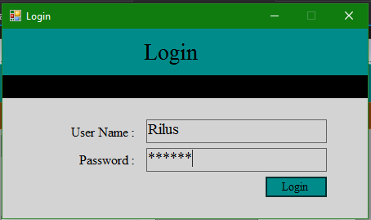

As an admin Add New Staff

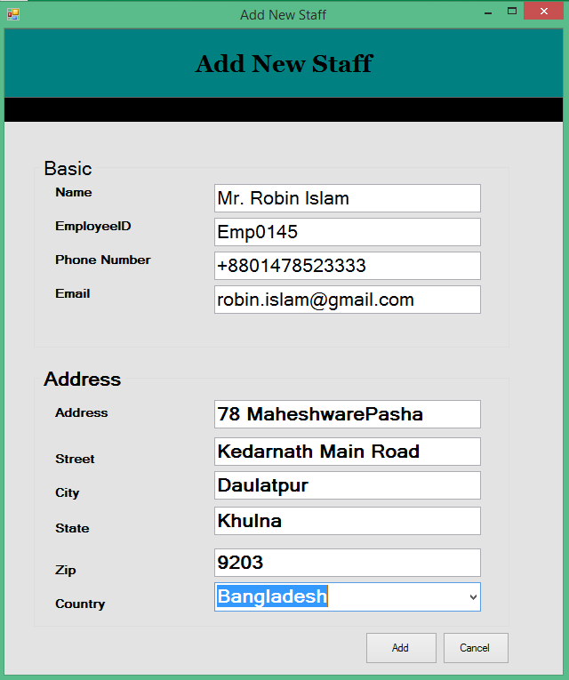

As a Staff/Admin update Staff

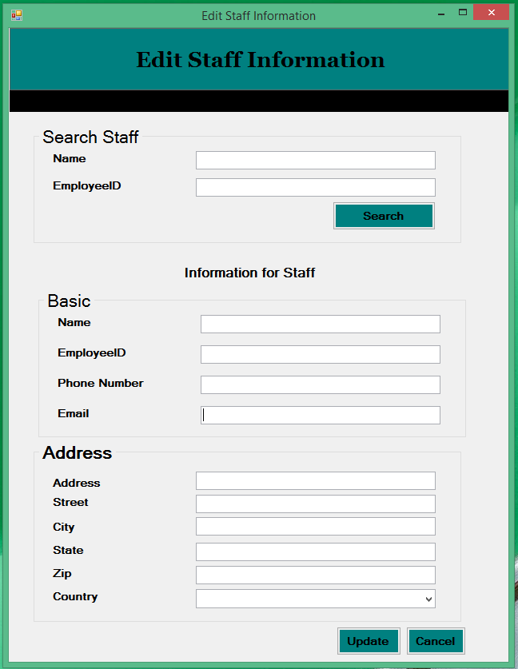

As an Admin/ Staff add new Doctor

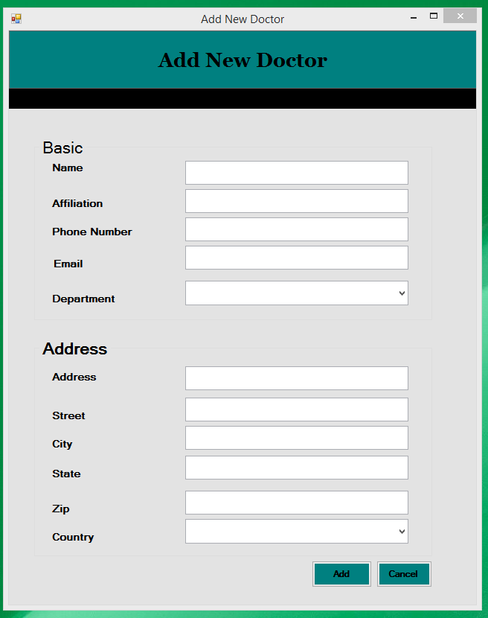

Updae Doctor Information
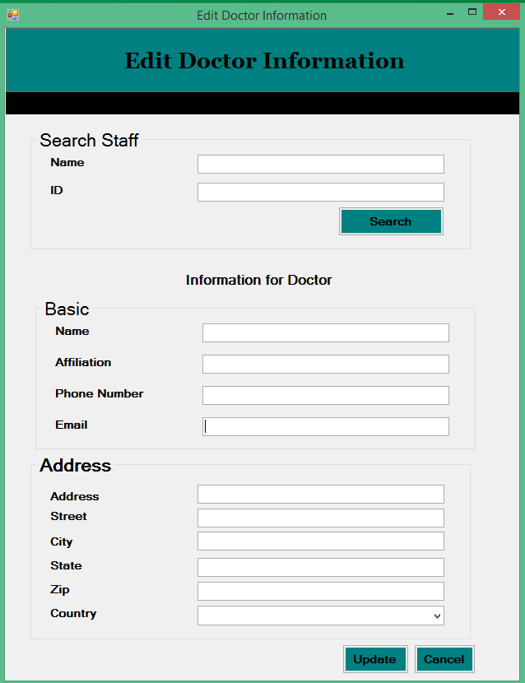

As Staff / Admin Add New Supplier

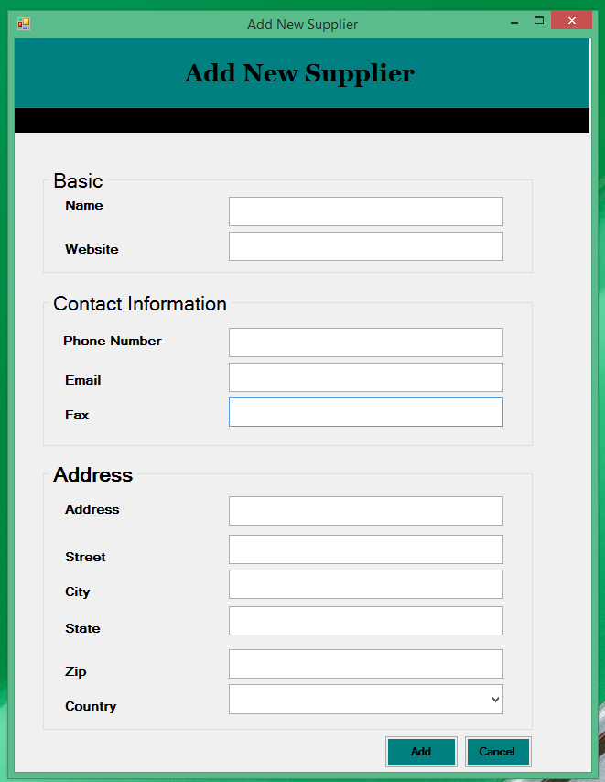

Update Supplier information

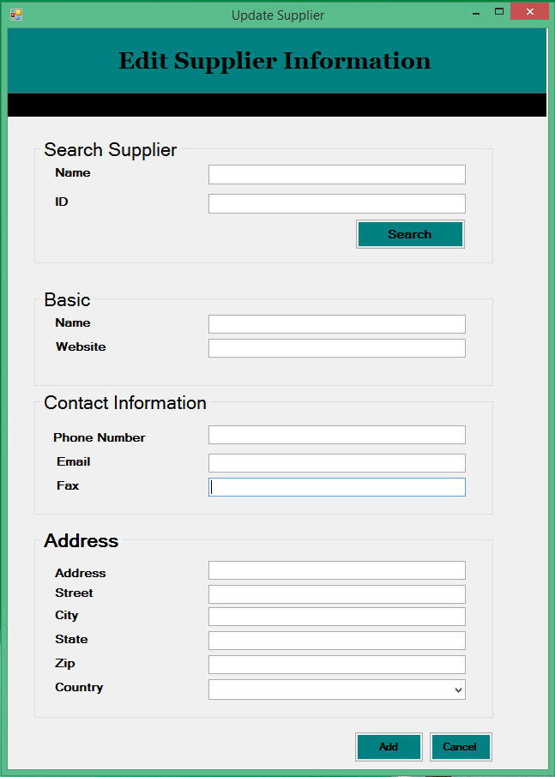

Add New Customer
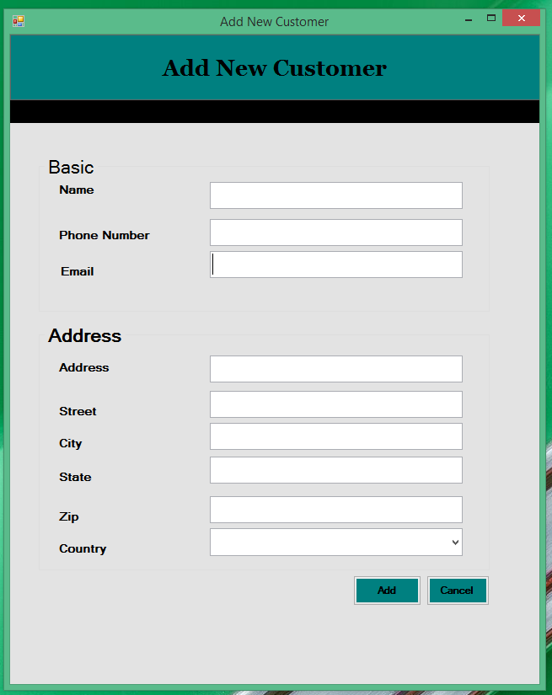

Edit /Delete Customer
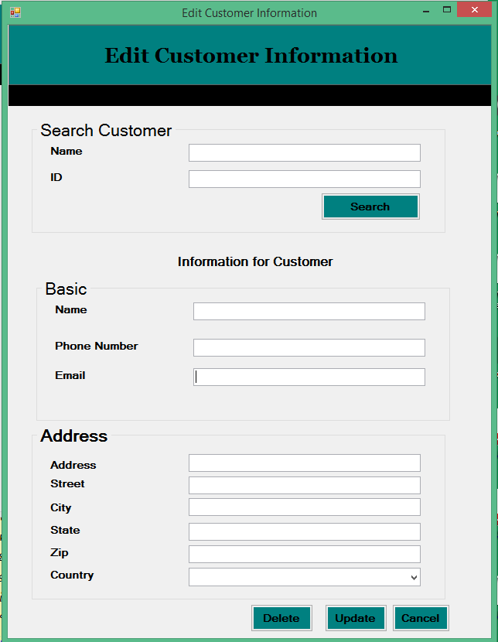

Create Account
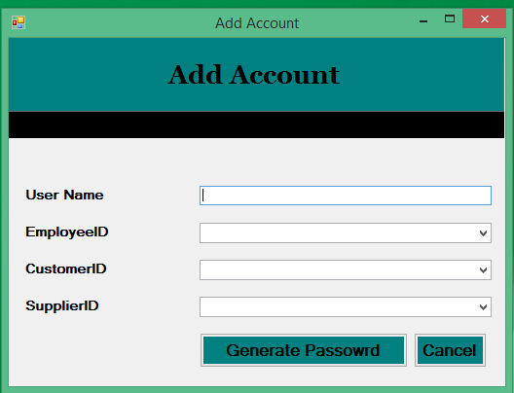

Change Password

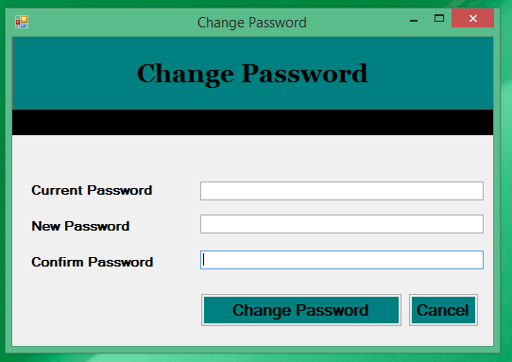

Add New Drug
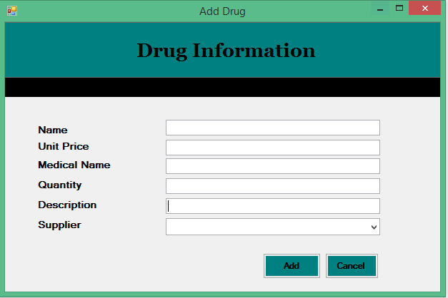

Search Drug
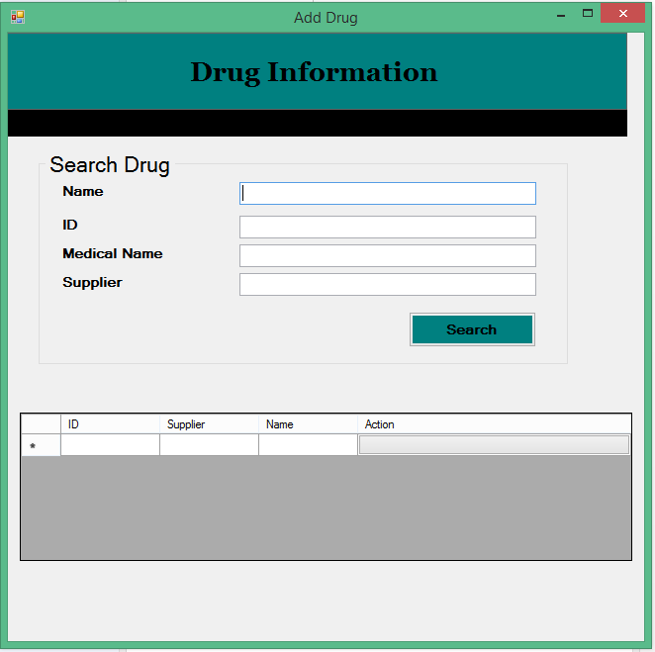

Edit /Update Drug
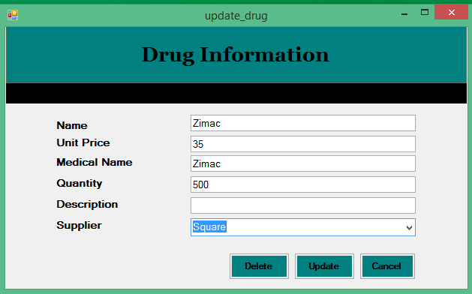

As a Stuff Order for Drug to Supplier

Select Supplier

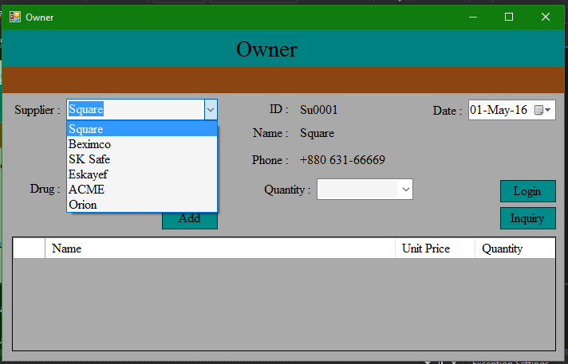

Select Drug

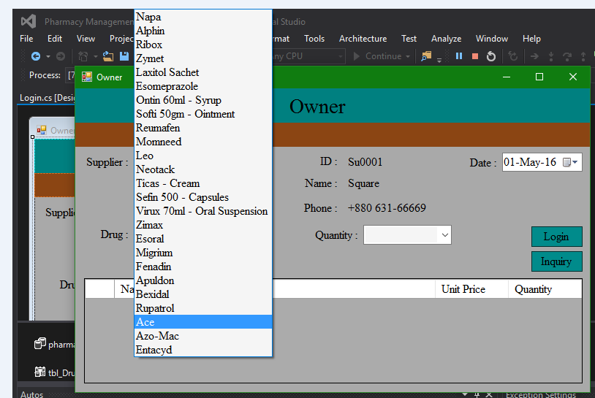

Give Quantity

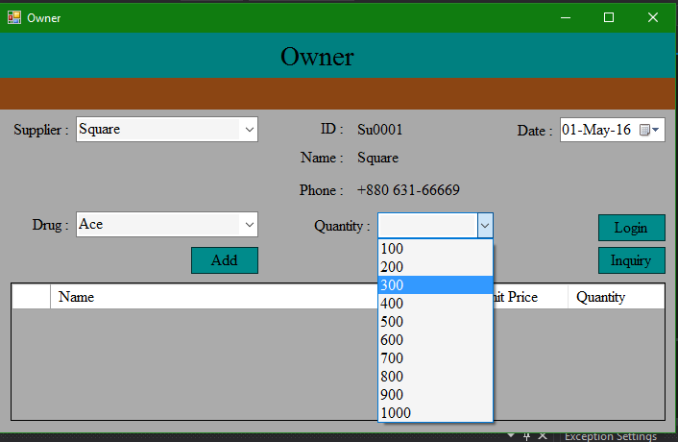

Finally Place Order

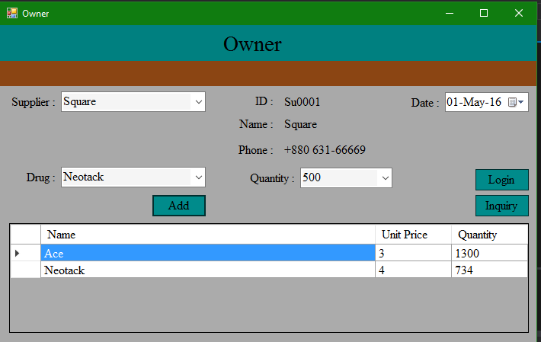

As a Customer Order for Drug to Pharmacy

Select Drug

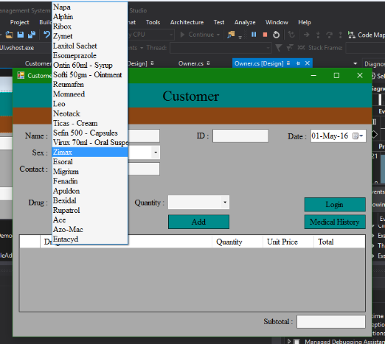

Give Quantity

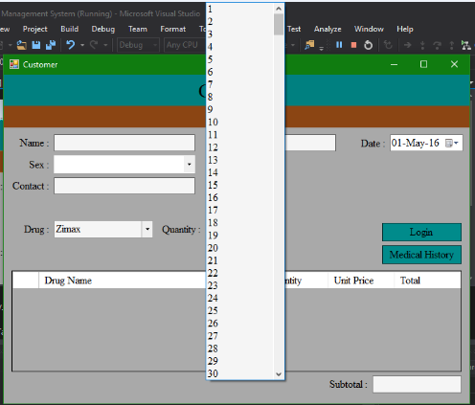

Place Order

