QuickNovel Ultimate 1.1.4 — Full Manual (EN)
Onboarding + modules + custom providers + bugs · 2026-10-30
Package: com.lagradost.quicknovel.ultimate | APK: QuickNovel-Ultimate-1.1.4-universal.apk

Table of contents
- Introduction
- Install
- Navigation map
- Library / Search / History / Sections
- Settings
- Custom providers
- Detail / download / reader / TTS
- Tutorials & beginner flows
- Screenshots
- Bug Word handoff
- QA & annex

1. Introduction
Ultimate searches, reads, listens (TTS) and downloads novels; imports EPUB/PDF. Fire themes, package com.lagradost.quicknovel.ultimate, Reading/Visited history, Import-B, custom providers, special-char filter off by default.

2. Install
- Uninstall old builds
- Install QuickNovel-Ultimate-1.1.4-universal.apk
- Skip upstream 3.x update dialog
- Open Ultimate only

3. Navigation
Tab | Role
Library | Local books + Import-B
Search | Online providers + multi-select
History | Reading / Visited
Settings | All configuration
Sections | Library shelves

4–7. Main modules
- Library: local search, Import-B, continue reading, follow, sort.
- Search: query, provider tune, popular, chips; special chars blocked unless enabled.
- History: Reading/Visited + date groups.
- Sections: Ultimate shelves.

8. Settings groups
- General: locale, provider langs, English providers, special chars, provider list
- Theme: Fire icons/launcher, nav/settings styles, colors
- App: updates, backup/restore
- New chapters: notify + frequency
- Gemini translation
- Tutorial dialogs
- Custom providers
- External reader + download path
- Logcat

9. Custom providers
- Settings → Add provider → Blog or Website → name/URL/lang → VALIDATE → Add
- Advanced: CSS fields, Madara preset, Test
- Manage: edit/delete (keeps downloads)
Advanced field | Use
Search URL + {query} | Search endpoint
resultItem / link / image | Result list
novel* selectors | Novel page
chapterLink / content | Chapters + body
Ajax / newest first | List behaviour

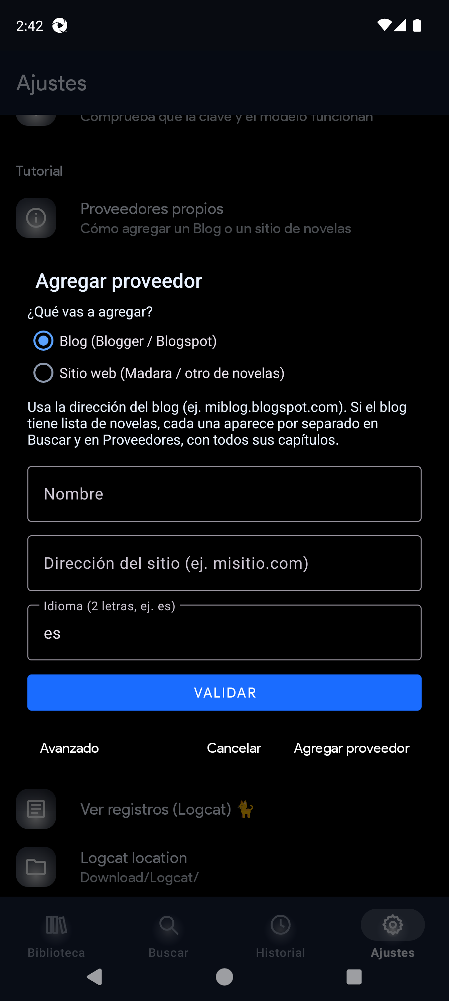
Add provider
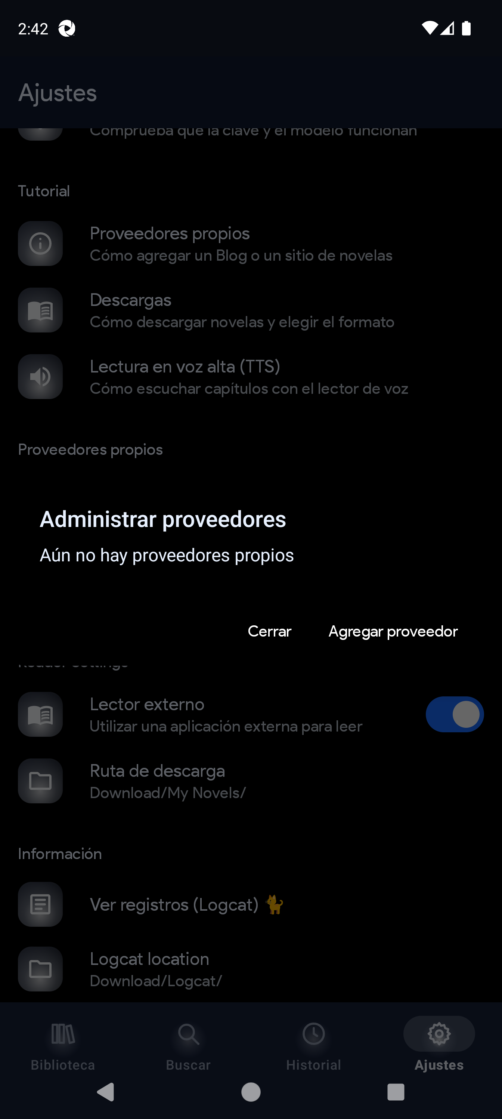
Manage

10–11. Detail, download, reader, TTS
- Read online vs Download (ranges, chapters-per-file, EPUB/PDF)
- TTS: speaker → bar/notification; Voice settings; Piper Dave/Lessac via Sherpa

12–13. Tutorials & flows
- In-app Tutorial: providers, downloads, TTS
- Flows: first search, offline download, import EPUB, add blog/site, follow updates

14. Screenshots
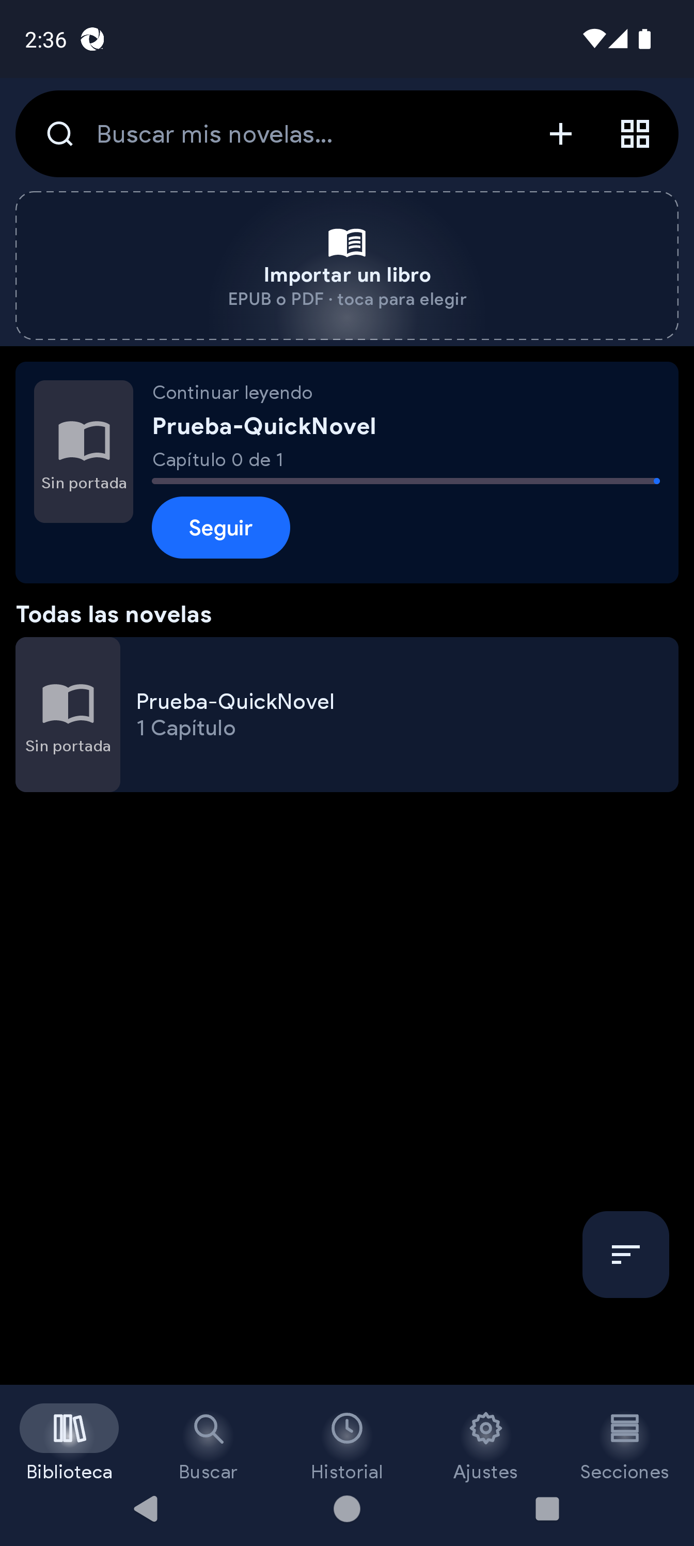
Library: local search, Import-B and novels
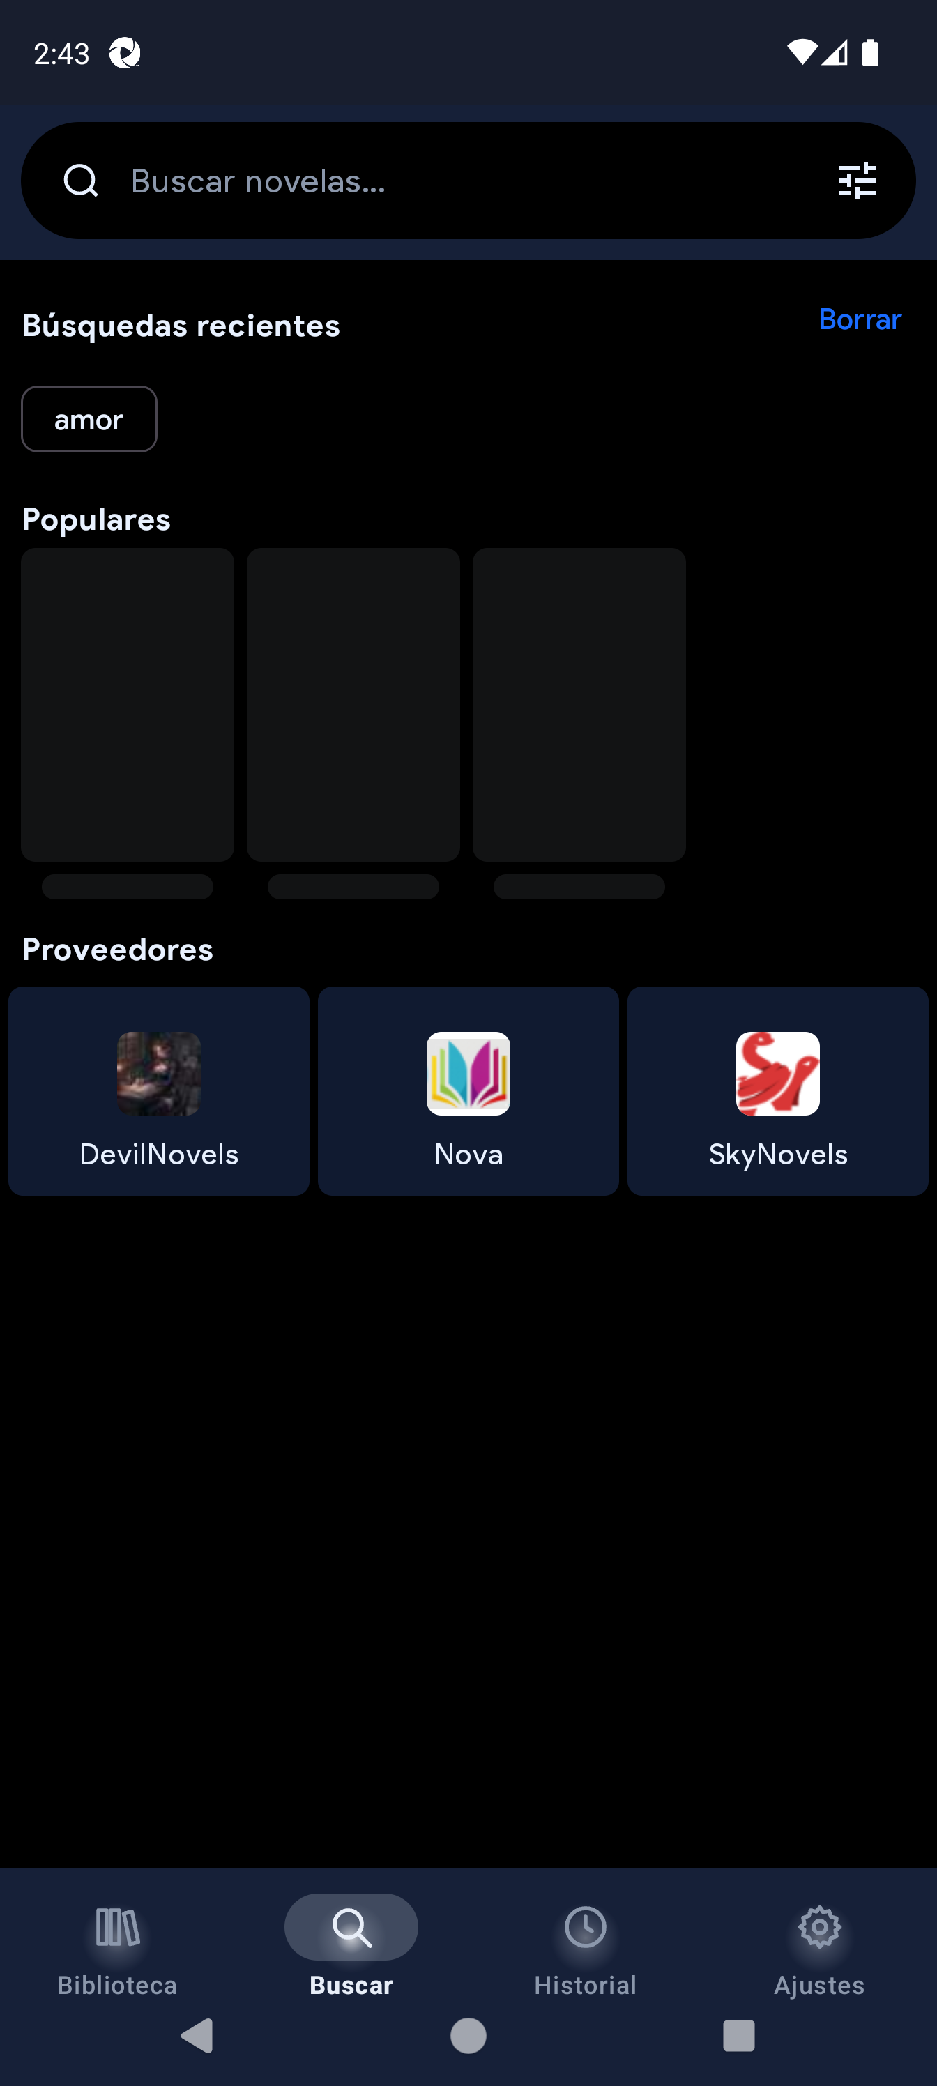
Search: field, popular and provider access
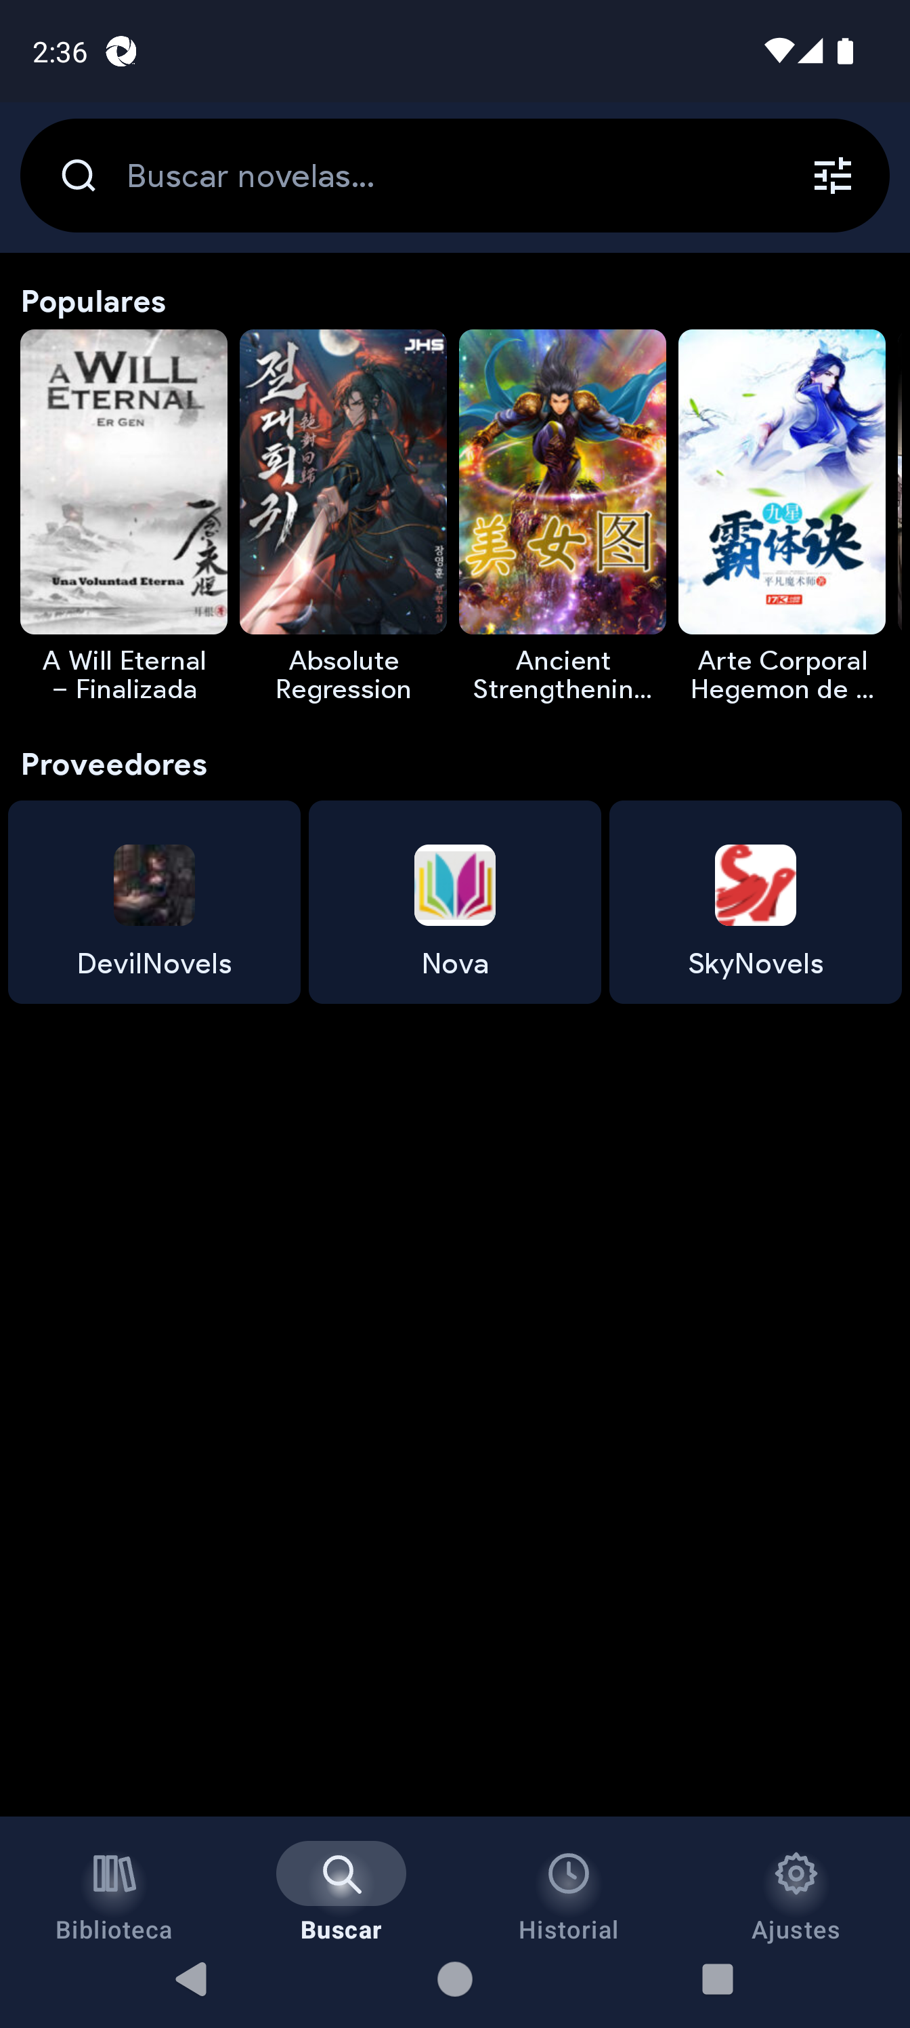
History: Reading / Visited
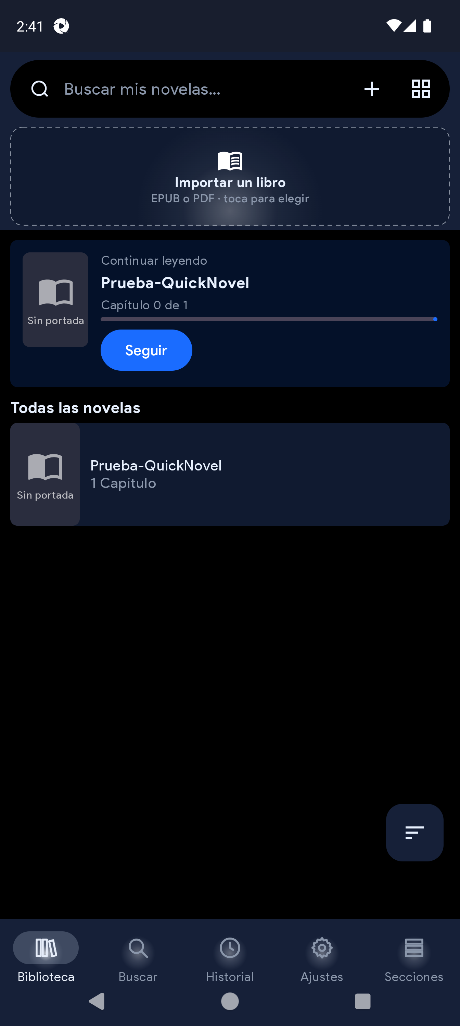
Settings (top)
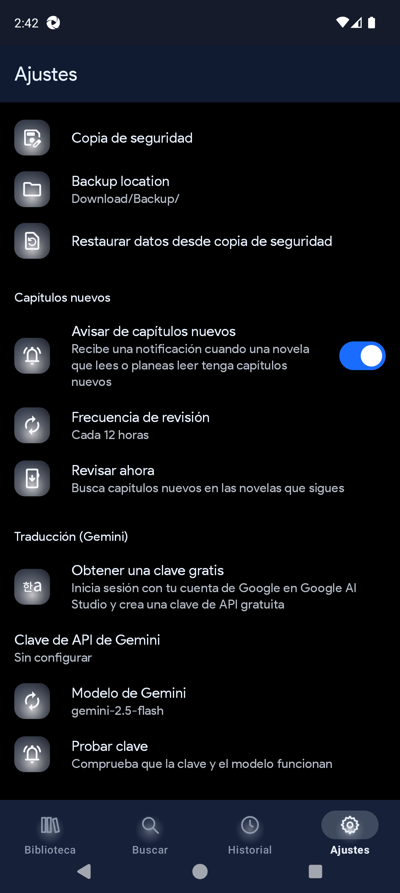
Settings: general / translation / tutorial area
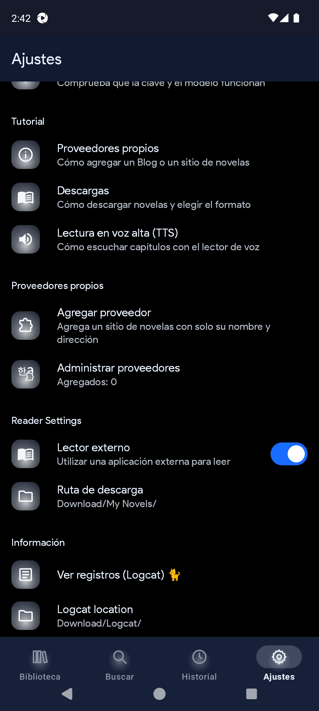
Settings: Tutorial + Custom providers
Add provider dialog (Blog / Website)
Manage custom providers
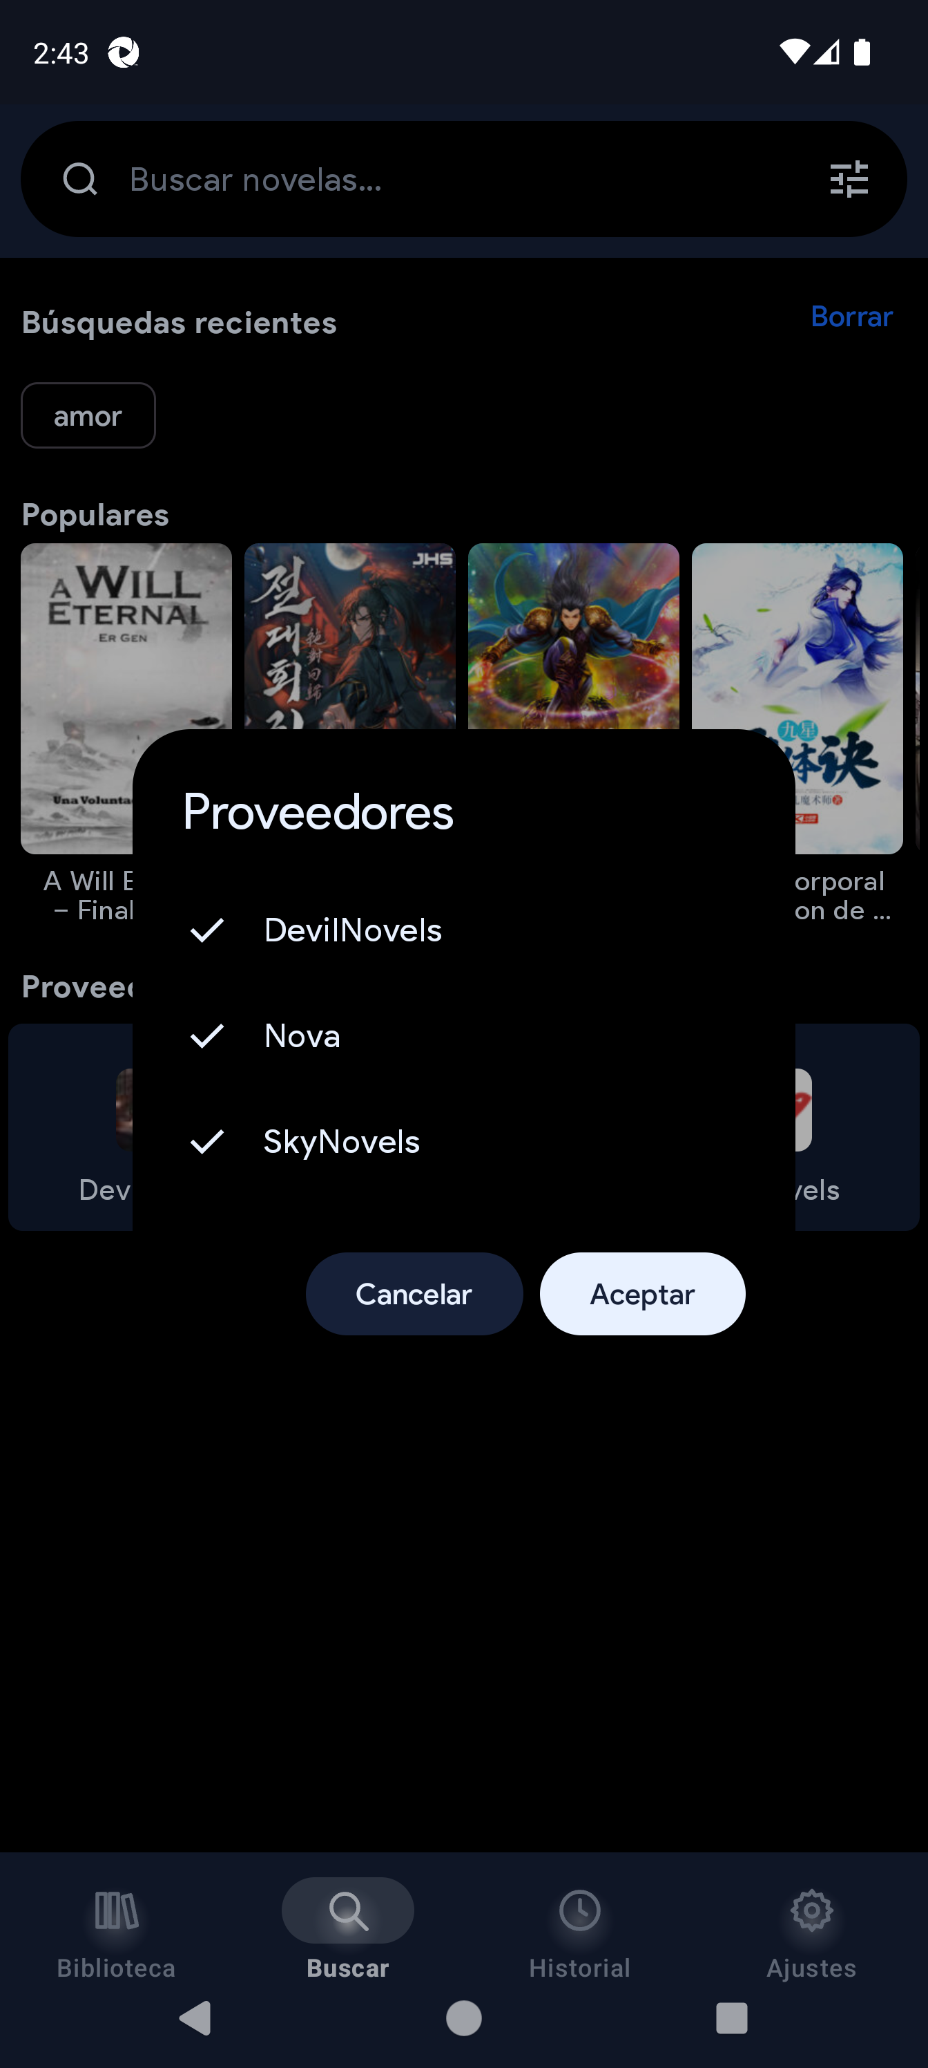
Search provider multi-select
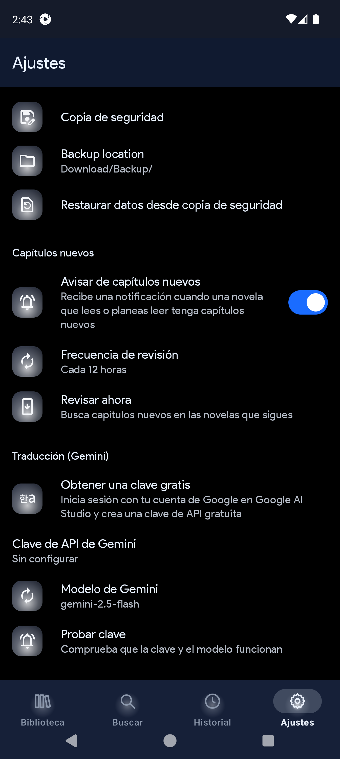
Library sections
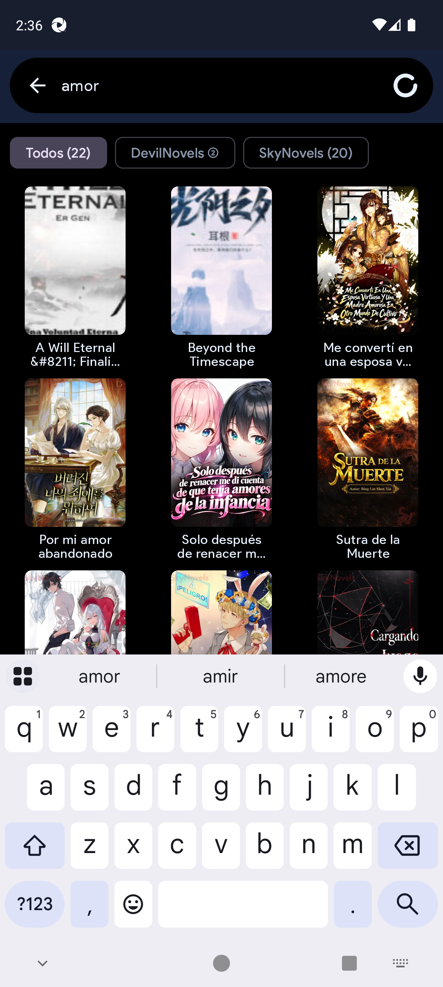
Search results with provider chips
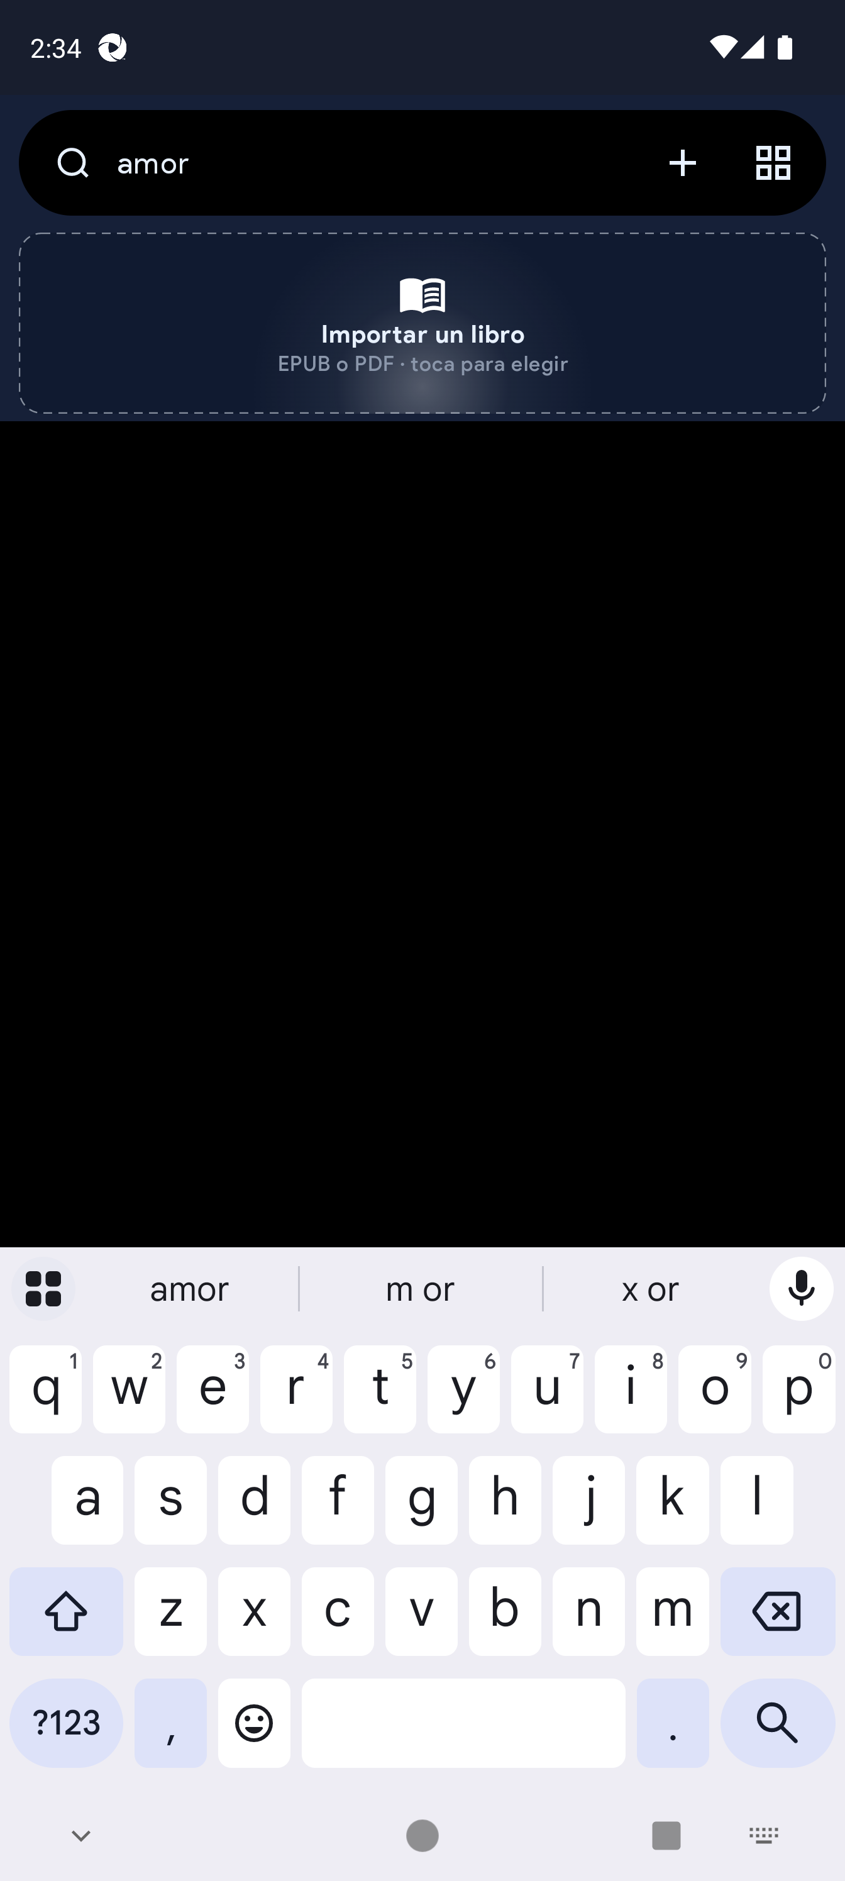
Novel detail flow

15. Bugs for Word
Use plantillas/Bug-Report-Template.docx. Required: ID, title, severity, module, environment, preconditions, steps, expected, actual, attachments.
- Confirm APK 1.1.4
- Reproduce 2+
- Save Bugs-QuickNovel-Ultimate-1.1.4-YYYY-MM-DD.docx

16. QA & annex
- gradlew :app:testDebugUnitTest
- e2e specs 01-09 + Allure
- https://github.com/RaffyRod/NovelReader
- Spanish: docs/manual-1.1.4/es/

